

PlayFab Storage

*\* This sample is compatible with the April 2018 XDK*

# Description

This sample demonstrates how to manage storage

# Using the sample

This sample is configured to work in the XDKS.1 sandbox.

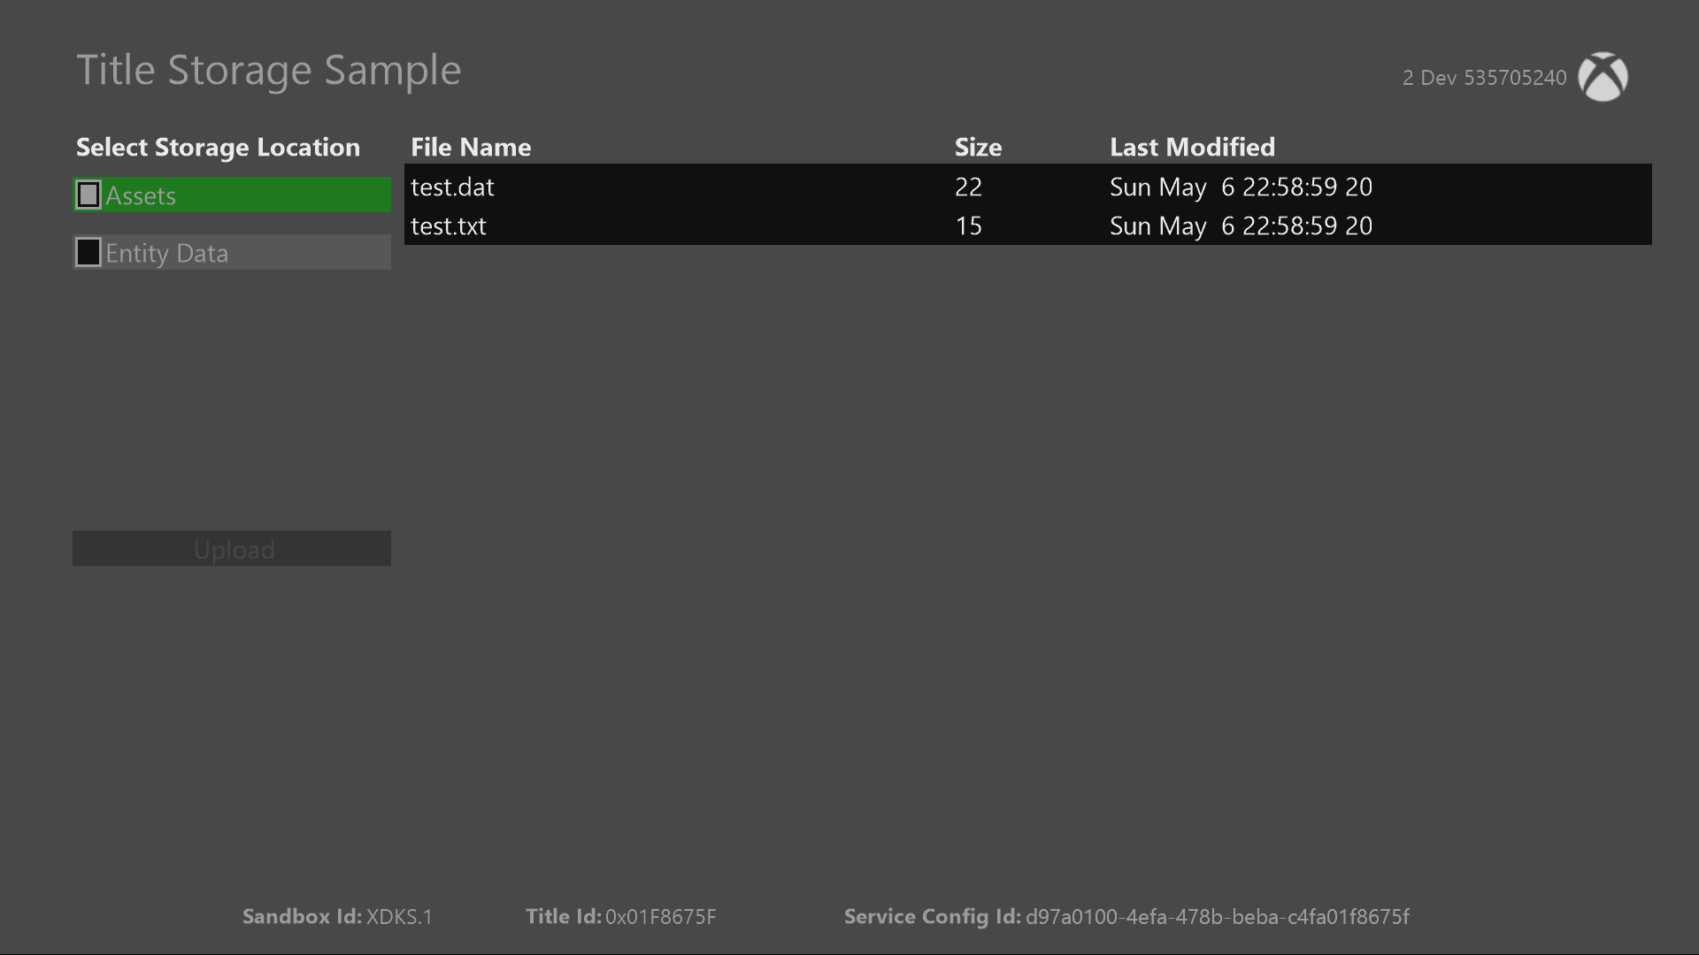

|  |  |
| --- | --- |
| Action | Gamepad |
| Select | A button |
| Navigate | Dpad Up/Down |
| Exit | View button |

# Implementation notes

In this version of the XDK, the sample also requires your Xbox One console to use the XDKS.1 **SandboxID**. To switch to this **SandboxID**, in the Xbox One XDK command prompt, use:

xbconfig sandboxid=XDKS.1

The PlayFab title ID must be set in the sample initialization code. This sample uses the PlayFab title ID “DC0” which is assigned to the **PlayFabSettings::titleId** static field.

In addition to entity storage, this sample uses content files (referred to as “Assets”) and is set up in the PlayFab dashboard as follows.

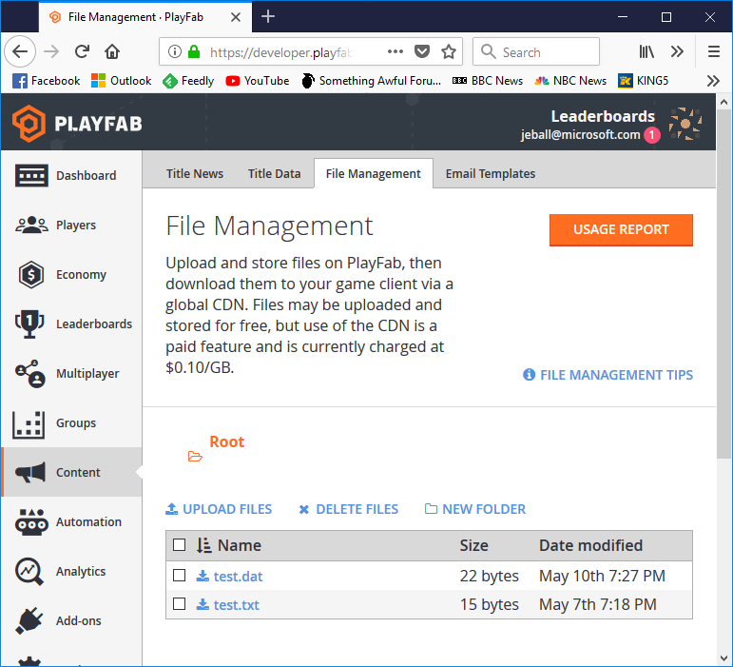

For assets, the content in the list has been hard coded to match what has been uploaded on the dashboard. A single call to **GetContentDownloadUrl** with the filename will provide the URL where the file can be downloaded.

For entities, we get the default entity using **GetEntityToken**. Using the token, we can call **GetFiles** to get a list of files available and needed information on size and the location where they can be retrieved. To upload, a call to **InitiateFileUploads** will provide unique URLs that can be used for an HTTP PUT call, with **FinalizeFileUploads** telling the server that the upload has been completed and **AbortFileUploads** aborting the upload request.

# Update history

**Initial Release:** May 2018

# Privacy Statement

When compiling and running a sample, the file name of the sample executable will be sent to Microsoft to help track sample usage. To opt-out of this data collection, you can remove the block of code in Main.cpp labeled “Sample Usage Telemetry”.

For more information about Microsoft’s privacy policies in general, see the [Microsoft Privacy Statement](https://privacy.microsoft.com/en-us/privacystatement/).