CADE ABRAMS

As an accomplished data scientist and researcher, I excel in cleansing, analyzing, and managing datasets. I specialize in translating technical insights into strategic guidance for executive decision-making. My passion lies in solving complex problems by leveraging advanced analytical techniques, including predictive modeling. Trained as an interdisciplinary scientist, I consistently derive actionable insights from data, delivering robust solutions that drive informed decisions.

# CONTACT INFO

 +1(000)-000-000

✉ [cade4420@gmail.com](mailto:cade4420@gmail.com)

 [github.com/Tcabrams44](https://github.com/Tcabrams44)

⇩

08/25/2022

| Present

08/16/2019

| 08/24/2022

# EXPERIENCE

## Postdoctoral Research Fellow – Data Scientist

University of South Carolina  Columbia, South Carolina

* Conducted advanced statistical analyses using R, including regression modeling and hypothesis testing, to extract meaningful insights for academic manuscripts.
* Applied innovative data processing techniques, enhancing sensitivity to developmental changes resulting effect sizes 3 times larger than traditional techniques.
* Collaborated with cross-functional teams to conduct statistical analyses, optimize data processing, and ensure the success of ongoing research projects.
* Managed project workflows effectively on GitHub, streamlining research processes through version control and collaborative tools.

## Doctoral Graduate Assistant

University of South Carolina  Columbia, South Carolina

* Collaboratively contributed to a 4-year project through data management, cleaning, and predictive modeling to advance motor skill assessment resulting in 5 publications and 12 presentations.
* Saved 42 hours across 8 data collections with custom R functions, improving eiciency and reducing data entry errors.
* Developed custom data indices for ROTC, yielding actionable insights, optimizing training, and achieving a 97.3% pass rate on the ACFT.

↑ [cade-abrams-phd](https://www.linkedin.com/in/cade-abrams-phd)

For more information, please contact me via email.

# SKILLS

R

Python Markdown Statistical Analysis Data Cleaning Data Wrangling Version Control

Commonly Used Libraries tidyverse ⋅ gggplot2 ⋅ Hmisc ⋅

pandas ⋅ NumPy ⋅ matplotlib

# EDUCATION

2023

#  SELECT PROJECTS

## 3-D Model of Motor and Cognitive Solutions

 [https://github.com/Tcabrams44/complexity‑dual‑task‑conceptual](https://github.com/Tcabrams44/complexity-dual-task-conceptual)

12 words or less!, 4 Keywords

BS in Exercise Science

Lander University 08/24/2017

MAT in Physical Education University of South Carolina

* Python
* Jupyter Notebook
* Data Visualization

08/24/2019

PhD emphasis in Motor Behavior

2023

## Beyond Traditional Approaches: Examining the Impact of SKIPping with PAX on Post-Error Slowing in Rural Preschoolers

 <https://osf.io/jyzpx/?view_only=24a908b0a4c842b2843f43a4a37bfd73>

12 words or less!, 4 Keywords

University of South Carolina 12/12/2022

⋅ Subspecialties in: Statistics and Cognitive Neuroscience

* R
* Innovative Data Processing Techniques
* Data Visualization

2020

## Custom R Script for Processing and Scoring Army Combat Fitness Test Results

 [here](https://osf.io/jyzpx/?view_only=24a908b0a4c842b2843f43a4a37bfd73)

12 words or less!, 4 Keywords

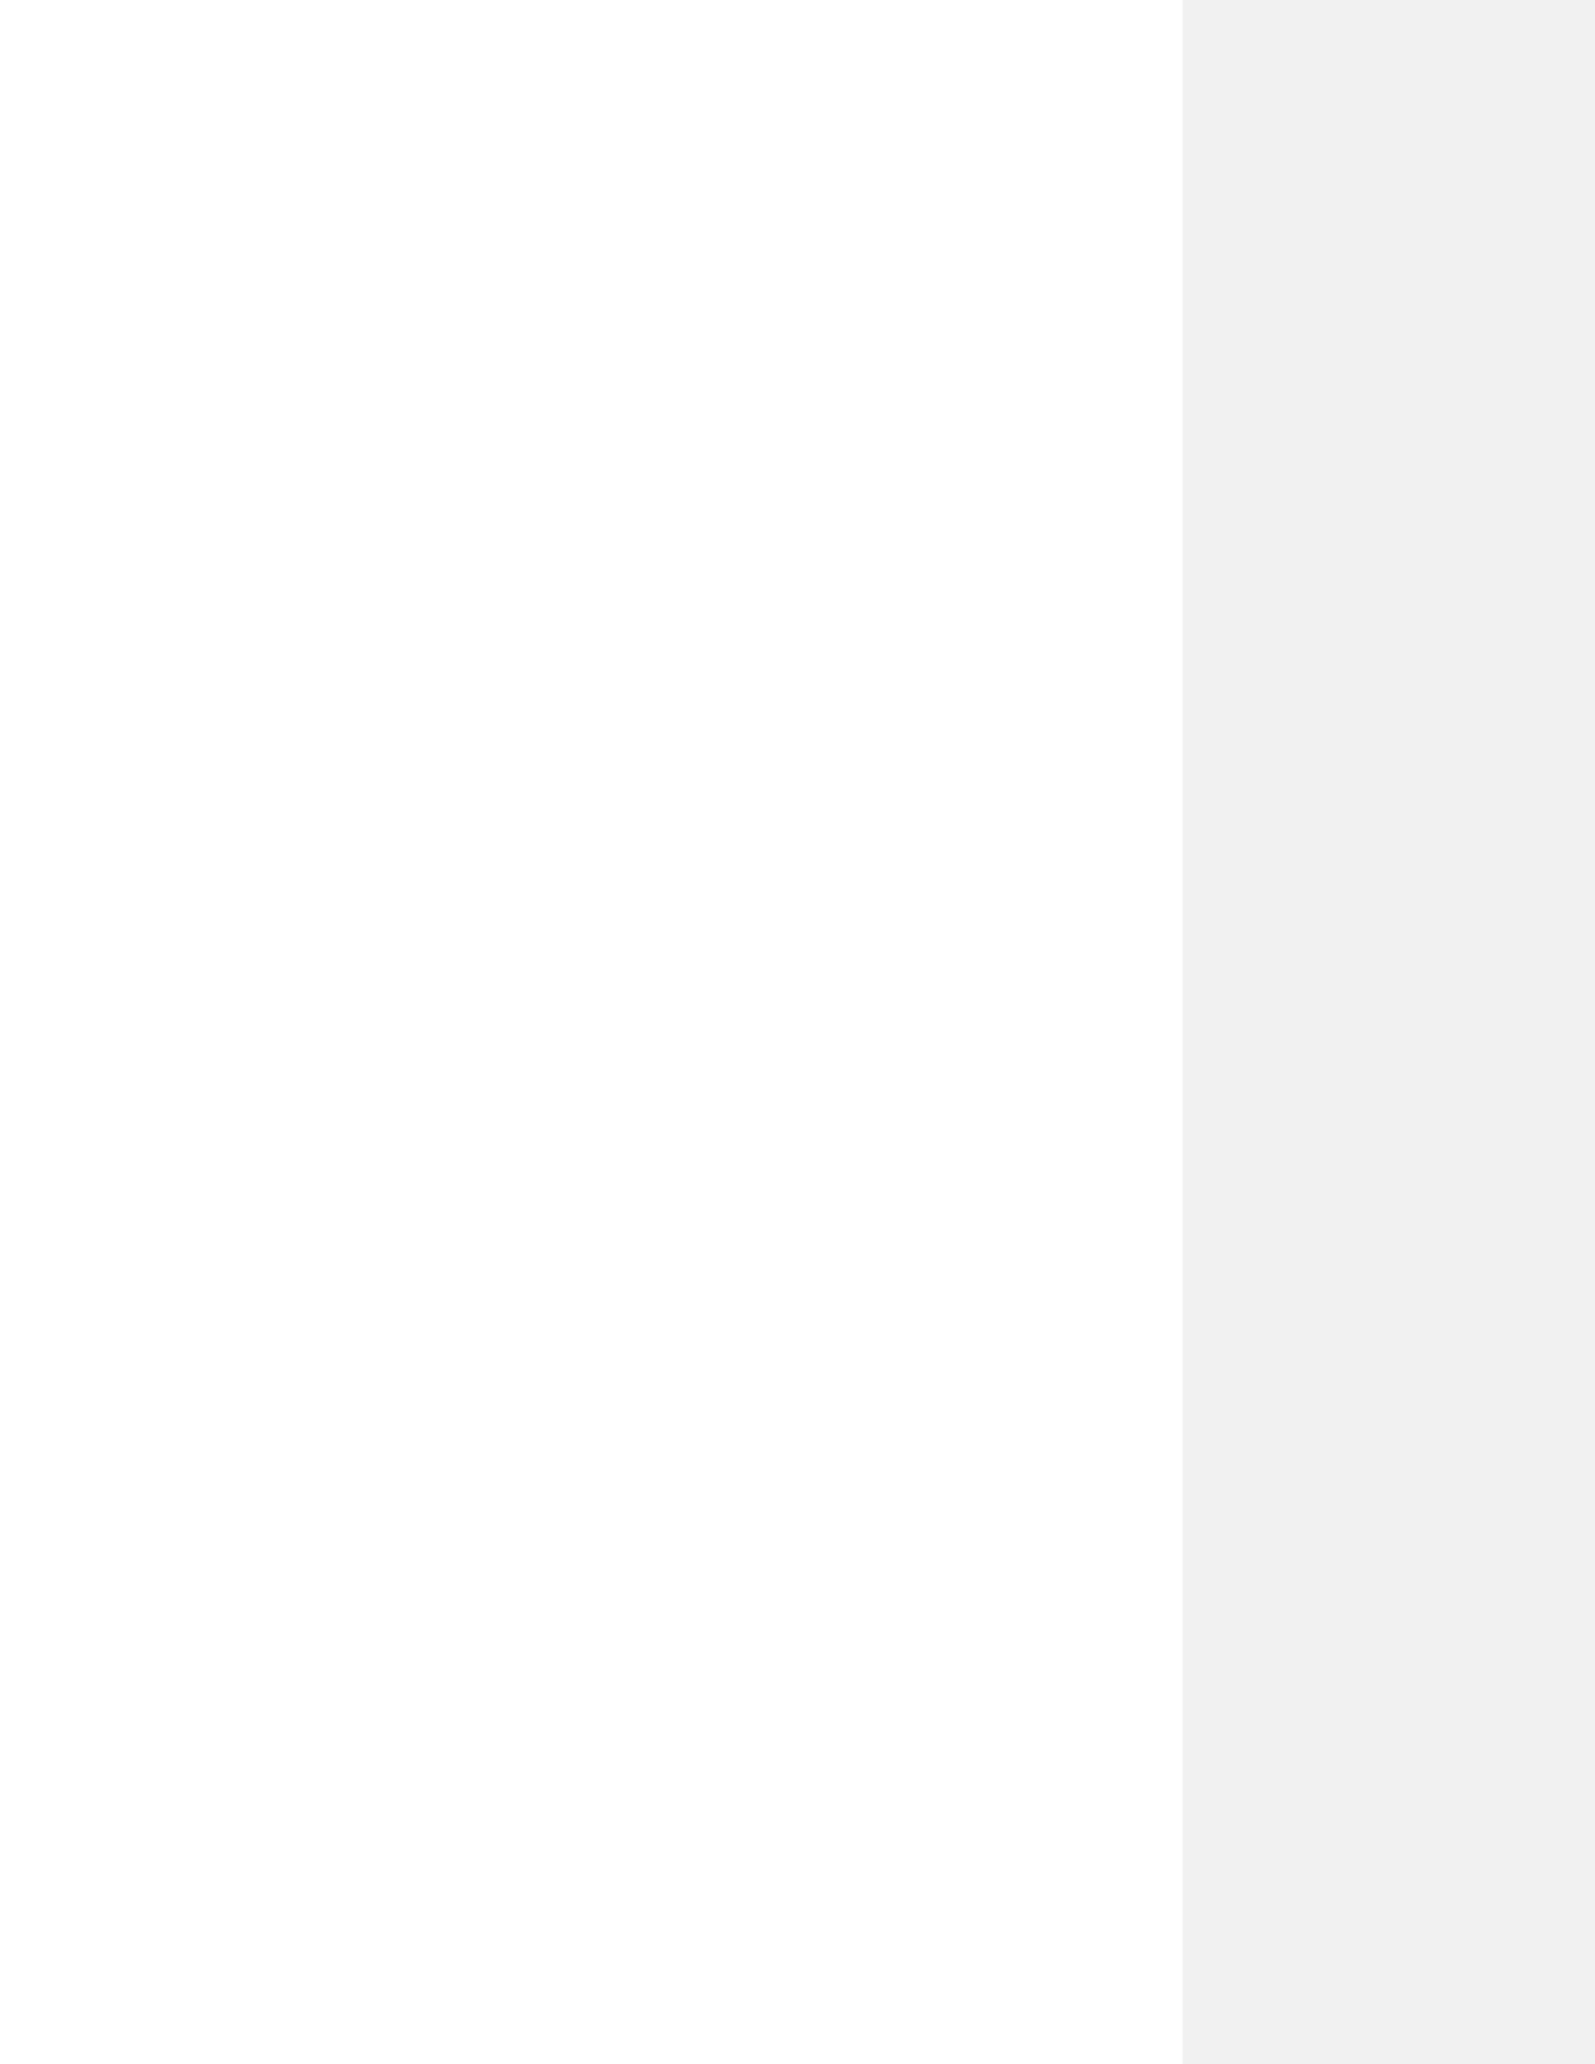

* + R
  + Object-Oriented Programming
  + Custom Functions
  + Data Processing