BUSA 310 — Business Analytics III
Assignment 2: Exploratory Data Analysis of Asset Prices
Total: 10 points
Name: ____________Andy Nguyen__________________
Additional tickers chosen (4): AAPL, JNJ, XOM, EFA
Date range used: _____2025-09-06___________ to _______2026-09-06_________

Instructions
Use Google Colab for all code. Organize your Google Drive as follows: BUSA310 → Assignment2 → Colab_Codes (notebooks) and Results (charts). Provide a shareable Colab link below and upload this completed document to Moodle.

Colab link: https://colab.research.google.com/drive/1aIiNpQcOt2B6DvgsMAuR-hvJIFJO24d1?usp=sharing

Highlight all written answers in red. Insert charts inline in the relevant sections. Show all calculations — answers without supporting arithmetic will not receive full credit.

AI Policy
Permitted: Using AI tools (ChatGPT, Copilot, Gemini, etc.) to write, debug, or understand code.

Not permitted: AI-written answers to any question, AI-written summaries, or AI-suggested investment strategies. Your answers must reflect your own interpretation of your own data.

AI Interaction Log (required): Complete Appendix A before uploading. Every AI conversation must be logged. A missing or clearly incomplete log results in a 2-point deduction.

Explain-it-back standard: Several questions require you to explain or modify code you may have generated with AI. These are graded on accuracy — it does not matter whether you used AI to write the code, only whether you understand it.

Section 1 — Data Collection and Organization (2 points)
Background
You will collect one year of daily closing prices for eight assets. Three are assigned: SPY (S&P 500 ETF — your market benchmark throughout this assignment), TSLA (Tesla), GM (General Motors), and BTCUSD (Bitcoin). You must also choose four additional tickers. To keep the analysis meaningful, your four choices must span at least three different sectors — for example, one technology company, one healthcare or pharmaceutical company, one energy or commodity-related asset, and one international ETF or non-U.S. equity. You may include one more cryptocurrency if you wish, but it counts as one of the four slots. Your date range must end no earlier than two weeks before the submission deadline.

Steps
(1) Load one year of daily data for all eight tickers using yfinance or pandas_datareader. Print the first 15 rows of the raw DataFrame (df).
(2) Run df.info() and df.describe() on the raw data and paste the output in your notebook.
(3) Create df_close containing only the closing (or adjusted closing) price for each of the eight tickers. Handle any missing values — document your approach in a notebook comment.

Questions
1. For each of your eight tickers, state: (a) the number of trading days in your dataset, (b) why this differs from 365, naming at least two specific categories of non-trading days, and (c) whether all eight tickers have exactly the same number of rows. If any differ, explain why.

Answer: For AAPL, EFA, GM, JNJ, SPY, TSLA, and XOM, my raw dataset contains 251 trading days each. BTCUSD contains 366 observations because Bitcoin trades continuously, including weekends and holidays. The number of stock-market trading days is lower than 365 because U.S. exchanges are closed on weekends and on market holidays, such as Thanksgiving, Christmas, New Year’s Day, and other exchange holidays. Therefore, the eight tickers do not all have exactly the same number of raw observations. BTCUSD has more because cryptocurrency markets operate 24/7, while the seven stocks and ETFs follow exchange trading calendars. After I kept only dates for which all eight assets had valid prices, the aligned df_close contained 251 rows and 8 columns.

- You chose four additional tickers. For each one, state the ticker symbol, the company or fund name, and which sector it represents. Explain in one sentence why you chose it — what does it add to the analysis that SPY, TSLA, BTCUSD and GM do not already cover?
Answer: I selected four additional assets:
Ticker | Company/Fund | Sector | Why I chose it
AAPL | Apple Inc. | Technology | AAPL adds large-cap technology exposure that is not directly represented by GM, TSLA, BTCUSD, or the broad SPY benchmark.
JNJ | Johnson & Johnson | Healthcare | JNJ adds a defensive healthcare company whose business and risk drivers differ substantially from automobiles and cryptocurrency.
XOM | Exxon Mobil Corp. | Energy | XOM adds energy-sector and commodity-sensitive exposure, giving the analysis a different source of economic risk.
EFA | iShares MSCI EAFE ETF | International Equity | EFA adds developed-market exposure outside the United States and therefore provides geographic diversification.

3. Run df_close.dtypes. Are all eight columns float64? Describe one realistic way a column could be imported as object dtype and write the pandas one-liner that converts it.
Answer: Yes. After creating df_close, all eight closing-price columns were stored as float64.
A realistic way a price column could instead be imported as an object dtype is if the source contained nonnumeric characters such as dollar signs, commas, or text such as "N/A". One pandas one-liner to convert the column is:
df_close['AAPL'] = pd.to_numeric(df_close['AAPL'], errors='coerce')
Note: the errors='coerce' option converts values that cannot be interpreted numerically into NaN.

Section 2 — Descriptive Statistics and Risk Metrics (3 points)
Steps
(1) Compute min, max, mean, and standard deviation of closing prices for each of the eight tickers. Display as a single table, two decimal places, no extra statistics.
(2) Compute the annual return for each ticker: (Final Close − Initial Close) / Initial Close. Express as a percentage with two decimal places.
(3) Compute the Sharpe ratio for each ticker using daily returns. Use the formula below, then annualize by multiplying by √252. Assume a daily risk-free rate of 0.045 / 252.
sharpe = (mean_daily_return - risk_free_daily) / std_daily_return [then × √252]
(4) Compute the rolling 30-day standard deviation of daily returns for each ticker. Print the last 10 rows.
(5) Compute the full pairwise correlation matrix for the eight tickers' closing prices. Round to two decimal places.

Results — paste your tables here

Ticker | Min | Max | Mean | Std
AAPL | 225.96 | 339.79 | 277.71 | 25.31
BTCUSD | 58,558.86 | 124,752.53 | 82,202.36 | 17,614.71
EFA | 88.22 | 108.81 | 98.42 | 5.80
GM | 54.88 | 90.11 | 75.99 | 8.52
JNJ | 170.32 | 278.43 | 223.04 | 27.84
SPY | 630.35 | 777.88 | 700.27 | 39.59
TSLA | 298.32 | 489.88 | 405.59 | 39.95
XOM | 106.76 | 169.22 | 136.55 | 18.89

Questions
- Rank all eight tickers by annual return, from highest to lowest. Which one had the best return? If you had invested $1,000 in that ticker at the start of your date range, what is the dollar value today? Show the arithmetic.

Answer: The annual-return ranking from highest to lowest was: JNJ 57.99% > GM 52.09% > XOM 49.38% > AAPL 35.01% > EFA 20.87% > SPY 20.02% > TSLA 2.22% > BTCUSD −28.91%.
Therefore, JNJ had the highest annual return at 57.99%.
If I had invested $1,000 in JNJ at the beginning of the period: $1,000×(1+0.5799)=$1,579.90
Therefore, the investment would be worth approximately $1,579.90, representing +$579.90 gain.

6. The Sharpe ratio adjusts return for risk. Which ticker has the highest Sharpe ratio? Is it the same as the highest annual return? If not, explain what this discrepancy tells you — which number is more useful for evaluating an investment, and why?
Answer: JNJ also had the highest Sharpe ratio, at 2.277, so in this dataset the asset with the highest annual return was also the asset with the highest risk-adjusted return. The next-highest Sharpe ratios were XOM at 1.529 and GM at 1.272. This means JNJ did not merely generate the largest return; it also generated the strongest excess return relative to the daily volatility it experienced. For comparing investments with different levels of risk, I would generally consider the Sharpe ratio more useful than annual return alone, because annual return ignores how much volatility an investor had to tolerate to earn that return. However, the Sharpe ratio should still be considered together with other risk measures rather than used by itself.

7. Look at your rolling 30-day volatility output. Choose one ticker and describe how its volatility changed over the year. Identify a period of elevated volatility and propose a plausible explanation for it (a brief news search is acceptable).

Answer: I chose BTCUSD because it showed the largest change in rolling 30-day volatility over the year. Its 30-day standard deviation of daily returns reached a peak of approximately 4.73% on March 16, 2026, which was the highest peak rolling volatility among all eight assets. By the end of the sample, BTCUSD’s rolling 30-day volatility had declined to approximately 2.53% on September 4, 2026. This means Bitcoin’s short-term risk was not constant throughout the year. Around March, its daily returns were much more dispersed, so investors faced substantially greater uncertainty and larger day-to-day price movements. By late August and early September, volatility had fallen to roughly half of its March peak, indicating a noticeably calmer trading environment. This example also shows why a single full-year standard deviation can hide meaningful changes in risk over time: rolling volatility reveals when an asset becomes temporarily much more or less risky. A plausible explanation is that Bitcoin is especially sensitive to changes in investor risk appetite and crypto-market sentiment, which can produce unusually large daily price movements during periods of uncertainty.

- Your correlation matrix contains 21 unique pairwise values. Without listing all 21, identify: (a) the single highest correlation pair, (b) the single lowest (or most negative) correlation pair, and (c) the pair that would be most useful for reducing portfolio volatility through diversification. Justify (c) — it may not be the same as (b).

Answer: The highest price-level correlation was between AAPL and SPY, approximately 0.89. while the lowest price-level correlation was between BTCUSD and JNJ, approximately −0.88. However, for portfolio diversification I would choose SPY and XOM, whose daily-return correlation was approximately −0.28.
I would not automatically choose BTCUSD–JNJ just because their price-level correlation is −0.88, because price-level correlations can be distorted by trends. The negative return correlation between SPY and XOM is more directly relevant for diversification: when their daily returns move less closely together, combining them can reduce portfolio volatility.

- Critical thinking: You computed correlations on price levels. Explain the statistical problem with this approach — what phenomenon in financial time series makes price-level correlations potentially spurious? What should you compute instead, and how would that change your correlation values directionally?

Answer: The statistical problem with correlating price levels is that financial prices are often non-stationary and trend over time. Two assets can both rise or fall over a long period and therefore show a very high positive or negative price correlation even if their actual day-to-day changes have little relationship. This can produce spurious correlation so I should calculate correlations using daily percentage returns instead which is: rt = (Pt − P(t−1))/(P(t−1))
Return correlations generally remove much of the common trending behavior and therefore tend to be smaller in absolute magnitude and more economically meaningful for portfolio diversification. This difference is visible in my own analysis: the most negative price-level correlation was BTCUSD–JNJ at −0.88, whereas the lowest daily-return correlation was only −0.28 for SPY–XOM.

- A classmate argues that the ticker with the lowest standard deviation is always the safest pick. Using at least two specific numbers from your analysis — including the Sharpe ratio — construct a counter-argument. Under what conditions would a higher-volatility asset actually be the more rational choice?

Answer: The claim that the asset with the lowest standard deviation is always safest is misleading. In my closing-price statistics, EFA had the lowest price-level standard deviation at 5.80, and it generated a 20.87% annual return with a Sharpe ratio of 1.010. JNJ, however, had higher annualized return volatility of 19.08%, but it generated a much larger 57.99% return and a 2.277 Sharpe ratio.
Therefore, taking more volatility can be rational when the additional return more than compensates the investor for that additional risk. JNJ was more volatile than EFA but produced a much stronger risk-adjusted outcome.
There is also another important issue: the 5.80 figure is the standard deviation of EFA’s dollar price level, so it should not be directly interpreted as EFA being less risky simply because it is numerically smaller. Price-level standard deviation depends partly on the scale of the asset price. Return volatility is a better cross-asset risk measure.

Section 3 — Visualization (3 points)
Part A — Normalized Price Index
(1) Create a line chart of raw closing prices for all eight tickers. Title, axis labels, and legend at bottom required.
(2) Create normalized_df_close by dividing each series by its first-day value and multiplying by 100.
(3) Create a second line chart using normalized_df_close with the same formatting. Save both to your Results folder and insert below.

Insert raw price chart:

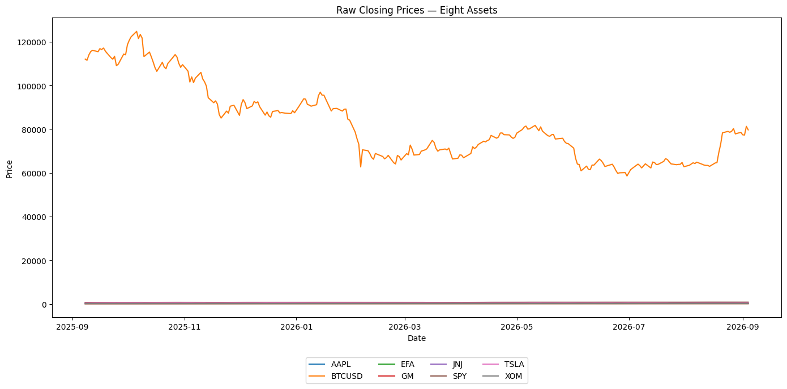

Insert normalized price chart:
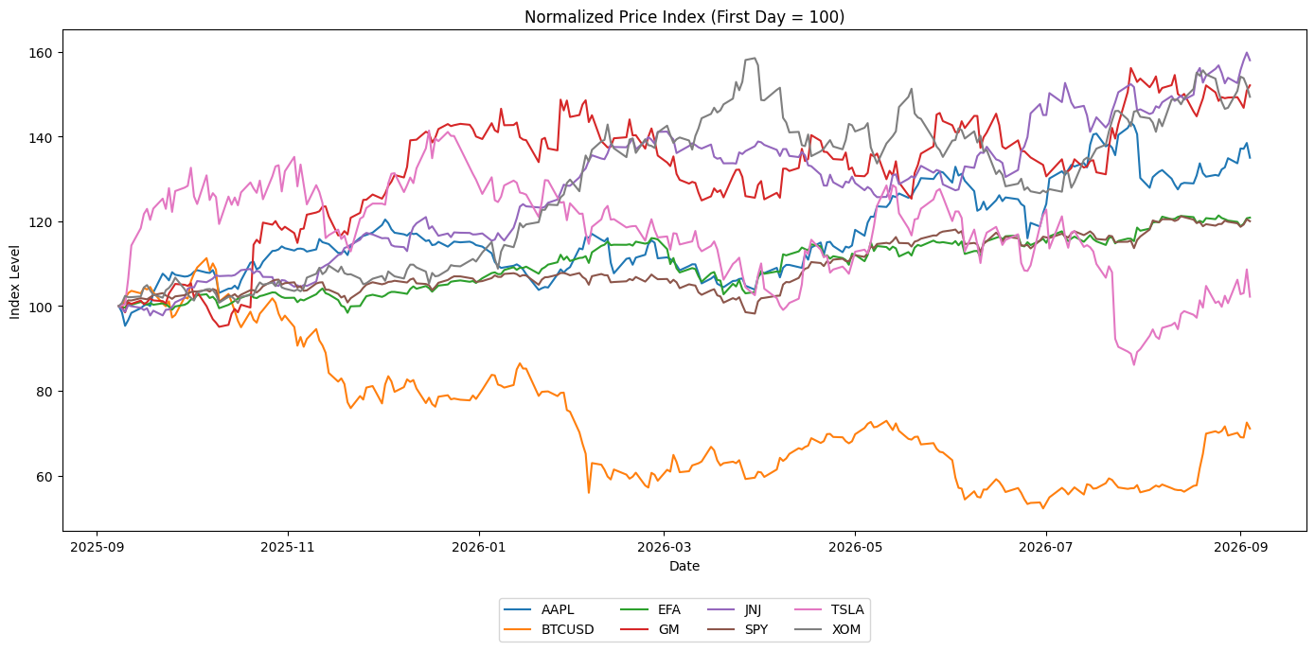

- Why is the raw price chart a poor basis for comparing performance across eight tickers? What specific visual problem does it create, and how does normalizing to base 100 correct it? Now that you have eight lines, identify which two tickers are most difficult to distinguish in your normalized chart and explain why that visual ambiguity occurs.

Answer: The raw closing-price chart is a poor basis for comparing investment performance because the assets trade at dramatically different dollar price levels. BTCUSD, for example, is quoted in the tens of thousands of dollars, while EFA is around $100. This forces the y-axis to accommodate Bitcoin and visually compresses most of the other seven series near the bottom of the chart.
Normalizing each asset to 100 on the first day solves this problem: Normalized(t) = Pt/P0×100
Each asset therefore begins at the same baseline, and differences in the lines represent percentage-like cumulative performance rather than differences in nominal price.
The two lines that were most difficult to distinguish were EFA and SPY. Their average absolute distance in the normalized chart was only 2.33 index points, meaning their cumulative paths were unusually close over the year.

- According to your normalized chart, which tickers outperformed SPY over the full year? Identify one specific period — roughly one to three months — where the spread between the best-performing and worst-performing ticker was largest, and describe what the chart shows. What might explain that divergence?

Answer: Five assets outperformed SPY over the full period: JNJ: 157.99, GM: 152.09, XOM: 149.38, AAPL: 135.01, EFA: 120.87
SPY ended at 120.02, while TSLA ended at 102.22 and BTCUSD at only 71.09.
The widest spread occurred approximately between April 27 and July 28, 2026. By July 28, GM was the best-performing asset and BTCUSD was the worst-performing, with a gap of approximately 99.18 normalized index points.
The chart therefore shows a major divergence during this period: GM continued to outperform strongly while Bitcoin had fallen substantially below its starting value.
A plausible explanation is that GM and Bitcoin were responding to very different asset-specific and macroeconomic drivers during this period. GM's performance is tied more closely to company fundamentals and the auto cycle, while Bitcoin is particularly sensitive to crypto-market sentiment and risk appetite. Therefore, the widening spread likely reflects diverging market conditions rather than a common factor affecting both assets equally.

Part B — Daily Return Subplots
(1) Compute daily percentage returns for all eight tickers using .pct_change().
(2) Create a subplot grid of daily return time series — arrange in rows and columns as you see fit, but each ticker must have its own panel with a title, y-axis label (%), and a horizontal reference line at y = 0. Save and insert below.

Insert daily return subplot:
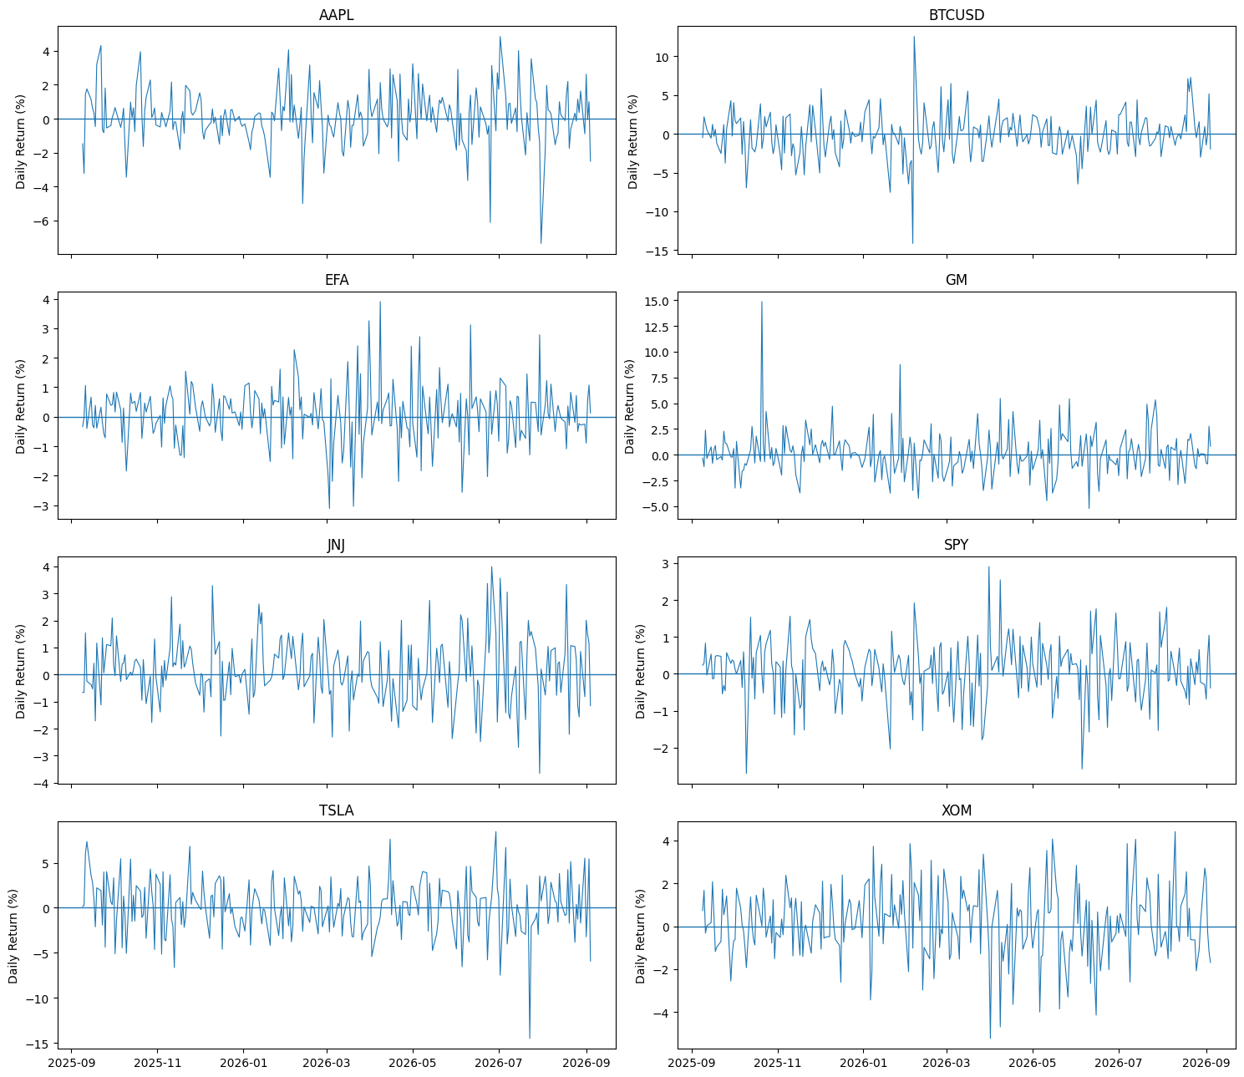

- Across all eight subplots, identify the single largest daily move (positive or negative) in your entire dataset — state the ticker, the approximate date, and the magnitude. Then identify a date where multiple tickers show large moves in the same direction on the same day. What does this co-movement suggest about the relationship between those assets?

Answer: The single largest one-day movement in the entire dataset occurred in GM on October 21, 2025, when its daily return was approximately +14.86%. A strong example of same-direction co-movement occurred on March 31, 2026, when six of the eight assets gained more than 2% on the same day.
When many different assets make unusually large moves in the same direction at the same time, it suggests that a common market-wide or macroeconomic factor is affecting them rather than all of the movements being driven independently by company-specific news.

- Code explanation: Explain mathematically what .pct_change() computes. Write the equivalent formula using only arithmetic operators for a single row. Why is the first row NaN? If a price were 0 on a given day, what would .pct_change() return, and what does that mean for your analysis?

Answer: .pct_change() calculates: rt = (Pt − P(t−1))/(P(t−1))
For a single row, the equivalent arithmetic expression is: (current_price - previous_price) / previous_price
The first row is NaN because there is no earlier price Pt−1 available from which to calculate a percentage change. If the previous price were zero, the denominator would be zero: Pt − 0 / 0 so the percentage return would be mathematically undefined and would generally appear as an infinite or invalid value. Such an observation should be investigated and cleaned because an ordinary percentage return cannot be meaningfully calculated from a zero starting price.

Part C — Return Distributions
(1) Create a subplot grid of daily return histograms — one per ticker, 30 bins, with a vertical line at the mean. Save and insert below.

Insert distribution histograms:
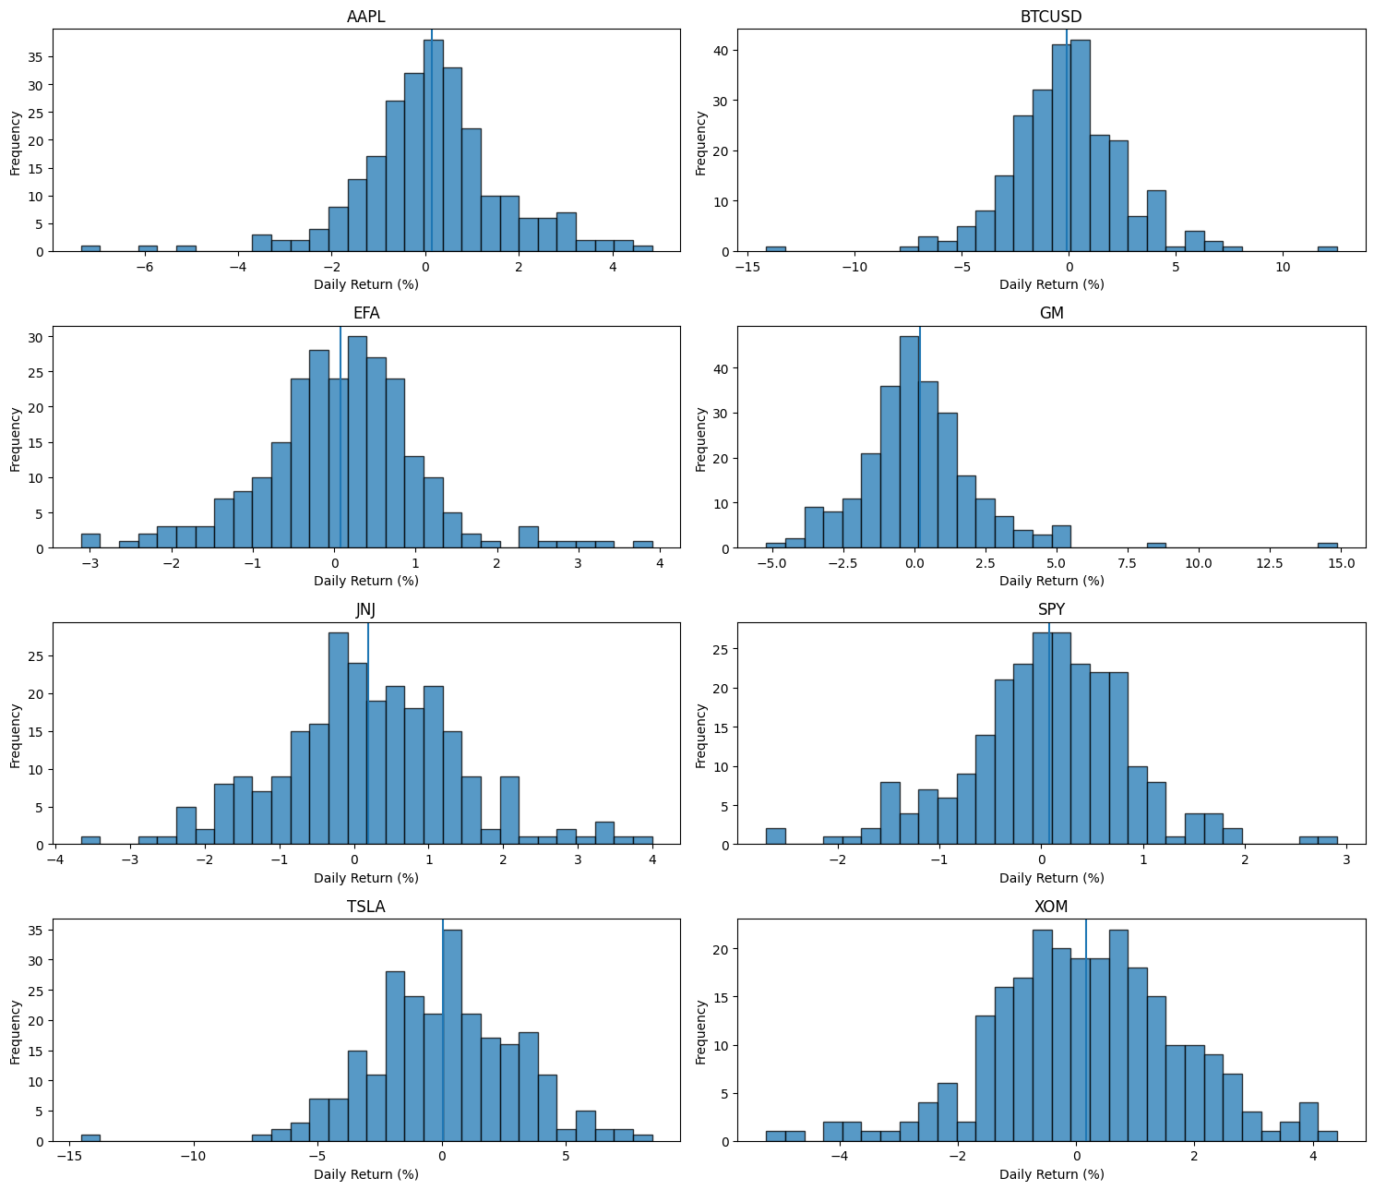

- For each of your eight tickers, characterize the distribution shape: is it roughly symmetric, left-skewed, right-skewed, or heavy-tailed? Rank your eight tickers from most normal-looking to least. For the most heavy-tailed distribution: what does excess kurtosis imply about the adequacy of using standard deviation alone to measure its risk?

Answer: Based on the skewness and excess-kurtosis values in my analysis:

Ticker | Skewness | Excess Kurtosis | Characterization
JNJ | 0.130 | 0.594 | Roughly symmetric; closest to normal
XOM | −0.180 | 0.578 | Roughly symmetric
SPY | −0.209 | 1.198 | Slightly left-skewed and heavy-tailed
EFA | 0.136 | 1.867 | Roughly symmetric but heavy-tailed
TSLA | −0.325 | 1.740 | Mildly left-skewed and heavy-tailed
AAPL | −0.449 | 3.045 | Left-leaning and strongly heavy-tailed
BTCUSD | −0.051 | 3.860 | Nearly symmetric center but strongly heavy-tailed
GM | 1.608 | 8.866 | Strongly right-skewed and extremely heavy-tailed
My ranking from most normal-looking to least normal-looking is: JNJ > XOM > SPY > EFA > TSLA > AAPL > BTCUSD > GM (these rankings come from the notebook’s normality score based on absolute skewness plus absolute excess kurtosis).
GM was the most heavy-tailed, with excess kurtosis of approximately 8.87. Such high excess kurtosis means that extreme daily returns occur more frequently than they would under a normal distribution. Therefore, standard deviation alone may understate tail risk, because it summarizes average dispersion but does not fully communicate the unusually high probability of extreme observations.

Part D — Correlation Heatmap
(1) Instead of a pair plot (which becomes unwieldy with eight tickers), create a heatmap of the correlation matrix using seaborn's sns.heatmap() with annot=True. Use a diverging colormap. Save and insert below.

Insert correlation heatmap:
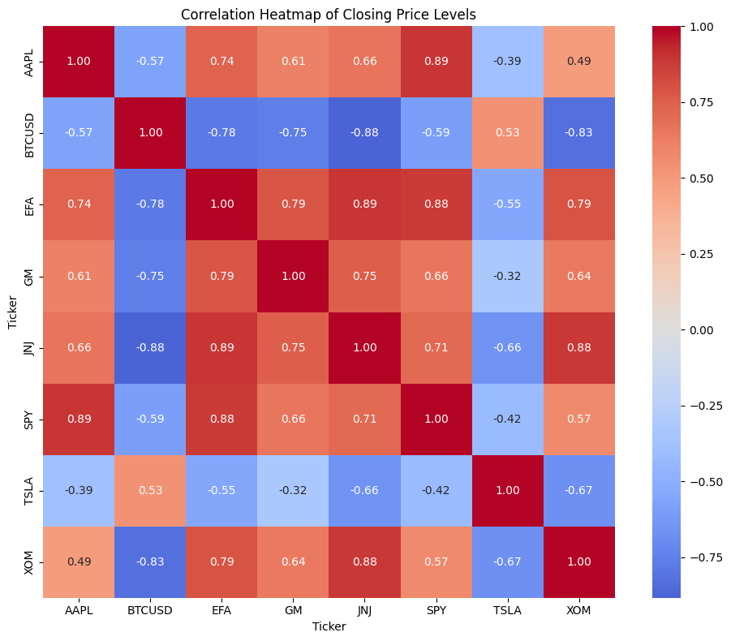

- Looking at your heatmap, identify one cluster of tickers that appear highly correlated with each other. What do those tickers have in common that might explain the clustering? Now identify the one ticker that appears most independent of the rest. What does that independence mean for a portfolio that includes it?

Answer: The strongest three-asset cluster in the price-level heatmap was EFA, JNJ, and XOM, with an average pairwise correlation of approximately 0.85.
Their individual price correlations were approximately: Corr(EFA,JNJ) = 0.89; Corr(EFA,XOM) = 0.79; Corr(JNJ,XOM) = 0.88
Although these assets are not in the same industry, all three are mature equity exposures that experienced strong upward price trends over much of the sample. That common trend can partly explain the cluster, and also reinforces the warning from Q9 that price-level correlations can exaggerate economic co-movement. BTCUSD was the most independent asset, with an average price-level correlation with the other seven assets of approximately −0.55.
That independence can potentially improve diversification because the asset does not move closely with the rest of the portfolio. However, diversification benefit alone does not make it appropriate for every investor: BTCUSD also had a −28.91% annual return, −0.664 Sharpe ratio, 43.96% annualized volatility, and later we find a −53.06% maximum drawdown, so its standalone risk is substantial.

Section 4 — Portfolio Construction (1.5 points)
Client Profile
Your client, David, is 61 years old and plans to retire in exactly six years. He has $40,000 to invest across your eight assets. He cannot sustain a loss exceeding 25% of his principal in any single year. He needs a return that meaningfully exceeds the current risk-free rate of 4.5% annually to justify equity exposure. He is not interested in speculative positions and wants steady growth with limited downside.

- Propose a portfolio allocation across all eight tickers. State the percentage for each ticker — they must sum to exactly 100%. Tickers you want to exclude must be listed at 0% with a reason. This must be your own recommendation, not AI-generated.

Answer: For David, I would allocate the $40,000 portfolio as follows:
Asset | Allocation | Dollar Amount
SPY | 45% | $18,000
JNJ | 20% | $8,000
XOM | 15% | $6,000
EFA | 15% | $6,000
AAPL | 5% | $2,000
TSLA | 0% | $0
GM | 0% | $0
BTCUSD | 0% | $0
Total | 100% | $40,000
These are the exact allocations in your executed notebook. TSLA and BTCUSD are excluded because David explicitly does not want speculative positions and both showed substantial volatility. GM is excluded despite its strong historical return because I would rather avoid adding a concentrated cyclical automobile position to a retirement-oriented portfolio when SPY already provides diversified U.S. equity exposure.

- Justify each non-zero allocation by citing at least one specific number from your Sections 2–3 analysis. Vague qualitative statements ("it seemed stable") will not receive credit. For each ticker in your portfolio, name the single most important quantitative reason it is included.
Answer:
SPY — 45%: The most important quantitative reason for including SPY is its 12.83% annualized volatility, the lowest return volatility among all eight assets, while it still generated a 20.02% annual return and a 1.147 Sharpe ratio. It therefore serves as the relatively stable core equity holding.
JNJ — 20%: JNJ had the strongest risk-adjusted performance in the sample: 57.99% annual return and a 2.277 Sharpe ratio, the highest of all eight assets. Its annualized volatility was 19.08%, substantially below GM, TSLA, and BTCUSD.
XOM — 15%: XOM produced a 49.38% annual return with a 1.529 Sharpe ratio. Its average daily-return correlation with the other assets was also −0.13, making it useful as a diversification component.
EFA — 15%: EFA returned 20.87% with only 15.67% annualized volatility, the second-lowest volatility after SPY. Its international exposure also reduces reliance on U.S.-only equity performance.
AAPL — 5%: AAPL generated a strong 35.01% annual return and a 1.152 Sharpe ratio, but its 25.12% annualized volatility was substantially higher than SPY or EFA. For that reason, I would retain it only as a small 5% growth allocation.
The quantitative anchors from the notebook are: SPY 20.02% return / 1.147 Sharpe / 12.83% volatility; AAPL 35.01% / 1.152 / 25.12%; JNJ 57.99% / 2.277 / 19.08%; XOM 49.38% / 1.529 / 25.69%; EFA 20.87% / 1.010 / 15.67%.

- Stress test: Assume all equity markets drop 20% uniformly in Year 1. Compute the approximate dollar value of David's portfolio after this decline. Show your arithmetic. Does this violate his 25% loss constraint? If yes, revise your allocation so it does not, and explain the trade-off you are making — what did you give up to achieve the constraint?
Answer: The initial portfolio value is: $40,000
Under the required stress scenario, all equity holdings decline by 20%. Because all of my non-zero positions are equity or equity ETFs: $40,000 × 0.20 = $8,000
Portfolio value after the decline: $40,000 − $8,000 = $32,000
Therefore, the portfolio would lose 8,000/40,000 = 20%, which is below David's maximum acceptable one-year loss of 25%. Therefore, the specified stress scenario does not violate his constraint, and no allocation revision is required.

- You built this recommendation from one year of data and Pearson correlations computed on price levels. Name three specific limitations of this approach for a six-year investment horizon. Then state one piece of information about David — not visible in your dataset — that would materially change your allocation if you knew it. Explain why.

Answer: There are at least three important limitations to using this analysis for a six-year investment decision:
First, one year of historical data is a very short sample relative to David's six-year horizon. It may represent only one market regime and may not capture a recession, prolonged bear market, interest-rate cycle, or major sector rotation.
Second, the required Pearson correlations were calculated on price levels, which can be misleading because financial prices are often non-stationary and trending. For diversification analysis, daily-return correlations are more meaningful.
Third, the estimated returns, volatility, Sharpe ratios, and correlations are backward-looking sample statistics. For example, JNJ's 57.99% one-year return should not be interpreted as an expected annual return for the next six years. Market relationships and performance can change substantially.
One additional piece of information about David that would materially change my recommendation is the size and composition of his other retirement assets and guaranteed income. If he already has substantial Social Security, pension income, bonds, and cash reserves, he may be able to tolerate more equity risk in this $40,000 portfolio. If this $40,000 represents most of his liquid retirement savings, I would want a considerably more defensive allocation.

Section 5 — Additional Analysis (0.5 points)
Create at least two additional analyses — charts, tables, or computed metrics — that go beyond anything required in Sections 1–4. These must be original ideas. Do not ask AI for suggestions and use them here. For each, write two to three sentences explaining what you created and what new insight it provides that is not visible in the required analyses.

Additional Analysis 1 — Description: Maximum Drawdown
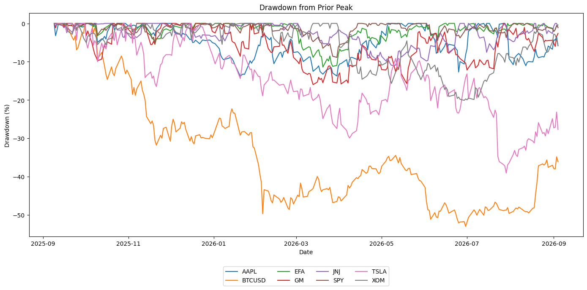
Insert figure or table:
Ticker | Maximum Drawdown
BTCUSD | −53.06%
TSLA | −39.10%
XOM | −20.11%
GM | −16.00%
AAPL | −13.80%
EFA | −11.42%
JNJ | −10.96%
SPY | −8.88%

I calculated the maximum drawdown for each asset, which measures the largest peak-to-trough loss experienced during the one-year sample. This provides information that standard deviation does not show because it focuses directly on the magnitude of sustained downside. BTCUSD had by far the largest maximum drawdown at −53.06%, followed by TSLA at −39.10%, while SPY had the smallest drawdown at only −8.88%. This result reinforces why SPY is more appropriate as the core holding for a retirement-oriented client and why BTCUSD and TSLA were excluded from my proposed portfolio.

Additional Analysis 2 — Description: Sortino Ratio and Downside Risk

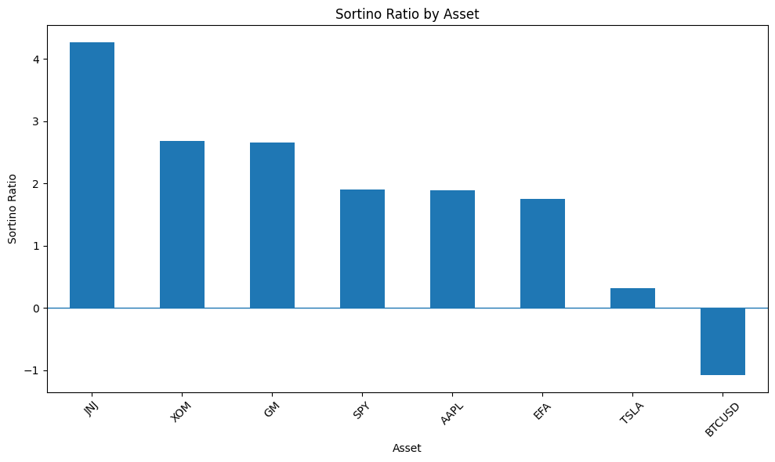

Insert figure or table:
Asset | Annualized Downside Deviation
SPY | 7.73%
EFA | 9.05%
JNJ | 10.17%
XOM | 14.68%
AAPL | 15.33%
GM | 16.39%
BTCUSD | 26.89%
TSLA | 28.70%

I calculated the Sortino ratio and annualized downside deviation to measure performance relative specifically to harmful downside risk. JNJ had the highest Sortino ratio at 4.273, while BTCUSD had the lowest at −1.086; SPY also had the lowest downside deviation at 7.73%, compared with 28.70% for TSLA. These results complement maximum drawdown by showing not only the worst historical loss, but also how effectively each asset compensated investors for downside risk.
Section 6 — Investment Memo (no AI — bonus: +0.5 points)
Write a memo of 300–400 words addressed to David and his spouse. You are a junior analyst presenting your findings and recommendation. Every factual claim must cite a specific number from your analysis. Vague statements earn no credit. Structure your memo as follows:

(1) Dataset: what data you used, time period, all eight tickers, and why you chose the four additional ones.
(2) Key findings: the three most important quantitative findings across Sections 2–3. Cite numbers.
(3) Recommendation: your allocation from Q17. Connect each position directly to a data finding.
(4) Risks and limitations: the two most important weaknesses of this analysis for a six-year horizon.

Memo (write below — no AI):

To: David and Spouse
From: Junior Investment Analyst (Mr. Andy Nguyen)
Subject: Six-Year Investment Portfolio Recommendation
I analyzed one year of daily price data for eight assets: SPY, TSLA, GM, BTCUSD, AAPL, JNJ, XOM, and EFA. The portfolio covers broad U.S. equities, technology, healthcare, energy, international equities, automobiles, and cryptocurrency. My objective was to identify a portfolio capable of earning returns meaningfully above the 4.5% risk-free rate while remaining consistent with your six-year retirement horizon and maximum acceptable one-year loss of 25%.
Three findings were particularly important. First, JNJ delivered the strongest risk-adjusted performance, generating a 57.99% annual return, a 2.277 Sharpe ratio, and the highest Sortino ratio at 4.273. Second, SPY provided the strongest defensive characteristics, with the lowest annualized volatility at 12.83%, the lowest downside deviation at 7.73%, and the smallest maximum drawdown at −8.88%. Third, the most speculative assets offered a much less attractive downside profile. BTCUSD returned −28.91%, had a Sortino ratio of −1.086, and experienced a maximum drawdown of −53.06%, while TSLA had the highest downside deviation at 28.70%.
Based on these results, I recommend allocating the $40,000 portfolio as follows: 45% SPY ($18,000), 20% JNJ ($8,000), 15% XOM ($6,000), 15% EFA ($6,000), and 5% AAPL ($2,000), with no allocation to TSLA, GM, or BTCUSD. SPY serves as the diversified core, while JNJ combines strong returns with favorable downside-adjusted performance. XOM adds energy exposure, EFA provides international diversification, and the small AAPL position provides additional growth potential without creating excessive concentration.
Under the required stress scenario in which equity markets decline uniformly by 20%, the portfolio would fall from $40,000 to $32,000, an $8,000 or 20% loss. This remains within your stated 25% maximum-loss constraint.
The recommendation should nevertheless be interpreted cautiously. One year of historical performance is short relative to a six-year investment horizon, and past returns, volatility, and correlations may not persist. Before implementing the portfolio, I would also want to understand your other retirement assets and guaranteed income, because those resources could materially change the appropriate level of investment risk.

Appendix A — AI Interaction Log (Required — missing = −2 points)
Complete one row for every AI interaction used during this assignment. Add rows as needed.

# | Tool | Prompt (exact or close summary) | Section | What you changed or verified
1 | ChatGPT | Helped build/debug the Assignment 2 Colab workflow, calculations, charts, and explanations | 3-4 | Ran all code, checked outputs against formulas, verified ticker/date choices, and edited final written responses to match the observed results
2
3
4
5
6
7
8

Grading Summary
Section | Points | Key criteria
1 — Data Collection (Q1–Q4) | 2.0 | Correct 7-ticker setup, sector variety justified, code explanation accurate
2 — Statistics & Risk (Q5–Q10) | 3.0 | Sharpe ratio computed correctly, rolling vol produced, correlations interpreted with specific values
3 — Visualization (Q11–Q16) | 3.0 | All charts present and formatted, heatmap used, written answers reference actual data and chart features
4 — Portfolio Construction (Q17–Q20) | 1.5 | Sums to 100%, every allocation backed by a number, stress test arithmetic shown, constraint checked
5 — Additional Analysis | 0.5 | Two original analyses with written explanations
AI Interaction Log | −2.0 if missing | Complete, honest, one row per interaction
6 — Investment Memo (bonus) | +0.5 | Original prose, every claim cited, appropriate for a non-expert audience
Total | 10 + 0.5 bonus

