CEE 530 PRESTRESSED CONCRETE
Project 1 — Assignment 4: Shear Design
Shear Design of Prestressed Double-T Beam
ACI 318-19 / Naaman Section 5.7 — Empirical Method (Vci / Vcw)

Spring 2026 | Due: 3/23/2026

Group 3
Hailey Crosson
Reyaneh Kazemian
Leohuns Robert Kambu
Prince Aminu
Chidchanok Pleesudjai (Fen)
Haribhushan Sirigineedi

Code Edition: CEE 530 (ACI 318-19 shear provisions)

SIGN CONVENTION: Compression = positive (+) Tension = negative (−)
UNIT SYSTEM: kip, in. (moments in kip-in., stresses in ksi)
METHOD: Detailed method — Vci / Vcw (ACI 318-19 Table 22.5.8.2)
Part 1 — Given Data
1.1 Beam Geometry
Section type: Double-T (precast, simply supported)
Span: L = (20 + 24 + 20) ft × 12 in./ft = 768 in. (64.0 ft)
Total depth: h = 28.00 in.
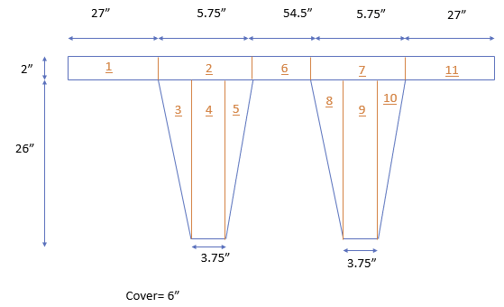
Fig. 1 — Beam elevation and support conditions
1.2 Section Properties
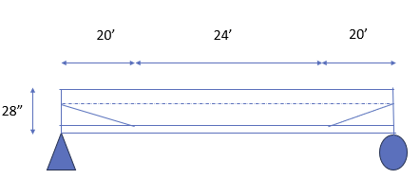
Fig. 2 — Section dimensions and vertex numbering
Property | Value
Ac | 487.000 in²
Ic | 34,638.82 in⁴
yc (from bottom) | 20.362 in.
yb | 20.362 in.
yt | 7.638 in.
bw (sum of stem widths) | 7.50 in.
St = Ic/yt | 4,535.1 in³
Sb = Ic/yb | 1,701.1 in³
1.3 Material Properties
Property | Value
f′c | 6.0 ksi
f′ci | 4.8 ksi
Ec | 4,700 ksi
fpu | 270 ksi
fpy | 243 ksi
Eps | 28,500 ksi
fy (stirrups) | 60 ksi
λ | 1.0 (normal weight)
φv | 0.75 (ACI Table 21.2.1)
√(f′c in psi) = √(6000) / 1000 = 0.07746 ksi (used throughout shear equations)
1.4 Prestress Data
Four 0.5-in. diameter Grade 270 strands, each Aps = 0.153 in².
Aps,total = 4 × 0.153 = 0.612 in²
Pi per strand = 25.0 kip → Fi,total = 4 × 25.0 = 100.0 kip
fpi = Pi/Aps = 25.0 / 0.153 = 163.4 ksi
Loss factor: η = 1 − 0.15 = 0.85
Pe,total = η × Fi = 0.85 × 100.0 = 85.0 kip

Tendon layout (y from bottom):
Tendons 1, 3 (straight): y = 6.00 in. (constant)
Tendons 2, 4 (harped): y = 20.36 in. at supports, sloping to y = 6.00 in. at x = 240 in., flat to x = 528 in., then sloping back.

Vertical prestress component Vp (harped tendons, sloped region 0 ≤ x ≤ 240 in.):
tan(α) = (20.36 − 6.00) / 240 = 14.36 / 240 = 0.05983
Pe per harped tendon = 0.153 × 163.4 × 0.85 = 21.25 kip
Vp = 2 × 21.25 × sin(α) = 2 × 21.25 × 0.05972
Vp = 2.538 kip (upward) [0 in flat zone, x ≥ 240 in.]
1.5 Applied Loads
Self-weight:
w_sw = Ac × (150/1728) / 1000 = 487.0 × 0.08681 / 1000
w_sw = 0.04227 kip/in. (0.5073 kip/ft)
Superimposed dead load (2-in. topping, 150 pcf):
w_SDL = 2 × 120 × (150/1728) / 1000
w_SDL = 0.02083 kip/in. (0.2500 kip/ft)
Live load:
w_LL = 0.42 kip/ft / 12 = 0.03500 kip/in. (0.4200 kip/ft)

Total unfactored dead load:
w_DL = w_sw + w_SDL = 0.04227 + 0.02083 = 0.06311 kip/in.
Factored load (ACI 318-19 Sec. 5.3.1b):
wu = 1.2 × w_DL + 1.6 × w_LL
= 1.2 × 0.06311 + 1.6 × 0.03500
= 0.07573 + 0.05600
wu = 0.13173 kip/in. (1.5808 kip/ft)
Part 2 — Shear Design Method
ACI 318-19 requires that the factored shear demand Vu at each section shall not exceed the design shear capacity φVn, where Vn = Vc + Vs. The concrete contribution Vc is taken as the lesser of two failure modes: flexural-shear cracking (Vci) and web-shear cracking (Vcw).

Flexural-shear cracking (Vci) initiates as a flexural crack that subsequently turns into a diagonal shear crack. It governs in regions of high moment (near midspan). A lower bound Vci,min is enforced.

Web-shear cracking (Vcw) initiates as a diagonal crack at the neutral axis before any flexural cracking occurs. It governs near the supports where shear is high and moment is low.

2.1 Key Equations
Eq. (1) — Flexural-shear strength (ACI 318-19 Eq. 22.5.8.3.1a):
Vci = 0.6λ√(f′c) × bw × dp + Vd + (Vi/Mmax) × Mcr
≥ Vci,min = 1.7λ√(f′c) × bw × dp [ACI 318-19 hard floor]
≤ Vci,max = 5.0λ√(f′c) × bw × dp [CEE 530 convention — governs]
where Vd = shear from unfactored dead load (SW + SDL); Vi and Mmax = factored shear and moment from superimposed loads only (1.2×wSDL + 1.6×wLL).

Eq. (2) — Cracking moment (ACI 318-19 Eq. 22.5.8.3.2a):
Mcr = (Ic/yb)(6λ√(f′c) + fce − fd)
where fce = compressive stress at the bottom fiber due to effective prestress alone; fd = tensile stress at the bottom fiber due to unfactored dead-load moment. When fd > 6λ√(f′c) + fce, Mcr = 0 and Vci,min governs.

Eq. (3) — Web-shear strength (ACI 318-19 Eq. 22.5.8.3.2):
Vcw = (3.5λ√(f′c) + 0.3fpc) × bw × dp + Vp
where fpc = Pe/Ac; Vp = vertical component of harped tendons.

Eq. (4): Vc = min(Vci, Vcw)
Eq. (5): Vs,req = max(Vu/φv − Vc, 0)
Eq. (6): Av/s = Vs / (fy × dp)
2.2 Bounds on Vci
Lower bound (ACI 318-19 hard floor): Prevents Vci from dropping unrealistically low near midspan where Vi → 0 or Mcr = 0:
Vci ≥ Vci,min = 1.7λ√(f′c) × bw × dp
Without this floor, Vci would reduce to just Vd + 0.6λ√(f′c)×bw×dp in regions where DL tension exceeds prestress + rupture (Mcr = 0) — an unconservatively small value.

Upper bound (CEE 530, Prof. Mobasher): Caps Vci near supports where Vi/Mmax → ∞ would inflate the three-term formula:
Vci ≤ Vci,max = 5.0λ√(f′c) × bw × dp
The 5.0 coefficient equals the upper cap on the simplified method Vc (ACI 318-19 Sec. 22.5.8.1). Using it as the Vci ceiling in the detailed method ensures that Vci can never exceed the simplified-method maximum — a course convention.

For this beam (bw = 7.50 in., dp = 22.40 in., f′c = 6.0 ksi):
Vci,min (ACI 318-19) = 1.7 × 1.0 × 0.07746 × 7.50 × 22.40 = 22.12 kip [floor]
Vci,max (CEE 530) = 5.0 × 1.0 × 0.07746 × 7.50 × 22.40 = 65.07 kip [cap]
Part 3 — Detailed Calculations at Section 1: x = 18 in. (1.5 ft)
3.1 Effective Depth dp
dp shall not be less than 0.80h per ACI 318-19 Sec. 22.5.3.2.
Tendon centroid at x = 18 in.:
T1,T3 (straight): y = 6.00 in.
T2,T4 (harped): y = 20.36 + (6.00−20.36)×(18/240) = 19.28 in.
y_ps = (6.00 + 19.28 + 6.00 + 19.28) / 4 = 12.642 in.
e = yc − y_ps = 20.362 − 12.642 = 7.721 in.

dp = max(h − y_ps, 0.80h)
= max(28.00 − 12.642, 0.80 × 28.00)
= max(15.358, 22.40)
dp = 22.40 in. [0.80h governs]
3.2 Modulus of Rupture fr
Per ACI 318-19 Table 22.5.8.2, fr for Vci/Mcr uses 6λ√(f′c in psi).
fr = 6 × 1.0 × √(6000) / 1000 = 6 × 77.46 / 1000
fr = 0.4648 ksi
3.3 Prestress Stress at Bottom Fiber fce
fce = compressive stress at bottom fiber due to effective prestress alone (positive = compression).
Formula: fce = Pe/Ac + Pe × e × yb / Ic

Substitution:
fce = 85.0/487.0 + 85.0 × 7.721 × 20.362 / 34,638.82
= 0.1745 + 13,359.3 / 34,638.82
= 0.1745 + 0.3858
fce = 0.5603 ksi (compression)
3.4 Dead-Load Stress at Bottom Fiber fd
Md = w_DL × x × (L−x) / 2
= 0.06311 × 18 × (768−18) / 2
= 0.06311 × 18 × 750 / 2
Md = 426.0 kip-in.

fd = Md × yb / Ic = 426.0 × 20.362 / 34,638.82
fd = 0.2504 ksi
3.5 Cracking Moment Mcr
fr + fce − fd = 0.4648 + 0.5603 − 0.2504 = 0.7747 ksi > 0 ✔

Mcr = (Ic/yb) × (fr + fce − fd)
= 1,701.1 × 0.7747
Mcr = 1,317.8 kip-in. (109.8 kip-ft)
3.6 Flexural-Shear Strength Vci
Load terms at x = 18 in.:
w_ext = 1.2 × w_SDL + 1.6 × w_LL = 1.2×0.02083 + 1.6×0.03500 = 0.08100 kip/in.
Vi = w_ext × (L/2 − x) = 0.08100 × (384 − 18) = 0.08100 × 366 = 29.646 kip
Mmax = w_ext × x × (L−x)/2 = 0.08100 × 18 × 750/2 = 546.75 kip-in.
Vd = w_DL × (L/2 − x) = 0.06311 × 366 = 23.097 kip

Three-term Vci from Eq. (1):
Term 1: 0.6 × 1.0 × 0.07746 × 7.50 × 22.40 = 7.808 kip
Term 2: Vd = 23.097 kip
Term 3: (Vi/Mmax) × Mcr = (29.646/546.75) × 1,317.8 = 71.454 kip
Sum: 7.808 + 23.097 + 71.454 = 102.36 kip

Bounds check:
Vci,min (ACI floor) = 1.7 × 1.0 × 0.07746 × 7.50 × 22.40 = 22.12 kip
Vci,max (CEE cap) = 5.0 × 1.0 × 0.07746 × 7.50 × 22.40 = 65.07 kip
Vci (computed) = 102.36 kip
Floor: 102.36 kip ≥ 22.12 kip → PASS
Cap: 102.36 kip > 65.07 kip → capped to Vci,max → FAIL
Vci = min(102.36, 65.07) = 65.07 kip
3.7 Web-Shear Strength Vcw
Centroidal prestress stress fpc:
fpc = Pe/Ac = 85.0/487.0 = 0.1745 ksi

Vertical prestress component Vp (x = 18 in., in sloped region):
Vp = 2.538 kip (upward)

Vcw from Eq. (3):
(3.5 × 0.07746 + 0.3 × 0.1745) × 7.50 × 22.40
= (0.27111 + 0.05235) × 168.00 = 54.343 kip
Vcw = 54.343 + 2.538
Vcw = 56.881 kip
3.8 Concrete Shear Capacity Vc
Vc = min(Vci, Vcw) = min(65.07, 56.881)
Vc = 56.88 kip → Vcw GOVERNS (web-shear cracking controls)
φVc = 0.75 × 56.88 = 42.66 kip
3.9 Shear Demand vs. Capacity
Vu = wu × (L/2 − x) = 0.13173 × (384 − 18) = 0.13173 × 366
Vu = 48.21 kip

Code check (ACI 318-19 Sec. 22.5.1.1):
Vu = 48.21 kip > φVc = 42.66 kip → FAIL
STATUS: Shear reinforcement required beyond minimum
3.10 Required Steel Contribution Vs
Vs,req = max(Vu/φv − Vc, 0)
= max(48.21/0.75 − 56.88, 0)
= max(64.28 − 56.88, 0)
Vs,req = 7.40 kip

Maximum Vs check (ACI 318-19 Sec. 22.5.1.2):
Vs,max = 8 × λ × √(f′c) × bw × dp = 8 × 0.07746 × 7.50 × 22.40 = 104.1 kip
Vs,req = 7.40 kip ≤ Vs,max = 104.1 kip (section size adequate) → PASS
3.11 Stirrup Design
Selected bar: #3 closed U-stirrups (2 legs × 0.11 in.²/leg = Av = 0.22 in.²)

Av/s from demand (Eq. 6):
Av/s_demand = Vs/(fy × dp) = 7.40/(60 × 22.40) = 7.40/1344
Av/s_demand = 0.00551 in.²/in.

Av/s minimum (from Part 4, Criterion 1 governs): 0.00726 in.²/in.
Av/s_min = 0.00726 > 0.00551 → minimum governs

Spacing:
s_req = Av / (Av/s) = 0.22 / 0.00726 = 30.30 in.
s_max = min(3h/4, 24 in.) = min(21.0, 24) = 21.0 in. [ACI Sec. 9.7.6.2.2]
s = min(30.30, 21.0)
s = 21 in. ← USE

Verify capacity:
Vs,prov = Av × fy × dp / s = 0.22 × 60 × 22.40 / 21 = 14.08 kip
φ(Vc + Vs) = 0.75 × (56.88 + 14.08) = 0.75 × 70.96 = 53.22 kip
φ(Vc + Vs) = 53.22 kip ≥ Vu = 48.21 kip → PASS

Part 4 — Minimum Shear Reinforcement (ACI 318-19 Table 9.6.3.3)
Three criteria shall be evaluated; the largest governs.

Criterion 1 (Eq. 9.6.3.3a):
Av/s = 0.75 × √(f′c in psi) × bw / fy
= 0.75 × 0.07746 × 7.50 / 60
Av/s_min1 = 0.00726 in.²/in. ← GOVERNS

Criterion 2 (Eq. 9.6.3.3b):
Av/s = (50/1000) × bw / fy = 0.050 × 7.50 / 60
Av/s_min2 = 0.00625 in.²/in.

Criterion 3 (Eq. 9.6.3.3c):
Av/s = (Aps × fpu)/(80 × fy × dp) × √(dp/bw)
= (0.612 × 270)/(80 × 60 × 22.40) × √(22.40/7.50)
= 165.24/107,520 × 1.728
Av/s_min3 = 0.00266 in.²/in.

Governing: Av/s_min = max(0.00726, 0.00625, 0.00266) = 0.00726 in.²/in. (Criterion 1)

Stirrup spacing limits (ACI 318-19 Sec. 9.7.6.2.2):
Basic: s_max = min(3h/4, 24 in.) = min(21.0, 24) = 21.0 in.
Tight trigger: Vs > 4√(f′c) × bw × dp = 52.06 kip
Vs,req = 7.40 kip ≤ 52.06 kip → basic limit applies
Part 5 — Summary at All Design Sections
Values computed at four design sections. bw = 7.50 in., dp = 22.40 in. (0.8h governs throughout), φv = 0.75.

Section | x (ft) | Vu (kip) | Vci (kip) | Vcw (kip) | Vc (kip) | φVc (kip) | Vs (kip) | Av/s | s (in.)
1 | 1.5 | 48.21 | 65.07† | 56.88 | 56.88 | 42.66 | 7.40 | 0.00726 | 21
2 | 10.0 | 34.78 | 24.47* | 56.88 | 24.47 | 18.35 | 21.90 | 0.01630 | 13
3 | 20.0 | 18.97 | 22.12* | 54.34 | 22.12 | 16.59 | 3.17 | 0.00726 | 21
4 | 32.0 | 0.00 | 22.12* | 54.34 | 22.12 | 16.59 | 0 | 0.00726 | 21
(*) Mcr = 0 at these sections; Vci governed by ACI floor (1.7λ√f′c×bw×dp = 22.12 kip) or slightly above.
(†) Vci three-term = 102.36 kip, capped to Vci,max = 5.0λ√f′c×bw×dp = 65.07 kip (CEE 530).

Key observation: Vcw governs at Section 1 (near support). At Sections 2–4, Vci governs because Mcr = 0 drops the three-term Vci to the ACI floor (22.12 kip), which is well below Vcw. Section 2 requires significant stirrup reinforcement (Vs = 21.90 kip, s = 13 in.).
Part 6 — Design Recommendation
Based on the analysis at all design sections:

Recommended stirrup design: #3 U-stirrups @ 13 in. in the support region (0–10 ft), transitioning to 21 in. elsewhere.

With the CEE 530 two-tier bounds (floor = 1.7, cap = 5.0), Vci governs at Sections 2–4 because Mcr = 0 drops the three-term Vci to the ACI floor (22.12 kip). Only at Section 1 does Vcw govern (56.88 kip). The critical section is Section 2 (x = 10 ft), where Vs = 21.90 kip requires Av/s = 0.01630 in.²/in., yielding s = 13 in. Beyond the drape point (x ≥ 20 ft), minimum Av/s governs and the spacing limit of 3h/4 = 21 in. controls.
Part 7 — Shear Design Figure
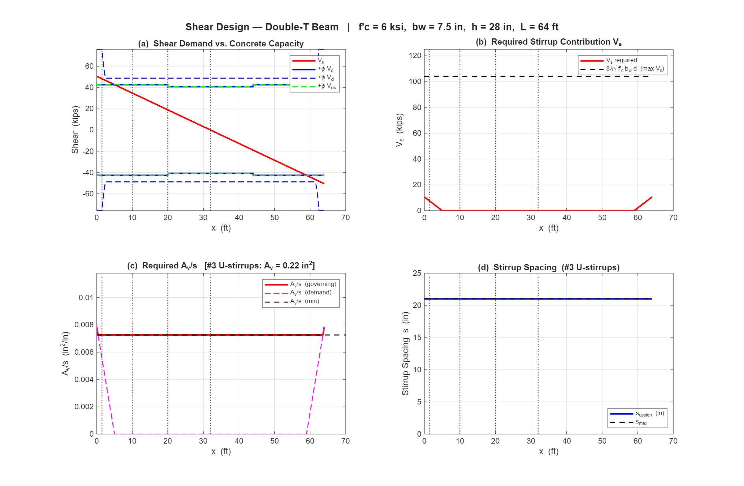
Fig. 3 — (a) Shear demand vs. concrete capacity; (b) Required Vs; (c) Required Av/s; (d) Stirrup spacing along span.
Part 8 — Final Summary
Check | Demand | Capacity | Status
dp ≥ 0.80h | 22.40 in. | 22.40 in. | OK (=)
Vu at Section 1 | 48.21 kip | — | —
φVc at Section 1 | — | 42.66 kip | —
Stirrups required? | Vu > φVc | — | YES
Vs,req (Section 1) | 7.40 kip | — | —
Vs ≤ Vs,max (section size) | 7.40 kip | 104.1 kip | PASS
φ(Vc + Vs) ≥ Vu | 48.21 kip | 53.22 kip | PASS
Av/s_min (Crit. 1 governs) | 0.00726 | — | —
s at Section 1 | 21 in. | 21 in. | USE

ACI Code References
ACI 318-19 Reference | Description
Table 22.5.8.2 | Detailed method (Vci / Vcw)
Eq. 22.5.8.3.1a | Vci flexural-shear (floor: 1.7λ√f′c×bw×dp; CEE 530 uses 5.0)
Eq. 22.5.8.3.2a | Mcr cracking moment
Eq. 22.5.8.3.2 | Vcw web-shear
Sec. 22.5.3.2 | Critical section at dp from support
Table 9.6.3.3 | Minimum Av/s (3 criteria)
Sec. 9.7.6.2.2 | Stirrup spacing limits (3h/4, 24 in.)
Table 21.2.1 | φ = 0.75 for shear
Sec. 5.3.1b | Factored load combination (1.2D + 1.6L)
Sec. 22.5.1.2 | Maximum Vs limit (8√f′c × bw × dp)

