Pain Points:
- FM Manager utilizes significant amount of time in non-core activities – preparing reports, managing multiple recording systems and following up on ground reports.

- FM Industry – A FM company/ client side team uses multiple systems including offline reports, and does not have a single system of record for recording and reporting.
Command Centers:
- Building owner manager – Real Estate Manager and Finance Manager do not have means to see the commercial impact of FM operations: Asset ROI, Asset health, Potential Downtime costs, Equity earned due to experience (Response times, Downtime Reduction, Asset condition)
- FM Manager – FM manager does not have a single window operational command center nor skilled analytical manpower to dynamically control costs like SLA deviations, manpower availability, work order creation and acceptance delays
Legacy Systems – Bad UI/UX and not mobile friendly
- FM technician spends significant time in recording on-ground notes and does not have a good mobile UI/UX to record this with legacy CMMS systems.
- Knowledge centralization – Team members have a lot of undocumented knowledge of the assets at a location and this does not get transferred to the systems . Legacy systems are not mobile friendly and do not have a good UI/UX. As a result, on ground reports are not effective in transferring information to the central command center.

Product Vision:
For Building asset managers, Facilities management teams , Our product is an AI native building experience management platform for Hard FM, energy management and space management.
- It is a lean API first platform which connects easily to existing legacy system, excel sheets, offline data, FM contracts for asset registry, Job Order history, contractual documents and manpower registry.
- It has a mobile friendly app interface and utilizes multi modal generative AI to make the process of inspection reporting, order creation and reporting; quick and convenient with voice, images and notes on the mobile app.
- It supports hybrid dataflows – manual as well as IOT data; to ensure richness of incoming data.
AI Native FMS
- Asset Onboarding: Low intervention and Quick – Inject asset registry from existing CMMS, Use Image detection and textual reading of specs information/ warranty documents to populate Asset Registry
- A predictive Asset condition – usage engine and maintenance engine based on real time/ past data and asset literature
- An intelligent work order system with mobile friendly interface and multi modal generative AI – auto notifications from asset engine and auto/ multimodal entries
- An intelligent command center for finance/ real estate teams

]
Command Center
- Financial, Operational
Excel UI Data & App Entry
Query based UI/UX
Intelligence, multi modal entry
Predictive Engine
WO notifications with automated WO creation
FM Order Systems
Query UI/ UX extended
Asset Registry
Templates
WO creation
Field notes
Vendor/ Supplier
Purchase Order
Invoicing
Manpower Registry

Databed & SOR
Asset Registry
WO history
Manpwoer Registry
Contract

MVP - User Stories:
- <Connector> As a facilities manager, I want to import data from my existing CMMS/ CAFM platform which includes my asset registry (auto generated QR code unique to each asset, which can be printed) and associated asset details/ documents, my word order history, my manpower registry and my FM contract; my excel templates that I maintain outside my existing CMMS/ CAFM platform and my offline records; so that I can have a single system of record for my operations and intelligence.

- <Command Center> As a Facilities manager, I want to view all my metrics on a single command center dashboard and I want to customize my insights based on standard FM metrics – Events based like SLA deviations, response times, downtime; Asset based – asset life, parameters and manpower based – resource profitability, response time, downtime, planned maintenance hygiene and also be able to provide custom FM metrics, which gets automatically detected from my contract document and calculated automatically

- <Preventive Maintenance> As a Facilities manager, I want to receive insights on preventive maintenance based on the historical/ real time data patterns/ technicial insights and on my consent, I want the system to automatically create work orders intelligently routed to the right technician based on availability/ distance/ expertise and scheduled at the right time based on severity.

- <Query Interface> As a facilities manager, I want to request any additional insights and information on a multi modal query-based interface, accessible on my homepage.

- <Downtime Response> As a facilities manager, I want to create an ad hoc work order through writing on a brief note on the query interface or my voice note on the same multi model query-based interface, accessible on my mobile phone.

- <Excel UI interface> As a facilities manager, I want to have an excel sheet like UI ; and maintain additional templates on excel sheet like UI within the platform and I want its information to be integrated for any insights.

- <Excel UI templates> As a facilities manager, I want to save my existing excel templates on my platform by importing the data or create new excel templates within and integrated with my platform.

- <Native Assets Entry> As a facilities manager, I want to create new assets in my asset register by entering a query and/ or taking a picture and/or adding any notes or attachments. So that the platform should identify the asset and add all necessary documents to it. I want to take a picture of the job order history or import excel files of work orders for the asset, so that the platform should also be able to add job order history and derived metrics for the command center. I want the system to generate a unique QR code for the asset once it is saved in registry and is printable.

- <Forms or Doc Templates> As a facilities manager, I want to query-to-create or use saved document templates or forms to be used for site permissions, vendor approvals etc; so that I do not have to spend my significant bandwidth in documentation and approvals.

- <FM Reporting> As a facilities manager, I want to auto generate my daily/ weekly/ monthly reports without any manual effort from the platform by querying them for the first time and then saving them as a template (periodic auto queries); so that I do not spend time on report preparation and can manage more locations/ manpower/ assets than before.

- <Sub vendors> As a facilities manager, I want to add suppliers or vendors to the platform and their contracts details (import document or manually) and assign work orders to them (like field technicians) along with all required documents from saved or generated templates; so that I can manage multiple vendors for my FM contract without any delays or document losses.

- <inspection to commercial> As a facilities manager, I want to track the entire journey if a work order has led to an invoice or a purchase order and if there are failures in the flow. I want to be notified if there is any breakage; so that there is no lost revenue, costs leakage or downtime threats or insufficient spare parts inventory due to the failures.

- <manpower register> As a facilities manager, I want to enter my manpower registry by importing from an excel sheet, images on the query interface; so that manpower registers are filled and updated with accurate information.

- <Inspection Reports> As a field technician, I want to enter my inspection report notes using a voice note and adding site pictures during a PPM or an adhoc WO during downtime; so that It gets auto populated as part of the inspection report for the respective work order

- <Manpower self entry - Inspection> As a FM technician, I want to enter details of my expertise, location and notes in a gamified manner (levels crossed when more information is entered).

  - I want to enter inspection notes easily with almost 50% config data pre filled and the remaining filled with my voice notes on the go.
  - I want the inspection report to be entered into my system and in addition, appropriate action within the platform is classified and taken: PPM with a future Work Order, Technician Insights etc.
  - I want to be rewarded with gamified points based on my inputs in the inspection report.
  - I want to know the impact caused by my insights and want to be rewarded with impact points for it.

- <Manpower Self Entry – General> As a FM technician or a manager, I want to be able to scan a QR code and add technical insights for any asset in the location. I want the technicial insights to be read, classified by the platform and appropriate action be taken.

Platform Snapshots:
- Opening Page should be a query interface with command center dashboard and other customizable views
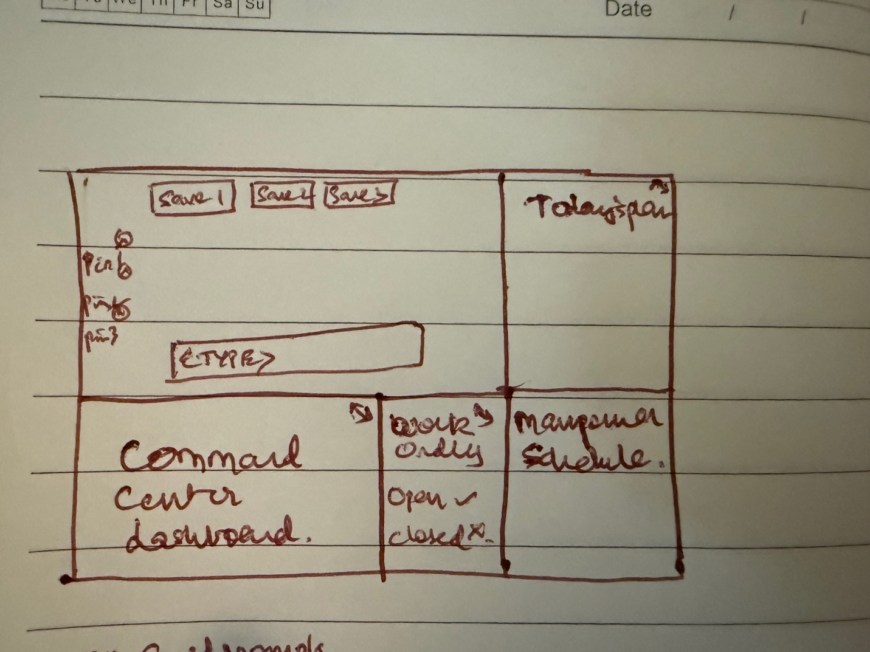

- Zooming in on query based interface, we have saved prompts and information fields across the platform being filled up with query responses.
