TUGAS PENDAHULUAN

PEMROGRAMAN PERANGKAT BERGERAK

MODUL IX

API PERANGKAT KERAS



Disusun Oleh :

Nama lengkap / NIM

Kelas

Asisten Praktikum : Muhammad Faza Zulian Gesit Al Barru

Aisyah Hasna Aulia

Dosen Pengampu :

Yudha Islami Sulistya, S.Kom., M.Cs.

PROGRAM STUDI S1 SOFTWARE ENGINEERING FAKULTAS INFORMATIKA

TELKOM UNIVERSITY PURWOKERTO 2024

TUGAS PENDAHULUAN

A. SOAL NOMOR 1

a) Buatlah satu project baru, yang mana di dalamnya memuat container berisi Icons.image_outlined, button camera, button gallery dan button hapus gambar. Button tidak harus berfungsi.

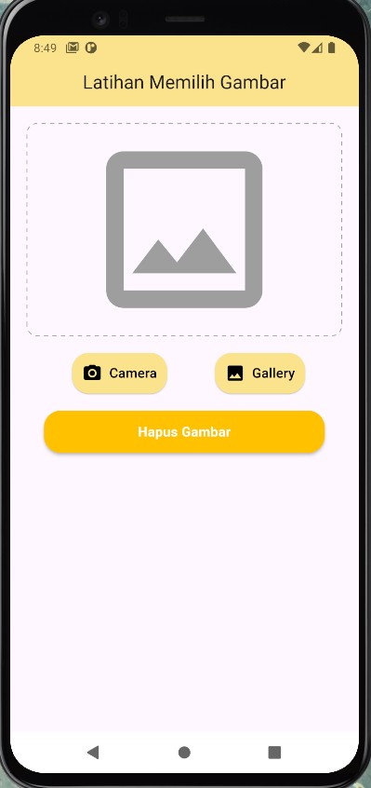Contoh tampilan

Source code

|  |
| --- |
| import 'package:flutter/material.dart';  void main() {    runApp(const MyApp());  }  class MyApp extends StatelessWidget {    const MyApp({super.key});    @override    Widget build(BuildContext context) {      return MaterialApp(        title: 'Flutter Demo',        theme: ThemeData(          colorScheme: ColorScheme.fromSeed(seedColor: Colors.deepPurple),          useMaterial3: true,        ),        home: const MyHomePage(title: 'Latihan Mengambil Gambar'),      );    }  }  class MyHomePage extends StatefulWidget {    const MyHomePage({super.key, required this.title});    final String title;    @override    State<MyHomePage> createState() => _MyHomePageState();  }  class _MyHomePageState extends State<MyHomePage> {    @override    Widget build(BuildContext context) {      return Scaffold(        appBar: AppBar(          backgroundColor: Theme.of(context).colorScheme.inversePrimary,          title: Text(widget.title),        ),        body: Center(          child: Column(            mainAxisAlignment: MainAxisAlignment.center,            children: <Widget>[              Container(                width: 200,                height: 200,                decoration: BoxDecoration(                  border: Border.all(color: Colors.black),                ),                child: const Icon(                  Icons.image_outlined,                  size: 100,                ),              ),              const SizedBox(height: 20),              Row(                mainAxisAlignment: MainAxisAlignment.center,                children: [                  ElevatedButton(                    onPressed: () {},                    child: const Text('Camera'),                  ),                  const SizedBox(width: 10),                  ElevatedButton(                    onPressed: () {},                    child: const Text('Gallery'),                  ),                ],              ),              const SizedBox(height: 10),              ElevatedButton(                onPressed: () {},                child: const Text('Hapus Gambar'),              ),            ],          ),        ),      );    }  } |

Screenshoot Output

Deskripsi Program

Program ini bertujuan untuk melakukan input upload gambar dari storage dan akan disimpan kedalam aplikasi, namun saat ini hanya berupa tampilan saja karena kedepannya akan dilakukan implementasi fungsi tersebut.