<https://www.handsontec.com/dataspecs/module/Rotary%20Encoder.pdf>

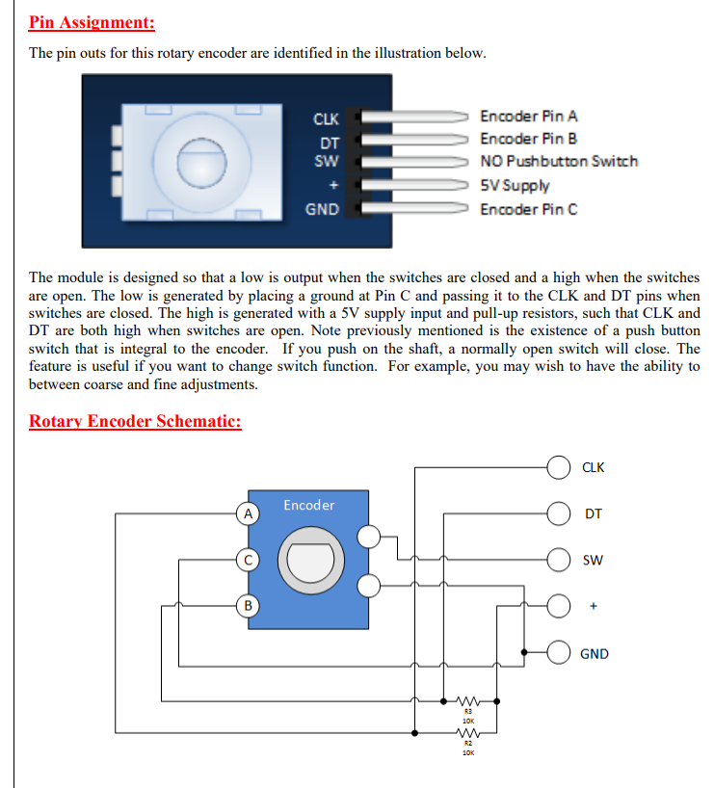

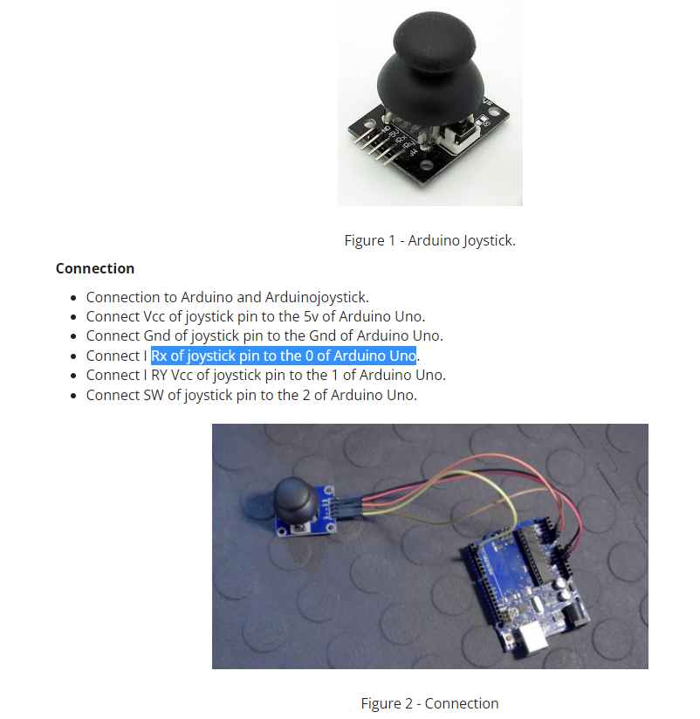

<https://lastminuteengineers.com/rotary-encoder-arduino-tutorial/>

