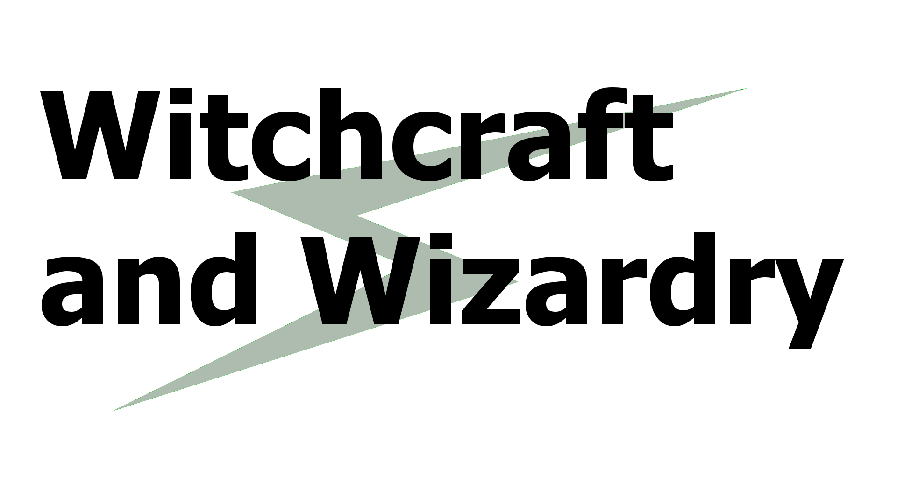

Concept

Version 0.1

Johannes Litger

Table of contents

Basic Concept 3

Graphics 4

Combat 5

Spells 6

Mechanics 7

# Basic Concept

The idea at the core of “Witchcraft and Wizardry” (also “WnW”) is to have wizards, witches and any other kind of “magical beings” that can cast spells do battle in an arena. The game will include legendary characters from different TV-series, movies, videogames, books and other media as well as characters created specifically for WnW. For example, there could be a battle between Lord Voldemort from Harry Potter and Gandalf from The Lord of The Rings. The different characters will have access to different spells depending on what imaginary world they stem from as well as some spells that are unique to the character.

Players will select one character each and fight against each other. 1v1 player vs player battles will be implemented first, 2v2 or 3v3 battles as well as artificial intelligence to fight player vs environment might be added at a later point.

# Graphics

The battles WnW will be displayed in 2 dimensions, from a side-view (like in games such as Smash Bros, Tekken or Streetfighter). The artistic style of the characters and environment should be “cartoony” in nature. Characters will play smooth but simple animations with some simple graphic effects for things like explosions. For simplicity, shadows and other advanced lightning techniques will not be included.

The game will not feature graphic content such as blood or injuries. Characters that are defeated will simply bow to their opponents, fade out of the image or play some other animation that indicates their defeat.

# Combat

Characters in WnW will be stationary, they cannot move horizontally or vertically. They will not be able to duck or evade spells using any other mechanic either.

Players will be able to make their characters cast spells by “drawing” runes. On touch-enabled devices, this will mean drawing the rune on the screen. Computer users will be able to choose between using a mouse to draw in a window, or pressing buttons on their keyboard.

Each player will start with a certain amount of hit-points. Being hit by enemy spells will reduce those points.

Offensive spells can be cast only directly towards the enemy character, they cannot be aimed. Defensive spells will be cast around the player, like a “bubble” that defends the character.

# Spells

Spells can generally be divided into offensive and defensive spells. Offensive spells are shot towards the enemy, defensive spells form a sort of shield around the own character.

Spells will also have different types, such as “Fire”, “Water” or “Earth”. These types will be decided by the original lore surrounding the character, so when more characters are added, more types might be implemented into the game. Spells of different types will have different effectiveness against other types of spells, like a large game of rock, paper, scissors. A defensive Water-spell may be much more effective against a Fire-attack than, say, a defensive Wood-spell.

# Mechanics

Spells will be drawn onto a screen that is divided into several (actual amount to be determined) squares. Drawing a spell requires the player to draw a line across some squares. What squares the player draws the line through and in which order will determine the spell that is cast. Spells that require more squares to be drawn through will be more effective that spells that require fewer squares.

Spells may also increase in strength if the rune is drawn on the screen faster. Players will have a handicap (either to be selected themselves or to be determined by their ability at playing the game), which will increase the number of squares on the screen (and decrease their individual size), so that each rune that is drawn must go through more squares that are smaller and therefore harder to hit. This will increase the difficulty of drawing runes exponentially, and make the game tougher on players with higher handicaps.

If a player draws a rune that does not belong to a specific spell, the player has essentially “wasted” that time and will not cast any spell with the malformed rune.

Several runes can (and should!) be combined to cast stronger spells. A player will be able to continuously draw runes until they decide to fire their spell, at which point they will draw a certain rune that casts the spell.