Table of Contents
INTRODUCTION 2
Part 1: Key milestones in 2024 4
1.1. General overview 4
1.2. Compartment structure 5
1.3. Guarantee calls and payment claims 7
1.4. Effective provisioning rate 10
Part 2: Investment strategy, portfolio composition and performance 10
2.1. Composition and characteristics of the portfolio 11
2.2. Environmental, social and governance (ESG) footprint 12
2.3. CPF performance in 2024 12
CONCLUSIONS 14

INTRODUCTION
This is the fourth annual report on the common provisioning fund (CPF) () covering the period from 1 January 2024 to 31 December 2024. It outlines the key developments related to the functioning of the CPF in 2024, and presents the main financial and risk parameters and the fund’s annual performance. It also presents the results of the Commission's actions to enhance the fund’s longer-term performance by introducing a diversified investment universe.
The CPF, established under Article 212 of Regulation (EU, Euratom) 2018/1046 of the European Parliament and of the Council of 18 July 2018 on the financial rules applicable to the general budget of the Union, holds all provisions set aside by the EU budget or contributed by participating Member States to cover the risk of losses on operations guaranteed by the internal () and external () guarantees implemented by the European Union. In addition to budgetary guarantees, provisions are held in the CPF in respect of most of the macro-financial assistance (MFA) loans to third counties (). The provisions held in the CPF constitute the capital reserve from which funds are drawn to meet guarantee calls on supported operations and other outflows.
The CPF became operational in January 2021. At the end of 2024 its net assets value stood at EUR 23.18 billion, making it the largest investment portfolio directly managed by the Commission.
The CPF successfully navigated market volatility in 2024, with a balanced exposure to multiple asset classes. The CPF’s diversification into equities further enhanced its overall performance. The portfolio achieved an absolute return () of 3.57%. Combined with the 2023 result (+5.21%), this has almost fully offset the losses incurred in 2022, a year marked by the steepest global bond sell-off seen in half a century.. The results have restored the CPF’s capacity to absorb losses over the lifetime of the budgetary guarantee programmes. Looking ahead, the current elevated interest-rate environment provides a prudent basis for medium-term performance, subject to the heightened uncertainty linked to geopolitical developments that could have a strong bearing on market conditions,.
This report focuses on issues related to the management of CPF assets. The evolution of contingent liabilities arising from budgetary guarantees and EU lending, against which CPF assets are held as provisions, is discussed in a separate report under Article 256 of the Financial Regulation.

Part 1: Key milestones in 2024

1.1. General overview
As in previous years, the fund was managed in line with the procedures under its established governance structure (), and with no operational incidents.
As at 31 December 2024, the value of net assets () was EUR 23.2 billion, representing an increase of EUR 4.5 billion on end-2023 (a 24% increase over the year). In 2024 the CPF received EUR 3.6 billion in net contributions from the EU budget or contributions from participating Member States and EFTA countries. The remainder of the increase in portfolio value (EUR 840 million) results from the increased market value of existing assets.
Figure 1: Evolution of the CPF’s net asset value (EUR billion)

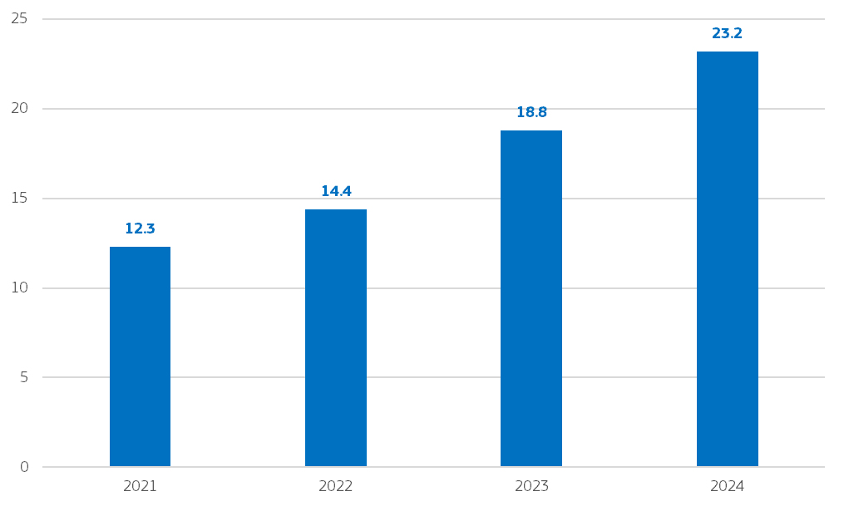
More information on the financial statements is available in the staff working document accompanying this report.

1.2. Compartment structure
While the assets of the CPF are managed in accordance with a common investment policy, they are held in different compartments linked to the individual budgetary guarantees and financial assistance programmes or to the individual Member State compartments for InvestEU.
The provisioning held by the CPF is earmarked per budgetary guarantee/financial assistance programme (or for the Member States that contribute the provisioning for their InvestEU compartment) in line with their respective legal frameworks (). The amounts assigned to each budgetary guarantee are booked in distinct compartments to allow provisoning levels to be tracked relative to the levels set by the legal basis establishing the guarantee. If provisions fall below certain levels, replenishments can be funded from the envelopes of the respective programmes.
In 2024, one new InvestEU Member State compartment () and one compartment for the Ukraine Facility Guarantee () were added.
On 31 December 2024 the CPF was composed of 18 compartments, with 15 of them being fully operational and containing funds. The remaining compartments will be activated on receipt of the corresponding first inflows.

Table 1: CPF compartments as at 31.12.2024
Compartment | Market value in EUR as at 31.12.2024
Compartments opened in 2021
EFSI | 8 880 303 795.93
GFEA () | 3 225 691 235.78
EFSD () | 761 545 053.25
InvestEU () | 5 530 142 834.06
Compartments opened in 2022
EFSD+ | 2 942 175 754.77
Post-2020 MFA | 128 662 217.57
Exceptional MFA Ukraine () | 240 575 443.20
Post-2020 Euratom loans | -
Repurposed ELM loans Ukraine | -
InvestEU Guarantee Romania | 187 974 119.28
InvestEU Guarantee Czech Republic | 44 099 186.75
InvestEU Guarantee Finland | 30 657 774.29
InvestEU Guarantee Greece | 252 204 112.19
InvestEU Blending Operations | 667 045 123.03
Compartments opened in 2023
InvestEU Guarantee Bulgaria | 79 674 706.38
InvestEU Guarantee Malta | 7 939 418.22
Compartments opened in 2024
Ukraine Guarantee | 201 878 310.31
InvestEU Guarantee Spain | -
TOTAL | 23 180 569 085.02

Figure 2: Size of CPF compartments as at 31.12.2024
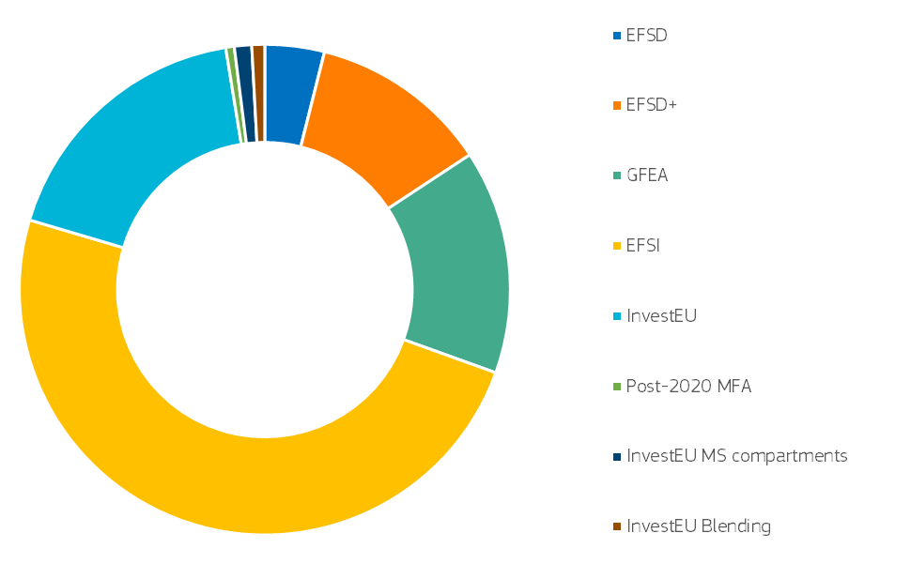

1.3. Guarantee calls and payment claims
The liquidity management of guarantee calls and the payment of claims is facilitated by a liquidity buffer, as provided for in the CPF Asset Management Guidelines (AMGs) (). The liquidity buffer is made up of limited reserves of cash held at the Commission’s Central Treasury to cover the cash outflows expected to materialise over a three-month period based on notifications from implementing partners.
The buffer started 2024 with a balance of EUR 106 million. During the year it received inflows of EUR 385 million (), while a net amount of nearly EUR 350 million was paid out in 2024 (). The compartments that were in overdraft were reset by assets from the CPF (amounting to EUR 61 million). As a result, at the end of 2024 the liquidity buffer balance stood at EUR 202 million.

The 2024 calls on the CPF provisions by the respective budgetary guarantees (), as well as other demands on the resources held by the CPF compartments, are summarized below ().
Table 2: CPF outflows in 2024, detailed overview
Compartment | in EUR million | Nature of outflow
EFSD | 6.14 | guarantee calls
EFSD+ | 0.09 | guarantee calls
GFEA  (Total: EUR 49.93 million) | 48.85 | guarantee calls
 | 1.08 | legal expenses
EFSI | 152.16 | guarantee calls
InvestEU EU | 96.78 | guarantee calls
InvestEU Romania | 10.30 | guarantee calls
InvestEU Malta | 0.53 | guarantee calls
InvestEU Bulgaria | 4.11 | guarantee calls
InvestEU Finland | 2.74 | guarantee calls
InvestEU Blending | 27.07 | guarantee calls
Total outflows | 349.85

Figure 3: 2024 CPF outflows (EUR million)
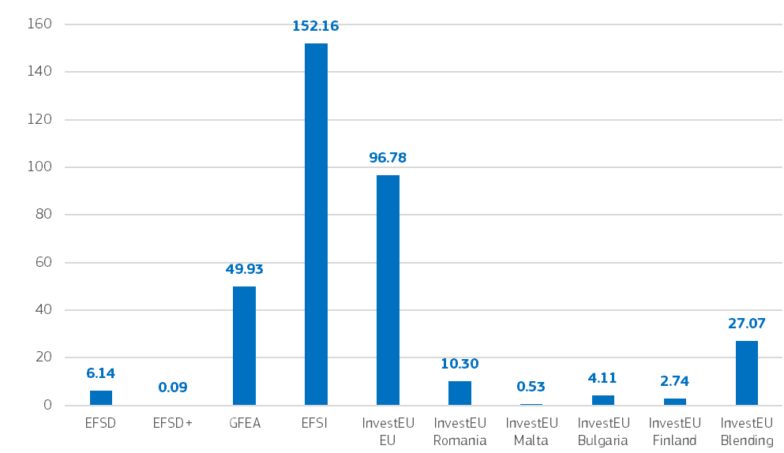

1.4. Effective provisioning rate
Article 216 of the Financial Regulation provides that the provisioning of budgetary guarantees and financial assistance to third countries in the CPF will be based on the Effective Provisioning Rate (EPR) as defined in that Article. The EPR takes account of the fact that the pooled management of the CPF – as opposed to the management of separate guarantee funds – could result in potential diversification if calls on the different compartments are not correlated in time or intensity.
The EPR is the ratio between
- the required amount of cash and cash equivalents held by the CPF, taking account of diversification effects between compartments, and
- the sum of the required amounts of cash and cash equivalents in the event that each compartment is managed separately.
By law, the EPR should be set at between 95% and 100%, with a figure below 100% reflecting some diversification effects. As a result of calculations based on the established methodology (), and given the prevailing macroeconomic and geopolitical uncertainties (some of the CPF compartments being highly dependent on the evolution of the situation in Ukraine), the Commission proposed that the EPR for 2024 remain at 100% due to the absence of any observed diversification between calls on the provisions of the different compartments. This approach was confirmed in the adopted 2025 Annual Budget.

Part 2: Investment strategy, portfolio composition and performance
The general principles and considerations informing the CPF investment strategy are established by the CPF Asset Management Guidelines and further described in the first CPF annual report for 2021 (). Based on the conservative approach enshrined in its Asset Management Guidelines, and low risk-tolerance, the CPF is managed in a way that should, at least, deliver capital preservation over its investment horizon (9 years) (). Reflecting this prudent investment policy, the assets in which the CPF can invest are limited to highly liquid and highly rated fixed income securities. The bulk of the CPF has been restricted to investment in euro and US dollar (hedged against currency risk) denominated investment-grade fixed income securities (bonds). The Asset Management Guidelines were modified in 2022 to allow some limited investment in equity exchange-traded funds to provide additional diversification opportunities for the CPF.

2.1. Composition and characteristics of the portfolio
As per its Asset Management Guidelines, the CPF maintains a liquid diversified portfolio, primarily investing in highly-rated debt instruments, such as bonds issued by governments, supra-nationals, state agencies and corporates.
At the year-end, the CPF portfolio was well diversified across the different asset classes in the eligible fixed income universe, including some limited exposure to equity ETFs, cash or cash equivalents and hedged US dollar denominated securities (USD). Figure 4 illustrates a growing allocation to sovereign/SSA assets and equities over the years, accompanied by a decline in covered and corporate bonds over the last four years. This trend reflects the introduction of equity as an eligible asset class and shifting perceptions of the relative attractiveness of different asset classes amid evolving market conditions.
The credit quality of the CPF portfolio was high, with an average rating of A, suggesting a negligible default probability (). Over 40% of the portfolio was invested in AAA securities (), with the rest distributed across the investment-grade scale.
USD-denominated investments represented 7% of the portfolio’s market value (), with currency risk hedged using forward contracts.
Equity represented 7% of the portfolio’s market value at the end of 2024 (). This contributed to the overall positive portfolio performance by accounting for 0.6% of total annual return.
As of December 2024, about 11% of the portfolio consisted of short-term liquid assets (), providing for a source of ready-to-hand liquidity in the event of large outflows exceeding the size of the liquidity buffer described above ().
Figure 4: CPF portfolio allocation at year-end (2024)
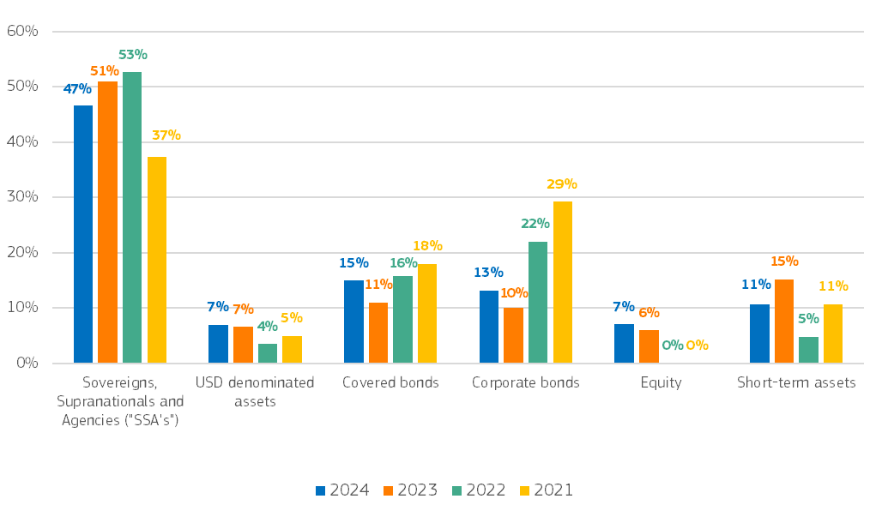

2.2. Environmental, social and governance (ESG) footprint
In 2024 the ESG footprint () of the portfolio increased further with the share of ESG-labelled bonds () reaching 16%, compared to 14.6% in 2023. The proactive approach to ESG investing favours ESG-labelled bonds, provided they align with risk management criteria and overall investment strategy.

2.3. CPF performance in 2024
In 2024, inflation dynamics and central bank actions continued to drive market developments (see Box). Despite this volatility, the gradual reduction in rates, combined with robust economic growth and resilient labour markets, provided overall support to financial markets and had a positive impact on the valuation of the CPF’s bond and equity holdings. Against this background, the CPF achieved an annual return of +3.57%, exceeding its portfolio benchmark () (+3.31%).

Market developments in 2024
Inflation data and respective action by central banks remained the main market drivers in 2024. Following the steady decrease in inflation throughout 2023, the new year began with markets pricing a continuation of this trend. This disinflationary trend was driven by a combination of factors, including supply chain improvements, easing energy prices and a cooling housing market.
In turn, interest rates were initially expected to fall steadily during 2024, with the European Central Bank (ECB) policy rate expected to fall from 4% at the beginning of the year to 2.25% by year-end. These market expectations had already suppressed bond yields and the German 10-Year government bond (Bund) was at its annual low at 2.02% in early January. As the year progressed, inflation proved to be stickier than expected and the pace of decrease towards the ECB’s 2% target was slower than initially anticipated. This slowly pushed yields higher and the German Bund reached a peak of 2.69% in late May. Once the ECB initiated the rate-cutting cycle with its first cut of 0.25% in June, yields began to gradually move lower and the German Bund ended the year at 2.36%, at which point the ECB had lowered its main policy rate by 1 percentage point in total, to 3%. Headline inflation slowly decreased towards ECB’s target, from 2.8% in January to 2.4% in December, after briefly dipping to as low as 1.8% in September.
In the USA, headline inflation remained even stickier than in Europe. The first inflation reading of the year came in at 3.1% in January, before dipping to 2.4% in September and then reversing to 2.9% at year-end. The Federal Reserve Bank also cut its key policy rate by a total of 1 percentage point, to a target range of 4.25%-4.50%. However, it only started in September, later than market expectations at the beginning of the year.
In terms of economic growth, the US outperformed Europe. In Europe, weaker growth in Germany was compensated by the strong performance of Spain, with EU average growth of close to 1%. The job market remained very strong in both the EU and the US, and the unemployment rates in both regions remained near record lows, boosting consumer confidence and spending.
Interest rate cuts, combined with decreasing inflation and good economic growth extended the market rally to most asset classes. Equity indices rose to all-time highs. The STOXX Europe 600 index was up 6%, while the US’s S&P 500 was up 23.3%.

CONCLUSIONS
During 2024, the CPF delivered a return of +3.57% exceeding its benchmark of +3.31%.Combined with the positive return of +5.21% in 2023,this has restored the market value of provisioning for most of the budgetary guarantees. Looking ahead, the current positive interest rate environment provides a foundation for sustained medium-term returns. However, heightened geopolitical risks could give rise to increased market volatility in 2025 in the CPF’s main asset classes (fixed income, equity).
The CPF broadened its strategy in 2023 by integrating pan-European equity indices alongside fixed income investments. In 2024, this equity diversification continued to have a positive impact on performance (equity contributing +0.6% to the total CPF performance), enhancing returns while maintaining a balanced risk profile.
Overall, while acknowledging the potential challenges ahead, particularly those arising from geopolitical uncertainties, the CPF remains strategically positioned to navigate volatility and pursue long-term stability and growth consistent with its investment objectives.

() Pursuant to Article 214 of the Financial Regulation (Regulation (EU, Euratom) 2018/1046 of the European Parliament and of the Council of 18 July 2018 on the financial rules applicable to the general budget of the Union, amending Regulations (EU) No 1296/2013, (EU) No 1301/2013, (EU) No 1303/2013, (EU) No 1304/2013, (EU) No 1309/2013, (EU) No 1316/2013, (EU) No 223/2014, (EU) No 283/2014, and Decision No 541/2014/EU and repealing Regulation (EU, Euratom) No 966/2012, OJ L 193, 30.7.2018, p. 1, the Commission must report annually to the European Parliament and to the Council on the common provisioning fund. The Asset Management Guidelines of the CPF (Commission Decision of 25.3.2020 on the Asset Management Guidelines of the common provisioning fund (C(2020) 1896 final, OJ C 131, 22.4.2020, p. 3-11) provide further guidance on the contents of this report.
() European Fund for Strategic Investments (EFSI) and InvestEU.
() External lending mandate (ELM), European Fund for Sustainable Development (EFSD) and European Fund for Sustainable Development Plus (EFSD+).
() Except MFA+ loans granted to Ukraine in 2023.
() Absolute return refers to the return on an investment or portfolio over a specified period of time, without any reference to a benchmark or market index.It represents the portfolio’s time-weighted percentage growth, measured so that cash inflows and outflows have no effect on the result.
() The governance structure was presented in the CPF annual report for 2021, EUR-Lex - 52022DC0213 - EN - EUR-Lex (europa.eu).
() The net asset value (NAV) of the CPF is determined by the value of the total assets, less the liabilities, on the respective NAV calculation date.
() In line with e.g. Articles 212.2, 212.4, 213.1 and 213.4 of the Financial Regulation.
() For Spain.
() Regulation (EU) 2024/792 of the European Parliament and of the Council of 29 February 2024 establishing the Ukraine Facility, OJ L, 2024/792, 29.2.2024.
() Guarantee Fund for external actions (GFEA), holding the provisions for the external lending mandate (ELM), legacy (macro-financial assistance - MFA) and Euratom programmes.
() European Fund for Sustainable Development.
() EU Compartment.
() Under Decision (EU) 2022/12018 and Decision (EU) 2022/1628 providing exceptional macro-financial assistance to Ukraine.
() Commission Decision of 25.3.2020 on the Asset Management Guidelines of the common provisioning fund (C(2020) 1896 final, OJ C 131, 22.4.2020, p. 3–11.
() Out of EUR 385 million, EUR 344 million correspond to CPF redemptions, EUR 41 million are recoveries.
() Compared to EUR 351 million in 2023.
() Individual guarantee calls are mentioned in a separate report under Article 41(5) of the Financial Regulation (FR).
() It is important to mention that payments may arise in 2025 or later, which may require ex post adjustment of the 2024 accounts.
() Commission Delegated Decision (EU, Euratom) C(2020)7684 supplementing Regulation (EU, Euratom) 2018/1046 of the European Parliament and of the Council with detailed conditions for the calculation of the effective provisioning rate of the common provisioning fund (OJ L 42, 5.2.2021, p. 12).
() EUR-Lex - 52022DC0213 - EN - EUR-Lex (europa.eu)
() Article 2(1) of the Asset Management Guidelines.
The assets of the CPF portfolio may be invested in hedged highly liquid bonds denominated in US dollars issued by sovereign and supranational entities solely for the purposes of diversification and exposure to another interest rate curve.
() 0.04% default probability over a one year horizon.
() Compared to over 36% in 2023.
() Compared to 6.6% in 2023.
() Compared to 5.5% in 2023.
() Compared to 15.2% in 2023.
() On top of liquidity buffer described in Section 1.5.
() ESG footprint – a quick score showing the portfolio’s overall impact on environmental, social, and governance issues.
() In assessing whether bonds are classified as ESG-labelled for the purposes of CPF allocation, the Commission relies on the published assessment of the ‘use of proceeds’ of the asset in question by the analytics and data providers which the Commission uses for its asset management function.
() As per the CPF Asset Management Guidelines (Decision COM(2020) 1896), the assets should be managed by the financial manager on the basis of an investment strategy that is expressed in the form of a Strategic Asset Allocation, reflecting the investment objectives and the risk tolerance. The investment strategy should be reflected in a strategic benchmark (the ‘benchmark’). The benchmark should be set in line with good industry practices.

