**Section 1.7—Linear Inequalities and Absolute Value Inequalities**

**Solving an Inequality**—the process of finding the set of numbers that make the inequality a true statement

**Interval Notation**—used to represent subsets (small collections) of real numbers

**Open Interval**—(a, b) represents the set of real numbers between, but not including a & b

$$\left(a,b\right)=\left\{\left.x\right|a<x<b\right\}$$

* x is greater than a AND less than b

**Closed Interval**— $\left[a,b\right]$ represents the set of real numbers between and including the points a & b

$$\left[a,b\right]=\left\{\left.x\right|a≤x≤b\right\}$$

* x is greater than or equal to a AND less than or equal to b

**Infinite Interval**— $\left(a,∞\right)$ represents the set of real numbers greater than a

$$\left(a,∞\right)=\left\{\left.x\right|x>a\right\}$$

* the infinity symbol does not represent a real number; it indicates that the interval extends indefinitely to the right

**Infinite Interval**— $\left.-∞,b\right.$ represents the set of real numbers that are less than or equal to b

$$\left.-∞,b\right.=\left\{\left.x\right|x≤b\right\}$$

* the infinity symbol does not represent a real number; it indicates that the interval extends indefinitely to the left

**Parentheses indicate endpoints that are not included in an interval.**

**Square brackets indicate endpoints that are included in an interval.**

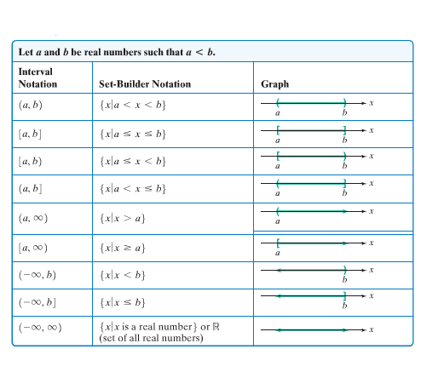The following table lists nine possible types of intervals used to describe the subset of numbers.

**Example**—Express each interval in set-builder notation and graph.

$\left.-2,5\right)$

$\left[1,3.5\right]$

$\left(-∞,-1\right)$

**Intersections and Unions of Intervals**

**Intersection**—set of elements that are common to both set A and set B; denoted $∩$

**Union**—set of elements that are in both set A or set B or both sets; denoted $∪$

**Finding Intersections and Unions of Intervals**

1. Graph each interval on a number line
2. Determine if you are looking for the intersection or union
   1. **Intersection**—take the portion of the number line that the two graphs have in common
   2. **Union**—take the portion of the number line that represents the total collection of numbers in the two graphs

**Example**—Use graphs to find each set

$\left[1,3\right]∩\left(2,6\right)$

$\left[1,3\right]∪\left(2,6\right)$

**Solving Linear Inequalities**

A linear inequality can be written in one of the following forms: $ax+b<0$, $ax+b≤0$, $ax+b>0$, or $ax+b≥0$.

What happens when you add, subtract, multiply or divide each side of an inequality by positive and negative numbers?

**When you multiply or divide both sides of an inequality by a negative number, reverse the inequality symbol.**

**Example**—Solve and graph the solution set on a number line $2-3x≤5$

**Example**—Solve and graph the solution set on a number line $3x+1>7x-15$

If there is no solution to an inequality, the solution set is the empty set, $∅$.

If an inequality is true for all real numbers, the solution set is $\left(-∞,∞\right)$ or $\left\{\left.x\right|xisareal​​number\right\}$

**Example**—Solve each inequality

$3\left(x+1\right)>3x+2$

$x+1≤x-1$

**Compound Inequality**—two inequalities written as one statement

* For example: $-3<2x+1and2x+1≤3$ can be written as the single compound inequality $-3<2x+1≤3$

An intersection is implied when you have a compound inequality.

The goal in solving an inequality is to isolate the variable in the middle.

You must perform the same operation on all three parts!!!

**Example**—Solve and graph the solution set on a number line $1≤2x+3<11$

**Solving Inequalities with Absolute Value**

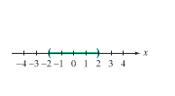When less than is used in an absolute value inequality, it means the distance from x is less than the value.

For example: $\left|x\right|<2$ means that the distance of x from 0 is less than 2; thus x can lie between -2 and 2. We would write that as (-2, 2) or $\left\{x|-2<x<2\right\}$

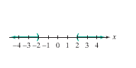When greater than is used in an absolute value inequality, it means the distance from x is greater than the value.

For example: $\left|x\right|>2$ means that the distance of x from 0 is greater than 2; thus x can be less than -2 or greater than 2. We would write $x<-2orx>2$; in interval notation as $\left(-∞,-2\right)∪\left(2,∞\right)$

If X is an algebraic expression and c is a positive number,

1. The solutions of $\left|X\right|<c$ are the numbers that satisfy $-c<X<c$
2. The solutions of $\left|X\right|>c$ are the numbers that satisfy $X<-corX>c$

These rules apply for $≤and≥$, when replacing < and > respectively.

**Example**—Solve and graph the solution set on a number line: $\left|x-2\right|<5$

**Example**—Solve and graph the solution set on the number line: $-3\left|5x-2\right|+20≥-19$

**Example**—Solve and graph the solution set on a number line: $18<\left|6-3x\right|$