**Section 2.1—Basics of Functions and Their Graphs**

**Relation**: any set of ordered pairs

**Domain**: set of all first values of the ordered pairs—the x-values

**Range**: set of all second values of the ordered pairs—the y-values

**Example**: Find the domain and range of the relation:

{(0, 9.1), (10, 6.7), (20, 10.7), (30, 13.2), (36, 17.4)}

**Function**: a relation in which each value in the domain corresponds to exactly one value in the range.

* a function can have a y-value repeated as long as it doesn’t have an x-value repeated

**Example**: Determine whether each is a function or not.

1. {(1, 2), (3, 4), (5, 6), (5, 8)}
2. {(1, 2), (3, 4), (6, 5), (8, 5)}

Functions are usually given in the form of an equation, not as a list of ordered pairs.

Not all equations are functions. If more than one value of y is found for x, then it is not a function.

**Example**: Determine whether each is a function.

1. 2x + y = 6

$x^{2}+y^{2}=1$

Functions are generally named with the letters f, g, h, F, G, or H; however, any letter can be used. “f” is the most commonly used.

$f\left(x\right)$ is functional notation.

* It represents the value of the function at that particular x-value.
* It does NOT mean f times x.
* f(x) and y represent the same thing, they are just different ways of writing the same thing. Like 2(2) and 4.

**Example**: Evaluate $f(x)=x^{2}-2x+7$ for each of the following:

$f\left(-5\right)$

$f\left(x+4\right)$

$f\left(-x\right)$

**Vertical Line Test**: If a vertical line intersects a graph in more than one place, it is not a function.

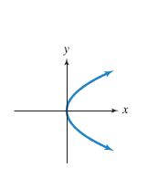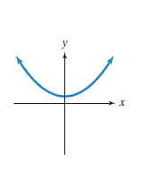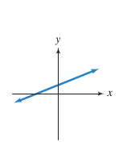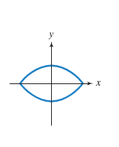

**Example**: Use the vertical line test to determine if the graphs are functions.

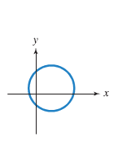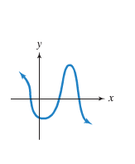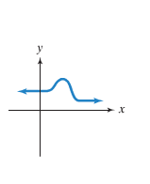

**Remember the following about graphs**:

* A closed dot indicates that the graph does not extend beyond this point and the point is included in the graph.
* An open dot indicates that the graph does not extend beyond this point and the point is NOT included in the graph.
* An arrow indicates that the graph extends indefinitely in that direction.

**Set-Builder Notation:**

[-3, -2] is interval notation. The brackets tell us the both -3 and -2 are included. The same written in set-builder notation looks like {x|-3 ≤ x ≤ -2}.

What would we use if ( ) were used instead of [ ]?

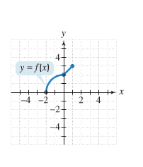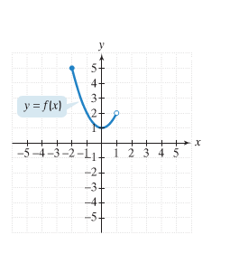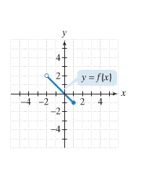

**Example**: Use the graph of each function to identify the domain and the range.

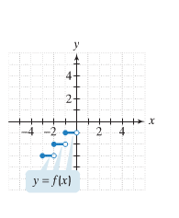

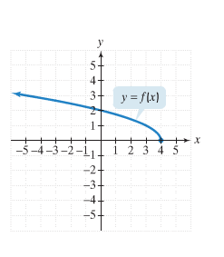

**Zeros of a Function**: the x-values for which $f\left(x\right)=0$.

**y-intercept**: where a graph crosses the y-axis. If the function has a y-intercept at 3, it is written $f\left(0\right)=3$.

A function can have more than one x-intercept but at most one y-intercept.