**Section 2.7—Inverse Functions**

**Definition of the Inverse of a Function**

Let $f$& $g$ be two functions such that

$f\left(g\left(x\right)\right)=x$ for every x in the domain of $g$

and $g\left(f\left(x\right)\right)=x$ for every x in the domain of $f$

* The function $g$ is the inverse of the function $f$ and is denoted $f^{-1}$ (read $"f-inverse"$).
* Thus $f\left(f^{-1}\left(x\right)\right)=x$ and $f^{-1}\left(f\left(x\right)\right)=x$.
* The domain of $f$ is equal to the range of $f^{-1}$, and vice versa.

**Example**—Show that each function is the inverse of the other.

$f\left(x\right)=4x-7$ $g\left(x\right)=\frac{x+7}{4}$

**In an inverse**:

* In $f^{-1}$, -1 is **not** an exponent and **does not mean $f^{-1}=\frac{1}{f}$**
* The two functions “undo” each other.

**Finding the Inverse of a Function**

* 1. Replace $f\left(x\right)$ with y in the equation.
  2. Interchange x & y.
  3. Solve for y.
     + If this equation is not a function, then $f$ does not have an inverse.
     + If this equation is a function, it does have an inverse.
  4. If $f$ has an inverse, replace y in Step 3 with $f^{-1}(x)$.
  5. Check this by showing that $f\left(f^{-1}\left(x\right)\right)=xandf^{-1}\left(f\left(x\right)\right)$.

**Example**—Find the inverse of each of the following:

$f\left(x\right)=2x+7$

$f\left(x\right)=4x^{3}-1$

$f\left(x\right)=\frac{3}{x}-1$

**Horizontal Line Test for Inverse Function**—a function $f$ has an inverse if there is no horizontal line that intersects the graph of function $f$ at more than one point.

**Example**—which of the following graphs represent functions that have inverse functions?

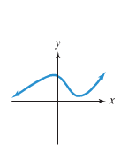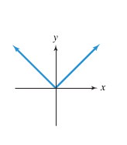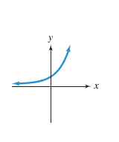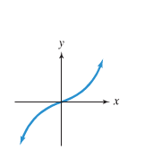

**One-to-One Function**—a function in which no two different ordered pairs have the same second component

* any function that passes the horizontal line test is a one-to-one function.
* The graph of $f^{-1}$ is a reflection of the graph of $f$ about the line y = x.
* If the point $\left(a,b\right)$ is on the graph of $f$, then $\left(b,a\right)$ is on the graph of $f^{-1}$.

**Example**—the graph of $f$ consists of two line segments, one from $\left(-2,-2\right)$ to $\left(-1,0\right)$ and a second from $\left(-1,0\right)$ to $\left(1,2\right)$. Graph $f$ and use the graph to graph the inverse.

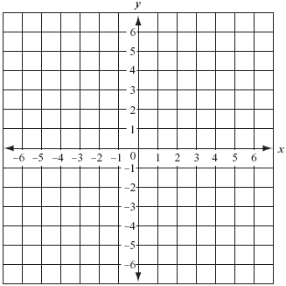

**Example**—Find the inverse of $f\left(x\right)=x^{2}+1,ifx≥0$. Graph $f$ and $f^{-1}$

in the same coordinate system

