**Section 2.8—Distance & Midpoint Formulas, and Circles**

**Distance Formula**—the distance, d, between the points $\left(x_{1},y_{1}\right)and\left(x_{2},y_{2}\right)$ in the rectangular coordinate system is

$d=\sqrt{{\left(x_{2}-x_{1}\right)}^{2}+{\left(y_{2}-y_{1}\right)}^{2}}$.

**Distance is never negative.**

**Example**—Find the distance between $\left(-4,9\right)$ and $\left(1,-3\right)$.

**Midpoint Formula**—If a segment has endpoints of $\left(x_{1},y_{1}\right)and\left(x_{2},y_{2}\right)$, then the coordinates of the segment’s midpoint are

$\left(\frac{x_{1}+x_{2}}{2},\frac{y_{1}+y_{2}}{2}\right)$.

**Example**—Find the midpoint of the line segment with coordinates $\left(1,2\right)$ and $\left(7,-3\right)$.

**Circle**—a set of all points in a plane that are equidistant from a fixed point

**Center**—the fixed point in a circle

**Radius**—the fixed distance from a circle’s center to any point that lies on the circle

**Standard Form of the Equation of a Circle**—

$${\left(x-h\right)}^{2}+{\left(y-k\right)}^{2}=r^{2}$$

with center $\left(h,k\right)$ and radius r.

**Example**—write the standard form of the equation of the circle with:

1. center $\left(0,0\right)$ and radius 4
2. center $\left(5,-6\right)$ and radius 10

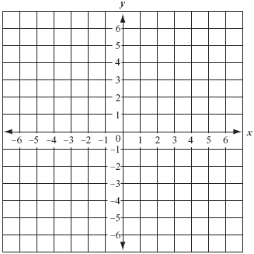**Example**—

1. Find the center and radius of the circle whose equation is ${\left(x+3\right)}^{2}+{\left(y-1\right)}^{2}=4$
2. Graph the circle
3. Use the graph to identify the relation’s domain and range.

**General Form of an Equation**—

$$x^{2}+y^{2}+Dx+Ey+F=0$$

where D, E, and F are real numbers.

**Example**—Write each of the following in standard form, graph the circle, and give the domain and range:





$x^{2}+y^{2}+4x-4y-1=0$

$x^{2}+y^{2}+8x-2y-8=0$

.