Quiz
Quiz is a python software application created using python, specifically with the python module “customtkinter”. This application helps users to store questions in the form of text, images and videos. The questions can then be answers later on in the future just like a quiz. This questions can be answered in two different formats; “Options” and “Without Options”. These formats will be talked about later on in the documentation. Quiz though comes along with it unique, clear, responsive and intriguing UI design, it also comes with essential features like;
- Text, image or even videos type questions as said earlier
- Back and forward features to jump to the previous questions while answering or entering/making questions. Note: Questions skipped will be indicated always as the respondent proceeds with the questions. Every question can be marked just in case the user skips it.
- Question editing, for instance, “Deleting a question”, “Adding a new question in an already established list of questions”, “Changing topic names, timer and scores”. More on that later on in the documentation.
- Hints in questions(based on the user’s preference).
- Clear feedback and review on the users result. These feedback include questions answered right or wrong, solutions to each answer(if the user assigns a solution for each of them) and total marks achieved.
- Can set the arrangement of questions in random order when answering them.
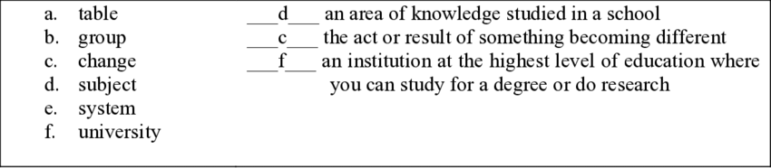
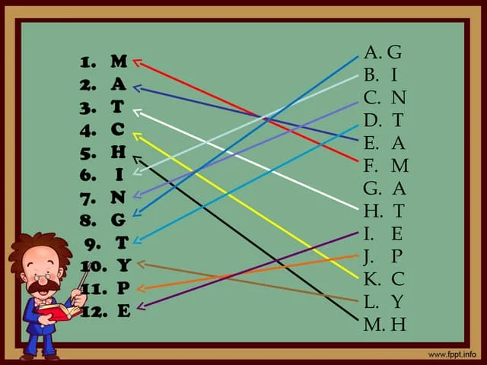

Although this application is advantageous, there are some downsides and limitations. These include;
- Topic names must not include spaces, numbers at the start and symbols. Explanation will be provided later on in the documentation.
- No grading system
- Some signs and symbols eg, mathematical symbols can be types or displayed. For instance, the square of x will be displayed as x^2 instead of x2.
- Options entry widgets have a limited no of character on different resolutions of monitors
- Videos will not have features like audio, play back, pause, etc due to python incapabilities for these features unlike other programming languages and modules.
- Limitations in UI design. Unlike HTML, CSS and JS, customtkinter doesn’t take the proper capabilities and features to display widgets in a more attractive way such as animation, style transformations, etc.
- While using the “Without Options” answering method, if answers aren’t exactly the same, the user will be marked incorrect even though he/she is right. For example, in a question, the user asked “What day was Jesus born?”, they may store 25/12/0000 as their answer. If the user or respondent gives an answer of 25 of December, 0AD, though this is correct, the respondent will be marked wrong due to the fact that their answer is not excatly the same as the answer stored by the author of the question.
- This app is not suitable for mathematics, language based subjects, etc. This is because mathematics and languages questions, ie an essay topic or mathematics question like solving a quadratic will be constant. Example, the use can only give a number of quadratic questions like find the x terms of x2 and question 2 is x2 +2x +1, and so on up to question 20. On the first attempt the respondent(person answering the questions) may answer each question correctly or incorrectly, regardless, they may not get the requires amount of practice, this is because if the user keeps answering the same questions they are not improving their skills thus remaining in the state they are in. Same applies for a language question such as write an essay about your best day ever. If the subject of interest is constant, there will be not progress, same applies for physics, chemistry, biology, religious, geographical questions as well. The app is only suitable for memorial based questions like “What is the capital of England”. And even if we could implement different question with similar structure by different resulting values, the answers aren’t the same as the answers provided by the user, therefore it can be marked and reviewed.
- In some exams, each questions attains a certain number of marks, the marks aren’t split up equally among all individual questions. ExamApp doesn’t have the functionality to do so as every question attains the same amount of marks regardless of the full marks assigned for that topic.
- Though you can add images, you can’t write, draw, sketch or do any thing on these images. For example, if a question asks you to identify a cat in an images by circling it, this wouldn’t be possible as the app doesn’t have the features to do so. Example 2 could be to draw a quadratic graph, this as well willl not be possible as sketching is a feature.
- Matching, fill the square/blank spaces and other features aren’t built-in as well. An example can be seen below.
- This application can’t be used as a progress tracing quiz app. For example, it can’t tell whether you are alright at certain questions and you can answer them perfectly most of the time therefore focusing your effort on questions that you have issues with.

Glossary
Here are the list of python names(variables, module names, function names) involved in the development of the application along with their use and connections.

