Databases Laboratory

Work №1

Creation and maintenance of databases

* Prerequisites: SQL Server Management Studio, Microsoft SQL Server.
* Objectives: Creation of DB’s, of maintenance plans and properties setting. Also studying physical architecture of the database.
* Task:

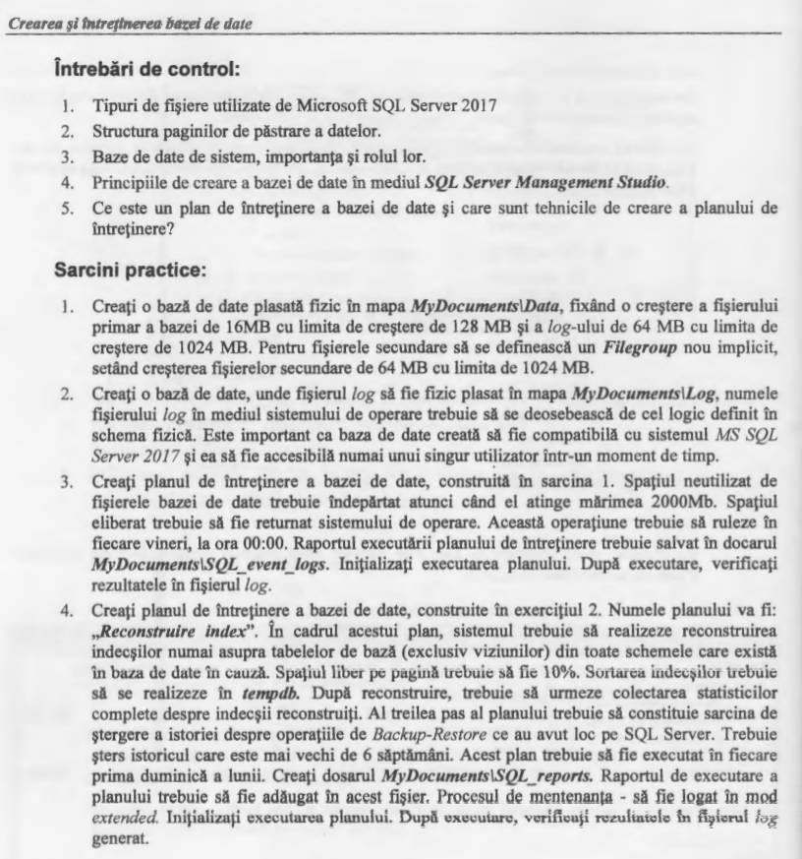

* Implementation:

Ex 1.

In this task I created the database BD-A, which has secondary file BD-123. The primary file has the initial size 16 MB and limitation 128 MB. Log-file and secondary file have initial size 64 MB and limitation 1024 MB.

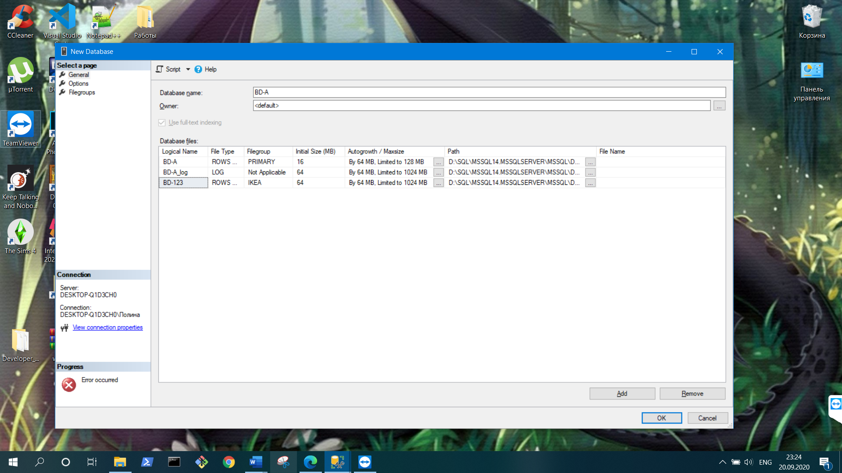

Ex 2.

In this task I created the second database BD-B, which was created by default. The only thing is that file name of log-file and its logical name has to be different by task given.

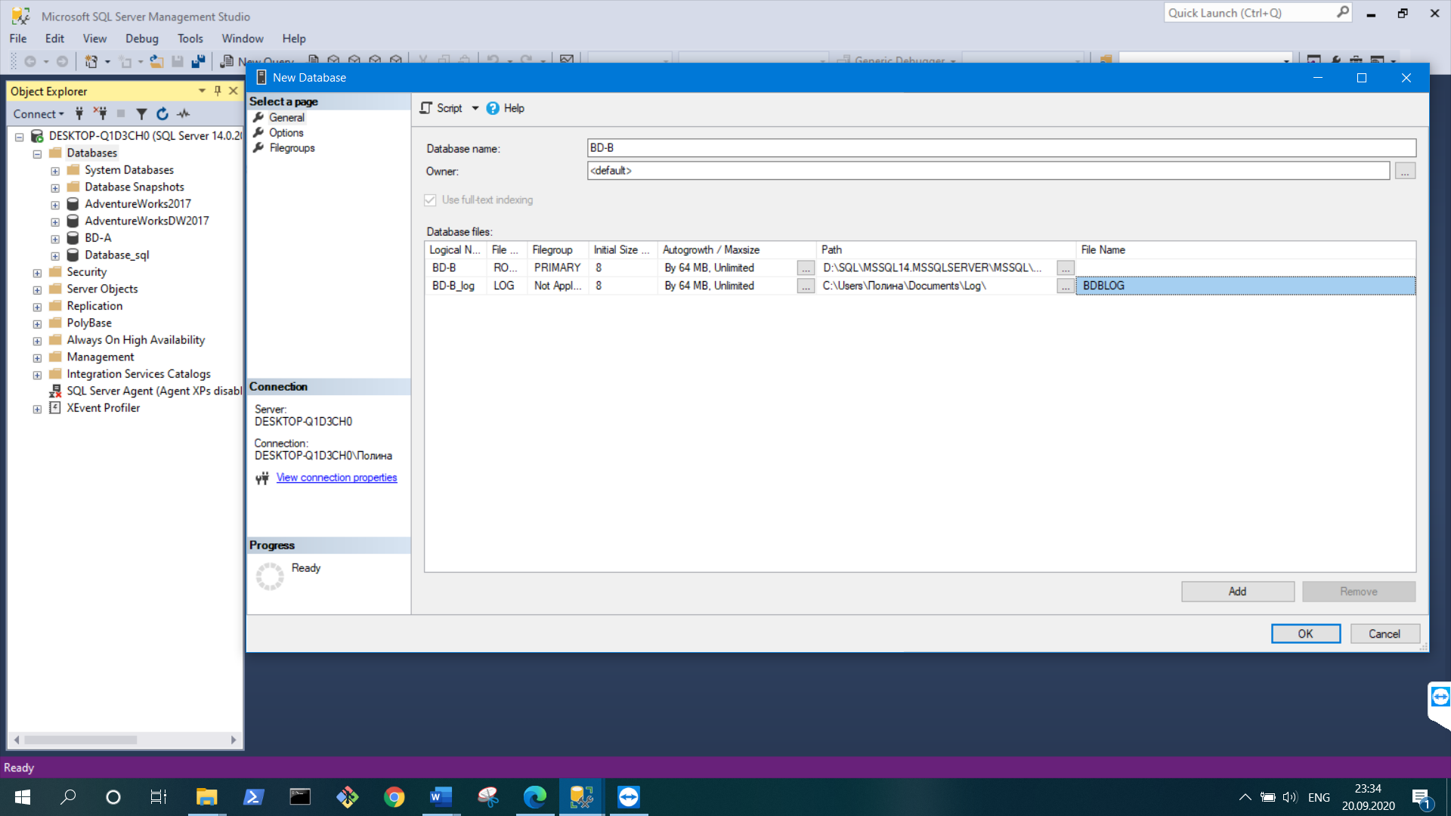

On this screenshot we see that this database has compatibility with SQL Server 2017 .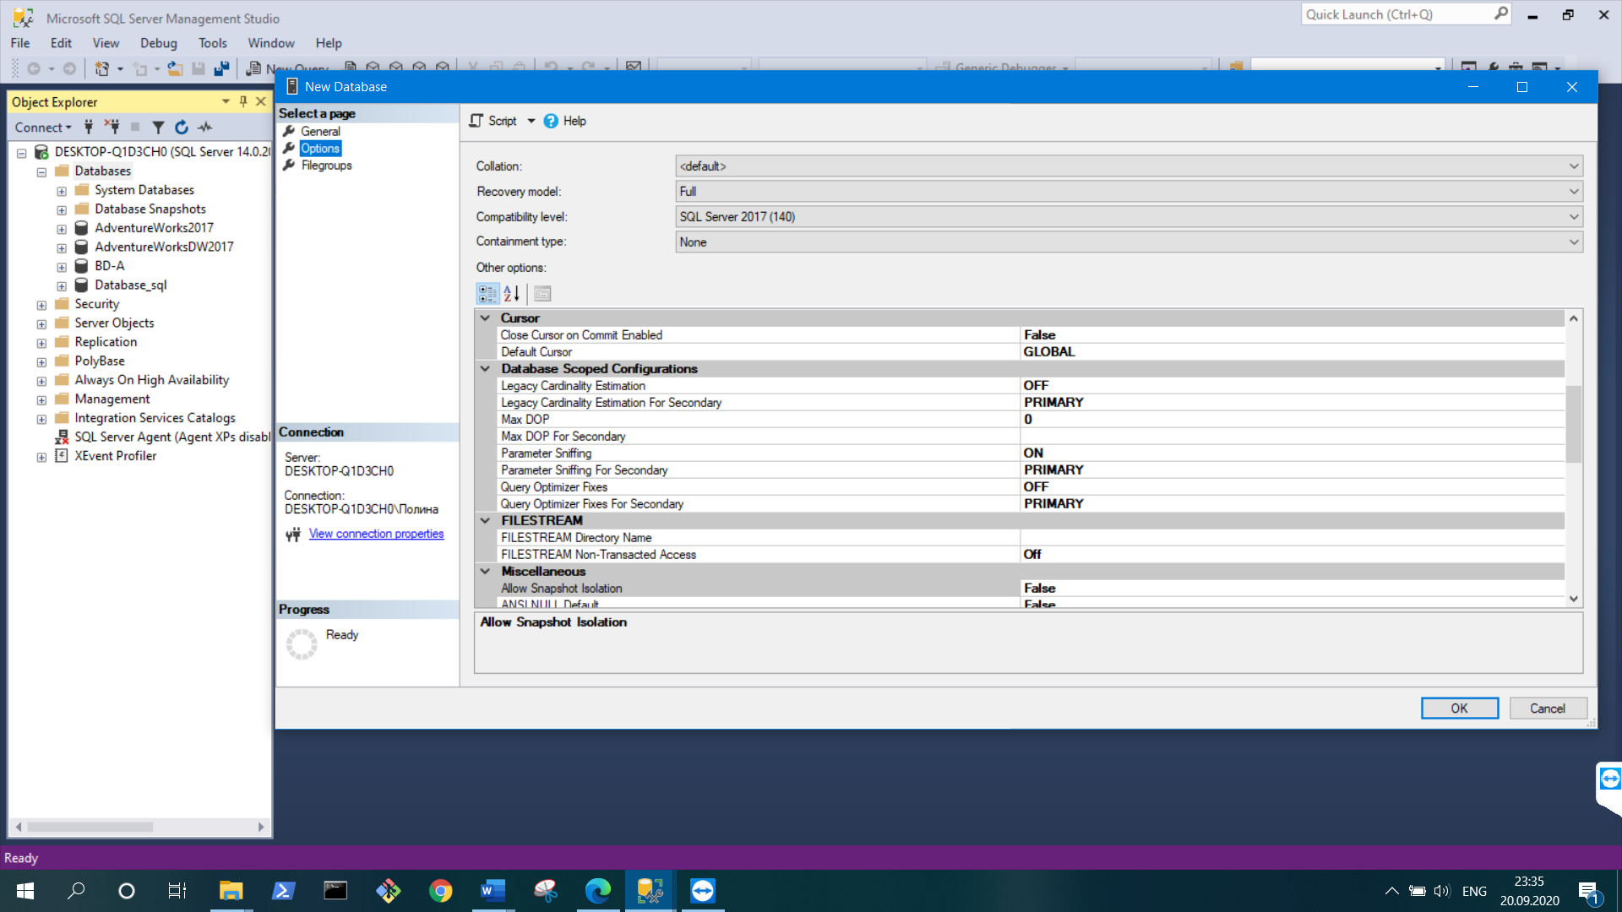

Ex 3.

In this task I created the maintenance plan MPW with one task- shrinking database. The database will be shrinked, when the limit of 2000MB will be obtained. This plan will be executed every Friday at midnight.

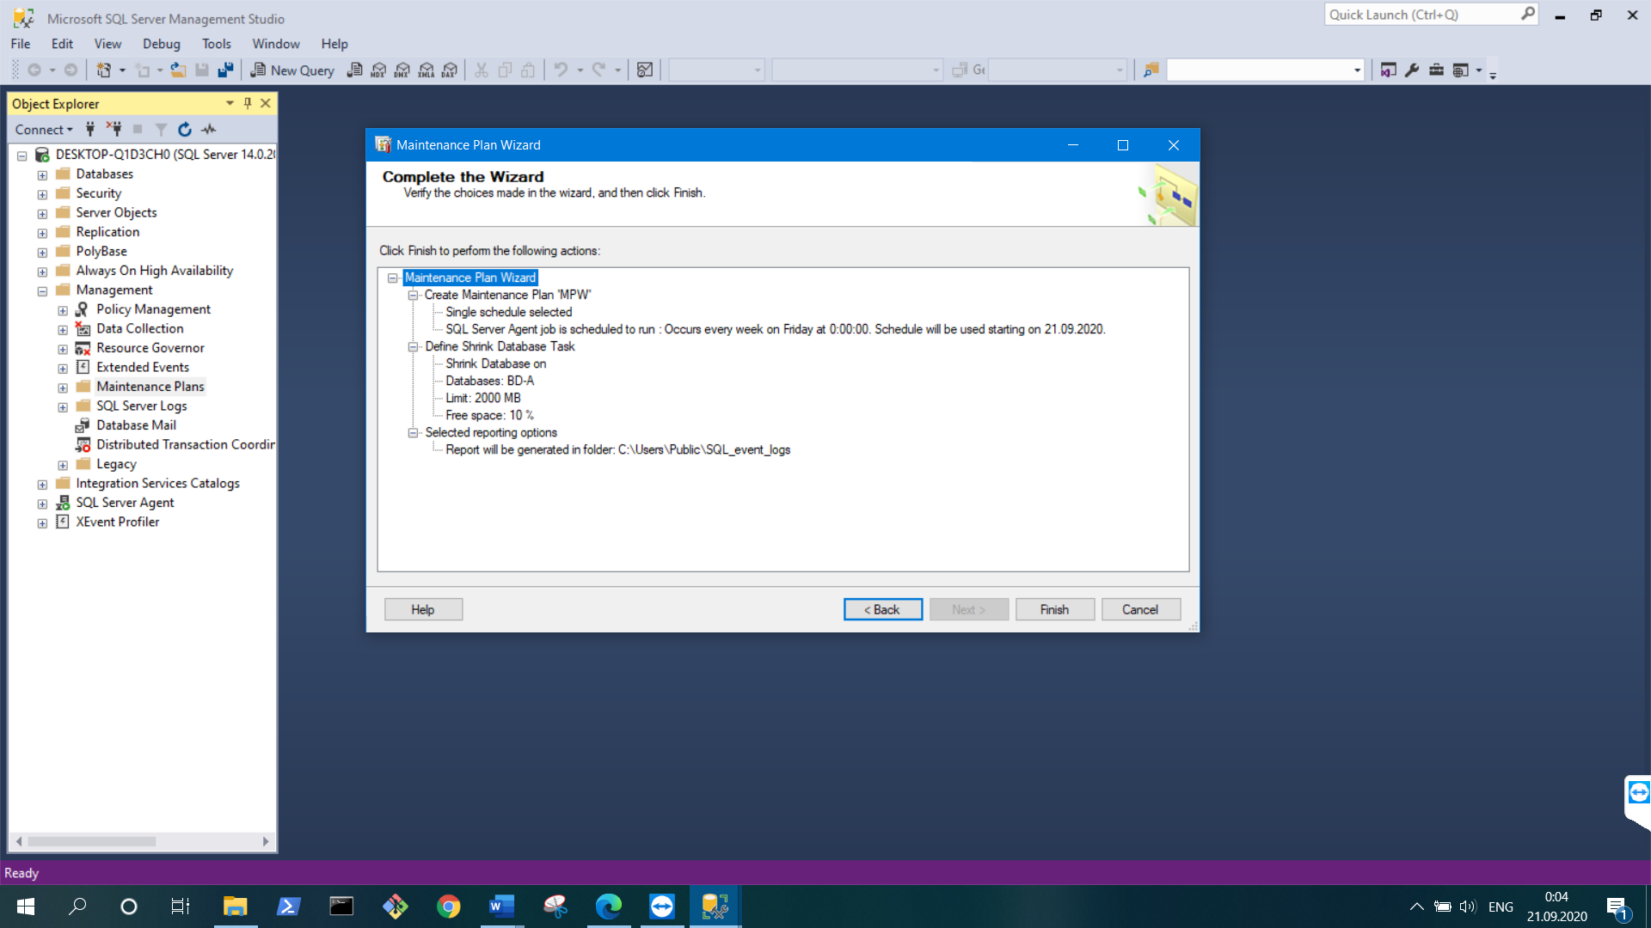

This screenshot shows that plan was executed successfully.

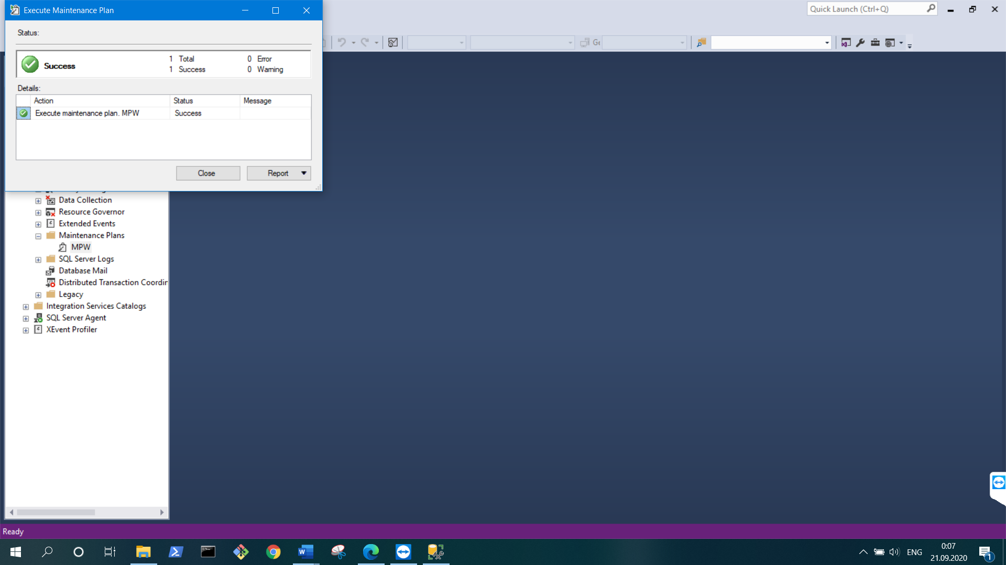

This screen represents the report of executed plan.

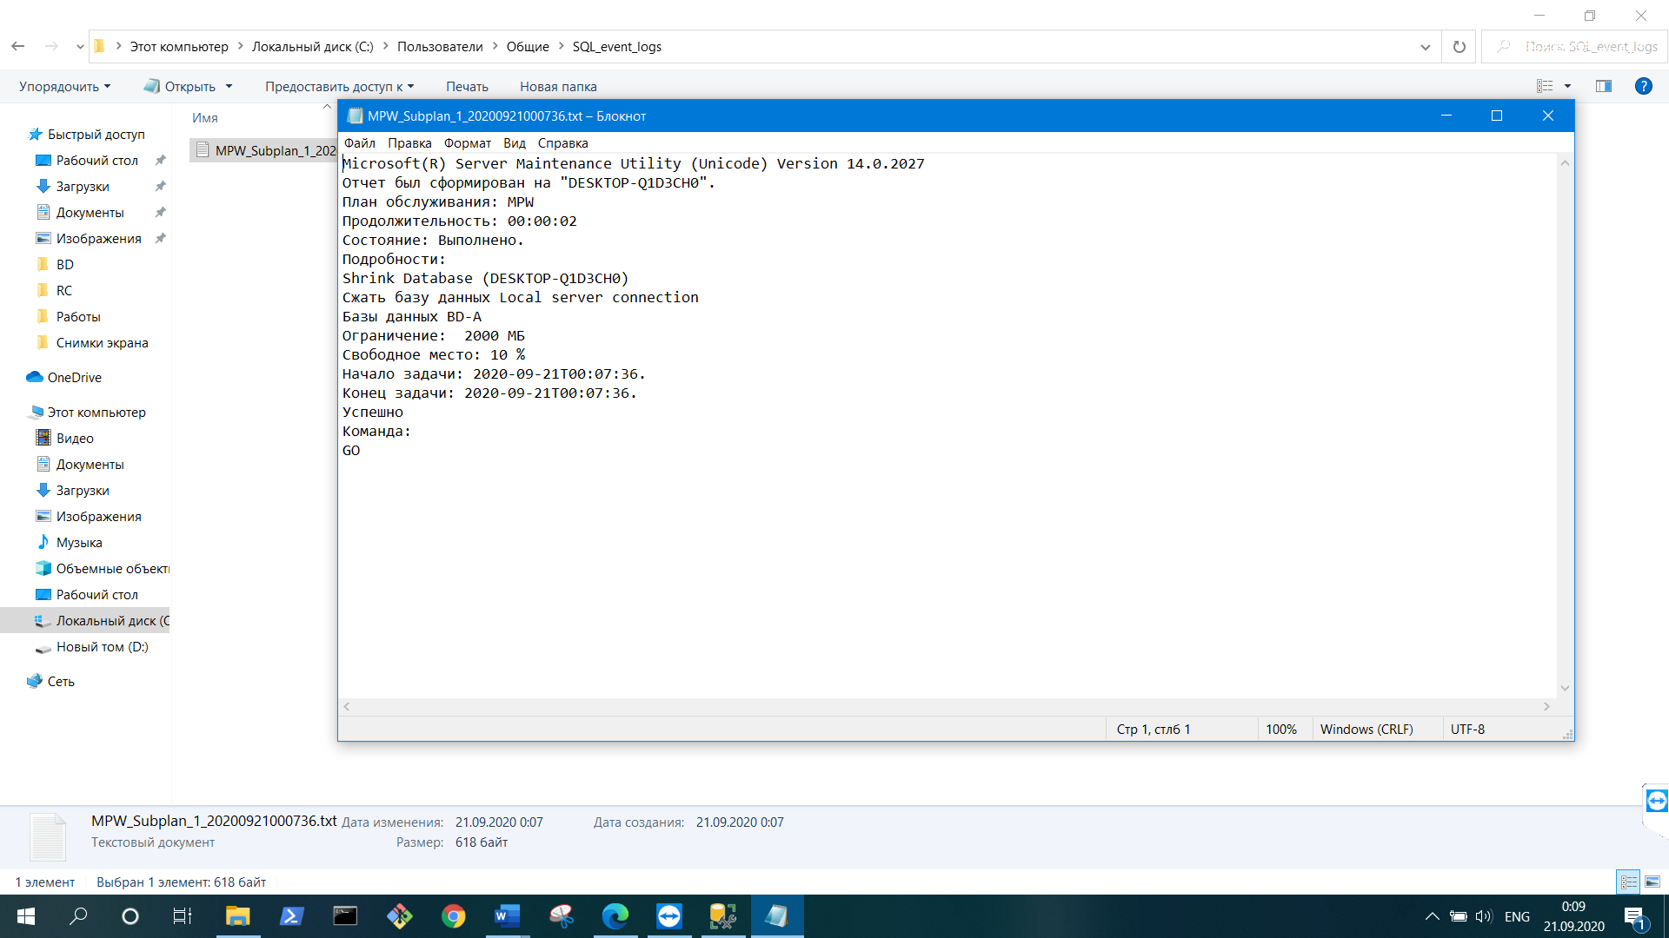

Ex 4.

In this task I created maintenance plan named “Reconstuire index” with three tasks. Tasks are: reorganize index, update statistics and history backup cleanup. The system cleans the history if it is older then six weeks. The update statistics task affects only on index statistics. This plan will be executed every first Sunday of month in midnight.

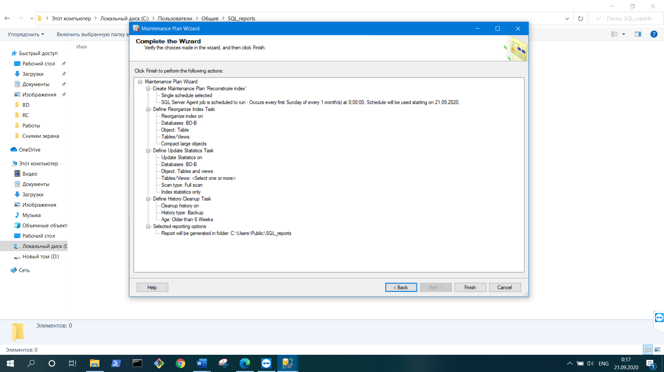

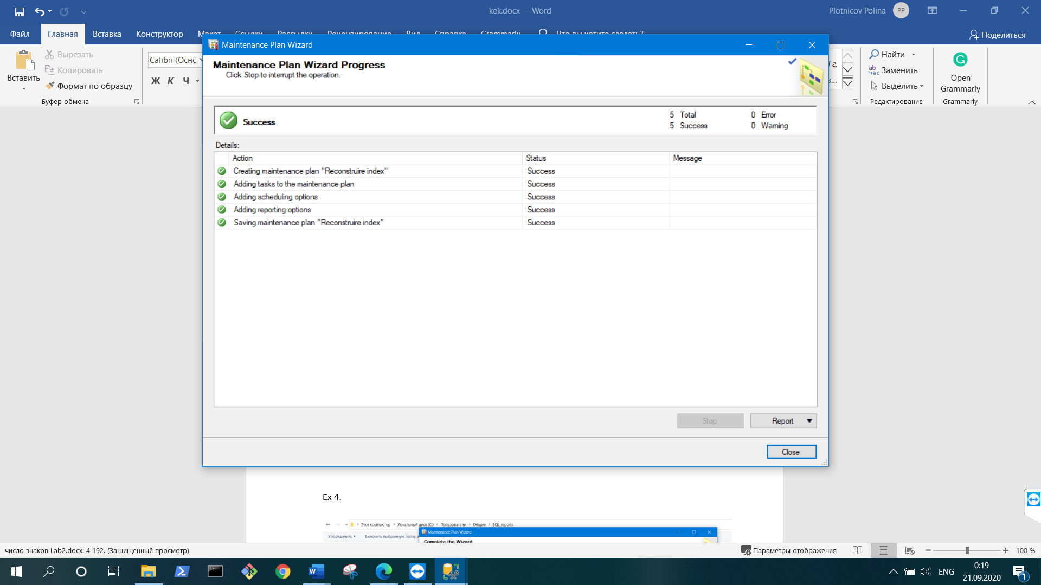

This screenshot represents the report of executed plan.

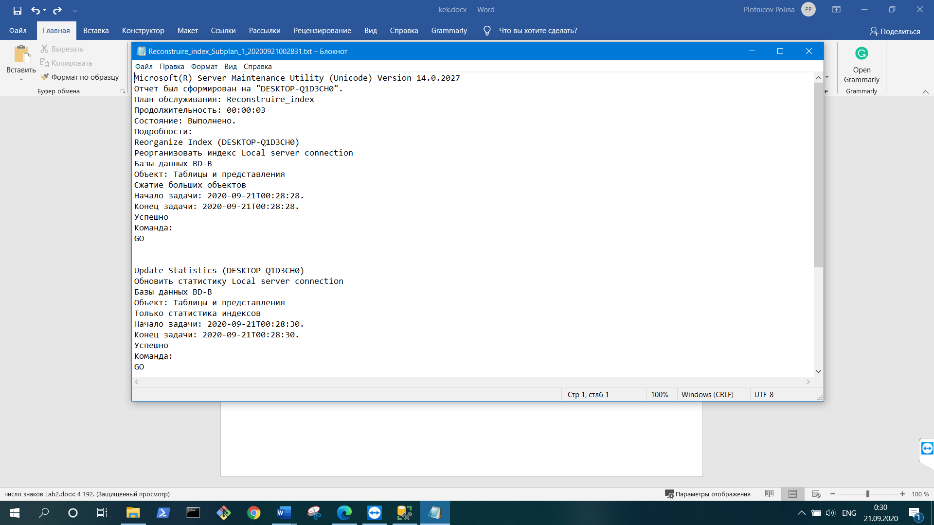

* Conclusion:

This laboratory work was my first activity in Microsoft SQL Server, however exploring the interface of this server. In this laboratory I practiced some basic configurations of SQL. For instance, creation databases and of maintenance plans and properties setting. Setting of databases: memory limiting, selecting the users. Setting of maintenance: scheduling, configurating and executing.