Databases Laboratory

Work №2

Creation and modification tables.

* Prerequisites: SQL Server Management Studio, Microsoft SQL Server.
* Objectives: During this work, I had to be done with creating a database and tables in it, editing them, and working with data types.
* Task:

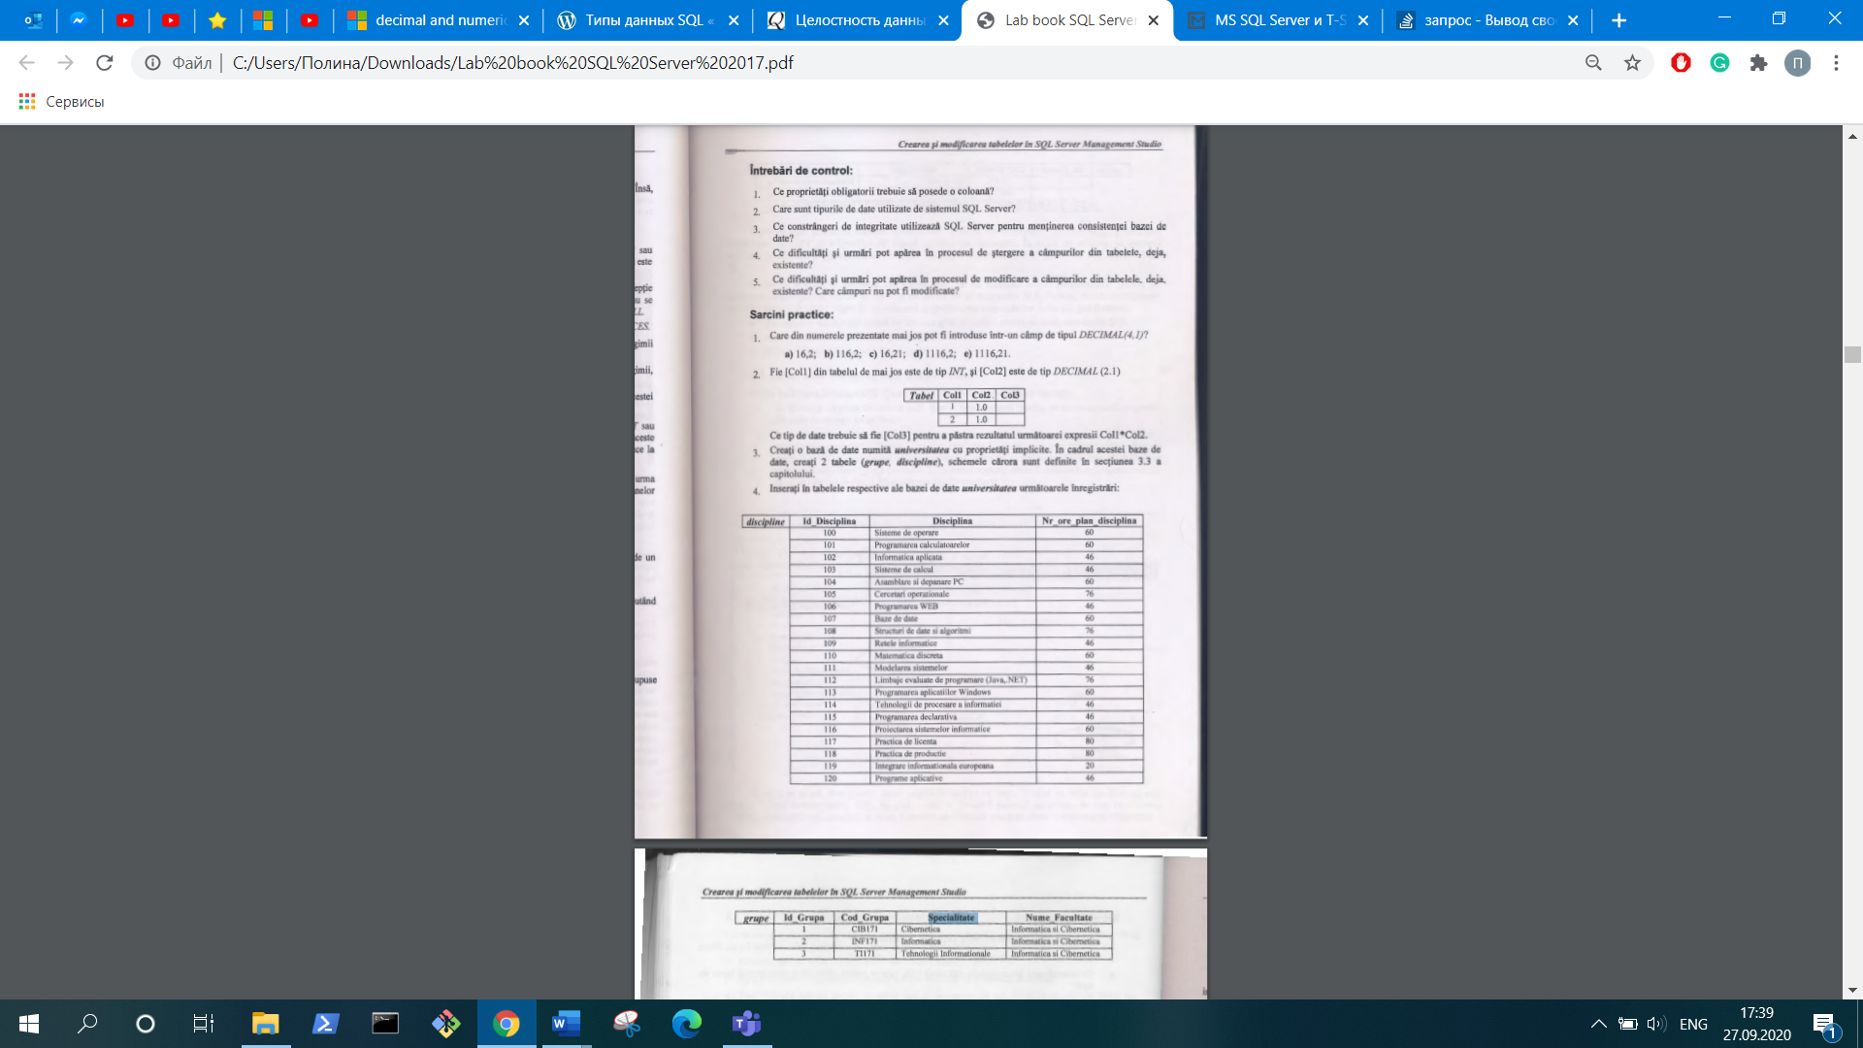

* Implementation:

Ex 1:

I have chosen the variant a) and b) after examining data types. Both have a maximum of 4 digits and 1 decimal place according to the type decimal(4,1).

Ex 2:

I consider the decimal type is right to display results in Col3. Also, I can use Int, without losing the precision of the calculation, because all values in Col2 have 0 after a point. Equally, a can use float, real, money, also without waste.

Ex 3:

In this task, I create a database “University” with two tables “discipline” and “grupe”.

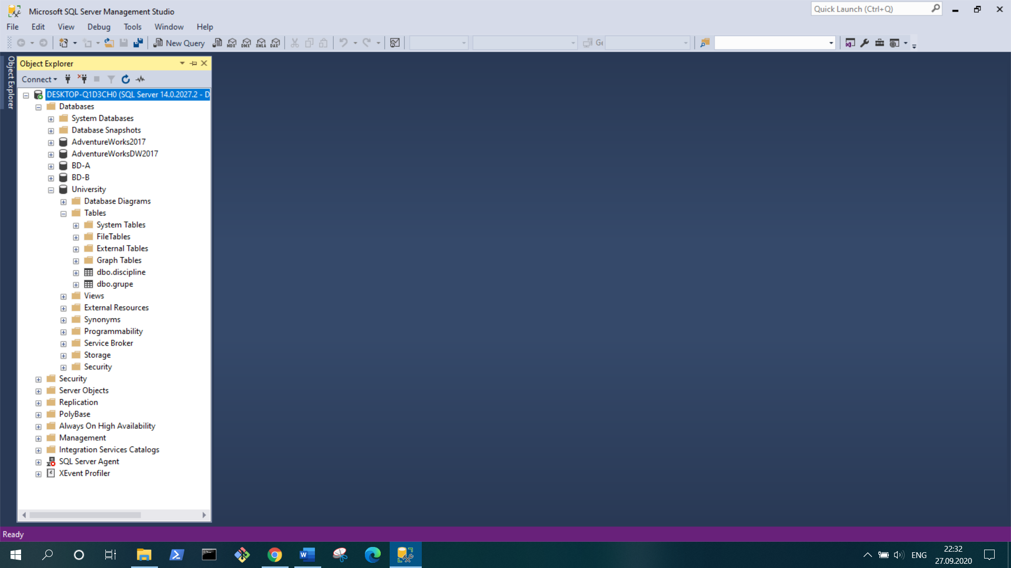

In this screenshot , I show the table “discipline” with the primary key “Id_Disciplina”.

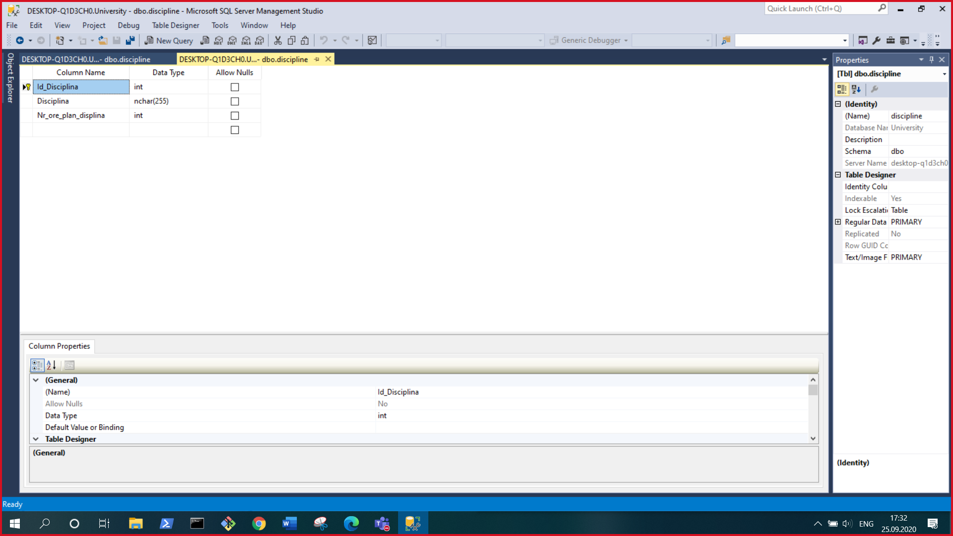

In this screenshot, I add the primary key.

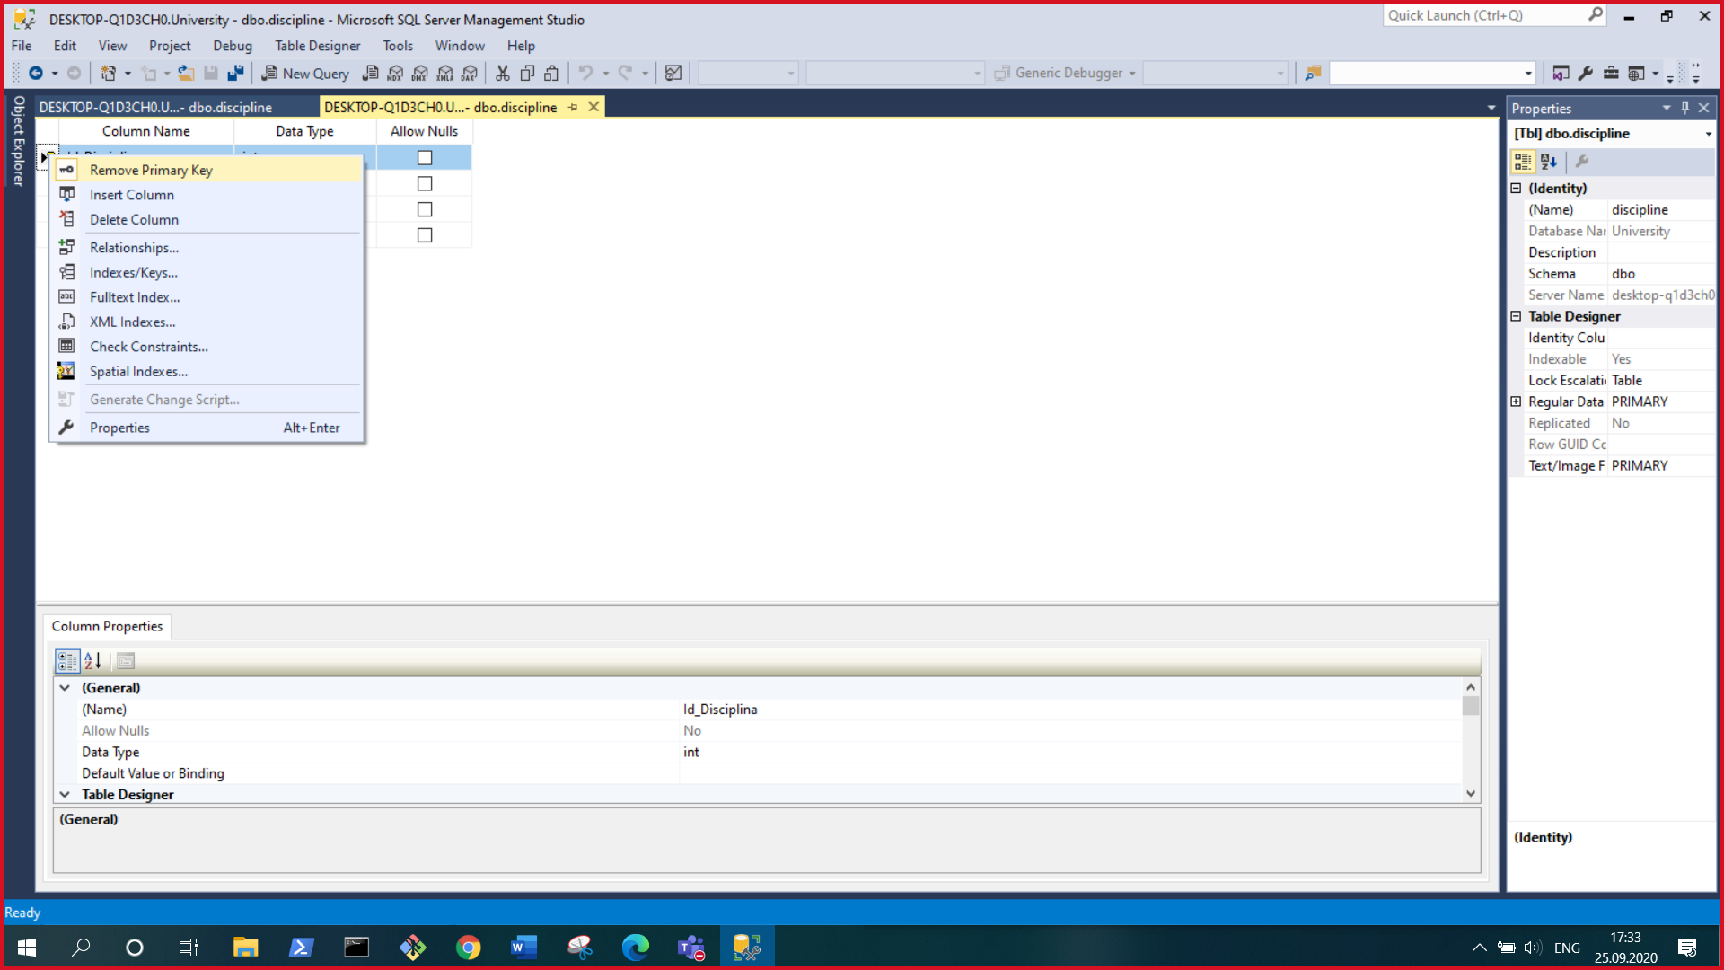

Here I create table “grupe”.

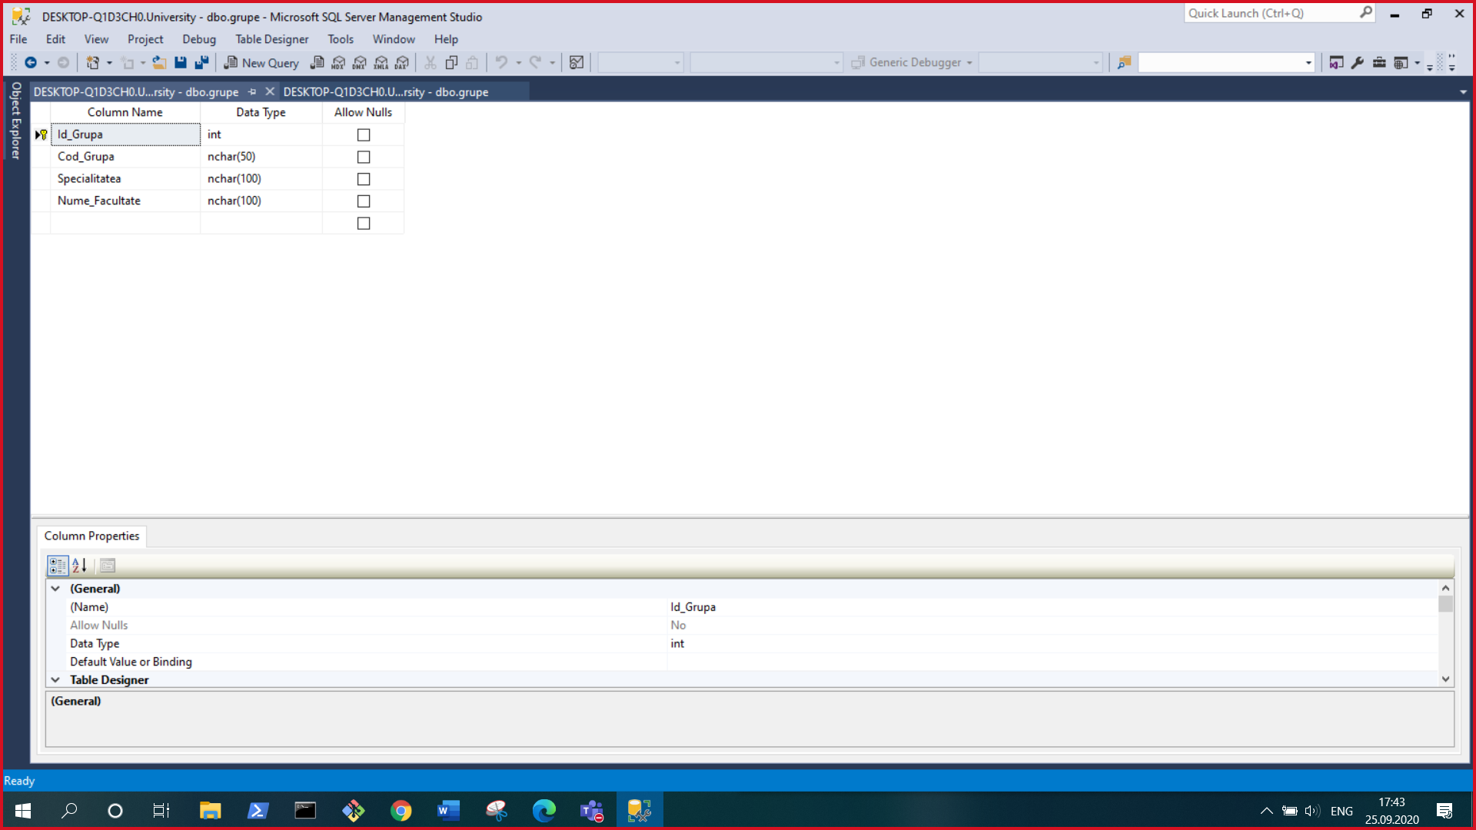

Ex 4:

In this task, I completed tables with data.

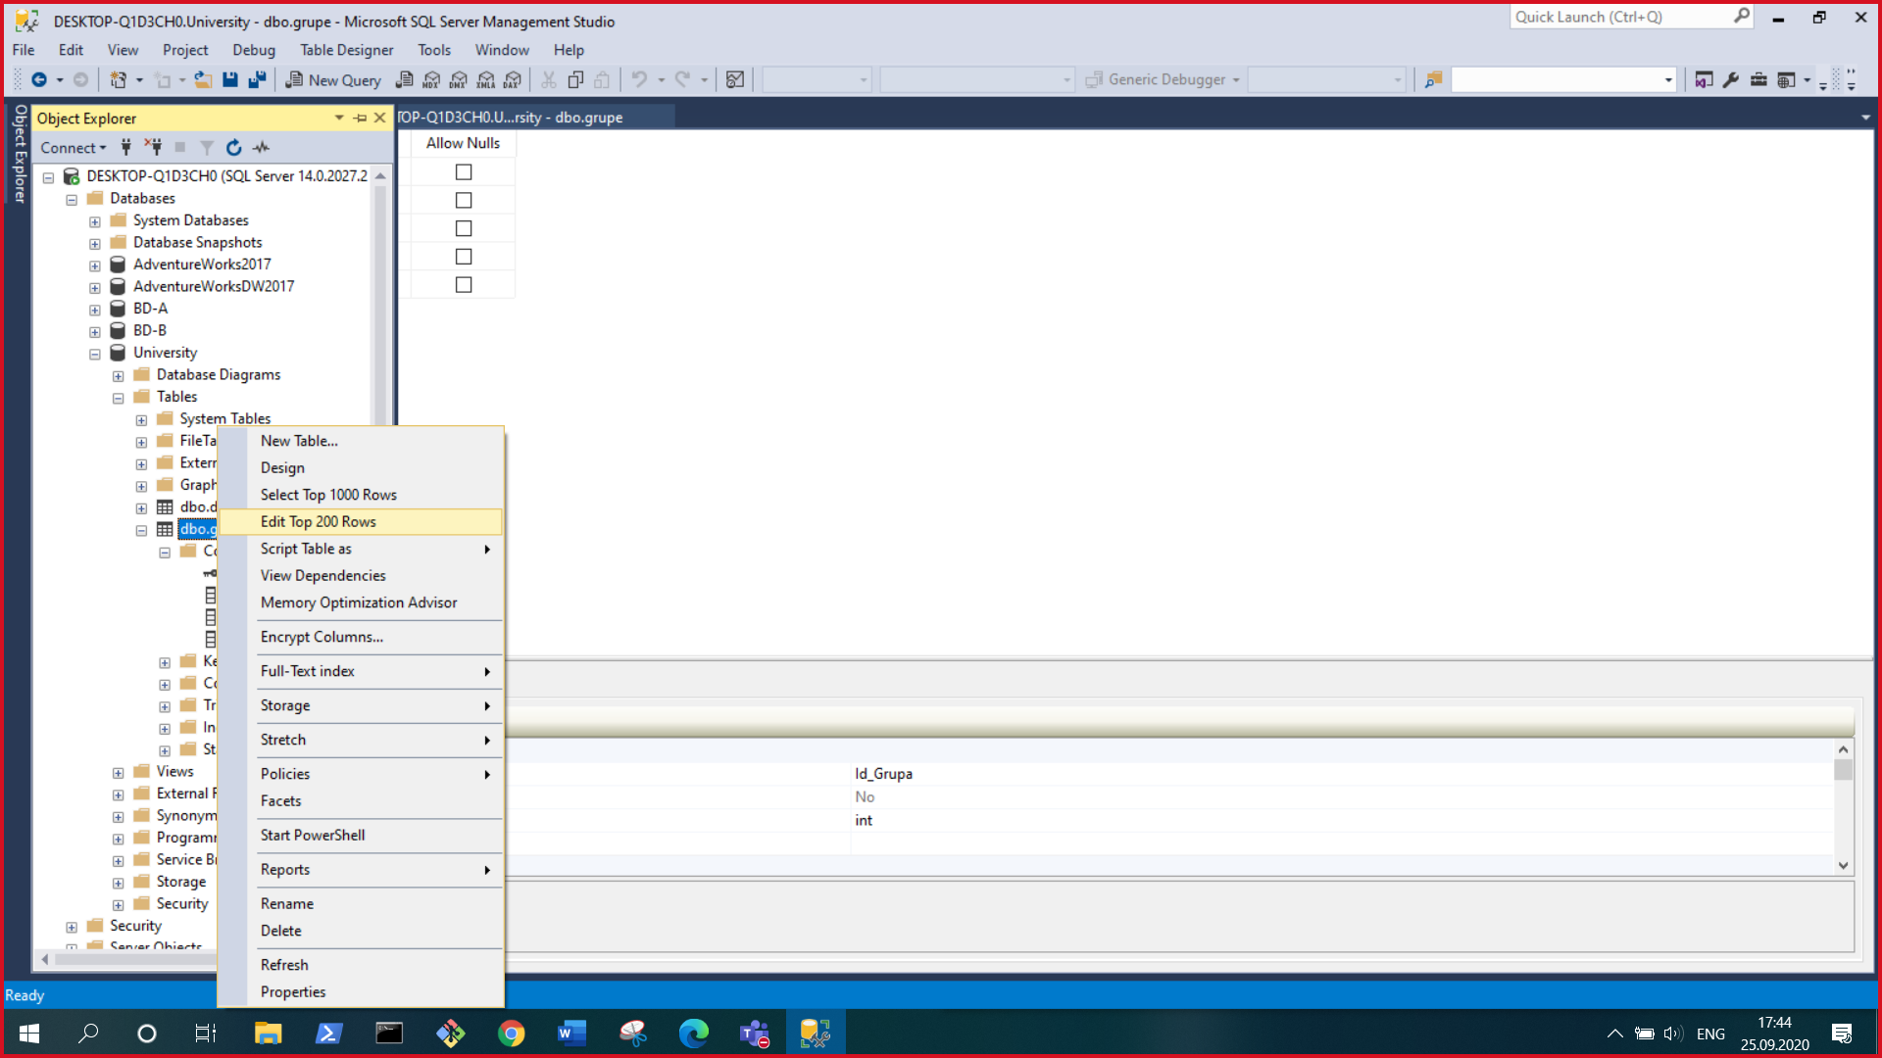

Given screenshots below show completed tables “discipline” and “grupe”.

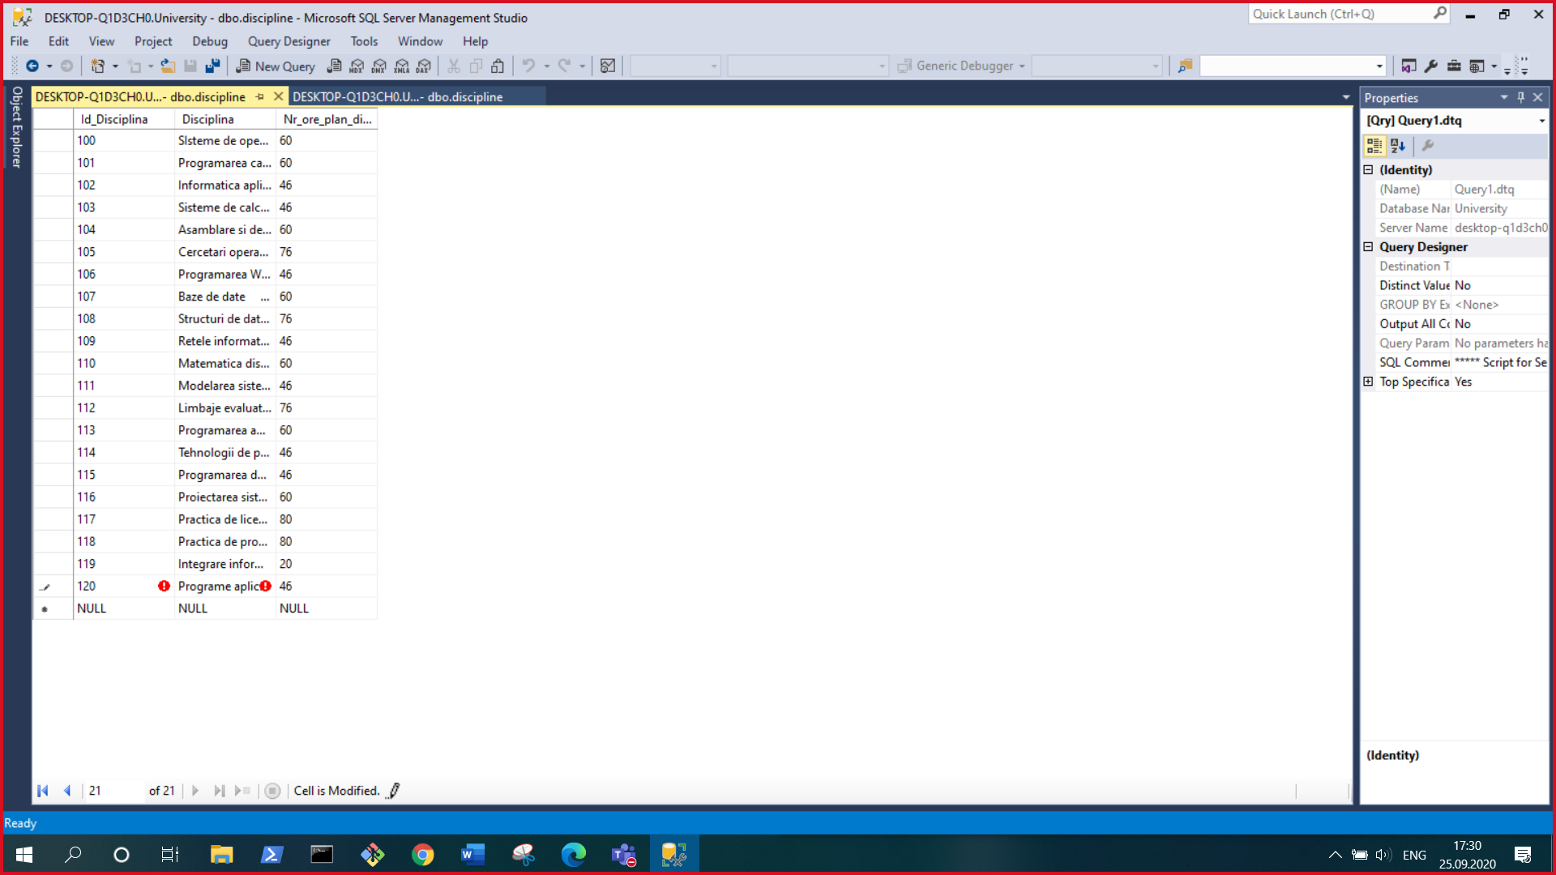

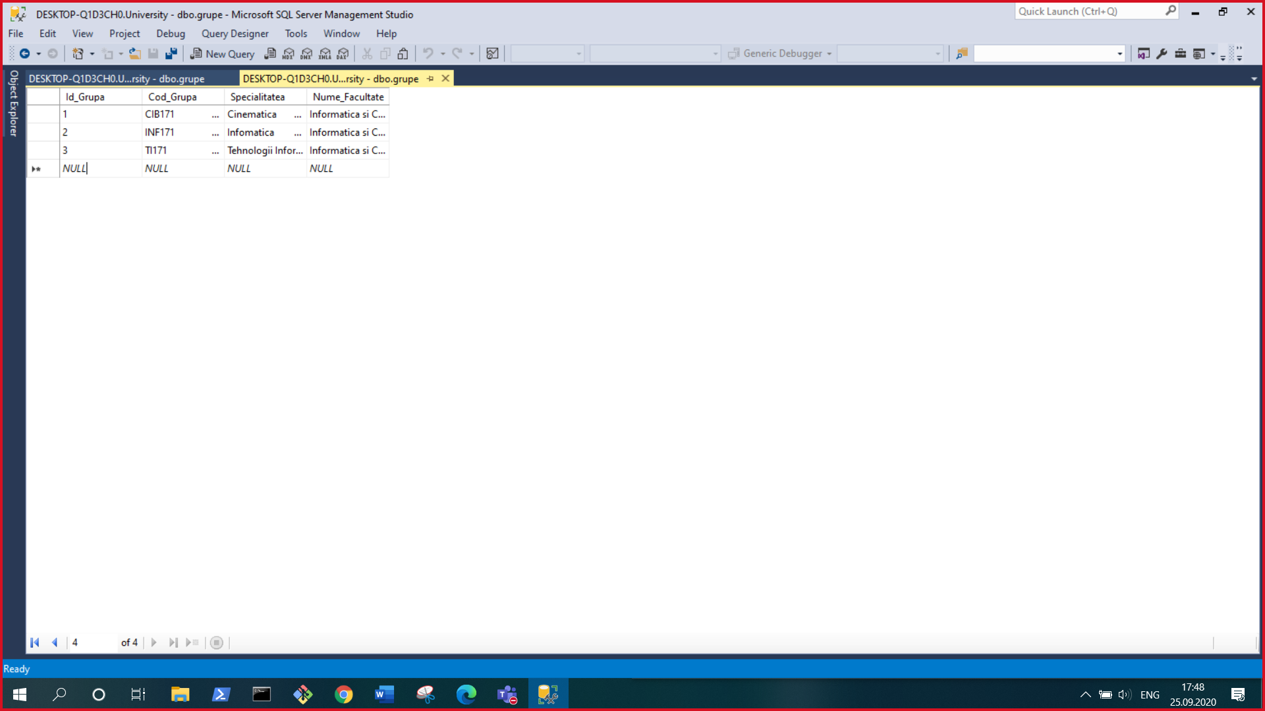

* Conclusion:

In his laboratory work, I learned data types of SQL. Also, I create my first table in SQL and execute some specifics of the table in SQL Server Management Studio. In fulfilling this work, I have learned how to generate the bases of the table, complete with data, refer to the primary key. Also, I pick type for dates in the table.