COUPLED AFFINITY-SYNTHESIZABILITY GUIDANCE FOR
TARGET-CONDITIONAL MOLECULAR DIFFUSION IN
STRUCTURE-BASED DRUG DESIGN

THESIS
Submitted as one of the requirements to obtain
MAGISTER — academic degree as listed in the student handbook

By:
STUDENT NAME
STUDENT IDENTIFICATION NUMBER

FACULTY OF COMPUTER SCIENCE
MASTER OF INFORMATICS STUDY PROGRAM
PRESIDENT UNIVERSITY
CIKARANG
MONTH, YEAR OF THE DEFENSE

Copyright by
STUDENT NAME
YEAR

COUPLED AFFINITY-SYNTHESIZABILITY GUIDANCE FOR
TARGET-CONDITIONAL MOLECULAR DIFFUSION IN
STRUCTURE-BASED DRUG DESIGN

By
STUDENT IDENTIFICATION NUMBER
Approved:
______________________________  Your Advisor Name  Thesis Advisor | ______________________________  Ahmad Fadhil N, Ph.D.  Program Head of MIT

_________________________________
Prof. Dr. Ir. Wiranto Herry Utomo, M.Kom.
Dean of Faculty of Computer Science

STATEMENT OF ORIGINALITY
In my capacity as an active student of President University and as the author of the thesis stated below:
Name : STUDENT NAME
Student ID number : STUDENT IDENTIFICATION NUMBER
Study Program : Master of Informatics
Faculty : Computer Science
I hereby declare that my thesis entitled “Coupled Affinity-Synthesizability Guidance for Target-Conditional Molecular Diffusion in Structure-Based Drug Design” is, to the best of my knowledge and belief, an original piece of work based on sound academic principles. If any plagiarism is detected in this thesis, I am willing to be personally responsible for the consequences of these acts of plagiarism, and will accept the sanctions against these acts in accordance with the rules and policies of President University.
I also declare that this work, either in whole or in part, has not been submitted to another university to obtain a degree.
Cikarang, DATE
( Full name & signature )

SCIENTIFIC PUBLICATION APPROVAL FOR ACADEMIC INTEREST
As an academic community member of President University, I, the undersigned:
Name : STUDENT NAME
Student ID number : STUDENT IDENTIFICATION NUMBER
Study program : Master of Informatics
for the purpose of development of science and technology, certify and approve to give President University a non-exclusive royalty-free right upon my final report with the title: “Coupled Affinity-Synthesizability Guidance for Target-Conditional Molecular Diffusion in Structure-Based Drug Design”.
With this non-exclusive royalty-free right, President University is entitled to converse, to convert, to manage in a database, to maintain, and to publish my final report, with the obligation of President University to mention my name as the copyright owner of my final report.
This statement I made in truth.
Cikarang, DATE
( Full name & signature )

ADVISOR APPROVAL FOR PUBLICATION
As an academic community member of President University, I, the undersigned:
Advisor Name : Your Advisor Name
Employee ID number : EMPLOYEE ID
Study program : Master of Informatics
Faculty : Computer Science
declare that the following thesis:
Title of thesis : Coupled Affinity-Synthesizability Guidance for Target-Conditional Molecular Diffusion in Structure-Based Drug Design
Thesis author : STUDENT NAME
Student ID number : STUDENT IDENTIFICATION NUMBER
will be published in: journal / institution’s repository / proceeding / unpublished / other (choose one, underline that applies).
Cikarang, DATE
( Advisor full name & signature )

SIMILARITY INDEX REPORT
Insert the similarity-check (Turnitin) report for the final version of this thesis here.

ABSTRACT
Structure-based drug design increasingly relies on three-dimensional diffusion models that generate ligands inside a protein pocket. A proposed way of improving such models is guidance with learned predictors of binding affinity and synthesizability. It was tested whether this idea survives when judged by independently computed evaluation outcomes rather than by the predictor's own score. A frozen TargetDiff model was guided by affinity and synthesizability predictors, and results were evaluated with AutoDock Vina docking, PoseBusters validity, ligand efficiency and the independently computed RA-score, using Kolmogorov–Smirnov tests with Benjamini–Hochberg correction, bootstrap intervals and negative controls.
Five routes were investigated: gradient guidance with an EGNN affinity predictor; a physics-anchored GIGN+PIGNet2 predictor and three mechanism variants; non-gradient rejection sampling; guidance toward synthesizability; and a pre-registered residual (delta-learning) training target. A leakage-safe, target-disjoint data split showed that an earlier generalisation gap was largely a split artefact, yet none of the routes produced a defensible improvement. Affinity guidance had no detectable effect across three orders of magnitude of guidance strength, and the predictor's gradient magnitude was positively correlated with the distance of an atom from the pocket (r = +0.24). Rejection sampling improved the raw docking score in 12 of 15 pockets but worsened ligand efficiency in 14 of 15 (on average 12 more heavy atoms, and 29 percentage points lower PoseBusters validity). Synthesizability guidance gave no supported gain; in an exploratory design it raised the predictor's own score while lowering the independently computed RA-score, a divergence that was not statistically confirmed after retraining on a leakage-safe split. The delta-target predictor (test R² = 0.117; target-clustered 95% CI −0.20 to 0.32) was significantly worse than a two-feature linear baseline (R² = 0.362) and than an EGNN (0.34–0.41), because the residual was not learnt better than by a constant.
The thesis contributes a reproducible, leakage-aware evaluation framework, an audited methodology, and a documented negative result that locates where learned guidance signals fail.
Keywords: structure-based drug design; diffusion models; classifier guidance; binding affinity prediction; data leakage; negative results

DEDICATION
To be written by the author (optional page).

ACKNOWLEDGMENTS
The author wishes to express… (to be written by the author).

TABLE OF CONTENTS
Page
DEDICATION ii
ACKNOWLEDGMENTS iii
LIST OF TABLES ix
LIST OF FIGURES xi
LIST OF ABBREVIATIONS xv
CHAPTER
I. INTRODUCTION 1
I.1 Background 1
I.2 Problem Statement and Importance 2
I.3 Related Work 3
I.4 Solution Employed and Novelty 3
I.5 Summary of Results 4
I.6 Research Objectives and Experimental Map 5
I.7 Organization of the Thesis 6
II. LITERATURE REVIEW 8
II.1 Deep Generative Models for Structure-Based Drug Design 8
II.2 Guidance of Diffusion Models 10
II.3 Predicting Binding Affinity 10
II.3.1 Docking scores and their biases 10
II.3.2 Learned scoring functions 11
II.3.3 Data leakage and shortcut learning 11
II.4 Evaluating Generated Molecules 12
II.5 Estimating Synthesizability 14
II.6 Residual (Delta) Learning for Scoring 14
II.7 Multi-Task Learning and Interaction Supervision 15
II.8 Positioning and Research Gap 16
III. RESEARCH METHODOLOGY AND EXPERIMENTAL INFRASTRUCTURE 18
III.1 Research Design 18
III.1.1 Pre-registration status of each route 20
III.2 Data 23
III.2.1 CrossDocked2020 and the pocket representation 23
III.2.2 Affinity labels 24
III.2.3 Splits used for predictor training 24
III.2.4 Synthesizability labels 25
III.3 Generative Model and Guidance Mechanism 26
III.3.1 The frozen diffusion model 26
III.3.2 Guidance on the clean-data estimate 26
III.4 Predictors 27
III.5 Evaluation Metrics 29
III.6 Statistical Protocol 30
III.6.1 Tests, corrections and intervals 30
III.6.2 What is shared and what is independent across a comparison 30
III.6.3 Decision bands and negative controls 31
III.6.4 A note on the wording of null results 32
III.6.5 Units of analysis 33
III.6.6 Target-clustered statistics for predictor comparisons 35
III.7 Computing Environment and Engineering 35
III.8 Integrity Checks 36
IV. AFFINITY PREDICTOR QUALITY, THE SPLIT ARTEFACT AND BASELINE GUIDANCE ABLATIONS 38
IV.1 The Original Affinity Predictor 38
IV.1.1 Training set-up 38
IV.1.2 Held-out quality 39
IV.2 Leakage and Coverage Audit 40
IV.3 Hyper-Parameter Sweep and Diagnostics on the Old Split 41
IV.3.1 Learning rate and depth 41
IV.3.2 Five diagnostics 42
IV.4 The Split Artefact: Leakage-Safe Re-Evaluation 43
IV.4.1 Construction of the split 43
IV.4.2 Result 43
IV.5 Baseline Guidance Ablations 45
IV.5.1 Task F: the original ablation 45
IV.5.2 Strength re-sweep with the original predictor 47
IV.5.3 Strength re-sweep with the repaired predictor 47
IV.6 Summary of the Chapter 48
V. ARCHITECTURE AND MECHANISM ROUTES: TRACKS A AND B, AND THE GRADIENT DIAGNOSTIC 50
V.1 Decision Rule for the Two Routes 50
V.2 Track A: A Physics-Anchored Predictor 51
V.2.1 Architecture and training 51
V.2.2 Predictive quality 52
V.2.3 Exploratory tier 53
V.2.4 Full tier 55
V.3 Track B: Three Mechanism Variants 57
V.3.1 B3: timestep-windowed guidance 57
V.3.2 B1: gradient-norm normalisation 58
V.3.3 B2: classifier-guidance reformulation 59
V.4 Diagnostic of the Gradient Direction 61
V.4.1 Method 61
V.4.2 Results 61
V.4.3 Interpretation and its limits 62
V.5 Conclusions of Tracks A and B 63
VI. REJECTION SAMPLING: THE AFFINITY PREDICTOR AS A POST-HOC RANKER (TRACK C) 65
VI.1 Design 65
VI.1.1 Pools, ranker and evaluation 65
VI.1.2 Statistics 66
VI.2 Results 67
VI.2.1 Raw docking score 67
VI.2.2 Ligand efficiency, size and validity 67
VI.2.3 Two pockets with the opposite behaviour 70
VI.2.4 Sensitivity to the selection fraction 70
VI.3 Post-Hoc Analysis of the Validity Loss 71
VI.4 Interpretation 72
VII. SYNTHESIZABILITY GUIDANCE (TRACK D) 74
VII.1 Target, Predictor and Guidance Design 74
VII.2 The Original Design: Divergence between the Own Score and the Independently Computed Score 75
VII.3 Re-Examination: Convergence and Leakage of the Synthesizability Predictor 76
VII.4 Guidance with the Leakage-Safe Predictor 77
VII.5 Diagnostic of the Synthesizability Gradient 80
VII.6 Conclusion of Track D 81
VIII. REDESIGN OF THE TRAINING TARGET: DELTA-LEARNING AGAINST THE DOCKING SCORE (TRACK E) 83
VIII.1 Rationale and Premise Checks 83
VIII.1.1 The two modifications 83
VIII.1.2 Premise checks that changed the plan 84
VIII.2 Design 86
VIII.2.1 Architecture and target 86
VIII.2.2 Anchor and its semantics 87
VIII.2.3 The auxiliary head and label reliability (E2, designed) 88
VIII.3 Pre-Registration 90
VIII.3.1 Arms, metrics and decision rules 90
VIII.3.2 Power, disclosed in advance and recomputed 91
VIII.4 Infrastructure and Verification 91
VIII.5 Results of the First Stage 93
VIII.5.1 Predictive quality 93
VIII.5.2 Pre-registered criteria 95
VIII.6 Why the Delta Target Failed 97
VIII.7 Limits of the Conclusion 99
VIII.8 Position in the Literature 99
VIII.9 Summary of the Chapter 100
IX. SYNTHESIS AND DISCUSSION 101
IX.1 Summary of the Evidence 101
IX.2 What the Evidence Supports 104
IX.2.1 Main finding 104
IX.2.2 Predictor quality is not guidance usefulness 105
IX.2.3 Grading the explanations 106
IX.2.4 The role of statistical power 108
IX.3 Methodological Findings 109
IX.4 Threats to Validity 111
IX.4.1 Internal validity 111
IX.4.2 External validity 112
IX.4.3 Construct validity 113
IX.5 Relation to the Literature 113
IX.6 Implications and Recommendations 114
X. CONCLUSIONS AND RECOMMENDATIONS 115
X.1 Conclusions 115
X.2 Contributions 117
X.3 Limitations 118
X.4 Recommendations for Future Work 119
REFERENCES 120
APPENDIX A. REPRODUCIBILITY AND REPOSITORY 126
A.1 Hardware and Software 126
A.2 Exact Identifiers for Reproduction 127
A.3 Reproducibility Checklist 128
A.4 Repository Layout 129
A.5 Reproducing the Results and This Document 130
APPENDIX B. LITERATURE SEARCH AND VERIFICATION 131
B.1 Search Strategy 131
B.2 Verification and Its Limits 131
APPENDIX C. TRACK A FULL-TIER RESULTS: ALL COMPARISONS 133
C.1 Per-Pocket, Per-Strength Results 133
APPENDIX D. TRACK E: PRE-REGISTRATION AMENDMENTS 135
D.1 Summary of the Amendments 135
APPENDIX E. POST-SYNTHESIS FOLLOW-UP: TESTING THE DIAGNOSED MECHANISM DIRECTLY 137
E.1 Scope and Relation to the Main Synthesis 137
E.2 Phase 1: Deepening the Pattern on the Predictor Itself 139
E.2.1 Noise-matched and Vina-derived training recipes 140
E.2.2 Gradient-alignment: optimising the diagnosed correlation directly 141
E.2.3 A global protein-language-model feature (ESM2) 143
E.2.4 Kitchen-sink: all four interventions combined 147
E.3 Phase 2: Independent Validation and the Hardest Generalisation Test 148
E.3.1 Does guidance change real chemistry, not just the raw score? (PLIP) 148
E.3.2 Generalisation to a protein family never seen in training 149
E.3.3 A side-finding: AlphaFold-predicted pockets as a robustness check 151
E.4 Phase 3: Sharpening the Representation and an Independent Label Check 154
E.4.1 A pocket-restricted protein-language-model feature 154
E.4.2 Independent cross-validation against ChEMBL 155
E.5 Direct Mechanistic Trace of the Guidance Nudge 157
E.5.1 Method 158
E.5.2 Result: the gap grows smoothly and ends two orders of magnitude below the raw nudge sum 159
E.5.3 A puzzle checked, not glossed over 160
E.5.4 Scope and what would have rejected this hypothesis 163
E.6 Pooled Statistical Correction Across the Entire Follow-up Phase 164
E.7 What This Appendix Adds to the Thesis's Central Claim 166

LIST OF TABLES
TABLE Page
1.1 Research objective, experiment, metric, result and conclusion 5
2.1 Relation of the closest prior work to the experiments of this thesis 16
3.1 Where a decision gate was applied, by route 20
3.2 Master summary of every experimental route, including the Appendix E follow-up 22
3.3 Data splits used for affinity predictors 25
3.4 Predictors used as guidance signals or ranking functions 27
3.5 Independent evaluation metrics 29
3.6 Unit of analysis and seed count, by route 34
4.1 Old split: validation and test quality of the affinity EGNN at selected epochs 39
4.2 Old split: learning-rate and depth sweep (validation n = 4,061, test n = 27 pockets) 41
4.3 Old split: diagnostics of the generalisation gap 42
4.4 Stage 0 checkpoint on the leakage-safe split (test n = 11,855) 43
4.5 Task F: unguided versus affinity-guided sampling (λ = 1.0), 20 pockets 46
4.6 Repaired predictor: single-pocket strength sweep (n = 8 per value) 48
5.1 Track A: predictive quality on the leakage-safe test set (n = 11,855) 52
5.2 Track A exploratory tier: 9 comparisons with the unguided baseline 53
5.3 Track A full tier: summary over eight pockets by guidance strength 55
5.4 Track B: summary of the three mechanism variants (Stage 0 EGNN, 2 to 3 pockets, n = 20 per condition) 57
6.1 Track C: top 10% selection by the Stage 0 ranker, per pocket 67
7.1 Original (placeholder) design, one pocket, n = 8 per value 75
7.2 SynthPredNet: original and leakage-safe evaluation 77
7.3 Leakage-safe predictor, bond-aware design, pocket BSD_ASPTE, n = 30 per value 78
7.4 Track D diagnostic: gradient magnitude against three atom-level proxies (n = 144 states) 80
8.1 Track E: reference predictors on the leakage-safe test set (127 targets; target-clustered 95% CI) 84
8.2 Track E, first stage: test-set results (127 targets; seed-averaged; target-clustered 95% CI) 93
8.3 Pre-registered criteria of the first stage, applied to E1 (seed-averaged; difference = E1 minus reference) 95
9.1 Summary of the experimental routes 101
9.2 Claim, evidence and scope, Tracks A to E 103
A.1 Exact package versions of the `drugdisc` environment, as actually installed 126
A.2 Checksums and identifiers of the principal frozen artefacts 127
A.3 Reproducibility checklist, marked only where actually verified 128
A.4 Principal elements of the repository 129
C.1 Track A full tier: all 24 comparisons with the unguided baseline 34
D.1 Track E amendments 135
E.1 Test-set predictive quality (leakage-safe split, Section III.3) of every checkpoint trained in the follow-up investigation 140
E.2 DIAG1 diagnostic (Section V.4 protocol) across every checkpoint of the follow-up investigation 142
E.3 ESM2 checkpoint, exploratory (n=8) versus confirmatory (n=24) independently computed docking test, paired by seed 144
E.4 AlphaFold-predicted versus crystal pocket geometry, full-scale result (n=835) 152
E.5 Independent cross-validation of this project's affinity labels against ChEMBL 156
E.6 Mean all-atom position gap between the guided and unguided trajectory, by diffusion step 159
E.7 Sources pooled into the single Benjamini–Hochberg correction across the follow-up phase 164

LIST OF FIGURES
FIGURE Page
3.1 Overall pipeline. A frozen TargetDiff denoiser proposes a clean-data estimate at each reverse step; a guidance predictor's gradient with respect to atom positions modifies that estimate; and the finished molecules are evaluated by tools that are independent of the guidance predictor and analysed with corrected statistics. 19
3.2 Decision logic applied to each comparison. The null-consistency check guards against implementation errors; the ligand-efficiency, heavy-atom and PoseBusters checks are applied to every apparent positive before it may be called a clear signal. 31
4.1 Test R² of the affinity predictor on the old split (n = 27 pockets) and on the leakage-safe split (n = 11,855 entries). Ligand-only random forests are shown in grey. Error bars are bootstrap 95% confidence intervals where available. 43
4.2 Test Pearson correlation of every guidance predictor trained in this thesis on the leakage-safe splits. The synthesizability predictor evaluated on its original random split (orange), which had no target-level separation and no test set, was superseded by the leakage-safe evaluation (green; Chapter VII). 45
5.1 Track A, full tier. (A) Mean shift of the independent Vina Dock score for each pocket and guidance strength (negative is better; no shift was significant after correction). (B) PoseBusters pass rate of the unguided samples (λ = 0) and of the guided samples, for each pocket (grey) and on average (red). 55
5.2 Track B: median shift of the independent Vina Dock score for every comparison (positive is worse). Open symbols mark comparisons in which the PoseBusters pass rate decreased. None of the 23 comparisons was significant after correction. Medians are shown because a single +286.58 kcal/mol outlier dominates the mean of one B1 and one B2 comparison. 57
5.3 Correlation of the per-atom gradient magnitude of the Stage 0 predictor with the heaviness of the atom type and with its distance to the pocket, over 144 captured states (3 pockets, 3 timesteps, 16 samples). Points are means of per-sample Pearson correlations; bars are bootstrap 95% confidence intervals. 61
6.1 Track C, top 10% selection by the Stage 0 ranker in 15 pockets. (A) Shift of the raw Vina Dock score with 95% bootstrap intervals; (B) shift of ligand efficiency (red: worse, green: better); (C) drop of the PoseBusters pass rate in percentage points. 67
6.2 Three top-ranked molecules from Track C pools (SQHC_ALIAD, XANLY_BACGL, CD38_HUMAN), re-docked and rendered with hydrogen-bond partner residues labelled. The large, high-affinity-scoring poses illustrate the kind of molecule the ranker favours before the size normalisation of Figure 6.1 is applied. 69
7.1 Track D. (A) Original design (placeholder features, n = 8, one pocket): the predictor's own score and the independently computed RA-score as a function of guidance strength. (B) Leakage-safe predictor with bond-aware features (n = 30, same pocket): shift of the independently computed RA-score with 95% bootstrap intervals; grey points rest on 6 and 2 scoreable molecules. 75
8.1 Design of Track E. A shared GIGN encoder feeds the E1 delta head (physics-sum readout with learned bias and free-sign scale, primary) and a scalar-MLP readout (ablation); the prediction is reconstructed as the Vina anchor plus the predicted correction. The E2 auxiliary head with PLIP labels was designed but not run. 86
8.2 The `vina` column of the annotation file against Vina 1.2.6 scores recomputed with this project's preparation for 100 reference poses. (A) Score-only evaluation; (B) local minimisation. The dashed line is the identity. 87
8.3 Stability of PLIP interaction labels under a 0.2 Å Gaussian perturbation of the ligand coordinates (100 complexes): (A) agreement at the level of atoms (Jaccard index) and (B) agreement at the level of complexes (presence of at least one interaction of the class). 89
8.4 Test R² of the Track E arms and the reference predictors on 127 held-out targets. Bars: target-clustered 95% confidence intervals; ticks: individual seeds; dotted and dashed vertical lines: the Stage 0 EGNN and the linear Vina + heavy-atom baseline. 93
8.5 Mean within-target Spearman correlation over the 73 test targets with at least 10 complexes (95% bootstrap intervals). All arms overlap with raw Vina. 93
8.6 Best validation error (standardised units; 1.0 corresponds to the variance of the target) of the three arms for each seed. Dashed lines: error of a constant predictor. The absolute target is learnt; the delta target is not learnt better than by a constant. 97
9.1 Fraction of comparisons significant after Benjamini–Hochberg correction, for every checkpoint that used the KS-test protocol of Section III.6.1. Counts in parentheses are the number of comparisons in that checkpoint. This fraction is a measure of statistical significance, not of successful molecular design: the large surviving fraction corresponds to the Track C ranker, whose raw docking improvement did not survive the size-normalised evaluation of Chapter VI and was accompanied by reduced physical validity. 102
9.2 Minimum Vina Dock shift detectable at 80% power as a function of the number of molecules per condition, computed from the two-sample normal-approximation formula at the range of within-pocket standard deviations measured in this project (1.1 to 1.6 kcal/mol), at the nominal 5% level and at a Bonferroni-equivalent level for 24 simultaneous tests. Vertical lines mark the sample sizes actually used in Track B (20) and in Track A's full tier and the Task F ablation (30). 33
9.3 Number of pockets or targets against the number of molecules or complexes evaluated per pocket or condition, for every checkpoint of Chapters IV to VIII (logarithmic scales). The pocket/molecule counts are those already stated in the corresponding chapter. 111
E.1 Direction consistency (fraction of comparisons favouring guidance, by median shift) for all five original thesis tracks and all seven distinct post-thesis follow-up branches, with sample size and, where greater than zero, the percentage significant after correction annotated per route. The one open marker (Track C ranker) flags the route independently shown to be confounded by molecular size (Chapter VI), not a route this appendix's checkpoints fall short of. 138
E.2 Test-set predictive quality (R², Pearson, Spearman) of every checkpoint trained in the follow-up investigation, read from each checkpoint's own training log. ESM2 (whole-protein) is the best of any variant; ESM2 (pocket-only, Section E.4.1) is the worst, including below the original checkpoint. 144
E.3 Vina Dock shift under guidance for the ESM2 checkpoint, exploratory tier (n=8, dashed) against the confirmatory tier (n=24, solid), by guidance strength λ. The effect size shrinks and a validity cost (loss of single-fragment rate) appears at the larger sample that was invisible at n=8, the same pattern documented for the soft-v relaxation result of Section V.2. 145
E.4 The diagnostic (distance-to-pocket gradient correlation, Table E.2) against the independently computed docking outcome, for every checkpoint of this appendix. The checkpoint with the strongest, most directly optimised diagnostic fix (gradient-alignment) has the flattest docking result; the checkpoint with the best incidental diagnostic (ESM2) has the closest approach to a corrected effect, which still does not survive correction. Diagnostic quality and the independently computed docking outcome dissociate across the full range tested. 146
E.5 PLIP-detected interaction-count shift under guidance on the ESM2 checkpoint, exploratory tier (n=8) against confirmatory tier (n=16, new seed). The sign of the effect reverses, not merely weakens, between the two tiers. 148
E.6 Test-set predictive quality of the Vina-target recipe evaluated on its ordinary, same-distribution test set against the same recipe trained with the entire kinase (PF00069) family held out and evaluated only on that family. Quality does not collapse on the unseen family. 151
E.7 Pocket RMSD between AlphaFold-predicted and crystal structures against pocket-local pLDDT confidence, for 835 leakage-safe-split targets. The strong negative correlation (Spearman −0.686) supports pLDDT as an average-case accuracy guide; the points in the lower right are confident predictions that are nonetheless substantially wrong at the binding site. 152
E.8 Pocket-local pLDDT against whole-protein pLDDT for the same 835 targets. Pocket confidence exceeds whole-protein confidence by 7.4 points on average, consistent with binding pockets lying in well-ordered regions, but the gap does not eliminate the overconfident minority of Figure E.7. 154
E.9 This project's affinity-label range against the independently curated ChEMBL Ki range, for the four targets used repeatedly throughout this appendix. Three of four targets overlap; CD38 does not. 156
E.10 Mean all-atom position gap between the guided (λ=1.0) and unguided (λ=0) trajectory, by reverse-diffusion step, for the paired deterministic trace of Section E.5. The gap is exactly zero until guidance is first applied, grows smoothly, and only accelerates in the final third of sampling. 159
E.11 2D structures of the two molecules of the paired trace: identical starting noise and identical stochastic draws, diverging only through the guidance nudge. The geometric divergence is at most 0.13 Å per atom, yet the discrete atom-type channel produces two chemically distinct, valid molecules. 160
E.12 The unguided (λ=0) molecule of the paired trace, docked into its pocket (PDB 1h36) and rendered with its hydrogen-bond partners. Renders the same molecule referenced in Figure E.11 and Table E.6 in its 3D binding context. 162
E.13 The guided (λ=1.0) molecule of the same paired trace, from bit-identical starting noise, docked into the same pocket. The two renders answer directly what happens to one generated molecule when the affinity gradient is applied from one diffusion step to the next: a smoothly growing, late-accelerating positional nudge that ends sub-Ångström, alongside a discrete identity change the positional trace alone does not explain. 163
E.14 Effect size and 95% confidence interval of every one of the 48 pooled comparisons of Table E.7, ordered by checkpoint. No interval is both significant after correction and in the beneficial direction. 165

LIST OF ABBREVIATIONS
AMP Automatic mixed precision
BH Benjamini–Hochberg (false-discovery-rate correction)
CI Confidence interval
DDPM Denoising diffusion probabilistic model
EGNN E(n)-equivariant graph neural network
GIGN Geometric interaction graph neural network
HA Heavy-atom count
KS Kolmogorov–Smirnov (test)
LE Ligand efficiency (Vina Dock score per heavy atom)
LMDB Lightning memory-mapped database
LP split Leakage-proof (target-disjoint) data split
MSE Mean squared error
PB PoseBusters physical-validity check
PLIP Protein–ligand interaction profiler
pK Negative decadic logarithm of an affinity constant (Ki, Kd or IC50)
RA-score Retrosynthetic accessibility score
SA score Synthetic accessibility score
SBDD Structure-based drug design
Vina AutoDock Vina docking program and scoring function
x̂₀ Clean-data estimate at a diffusion step

CHAPTER I
INTRODUCTION
I.1 Background
Structure-based drug design (SBDD) seeks small molecules that bind a protein of known three-dimensional structure. Classically, candidates are proposed by medicinal chemists or drawn from large compound libraries, placed in the binding pocket by docking programs, and ranked by scoring functions such as the empirical function of AutoDock Vina [10], [44]. In recent years, deep generative models have been added to this workflow. Pocket-conditioned three-dimensional diffusion models, of which TargetDiff is a representative example [20], learn the joint distribution of atom types and coordinates of ligands inside a pocket and can produce new molecules directly in the binding site, following the general principle of denoising diffusion probabilistic models [21].
A generative model that reproduces the training distribution is not, by itself, a drug-design tool: most sampled molecules bind poorly, cannot be synthesized, or are physically implausible. A natural remedy, borrowed from image generation, is guidance. In classifier guidance, the gradient of an auxiliary predictor is used to steer each denoising step toward inputs that the predictor scores highly [9]. For drug design, the auxiliary predictors are learned models of binding affinity and of synthesizability, and the appeal is obvious: the generator remains fixed, and only a small, cheaply trained predictor must be supplied. This idea motivated the original formulation of this thesis, the coupled use of an affinity signal and a synthesizability signal to steer a target-conditional diffusion model.
I.2 Problem Statement and Importance
The central question of this thesis is whether learned guidance signals improve generated molecules on real outcomes, that is, on quantities that are computed independently of the guidance model and that a medicinal chemist would recognise as meaningful. The question is important for three reasons. First, published evaluations of generative SBDD methods rely heavily on docking scores, and it has been reported that docking scores can be inflated simply by making molecules larger or by adding particular functional groups, without a corresponding gain in binding [18], [50]. A guidance signal that raises such a score is therefore not automatically a success. Second, learned affinity predictors are known to be sensitive to data leakage between training and test sets, and to exploit ligand-only shortcuts [19], [30], [46]; a predictor that looks accurate on a leaky benchmark may be useless for a new target. Third, negative and null results about widely used techniques are rarely reported, although they determine where a field should invest its effort.
The problem can therefore be stated precisely: given a frozen, pretrained pocket-conditioned diffusion model and learned predictors of affinity and synthesizability that are accurate on leakage-safe held-out targets, does gradient-based guidance, or post-hoc selection with the same predictors, produce statistically detectable and non-degenerate improvements in independently computed docking score, physical validity, ligand efficiency and synthesizability?
I.3 Related Work
Three bodies of work are most closely related. The first concerns diffusion models for SBDD and their guidance or conditioning by interaction information: interaction-conditioned generators [28], [49], [57] and diffusion models that inject priors derived from affinity networks [22]. The second concerns learned scoring functions and the reliability of their evaluation, including physics-informed and interaction-explicit architectures [34], [52], leakage-controlled benchmarks [19], [30] and critiques of shortcut learning [40], [46]. The third concerns the evaluation of generative SBDD methods themselves, where independent work has questioned the reliability of docking scores as a success criterion and the practice of selecting checkpoints on test data [18]. Chapter II reviews these areas in detail and identifies the specific gap addressed here: to the best of the author's knowledge, no study has evaluated learned guidance for a frozen 3D diffusion generator against independently computed evaluation outcomes under a leakage-safe, statistically corrected protocol that includes negative controls.
I.4 Solution Employed and Novelty
Rather than proposing a single new guidance method, this thesis employs a falsification design. Guidance was implemented on the clean-data estimate of a frozen TargetDiff model, and four mechanistically distinct routes were then tested against the same evaluation harness: in-loop gradient guidance with two predictor architectures and three mechanism variants (Chapters IV and V), non-gradient rejection sampling with the same affinity predictor as a ranker (Chapter VI), and gradient guidance toward synthesizability (Chapter VII). Each route was assigned pre-declared decision bands, corrected for multiple comparisons, and accompanied by quality-degradation checks (ligand efficiency, molecular size and PoseBusters validity) and negative controls. Two diagnostics were used to ask why a route failed, not only whether it did.
A fifth route, described in Chapter VIII, is the redesign of the predictor's training target as a residual against the docking score (delta-learning), which was pre-registered, implemented on a resumable training infrastructure with unit tests and a test-set-selection audit, and evaluated with target-clustered statistics. The novelty of the work lies in (i) the leakage-safe, target-level evaluation of predictors used for guidance; (ii) the systematic, statistically disciplined mapping of where gradient guidance and rejection sampling fail; (iii) the mechanistic diagnostics; and (iv) the methodological audits that accompany the results, including the recognition that an earlier generalisation gap was largely a split artefact.
I.5 Summary of Results
None of the five routes produced a defensible improvement. Affinity guidance produced no detectable effect on the independently computed docking score at any tested strength, and the magnitude of the predictor's gradient was positively correlated with the distance of an atom from the pocket, not with proximity to binding contacts. Rejection sampling improved raw docking scores in 12 of 15 pockets, but ligand efficiency worsened significantly in 14 of 15, the selected molecules were on average 12 heavy atoms larger, and PoseBusters validity fell by 29 percentage points. Synthesizability guidance gave no supported gain: in the exploratory design the guidance model's own score rose while the independently computed RA-score fell, and after two fixes this divergence was still present in sign but was not statistically confirmed. Finally, the delta-target predictor was significantly worse than simple baselines, because the residual was not learnt better than by a constant. These findings are reported as legitimate scientific outcomes, together with the limits within which they hold.
I.6 Research Objectives and Experimental Map
The problem statement of Section I.2 is one question; Table 1.1 unpacks it into the specific sub-objective that each route was designed to answer, the metric that decided it, and the conclusion actually drawn. Every row maps to exactly one chapter, so this table also serves as a map of the thesis.
Table 1.1 Research objective, experiment, metric, result and conclusion
Research objective | Experiment / Track | Primary metric | Result | Conclusion
Does gradient guidance with the original predictor affect the independently computed docking score? | Baseline ablation (IV) | Vina Dock (Mann–Whitney, Wilcoxon) | No effect at any of 3 orders of magnitude of λ | Predictor repair alone does not produce an effect
Does the predictor's architecture limit gradient guidance? | Track A (V) | Vina Dock (KS, BH) | 0/24 significant; direction consistency weakened with more data | Architecture is not the limiting factor at the scale tested
Does the guidance mechanism (scale, objective, timing) limit it? | Track B (V) | Vina Dock (KS, BH) | 0/23 significant; one variant worse by median in 6/6 | Mechanism variants do not rescue guidance on a fixed representation
What does the affinity gradient actually encode? | Diagnostic (V.4) | Gradient-magnitude/distance correlation | +0.240 (wrong direction), not explained by atom heaviness | Gradient magnitude increases with distance from the pocket in the measured states
Can non-gradient, post-hoc selection succeed where gradient guidance failed? | Track C (VI) | Vina Dock, ligand efficiency, PoseBusters | Raw gain in 12/15 pockets, confounded by size in 14/15 | The apparent docking gain does not survive size-normalised evaluation and is accompanied by reduced physical validity
Does the same guidance mechanism work for synthesizability? | Track D (VII) | Independently computed RAscore (KS, BH) | 0/5 significant at the powered scale; own-score/independent-score divergence not confirmed | No supported gain; the mechanism of the divergence is undiagnosed
Does a residual (delta) training target improve the predictor? | Track E (VIII) | Target-clustered R² | R² = 0.117, worse than a linear baseline (0.362) and an EGNN (0.34–0.41) | Falsified at this scale; the auxiliary arm (E2) was not run
Does directly repairing the diagnosed gradient mechanism produce an effect? | Appendix E, Phase 1 | Vina Dock (Wilcoxon); DIAG1 correlation | Strongest diagnostic fix of any checkpoint (−0.78); still 0/32 pooled tests significant | Repairing the diagnosed mechanism does not, by itself, produce an effect
Does the null survive independent, non-docking validation and the hardest generalisation split available? | Appendix E, Phase 2 | PLIP interaction counts; R² on an unseen protein family | Interaction-count signal reverses sign on confirmation; predictive quality holds (R² = 0.507) on an unseen kinase family, docking effect still null | The null is not an artefact of a docking-only metric or of family-level leakage
What happens, mechanistically, to a single molecule when the gradient is applied? | Appendix E, Section E.5 | Per-step, per-atom position gap | Gap ≈ 0.05 Å mean after 1,000 steps, ≈1% of the raw cumulative nudge | The nudge is mostly drowned out by the sampler's own step noise, not actively cancelled

I.7 Organization of the Thesis
Chapter II reviews the literature. Chapter III describes the data, models, guidance mechanism, evaluation metrics, statistical protocol and integrity checks. Chapter IV reports predictor quality, the discovery of the split artefact and the baseline guidance ablations. Chapter V reports the architecture and mechanism routes (Tracks A and B) and the gradient diagnostic. Chapter VI reports rejection sampling (Track C), Chapter VII synthesizability guidance (Track D) and Chapter VIII the delta-learning redesign (Track E). Chapter IX synthesises and discusses the findings across tracks, and Chapter X concludes and outlines future work.

CHAPTER II
LITERATURE REVIEW
This chapter reviews the literature on which the experimental chapters build. It proceeds from the generative models that are guided, through the predictors that supply the guidance signal and the pitfalls in evaluating both, to the two methodological ideas (residual learning and interaction supervision) that motivate the final experiment. Throughout, statements are limited to what the cited sources report. Where a body of work could not be examined in full, this is stated in the text.
II.1 Deep Generative Models for Structure-Based Drug Design
The generation of ligands conditioned on a protein pocket has been approached with several model families. Early voxel-grid and autoregressive atom-placement models were followed by non-autoregressive models based on denoising diffusion [21], which learn to reverse a gradual noising process. TargetDiff [20] applies an equivariant diffusion model to the joint distribution of ligand atom coordinates and atom types conditioned on a protein pocket, and additionally uses the learned representation for affinity prediction. It is trained on the CrossDocked2020 data set [15], which contains 22.5 million poses of ligands docked into multiple similar binding pockets of the Protein Data Bank. Because CrossDocked2020 was produced by cross-docking, the poses are docking outputs rather than experimental complexes, a property whose consequences for evaluation are discussed in Section II.4.
Equivariant graph networks [39] provide the architectural basis for such models: node features are updated from invariant quantities such as distances, and coordinates are updated along relative position vectors, so that rotating or translating the complex rotates or translates the output. The same family of networks is used in this thesis for the affinity predictor that supplies guidance (Chapter III).
Recent work has attempted to inject interaction knowledge into 3D generators. DeepICL conditions an autoregressive generator on atom-level interaction labels of four types (hydrogen bond, salt bridge, hydrophobic and π-stacking) extracted from reference structures with the protein–ligand interaction profiler PLIP during training, and reports improved docking scores against a baseline without interaction information [57]. InterDiff conditions a diffusion model on interaction "prompts" detected with BINANA, uses cross-attention to inject them, and adds a cross-entropy loss that classifies protein-atom features into interaction types inside the denoiser [49]. BInD treats non-covalent interactions extracted with PLIP as an additional categorical channel that is generated jointly with atoms and bonds under its own loss, and applies knowledge-based guidance terms after the network prediction [28]. An earlier recurrent generator was constrained by an interaction fingerprint computed on docking poses [55]. DPDiff, a diffusion model on CrossDocked2020, extracts "interaction priors" from two pretrained affinity-prediction networks during sampling, using intermediate diffusion predictions as input [22]. Its ablation reports that a geometry-based prior that was pretrained on accurate poses degraded generation when queried on noisy intermediate structures, because of the mismatch between training and sampling inputs [22]. This observation is directly relevant to guidance and is returned to in Chapters V and IX.
II.2 Guidance of Diffusion Models
Classifier guidance modifies the reverse process of a diffusion model with the gradient of the log-probability of a target class under an auxiliary classifier evaluated on noisy inputs, thereby trading diversity for fidelity to the class [9]. In molecular generation, the same principle has been applied with regressors of properties such as affinity. Two design decisions distinguish implementations. First, the guidance predictor may be trained on noisy inputs at every diffusion time, or on clean structures and then evaluated on the model's clean-data estimate. The latter avoids retraining and is cheaper, but the predictor then receives inputs that differ from its training distribution, particularly at early, noisy steps. Second, the guidance may act on continuous coordinates only, or also on discrete atom types; discrete types require a differentiable relaxation and, for predictors that use bond-derived features, an estimate of connectivity that does not exist during sampling. Both decisions are made explicitly in Chapter III, and the second is examined empirically in Chapter VII.
II.3 Predicting Binding Affinity
II.3.1 Docking scores and their biases
AutoDock Vina combines an empirical scoring function with efficient conformational search and has been extended in later releases with additional features and Python bindings [10], [44]. Its score is reported in kcal/mol and, being fast, is used ubiquitously both to evaluate generated molecules and as a label or baseline for machine-learned scoring. Its limitations are well documented. In a systematic analysis of docking successes and failures on the DUD-E benchmark, the Vina scoring function was reported to show a bias toward compounds of higher molecular weight [50]. Re-parameterisations of the function, such as Vinardo, were introduced because the conventional approach of fitting empirical terms by linear regression to experimental affinities does not yield a function with optimal docking capabilities [35]. The choice of docking-based baseline therefore matters, a point that becomes central to the delta-learning experiment of Chapter VIII.
II.3.2 Learned scoring functions
Machine-learned scoring functions have been built on convolutional and graph architectures. GIGN unifies covalent and non-covalent interactions in one heterogeneous message-passing layer that is invariant to rotations and translations of the complex, and reports state-of-the-art performance on three external test sets [52]. PIGNet predicts atom–atom pairwise interaction terms with physics-informed equations whose parameters are produced by a neural network and sums them to obtain the affinity, and augments the training data with additional poses and ligands to improve generalisation [34]. Interformer combines a graph-transformer with an interaction-aware mixture density network for docking and affinity prediction [27], and PLANET is trained with three objectives (affinity, protein–ligand contact map and ligand distance matrix) [56]. A framework that adds an adjustable affinity term to the training of a mixture density network was proposed to balance scoring, docking, ranking and screening powers, which the authors note are rarely achieved simultaneously by a single machine-learned function [42]. The GIGN layers and the PIGNet physics decomposition are the two architectural ingredients of the physics-anchored predictor examined in Chapter V.
II.3.3 Data leakage and shortcut learning
A large part of the recent literature concerns the reliability of the reported performance of these models. A study with modular graph networks showed that an explicit description of protein–ligand non-covalent interactions provided no advantage over ligand or protein descriptors alone, and that simple models that infer the affinity of a test sample from the closest ligands or proteins in the training set already performed well, which the authors interpreted as memorisation dominating true learning [46]. Retraining top models on PDBbind CleanSplit, which removes structure-based train–test leakage and redundancy within the training set, caused their benchmark performance to drop substantially, indicating that reported performance was largely driven by leakage [19]. The Leak Proof PDBBind data set re-organises PDBbind so that proteins and ligands with high sequence and structural similarity do not cross the split, and reports that models retrained on it perform better on a new independent set [30]. Complementary evidence comes from work in which the injection of additional geometric descriptors into a graph network gave no statistically significant improvement on leak-controlled splits [3], and from a scoring function whose attributions were compared with a distance-based interaction profiler in order to test whether it had learned interactions rather than data-set biases [40]. The leakage-safe, target-level split used in this thesis (Chapter III) follows the spirit of these studies; it is an adaptation of the Leak Proof PDBBind procedure to CrossDocked2020 and not the published data set itself.
II.4 Evaluating Generated Molecules
The reliability of docking scores as the success criterion for generative models has been questioned directly. A study that proposed practical alternative metrics reported that Vina scores can be inflated simply by increasing the number of atoms in a molecule, and that current SBDD models with high Vina scores fall short on measures of practical usability [16], [18]. In its published (ICLR 2025) version, the same work states that "some models use trained Vina predictors to guide sampling, prioritizing the hacking of Vina scores rather than generating reliable and actual effective molecules", and that "many existing models use the test set as a validation set to select checkpoints during training, which risks data leakage" [18]. It also observes that the structures in CrossDocked2020 are generated by docking software rather than being real complexes, and that the selection of the data relies on docking software, so that the ligands chosen for training tend to be favoured by the docking software [18]. That study defines a "delta score" as the mean difference between the docking score of a molecule against a randomly sampled other target and against its own target, i.e. a measure of specificity [17], [18], [37]. This quantity is unrelated to the residual-against-docking-score target ("delta-learning") used in Chapter VIII, and the shared name is a terminological collision that is disambiguated wherever it arises in this thesis.
Physical plausibility is an independent axis of evaluation. PoseBusters is a suite of chemical and geometric checks (stereochemistry, planarity of aromatic rings, bond lengths, protein–ligand clashes) which showed that several deep-learning docking methods frequently produce physically implausible poses even when their root-mean-square deviation from the native pose is low [6]. A related study of interaction recovery reported that ignoring interaction fingerprints can lead to an overestimation of model performance, notably for co-folding models that often fail to recapitulate key interactions [12]. Together, these works motivate the multi-criterion evaluation harness of Chapter III, in which a docking score is never interpreted without a size-normalised measure (ligand efficiency) and a physical-validity check.
II.5 Estimating Synthesizability
Two families of synthesizability estimates are in common use. The synthetic accessibility score (SA score) combines fragment contributions derived from one million PubChem molecules with a complexity penalty and maps a molecule to a value between 1 (easy) and 10 (very difficult) [13]. The retrosynthetic accessibility score (RAscore) is a machine-learned classifier that predicts whether a synthetic route can be found for a compound by the computer-aided synthesis planning tool AiZynthFinder, and is at least 4500 times faster than the underlying planning [43]. In this thesis, the RAscore is used as the target of the synthesizability guidance predictor and, independently, as an evaluation metric computed with the reference implementation (Chapters III and VII). A pre-screening tool for enumerated and generated compounds, it does not by itself certify that a route exists.
II.6 Residual (Delta) Learning for Scoring
Delta-learning trains a model to predict the difference between a high-quality target and a cheap baseline, so that the baseline supplies the bulk of the prediction. It was introduced for quantum chemistry, where machine-learning corrections added to approximate legacy methods reproduce high-level enthalpies of large molecular sets after training on 1–10% of the data [36], and it remains in use, for example for correcting a semiempirical method in the prediction of reaction barrier heights [25]. For protein–ligand scoring, ΔVinaRF20 adds a random forest with 20 descriptors to the Vina score; its authors report that direct random-forest scoring functions gain in scoring power but lose docking and screening power relative to classical functions, whereas the delta formulation was superior in all power tests of two Comparative Assessment of Scoring Functions (CASF) benchmarks [47]. Related work re-scored Vina poses with random forests [29], and a delta model built on a linear empirical baseline and gradient boosting reported Pearson correlations of 0.853, 0.839 and 0.813 on locally optimised, redocked and ensemble-docked poses of the CASF-2016 core set [51]. All of these use tree ensembles on hand-crafted features and are evaluated on the CASF core set, which the leakage literature of Section II.3.3 shows to overlap with common training data. To the best of the author's knowledge, a matched comparison of a residual target against an absolute target for the same graph neural network on a leakage-controlled split was not found in the literature searched; the search strategy and its limits are documented in Appendix B.
II.7 Multi-Task Learning and Interaction Supervision
Multi-task training with auxiliary objectives is a common way of regularising a main task. Its central practical difficulty is balancing the losses. Uncertainty weighting learns per-task weights from homoscedastic uncertainty [26]; gradient normalisation equalises gradient magnitudes at a shared layer [7]; gradient surgery projects a task gradient off the gradient of a conflicting task [53]; and dual balancing acts on both loss scales and gradient magnitudes [32]. Auxiliary tasks can also cause negative transfer, for which dedicated remedies have been proposed [23], and in molecular graph networks auxiliary learning combined with gradient surgery has been used to counter it [8]. Multi-task learning has also been surveyed specifically for drug design [2].
Interaction supervision requires a source of interaction labels. PLIP detects seven types of non-covalent interaction at single-atom level from a three-dimensional complex, accepts custom complexes, for example from docking, and is designed for high-throughput use [1], [38], [41]. Alternative encodings include the interaction fingerprints of ProLIF [5] and of related tools [14], [48]. Whether such labels are reliable on poses that are not experimental is not settled: predicted poses can differ from experimental ones in their interaction profiles [12], and the stability of PLIP labels under coordinate perturbation was not characterised in the literature found, which is why it was measured in this thesis (Chapter VIII).
II.8 Positioning and Research Gap
Table 2.1 summarises how the closest bodies of work relate to the experiments of this thesis. Interaction information has been used to condition or co-generate with 3D generators [22], [28], [57], and, in one case, as an auxiliary classification loss inside the generator's own denoiser [49]. Residual learning has been applied to scoring with tree ensembles [47], [51]. Multi-objective affinity networks with structural auxiliary targets exist [56]. What was not found, within the limits of the searches described in Appendix B, is a study that (i) evaluates learned affinity or synthesizability guidance for a frozen 3D diffusion generator against independently computed outcomes under a leakage-safe, statistically corrected protocol with negative controls, or (ii) combines a residual target against a docking score with typed interaction supervision on a separate guidance predictor whose gradient steers the generator. The first gap motivates Chapters IV to VII; the second motivates the design of Chapter VIII, in which only the residual-target component was ultimately tested.
Table 2.1 Relation of the closest prior work to the experiments of this thesis
Work | 3D diffusion SBDD | Learned guidance predictor (separate from the generator) | Interaction information | Residual (delta) target | Target-disjoint, leakage-safe evaluation | Evaluation independent of the model, with negative controls
DeepICL [57] | No (autoregressive) | No (conditioning, not guidance) | PLIP labels as conditioning | No | Not the focus of that study, as reviewed | Not the focus of that study, as reviewed
InterDiff [49] | Yes | No (in-denoiser conditioning) | BINANA types; classification loss in denoiser | No | Not the focus of that study, as reviewed | Not the focus of that study, as reviewed
BInD [28] | Yes | No (co-generated, not a separate predictor) | PLIP interactions co-generated | No | Not the focus of that study, as reviewed | Not the focus of that study, as reviewed
DPDiff [22] | Yes | Yes (affinity-network priors) | Latent priors from affinity networks | No | Not the focus of that study, as reviewed | Not the focus of that study, as reviewed
PLANET [56] | No (scoring model only) | n/a | Contact map (not typed) | No | Not the focus of that study, as reviewed | Not the focus of that study, as reviewed
ΔVinaRF20 [47]; Δ-XGBoost [51] | No (scoring functions) | n/a | No | Yes (tree ensembles) | No (CASF core set; Section II.3.3) | Not the focus of that study, as reviewed
This thesis | Yes (frozen TargetDiff) | Yes (EGNN / GIGN+PIGNet2 / SynthPredNet) | PLIP labels (designed, not tested; Appendix D) | Yes (graph network; falsified at this scale) | Yes (LP-split adaptation; Section III.2) | Yes (KS/Wilcoxon + BH, bootstrap CIs, negative controls; Section III.6)
The table lists what each source reports, as read during the search of Appendix B; "not the focus of that study, as reviewed" means the question this thesis asks was not what that work set out to answer, not that the work is deficient. It does not claim that no other work anywhere addresses these questions (see Appendix B for the limits of the search).

CHAPTER III
RESEARCH METHODOLOGY AND EXPERIMENTAL INFRASTRUCTURE
This chapter describes the research design, data, generative model, guidance mechanism, predictors, evaluation metrics, statistical protocol and integrity checks that are shared by all experiments. Track-specific settings are given in the chapter of the corresponding track.
III.1 Research Design
The research was organised as a falsification study. A hypothesis, that a learned predictor can steer a frozen diffusion model toward molecules that are better on independently computed evaluation outcomes, was tested by mechanistically distinct routes, each of which was assigned a decision rule before its results were inspected. The routes are named Tracks A to E in the experiment logs of the project and in this thesis: Track A (physics-anchored predictor architecture), Track B (three variants of the guidance mechanism on a fixed predictor), Track C (non-gradient rejection sampling), Track D (synthesizability guidance) and Track E (a redesigned training target). A standing rule required two independent routes, one varying the predictor architecture and one varying the mechanism, to both fail before the approach was considered not viable, because a failure of the mechanism alone does not exclude a better predictor, and vice versa.
Every route followed a two-tier protocol. An exploratory tier, with few pockets, few molecules and partially trained models, was used to obtain a cheap first reading and to derive stable operating ranges. A full tier with converged models, more pockets and more molecules was run only when its cost was justified, and its verdict was taken from the pre-declared decision bands. Each checkpoint was dual-criterion: the predictor had to be accurate on held-out targets, and its guidance had to change an independently computed outcome. These two criteria are deliberately kept separate and are never substituted for one another: a predictor's held-out accuracy is a property of the predictor alone, measured once, on a fixed test set, independently of any generator; its usefulness as a guidance signal is a property of the coupled predictor-plus-sampler system, measured separately, on generated molecules, by tools that do not see the predictor's output. Chapter IX (Section IX.2.2) returns to this distinction once the full evidence is in; it is stated here because every route of this thesis measures the two quantities on this footing from the outset, not only in hindsight. Figure 3.1 shows the overall pipeline.
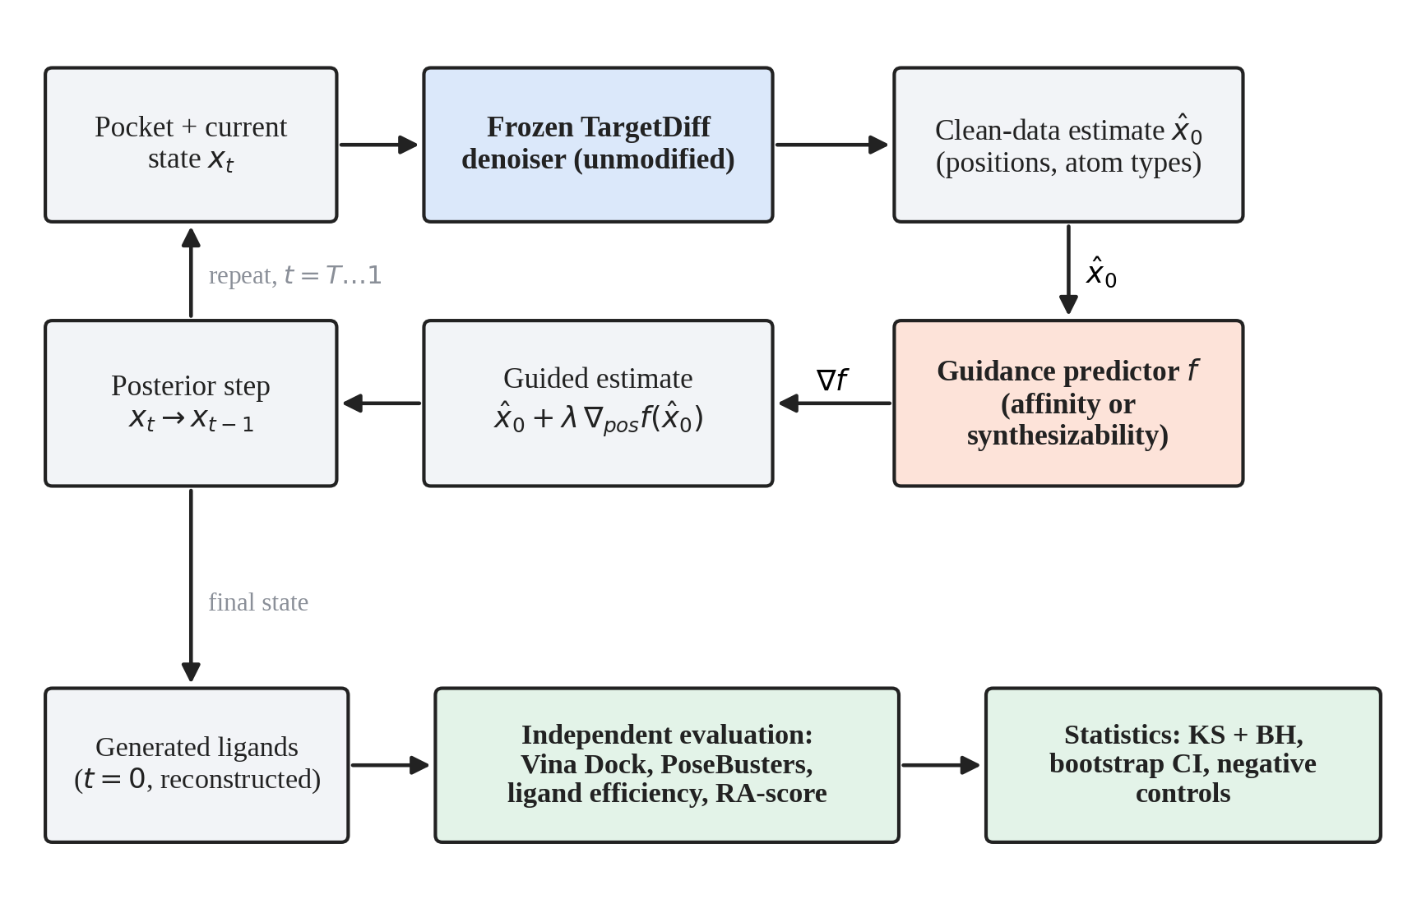
Figure 3.1 Overall pipeline. A frozen TargetDiff denoiser proposes a clean-data estimate at each reverse step; a guidance predictor's gradient with respect to atom positions modifies that estimate; and the finished molecules are evaluated by tools that are independent of the guidance predictor and analysed with corrected statistics.
III.1.1 Pre-registration status of each route
Not every route in this thesis carries the same evidentiary status, and the distinction matters for how its result should be read. Four categories are used throughout, and every analysis in this thesis belongs to exactly one of them. Pre-registered means a frozen, version-controlled document fixed the hypothesis, the primary metric, the decision thresholds and the stopping rule before any model of that route was trained; only Track E (Chapter VIII) meets this bar, and its amendments are logged, dated and never edited in place (Appendix D). Planned, not pre-registered means the decision bands, correction procedure and quality-degradation checks were declared in the project's working log before the results of that specific checkpoint were inspected, following the shared protocol of this chapter, but without a frozen external document; Tracks A, B, C and D, the baseline ablation of Chapter IV, and the gradient diagnostic of Section V.4 are of this kind. Post hoc means a question was formed after seeing a result and is reported as exploratory and uncorrected for multiple comparisons unless stated otherwise; this applies to specific, individually flagged analyses, such as the pocket-size correlation of Section VI.3 and the pooled Mann–Whitney check of Chapter IV. Appendix E follow-up means the analysis was conducted after Chapter IX's synthesis had been written and frozen, outside the decision sequence of Tracks A to E described below; it follows this project's general exploratory-then-confirmatory discipline (the two-tier protocol of Section III.1) but was not pre-registered, and it is reported in full as Appendix E with its own, explicitly dated chronology (Section E.1).
Table 3.1 makes explicit where a pass/fail gate was actually applied, since not every route had one. Tracks A to D were stopped or extended by the shared decision bands of Section III.6.3 (no comparison may be called a clear signal without surviving correction and the degradation checks), applied after each tier; no route was permitted to continue to a more expensive tier without first clearing this check. Track E additionally carried its own, pre-registered numerical gates, frozen before training (Appendix D). Appendix E's follow-up phase used the same confirm-before-reporting discipline as a working practice (no encouraging small-sample result was reported before a larger, confirmatory run) but applied no frozen stopping rule, because it was not pre-registered.
Table 3.1 Where a decision gate was applied, by route
Route | Gate type | Condition to continue or to declare a positive result | Consequence if not met
Baseline ablation (IV) | Shared decision bands (planned) | No significant Mann–Whitney/Wilcoxon shift; no PoseBusters/LE degradation | Verdict recorded as no signal; motivated Tracks A–D
Track A (V) | Shared decision bands (planned) | Exploratory tier's cost of the full tier was justified by its yellow-flag result; full tier itself gated by the same bands | Full tier was run; its own null stopped the route
Track B (V) | Shared decision bands (planned) | Same as above, applied per variant (B1–B3) | Each variant's null closed that variant; no further variants of the same kind were run
Track C (VI) | Shared decision bands (planned) + negative control | Scrambled-filter control must agree with the random-subset control | Disagreement would have been read as an implementation bug, not a result; it did not occur
Track D (VII) | Shared decision bands (planned) | Divergence at the exploratory scale must be resolved before the multi-pocket confirmation (step D.4) was run | Divergence persisted only partially; D.4 was explicitly skipped by this pre-declared rule
Track E (VIII) | Pre-registered numerical gate (C1a, then C4) | Point estimate and interval of the primary comparison must clear a stated margin; the gradient-distance gate C4 applies only if C1a passes | C1a's upper bounds excluded the required margin; E1 declared falsified at this scale; C4 and E2 were not run
Appendix E (post-synthesis) | Working discipline, not a frozen gate | Exploratory tier (n≈8) must be confirmed at larger n before being reported as a finding | Applied uniformly (e.g. the ESM2 and PLIP exploratory signals); no frozen pass/fail threshold existed to stop the phase itself

Table 3.2 summarises every route at a glance, including the follow-up investigation of Appendix E, with the predictor used, what was intervened on, the scale of evidence, the primary outcome metric, the correction applied, and the verdict. It is a map for the chapters that follow, not a substitute for them.
Table 3.2 Master summary of every experimental route, including the Appendix E follow-up
Route | Predictor | Intervention | Pockets / targets | Units per condition | Primary metric | Correction | Verdict
Baseline (IV) | Stage 0 EGNN | Guidance strength λ | 20 pockets; 8 pockets × 3 λ | 8–10 molecules | Vina Dock (Mann–Whitney, Wilcoxon) | Not explicitly corrected (pre-dates the KS/BH protocol below) | No effect at any tested λ
Track A (V) | GIGN + PIGNet2 | Predictor architecture | 8 pockets (full tier) | 29–30 molecules | Vina Dock (KS) | BH, 24 tests | 0/24 significant
Track B (V) | Stage 0 EGNN | Gradient scale (B1), objective (B2), timing (B3) | 2–3 pockets | 20 molecules | Vina Dock (KS) | BH, 23 tests | 0/23 significant
Diagnostic (V.4) | Stage 0 EGNN | None (read-only probe) | 3 pockets, 144 states | n/a | Gradient–distance correlation | Bootstrap CI only; no gate | +0.240, wrong direction
Track C (VI) | Stage 0 EGNN (as ranker) | Post-hoc top-10% selection | 15 pockets | ~590 molecules/pocket pool | Vina Dock, LE, PoseBusters (KS) | BH, 15 tests | Raw gain confounded by size
Track D (VII) | SynthPredNet | Synthesizability guidance | 1 pocket (powered tier) | 30 molecules | Independently computed RAscore (KS) | BH, 5 tests | 0/5 significant
Track E (VIII) | GIGN delta head | Training target (residual vs. Vina) | 127 test targets | n/a (predictor comparison) | Target-clustered R² | Pre-registered gate (bootstrap CI) | Falsified at this scale
Follow-up (App. E) | 8 further checkpoints (EGNN / GIGN variants) | 4 mechanism-level fixes, alone and combined, plus validation and a mechanistic trace | 1 fixed pocket + CDK6 (unseen family) + 835 (AlphaFold side-check) | 8–24 molecules per λ | Vina Dock, PLIP interactions, R² | Pooled BH, 48 tests | 0/48 significant
"n/a" marks routes that compare trained predictors on a held-out test set rather than generated molecules under guidance. The diagnostic of row 4 is not a guidance checkpoint and carried no pass/fail gate (Section V.4).

III.2 Data
III.2.1 CrossDocked2020 and the pocket representation
All generative sampling used the pretrained TargetDiff model, which was trained on the CrossDocked2020 data set [15], [20]. The processed data set used here is the pocket-cropped version of the original TargetDiff release (residues within 10 Å of the ligand; a stored ligand pose within 1 Å RMSD of the docked pose), held in a lightning memory-mapped database (LMDB) with 166,500 protein–ligand entries. The official split of that release assigns 99,990 pocket instances to training (1,905 unique targets) and 100 to testing (93 unique targets), with no target overlap between the two. Each entry stores protein atom positions and element/amino-acid identifiers, ligand atom positions, elements and bonds, and file names; it does not store residue indices or chains. Since the poses are cross-docking outputs [18], they were treated throughout as docked poses, not as experimental complexes.
III.2.2 Affinity labels
Experimental binding affinities were taken from the annotation file distributed with the same release, which contains 184,087 entries keyed by the ligand file name, of which 76,803 carry a non-zero pK. These are experimental pKd, pKi or pIC50 values derived from PDBbind, not docking scores, which excludes a possible form of label leakage in which training labels are computed with the same docking configuration that is later used for evaluation. The file also stores, for each pose, an RMSD value and a Vina-type score; the latter is used in Chapter VIII as the anchor of the residual target. Its semantics were examined explicitly (Section VIII.3).
III.2.3 Splits used for predictor training
Three target-level structures were used. The old split (the first version of the affinity predictor) took a random 90/10 division of pocket instances of the official training partition as training and validation sets, and the labelled officially-held-out pockets as the test set; this gave 6,000 training instances (507 targets, after a subsampling made necessary by the training time), 4,061 validation instances (456 targets) and only 27 test pockets (26 targets). Because validation and training shared 74% of their targets, validation measured interpolation within seen targets rather than transfer to a new target.
The leakage-safe (LP) split was constructed for this thesis by adapting the Leak Proof PDBBind procedure [30] to CrossDocked2020 at target granularity, so that all entries of a target move together. Targets were assigned to families using UniProt information; a small random test set was seeded per family and expanded with any target whose protein sequence identity exceeded 0.9, whose ligand similarity exceeded 0.99, or whose pocket-histogram cosine similarity exceeded 0.97 to a current test member; a validation set was formed analogously with a protein-identity threshold of 0.5; and any training target with ligand similarity above 0.99 to a validation or test target was discarded. The pocket-similarity threshold was recalibrated from the originally sketched 0.8 and 0.95, because an empirical check on 3,000 random target pairs showed that a 20-dimensional amino-acid-composition histogram is too coarse for two-tier thresholding (mean 0.69, 99.9th percentile 0.94 among unrelated pairs). The resulting split, restricted to entries with a non-zero pK and an RMSD below 2 Å (1,041 targets, 76,803 entries), is summarised in Table 3.3.
Table 3.3 Data splits used for affinity predictors
Split | Train (targets / entries) | Validation | Test | Comment
Old split | 507 / 6,000 | 456 / 4,061 | 26 / 27 | Validation shares 74% of targets with training
LP split | 779 / 46,964 | 65 / 6,069 | 127 / 11,855 | Target-disjoint; 31 targets discarded
Synthesizability (LP-derived) | 8,835 entries | 1,015 | 1,940 | 3,210 of 15,000 discarded (target not assigned)
Entries are complexes (pocket–ligand pairs). Test-set statistics in Chapters VIII use the 127 test targets as the resampling unit.

III.2.4 Synthesizability labels
Synthesizability labels were obtained by computing the RAscore [43] of 15,000 ligands of the training partition, giving a target in [0, 1]. The original random 90/10 split of these labels had no held-out test set and no leakage check; it was replaced (Chapter VII) by the target-level assignment of the LP split, applied by target identity without recomputing any label.
III.3 Generative Model and Guidance Mechanism
III.3.1 The frozen diffusion model
The generator was the pretrained TargetDiff checkpoint [20], used without modification. It models ligand atom coordinates and 13 atom-type classes (atomic number and aromaticity pairs) over 1,000 diffusion steps, conditioned on the pocket. Bonds are not modelled: they are assigned after sampling by a reconstruction procedure that turns coordinates and types into a molecule. The number of ligand atoms is drawn from a prior before sampling begins and is therefore fixed for the whole trajectory.
III.3.2 Guidance on the clean-data estimate
The guidance loop re-implements the reverse sampling step so that the pretrained model and its posterior functions are used unchanged, and a guidance term is added to the clean-data estimate before the posterior step. Denoting the estimate by x̂₀, the guided estimate is
\\hat{x}_0' = \\hat{x}_0 + \\lambda \\nabla_{pos} f(\\hat{x}_0) (3.1)
where f is the guidance predictor and λ the guidance strength. With λ = 0 the loop performs exactly the same computation as the unguided sampler (verified against the original implementation, up to the non-determinism of GPU scatter operations, which already makes two calls of the original sampler with the same seed differ at the level of 10⁻⁶). The equation above was written with the gradient taken only through the guidance predictor and not through the diffusion network, which is a deliberate compute trade-off on a 4 GB GPU: back-propagation through the denoiser at each of 1,000 steps would multiply memory and runtime by roughly the depth of the network. Consequently, the guidance predictors are trained on clean ligand structures and evaluated on x̂₀, which are the conditions under which the literature reports the mismatch problem for noisy intermediate structures [22]. Two further scope decisions were made and are disclosed. First, guidance acts on positions only; the gradient with respect to atom types is set to zero, because the predictors use bond-derived features (degree, hydrogen count and hybridisation) that do not exist during sampling. These fields were filled with a fixed placeholder for the affinity predictors, and an alternative, differentiable bond-aware estimate was tested for the synthesizability predictor (Chapter VII). Second, guidance can be restricted to a window of diffusion steps, and the gradient can be rescaled to unit norm per atom before λ is applied; both are used only in the Track B variants.
III.4 Predictors
Table 3.4 summarises the predictors. All were trained on clean structures with mean-squared-error (regression) or cross-entropy (classification) objectives and selected by validation loss.
Table 3.4 Predictors used as guidance signals or ranking functions
Predictor | Architecture | Parameters | Training set | Held-out test result
Stage 0 EGNN (affinity) | 6-layer EGNN, hidden 256, 48 nearest neighbours, 10 Å cut-off, MSE | 2.55 M | LP split, 6,000-entry subsample | R² 0.342, Pearson 0.609 (n = 11,855)
GIGN + PIGNet2 (affinity) | 3 GIGN interaction layers, PIGNet2 physics readout, hidden 256 | 0.49 M | LP split, all 46,964 | R² −0.189, Pearson 0.581 (n = 11,855)
Classifier head (affinity) | Linear head on frozen Stage 0 embedding | Head only | Median-binarised pK (7.03) | AUROC 0.677 (test)
SynthPredNet (RA-score) | Ligand-only EGNN, sigmoid output | 0.43 M | LP-derived, 8,835 entries | R² 0.414, Pearson 0.647 (n = 1,940)
Reference-model details are reproduced in the chapters of the corresponding tracks. Parameter counts are those printed in the training logs.

The Stage 0 EGNN is the affinity predictor of the project's original guidance implementation, an E(n)-equivariant network [39] applied to the pocket–ligand point cloud, with a scatter-sum readout and an MLP head. It was trained with Adam (learning rate 10⁻⁴), batch size 1, a Gaussian position noise of 0.1 Å, and a plateau learning-rate scheduler with early stopping; the same configuration was retrained, unchanged, on the LP split, which defines the Stage 0 checkpoint. The GIGN + PIGNet2 predictor combines the heterogeneous interaction layers of GIGN [52], in which covalent (or covalent-proxy) and non-covalent edges share one message pass and are differentiated by separate MLPs, with the physics-decomposed readout of PIGNet [34]: pairwise Morse-type van der Waals, hydrogen-bond, metal and hydrophobic terms between ligand and protein atoms are summed to the prediction. Protein covalent edges, which are not available in the LMDB, were approximated by a distance cut-off. The classifier head is a linear head fitted on the pooled embedding of the frozen Stage 0 network for the task of predicting whether the pK is above the median of the training set; its gradient log p(y = 1 | x) is the classical classifier-guidance target [9]. SynthPredNet is a ligand-only EGNN that regresses the RAscore; it has no protein input.
III.5 Evaluation Metrics
Guidance effects were never evaluated with the guidance predictor's own output. Every generated molecule was reconstructed and, when valid, evaluated as summarised in Table 3.5.
Table 3.5 Independent evaluation metrics
Metric | Definition | Direction
Vina Dock | AutoDock Vina 1.2.6 [10] re-docking against the real receptor of the pocket, exhaustiveness 8 or 16 (kcal/mol) | Lower is better
Ligand efficiency (LE) | Vina Dock divided by the number of heavy atoms | Lower is better
PoseBusters validity | Fraction of poses passing the PoseBusters checks [6] in docking configuration | Higher is better
RA-score | Independently computed RAscore model [43] applied to the reconstructed molecule | Higher is better
QED, SA score | Drug-likeness; synthetic accessibility [13] rescaled to [0, 1] following the TargetDiff evaluation code | Higher is better
Validity, uniqueness, diversity | Fraction reconstructable; fraction unique; mean 1 − Tanimoto (Morgan radius 2, 1,024 bits) | Higher is better
Standard success | Vina Dock < −8.18, QED > 0.25 and SA > 0.59 | Higher is better
Honest success | Standard success, additionally PoseBusters-valid with LE within a stated tolerance of the reference ligand | Higher is better

The receptor files used for docking were coordinate-matched to the processed data (Chapter IV describes an incident in which files from a different mirror produced meaningless scores). Ligand efficiency and the heavy-atom count were computed in every experiment because raw Vina scores can be improved mechanically by enlarging molecules [18], [50]; PoseBusters validity was computed because a favourable score can be obtained from physically implausible poses [6]; and the RAscore was computed with the reference implementation, independently of the guidance model's own approximation.
III.6 Statistical Protocol
III.6.1 Tests, corrections and intervals
The primary test of a guidance effect was the two-sample Kolmogorov–Smirnov (KS) test of the Vina Dock distribution of guided versus unguided molecules within a pocket. For every checkpoint, all tests of that checkpoint were corrected together with the Benjamini–Hochberg (BH) procedure for the false discovery rate [4]. Effect sizes were reported with 95% confidence intervals obtained by case-resampling bootstrap [11] with 2,000 resamples, and the median shift was reported alongside the mean, because a single pathological pose can dominate a mean (an example, a Vina Dock of +286.58 kcal/mol from a malformed pose, is documented in Chapter V). Mann–Whitney U tests (unpaired) and Wilcoxon signed-rank tests (paired by pocket) were used in the earlier ablations. Correlations were Pearson or Spearman with bootstrap intervals; partial correlations were computed by linear residualisation.
III.6.2 What is shared and what is independent across a comparison
Two different designs are used in this thesis, and they are not interchangeable. In the independent-sample design, used for the KS tests above, each molecule of the guided condition and each molecule of the unguided condition is sampled from its own, separately drawn initial noise; nothing is shared between the two groups beyond the pocket and the model, and the two samples are treated as independent draws from their respective distributions. In the paired design, used for the Wilcoxon signed-rank tests of Track B, the gradient-alignment trace of Section E.5, and several of the n = 8 exploratory tiers of Appendix E, the same initial noise (the same random seed, consumed in the same order) is reused across every λ value of a given pocket, so that a guided and an unguided molecule at that position in the sequence begin from bit-identical noise and encounter the same per-step stochastic draws up to the first point at which guidance is applied; only the guidance intervention itself then differs between the paired molecules. This is why the two trajectories of the mechanistic trace (Appendix E.5) are described as diverging "only through the guidance nudge": nothing else differs between them by construction. Pairing is appropriate here because it removes the between-sample noise contributed by independently drawn initial positions and step noise, which is the dominant source of variance at the small n of the exploratory tiers, leaving the guidance effect as the main remaining source of a paired difference; it is reported as a Wilcoxon signed-rank test, not a paired t-test, because the shift is not assumed to be normally distributed. Different pockets, and different seeds within the same pocket in a multi-seed design (Track C, Track E), are independent of one another; pairing is never used across pockets or across seeds, only across λ within one seed of one pocket.
III.6.3 Decision bands and negative controls
Each comparison was assigned one of five verdicts by pre-declared rules (Figure 3.2): no signal (fails BH correction); signal, wrong direction; signal but confounded by size (ligand-efficiency degradation surviving BH correction, or a significant heavy-atom shift); signal but quality degraded (PoseBusters validity dropping by more than 10 percentage points); and clear signal. A verdict of suspect implementation bug was assigned if a scrambled-filter negative control disagreed with a random-subset control (Track C). Because a scrambled top-k selection is mathematically equivalent to a random subset, this control is an implementation sanity check and not an independent hypothesis test.
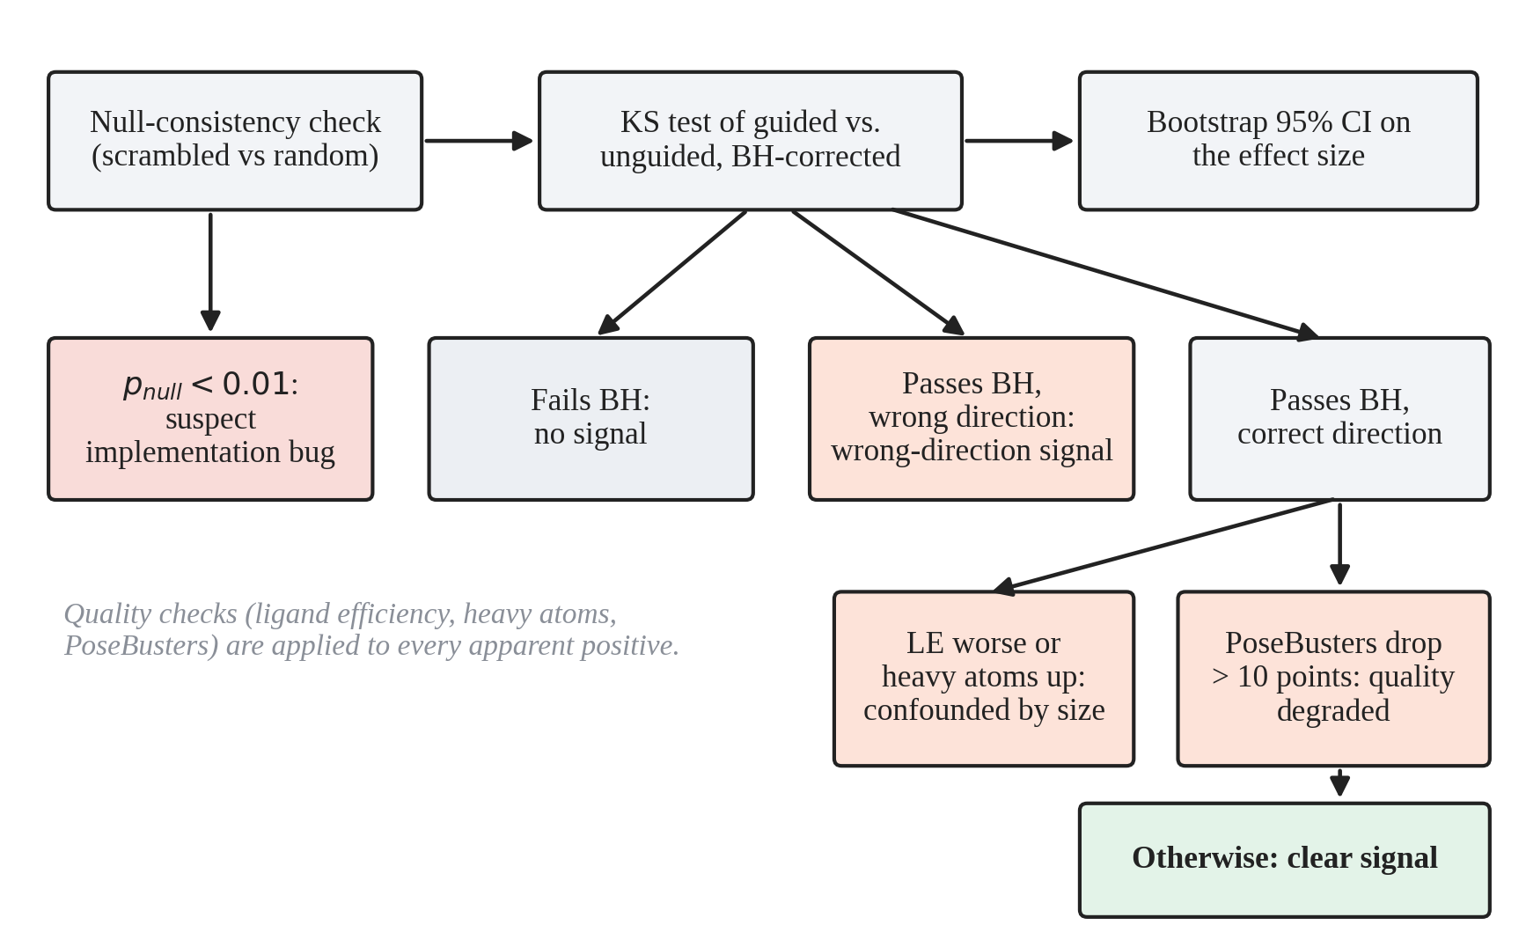
Figure 3.2 Decision logic applied to each comparison. The null-consistency check guards against implementation errors; the ligand-efficiency, heavy-atom and PoseBusters checks are applied to every apparent positive before it may be called a clear signal.
III.6.4 A note on the wording of null results
This thesis uses five distinct phrases for a comparison that did not support a positive claim, and they are not interchangeable. No significant effect is the narrowest and most frequent: a specific test did not survive the stated correction at the stated sample size, and nothing is implied about effects of a different size or at a different scale. No evidence of an effect is used when several such tests are taken together (for example, across an entire checkpoint or phase) and none of them individually or in combination supports a positive claim. No effect of practical size is reserved for cases in which a power calculation (Section V.1, Figure 9.2) bounds the effect that could have been missed, so the claim is about magnitude and not only about significance. Failed criterion or failed its pre-declared criterion is used for a route governed by explicit decision bands (Section III.1.1) that did not clear them, independently of whether a numerical test was involved. Falsified at this scale is reserved for Track E, the one route with a pre-registered numerical margin (Appendix D): it means the pre-declared rule was applied exactly as written and returned a negative verdict, not merely that a result failed to reach significance. None of these phrases is used to claim that no effect exists under conditions that were not tested; that distinction is kept explicit throughout and restated in Chapter X.
III.6.5 Units of analysis
This thesis reports counts at several different levels, and conflating them would misstate the amount of independent evidence behind a number. From smallest to largest: an atom is one position in one molecule, the unit of the gradient diagnostics (Section V.4, Section VII.4) and of the mechanistic trace (Appendix E.5); a molecule is one sampled, reconstructed ligand, the unit that a per-condition count such as "n = 30 molecules" refers to, and molecules from the same condition and pocket are not independent of one another in the strict sense when they share initial noise under the paired design of Section III.6.2, only across conditions; a complex is one protein-ligand pair in a training or test set, the unit of Table 3.3 and of the predictor-quality tables of Chapters IV, V and VIII; a pocket or target is one protein binding site, the unit that a KS test or a target-clustered bootstrap resamples, and is the appropriate independent unit whenever several complexes or molecules of the same pocket are compared, because within-pocket observations share the receptor and are not independent; a seed indexes one full, independent repetition of a stochastic procedure (sampling, or training) with different random initialisation, and is the unit that bounds the variance not captured by resampling a fixed set of results; and a statistical comparison (a row of Table C.1, for example) is one test, the unit that a multiple-comparison correction is applied across. Table 3.6 states, for every route, which of these levels was treated as the independent replication unit for its primary test, and how many seeds were used.
Table 3.6 Unit of analysis and seed count, by route
Route | Statistical / replication unit | Molecules or complexes per unit | Seeds
Baseline ablation (IV) | Pocket | 8–10 | 1 (strength sweeps); 3 (Task F)
Track A (V) | Pocket | 20 (exploratory); 29–30 (full tier) | 1
Track B (V) | Pocket | 20 | 1 (paired across λ within a pocket)
Diagnostic (V.4, VII.4) | Captured state (pocket × timestep × sample) | n/a (144 states total) | n/a (read-only probe, no training)
Track C (VI) | Pocket | ~590 pool members | 2 (combined per pocket)
Track D (VII) | Pocket | 8 (original); 30 (leakage-safe) | 1 (paired across λ)
Track E (VIII) | Target (127 test targets; complexes within a target are not independent) | n/a (predictor comparison, not generated molecules) | 3 per arm (plus 2 extra EGNN seeds)
Follow-up (App. E) | Pocket (1 fixed); target (CDK6 unseen family; 835 for the AlphaFold side-check) | 8 (exploratory); 16–24 (confirmatory) | 1 (paired across λ within a tier)
"n/a" marks a row for which the concept does not apply (the diagnostic captures states, not molecules; Track E compares predictors on an existing test set rather than molecules it generated). A single seed per λ-sweep does not mean a single molecule: it means the molecules within that sweep share one initial-noise draw per the paired design of Section III.6.2, while the sweep itself is not independently repeated.

III.6.6 Target-clustered statistics for predictor comparisons
For comparisons of predictors on the LP test set (Chapter VIII), the independent unit was the target and not the complex, since complexes of one target are strongly dependent. Confidence intervals were obtained by resampling the 127 test targets with replacement (2,000 resamples, fixed seed), and paired differences between two predictors were computed inside each resample so that shared sampling noise cancels. For predictors trained with several seeds, the value of an arm inside a resample was the mean over its seeds. One-sided p-values were BH-adjusted over the tests of a stage, and intervals were reported at 90, 95 and 99%. This resampling unit produces intervals that are several times wider than complex-level bootstrap intervals; the difference is quantified in Chapter VIII.
III.7 Computing Environment and Engineering
All experiments ran on a single laptop with an RTX 3050 GPU (4 GB), a 20-thread CPU and 31 GB of RAM. Long runs were made resumable: sampling and docking jobs wrote one result directory per (variant, pocket, seed) unit and could be restarted after a shutdown, which occurred and was recovered from without loss during the Task F run; the Track E trainers additionally wrote atomic, mid-epoch checkpoints and handled termination signals (Chapter VIII). Two optimisations were adopted for the largest run (Track C) after their effect on quality had been checked: bf16 automatic mixed precision for the diffusion core's forward pass only (about 14% faster sampling, with a shift of the Vina Dock mean of 0.1–0.13 kcal/mol, within the run-to-run variation between two fp32 baselines), and docking of two molecules in parallel processes (about twice as fast). Increasing the sampling batch size gave only about 3% higher throughput, and `torch.compile` was not attempted because of the risk of graph breaks in the conditional sampling loop. Together the two adopted changes reduced the per-pool time from about 5.75 h to about 4.6 h.
III.8 Integrity Checks
Several checks were made part of the method because they had changed conclusions during the project. (i) Leakage. Before any retraining, the target identifiers of the 20 pockets of the guidance ablation were compared with the training and validation index sets of the affinity model, and the intersection was empty; the labels were verified to be experimental affinities and not docking scores. A coarse gene-symbol check found one coincidental mnemonic match between unrelated proteins; because no sequence-level clustering was available at that time, a bill of health at the fold-family level was not asserted, and the LP split was later built precisely to close that gap. (ii) Coordinate frames. An early attempt that used receptor files from a different data mirror produced meaningless zero-interaction docking scores because of a coordinate-frame mismatch; it was caught in a dry run and the coordinate-matched files were used. (iii) Outliers. A single pathological docking score was investigated and shown to be a genuine, if degenerate, outcome and not a sentinel value (Chapter V). (iv) Analysis errors. An exploratory analysis that truncated a pooled sample to its first 300 molecules gave a wrong conclusion and was corrected by re-deriving the numbers from a saved script (Chapter VI). (v) Checkpoint selection. All trainers select checkpoints by validation criteria. The Stage 0, Track A and synthesizability trainers also compute and log test metrics at every validation improvement, so that test numbers were visible during development, although they were not used for selection; the Track E trainers evaluate the test set once, after training, and this is enforced by an automated test (Chapter VIII). One older hyper-parameter sweep labelled a configuration as best on the basis of its test metrics (27 pockets), and this configuration was reused in a learning-curve diagnostic; it was not used for any deployed or guidance model, and the diagnostic is read with that caveat (Chapter IV).

CHAPTER IV
AFFINITY PREDICTOR QUALITY, THE SPLIT ARTEFACT AND BASELINE GUIDANCE ABLATIONS
This chapter reports the first phase of the experimental work. It starts with the affinity predictor of the original guidance implementation, shows that its poor held-out quality was investigated through a leakage audit, a hyper-parameter sweep and five diagnostics, and then shows that most of the apparent generalisation gap was caused by the way the data had been split. After the predictor had been repaired in this sense, the first guidance ablations were run, on the original and on the repaired predictor. All of them returned null results, which motivated the routes reported in Chapters V to VIII.
IV.1 The Original Affinity Predictor
IV.1.1 Training set-up
The first guidance predictor was the Stage 0 EGNN architecture of Table 3.4, trained to regress the experimental pK of a pocket–ligand pair from the docked pose. Training used the official CrossDocked2020 training partition with a random 90/10 division of pocket instances into training and validation sets, a random subsample of 6,000 training instances (507 targets) because of the training time on a 4 GB GPU, and the 27 labelled pockets of the official test partition as the held-out test set (26 targets, disjoint from training). The label distributions were similar (training 6.76 ± 1.84, validation 6.85 ± 1.89, test 5.71 ± 1.81 pK units), although the test mean was lower. Training was run for at most 20 epochs with early stopping, and the checkpoint of the last epoch, which had the lowest validation loss (1.375), was deployed.
IV.1.2 Held-out quality
The validation and test results of the deployed predictor differed strongly (Table 4.1). Validation Pearson correlation rose steadily to 0.79, whereas test Pearson correlation fluctuated between 0.12 and 0.39 with no trend, and test R² was negative at every logged epoch, meaning that the predictions were worse than always predicting the training mean. The deployed checkpoint was not even the best on the test set: the highest test correlation (0.386) was recorded at epoch 3, which was not a running-best validation epoch.
Table 4.1 Old split: validation and test quality of the affinity EGNN at selected epochs
Epoch | Val Pearson | Val R² | Test Pearson | Test Spearman | Test R² | Test RMSE (pK)
3 | n/a | n/a | 0.386 | 0.321 | −0.454 | 2.188
5 | 0.682 | 0.452 | 0.315 | 0.237 | −0.401 | 2.148
10 | 0.745 | 0.548 | 0.381 | 0.313 | −0.161 | 1.955
15 | 0.768 | 0.590 | 0.121 | 0.150 | −0.797 | 2.433
19 | 0.795 | 0.616 | 0.327 | 0.304 | −0.275 | 2.049
20 (deployed) | 0.788 | 0.616 | 0.233 | 0.141 | −0.537 | 2.250
Validation n = 4,061 pocket instances; test n = 27 pockets. Only epochs at which the validation loss improved were logged. Test metrics were logged during training but were not used for checkpoint selection.

The disagreement between validation and test had a structural explanation that was recognised at this point. Because the validation set was a random division of pocket instances, and CrossDocked2020 contains many poses of each target, the validation set shared 74% of its targets with the training set (507 training targets and 456 validation targets drawn from one pool of about 1,900 targets). The validation loss therefore measured interpolation among poses of partly seen targets, whereas guidance requires transfer to an unseen pocket, which only the test set measured. With 27 test pockets, however, the test numbers themselves carried large sampling uncertainty.
IV.2 Leakage and Coverage Audit
Before any retraining, it was checked whether the near-zero test quality, or the later null guidance results, could be explained by leakage. The audit found the following.
(i) Pocket level: the 20 target identifiers of the guidance ablation of Section IV.5 were compared with the training and validation index sets rebuilt with the true training seed, and no target was shared. Seven of these 20 targets were, however, members of the 27-pocket test set of the predictor, for which metrics (not gradients) had been computed during training; this is disclosed because it is relevant for a strict reading of "independent test".
(ii) Label provenance: the labels were experimental pKd, pKi and pIC50 values, not docking scores. This rules out the subtler leakage in which a predictor is trained on labels produced by the same docking configuration that is later used for evaluation.
(iii) Family level: only a coarse gene-symbol comparison was possible at that time. One coincidental match was found between two proteins with the same four-letter mnemonic but different organisms and folds. Because no sequence-identity clustering was available, the audit did not claim the absence of leakage at the fold-family level. The leakage-safe split of Section IV.4 was built to close this gap.
(iv) Coverage: 76,803 of the 184,087 annotated entries had a non-zero pK. The training subsample was wide but shallow, with about 11.8 examples per target.
The audit therefore found no disqualifying leakage in the sense of the guidance evaluation, and it directed the investigation toward generalisation.
IV.3 Hyper-Parameter Sweep and Diagnostics on the Old Split
IV.3.1 Learning rate and depth
A light sweep varied the learning rate and the depth of the EGNN, with all other settings, the data and the seed held fixed, and with a full 20-epoch budget per configuration (Table 4.2). Lowering the learning rate to 3 × 10⁻⁵ gave the only configuration with a positive test R² (0.046) and a clearly better test correlation (0.538) than the deployed configuration (0.233). A shallower, four-layer network had the best validation quality of all four configurations (Pearson 0.806) and the worst test quality (0.119), an illustration of how validation loss on shared-target data can select for models that transfer worse.
Table 4.2 Old split: learning-rate and depth sweep (validation n = 4,061, test n = 27 pockets)
Configuration | Val Pearson | Val R² | Test Pearson | Test R² | Test RMSE (pK)
Baseline (lr 1e-4, 6 layers; deployed) | 0.788 | 0.616 | 0.233 | −0.537 | 2.250
lr 3e-5, 6 layers | 0.803 | 0.628 | 0.538 | 0.046 | 1.772
lr 3e-4, 6 layers | 0.727 | 0.523 | 0.272 | −0.442 | 2.179
lr 1e-4, 4 layers | 0.806 | 0.641 | 0.119 | −0.671 | 2.346
The best configuration was labelled as such on the basis of its test metrics, so its test performance is optimistic; it was used only in the learning-curve diagnostic below and was not deployed as a guidance model.

The improvement must, however, be read with the bootstrap intervals for n = 27. The 95% intervals of the test R² of the best configuration (−0.601 to 0.445) and of the deployed configuration (−1.769 to 0.183) overlapped, so a positive R² could not be claimed. The correlation intervals were more informative: 0.230 to 0.775 for the best configuration, which excludes zero, and −0.145 to 0.595 for the deployed one.
IV.3.2 Five diagnostics
Five diagnostics were applied to characterise the gap (Table 4.3).
Table 4.3 Old split: diagnostics of the generalisation gap
Diagnostic | Result | Reading
Ligand-only baseline (ECFP4, no protein) | Random forest: test Pearson 0.493, R² 0.047; ridge: 0.427, −0.769 | A model without the pocket matches the best EGNN (0.538, 0.046)
Heavy-atom count vs. prediction | Pearson 0.799 (p < 0.001, n = 27) | Much of the prediction is explained by ligand size
Pocket scrambling (20 pairs) | Mean change of 1.49 pK units (SD of predictions 1.77) | The model reacts to the pocket, without evidence of benefit from it
Per-target error | 26 of 26 groups are singletons | No per-target correlation computable; inconclusive
Learning curve (25/50/75/100% of targets) | Pearson 0.298, 0.305, 0.296, 0.538 (CIs overlap) | Too imprecise to resolve whether more targets help
The learning curve used 127, 254, 380 and 507 targets with the configuration lr 3e-5. All intervals overlapped with their neighbours.

Two readings are supported by these diagnostics. First, on this split, a representation without any protein information was indistinguishable from the pocket-aware network, so the gap was not specific to the EGNN. Second, the predictions correlated strongly with the ligand's heavy-atom count, the same kind of shortcut that is known to inflate docking scores of generated molecules [18], [50]. A third possible reading, that more training data would close the gap, was not confirmed: the learning curve was flat between 25 and 75% of the targets and rose only at 100%, but the four intervals overlapped, so the test set with 27 pockets was too small to resolve this question. At this point the investigation concluded that the gap was more consistent with data scarcity and superficial features than with an architecture flaw. This conclusion was revised in the next section.
IV.4 The Split Artefact: Leakage-Safe Re-Evaluation
IV.4.1 Construction of the split
The diagnostics above had been obtained on a split in which the validation set overlapped with the training set by target and the test set contained only 27 pockets. To repeat the evaluation under a defensible protocol, the target-level leakage-safe (LP) split described in Section III.2.3 was constructed. Two calibration problems were found and repaired during its construction: a rule that seeded the test set had to be bounded to avoid its runaway growth, and a ligand-identity overlap between validation and test that had passed the original algorithm was removed by an explicit check. The final split had 779 training targets (46,964 entries), 65 validation targets (6,069 entries) and 127 test targets (11,855 entries), with 31 targets discarded for ligand contamination and verified zero target overlap between any two subsets.
IV.4.2 Result
The Stage 0 EGNN configuration was retrained on this split without changing any architecture or hyper-parameter (6,000-entry training subsample, learning rate 10⁻⁴; best validation loss at epoch 4, early stopping after epoch 9). On the 11,855 test entries it reached a Pearson correlation of 0.609 (95% CI 0.597 to 0.621) and R² of 0.342 (0.322 to 0.361), as shown in Table 4.4 and Figure 4.1. A ligand-only random forest reached R² 0.195, so on the repaired split, the pocket-aware model had a nominal advantage over the ligand-only baseline, opposite to the pattern on the old split (this difference was not tested pairwise, and the complex-level interval is optimistic; see Chapter VIII). The correlation of the predictions with the heavy-atom count decreased modestly, from 0.799 to 0.719, and remained strong.
Table 4.4 Stage 0 checkpoint on the leakage-safe split (test n = 11,855)
Model | Val Pearson | Val R² | Test Pearson (95% CI) | Test R² (95% CI)
Ligand-only ridge | 0.274 | −0.689 | 0.375 | −0.602
Ligand-only random forest | 0.405 | 0.123 | 0.462 | 0.195
EGNN (lr 1e-4, 6 layers, unchanged) | 0.637 | 0.394 | 0.609 (0.597, 0.621) | 0.342 (0.322, 0.361)

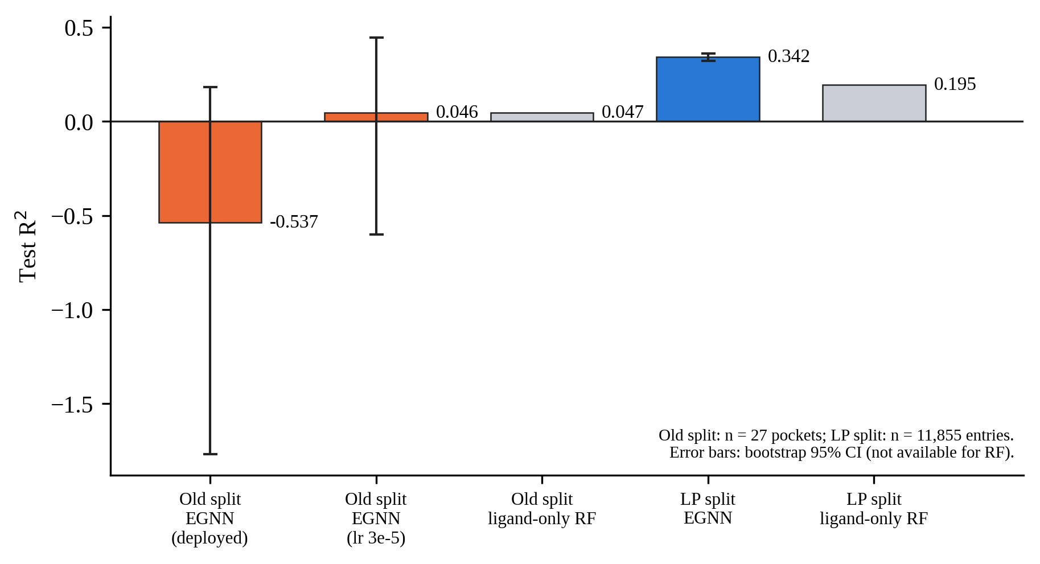
Figure 4.1 Test R² of the affinity predictor on the old split (n = 27 pockets) and on the leakage-safe split (n = 11,855 entries). Ligand-only random forests are shown in grey. Error bars are bootstrap 95% confidence intervals where available.
This result contradicted the expectation stated when the split was built, namely that the split alone would not repair the model, and it contradicted the reading of the previous section. It is reported as such. A substantial part of the earlier gap was a consequence of the split construction (target-overlapping validation data and a 27-pocket test set), and not of the EGNN architecture or an unavoidable data limit. The earlier diagnostics were correct as measurements on that split, but the causal story built upon them was answering the wrong question. Two limits of this conclusion should be noted. The comparison is between models evaluated on different test sets, so the two R² values are not paired estimates; and the size shortcut (correlation 0.719) is still present, so a better-than-baseline predictor is not the same as a predictor that has learned binding chemistry.
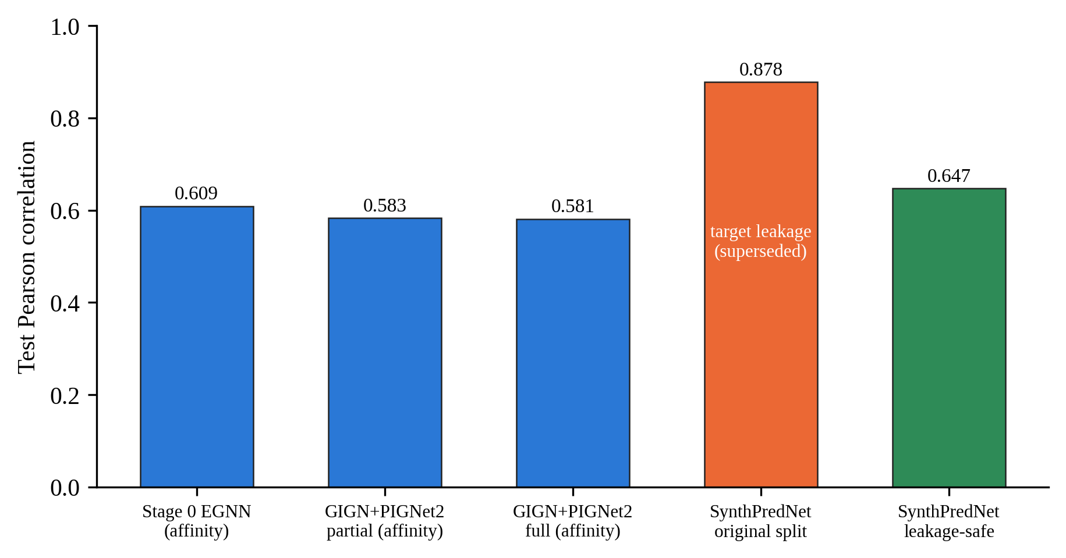
Figure 4.2 Test Pearson correlation of every guidance predictor trained in this thesis on the leakage-safe splits. The synthesizability predictor evaluated on its original random split (orange), which had no target-level separation and no test set, was superseded by the leakage-safe evaluation (green; Chapter VII).
IV.5 Baseline Guidance Ablations
IV.5.1 Task F: the original ablation
The first guidance ablation compared unguided sampling with affinity-guided sampling, with the original predictor at λ = 1.0. It used 20 of the 100 official test pockets (every fifth pocket in the official order, with one substitution because a receptor file was missing from the data mirror), each from a distinct protein family, 3 seeds and 10 molecules per (variant, pocket, seed), giving 1,193 scored molecules (597 unguided and 596 guided; 0 failed runs). Docking used AutoDock Vina with exhaustiveness 16 against coordinate-matched receptors; an earlier attempt with receptor files from a different data mirror had produced meaningless zero-interaction scores because of a coordinate-frame mismatch, and was caught in a dry run. The value λ = 1.0 had been chosen in an earlier single-pocket sweep because it was the strongest tested value that left validity unaffected.
No metric differed significantly between the variants (Table 4.5); all p-values were above 0.27 and most above 0.6, for both the pooled Mann–Whitney test and the Wilcoxon test paired by pocket (n = 20). The standard deviation of the unguided Vina Dock (10.08 kcal/mol) was four times that of the guided condition (2.41), which indicated a heavy-tailed distribution produced by a few extreme poses; the paired test, which is more robust to such outliers, agreed with the unpaired test. The numerically lower guided mean Vina Dock (−7.25 against −6.81 kcal/mol) was not distinguishable from noise (p = 0.96 unpaired, 0.55 paired), and the ligand efficiency did not worsen (−0.372 against −0.340), so no signature of Vina hacking [18] was found. Because there was no significant gain, there was also no gain to be tested for authenticity.
Table 4.5 Task F: unguided versus affinity-guided sampling (λ = 1.0), 20 pockets
Metric | Unguided | Guided | Mann–Whitney p | Wilcoxon (paired) p
Validity rate | 0.995 | 0.993 | n/a | n/a
QED | 0.449 ± 0.185 | 0.452 ± 0.185 | 0.889 | 0.648
SA score | 0.601 ± 0.122 | 0.600 ± 0.121 | 0.798 | 0.277
RA-score | 0.435 ± 0.386 | 0.429 ± 0.387 | 0.816 | 0.312
Vina Dock (kcal/mol) | −6.813 ± 10.079 | −7.251 ± 2.409 | 0.961 | 0.546
Ligand efficiency | −0.340 ± 0.749 | −0.372 ± 0.109 | 0.956 | 0.330
PoseBusters pass rate | 0.551 | 0.545 | n/a | n/a
Standard success rate | 0.0704 | 0.0705 | n/a | n/a
Honest success rate | 0.0302 | 0.0268 | n/a | n/a
Values are means ± standard deviations over molecules. The dual-guidance configuration was identical to the affinity-only variant because the synthesizability weight had been set to zero after the finding reported in Chapter VII.

IV.5.2 Strength re-sweep with the original predictor
Two explanations were considered for the null result: that λ = 1.0 was too weak, or that the predictor's gradient carried no useful signal. The first was tested by docking molecules generated at nine values of λ between 1 and 30 on the bundled example pocket (n = 8 per value). Fragmentation of the molecules started between λ = 20 and λ = 30 (50% single-fragment rate at λ = 30), which defined 20 as the practical safety ceiling. Within the safe range, no comparison with λ = 1.0 was significant (Mann–Whitney p between 0.79 and 1.00 for all eight comparisons), and the mean Vina Dock moved non-monotonically within a band of about 2 kcal/mol. The predictor's own score rose by only about 1.2% across the range, and this drift did not correspond to any trend in independent Vina Dock. The first explanation was therefore refuted, and the null result was not an artefact of an overly conservative operating point.
IV.5.3 Strength re-sweep with the repaired predictor
The same question was asked again after the repair of Section IV.4, because the improved predictor could have been expected to change the result. The sweep covered eight values of λ from 0 to 100, with n = 8 molecules per value. Robustness improved markedly: fragmentation appeared only at λ = 100 (one of eight molecules), against λ = 30 for the original predictor. The independent Vina Dock, however, showed no dose–response (Table 4.6); the comparison of each value against unguided sampling had p between 0.69 and 1.00.
Table 4.6 Repaired predictor: single-pocket strength sweep (n = 8 per value)
λ | Single-fragment rate | Mean own score | Mean Vina Dock (kcal/mol) | SD
0 (unguided) | 1.00 | 7.891 | −10.500 | 1.411
0.1 | 1.00 | 7.904 | −10.370 | 1.562
0.3 | 1.00 | 7.904 | −10.427 | 1.490
1.0 | 1.00 | 7.904 | −10.503 | 1.353
3.0 | 1.00 | 7.901 | −10.689 | 1.438
10.0 | 1.00 | 7.893 | −10.495 | 1.115
30.0 | 1.00 | 7.914 | −10.503 | 1.393
100.0 | 0.875 | 7.993 | −10.715 | 0.834
Mann–Whitney U tests against λ = 0: p ≥ 0.69 for every value.

A confirmation over eight diverse pockets (one seed, n = 8 per condition, λ = 0.3, 10 and 100, independent Vina docking with exhaustiveness 16, 32 runs and no failure) gave all 24 pocket-level comparisons as non-significant (p from 0.105 to 1.000). A paired-by-pocket Wilcoxon test at λ = 0.3 reached nominal significance (p = 0.023), but the effect was a consistent, tiny, wrong-directed shift (+0.030 kcal/mol, that is, slightly worse binding under guidance; seven of eight pockets shifting by +0.01 to +0.055), an order of magnitude below the typical per-molecule standard deviation of 1.1–1.6 kcal/mol. With six primary tests, one nominal p < 0.05 is expected by chance, and the other two λ values showed no pattern (p = 0.547 and 0.742). It was reported for completeness, and was not treated as evidence that guidance works.
IV.6 Summary of the Chapter
Three results of this chapter carry forward. First, an apparent generalisation gap of the affinity predictor was in large part a split artefact: after moving to a target-disjoint split of adequate size, the same architecture explained 34% of test variance (Figure 4.2), with an interval that excluded zero and a nominal margin over a ligand-only baseline (0.20). Both statements rest on complex-level resampling, and Chapter VIII shows that target-level resampling widens the interval about eight times and makes the network indistinguishable from a two-feature linear baseline. Second, the size shortcut remained (correlation 0.72 with heavy-atom count). Third, and decisive for the rest of the thesis, repairing the predictor was necessary but not sufficient: with the repaired predictor as with the original one, guidance produced no detectable change in the independently computed docking score at any tested strength (a span of three orders of magnitude for the repaired predictor). Guidance also changed the predictor's own score only marginally, by 1 to 2%. Two questions followed: whether a differently constructed predictor or a differently constructed guidance mechanism could recover a signal (Chapter V), and whether the same predictor used without a gradient, as a ranker of finished molecules, would do better (Chapter VI).

CHAPTER V
ARCHITECTURE AND MECHANISM ROUTES: TRACKS A AND B, AND THE GRADIENT DIAGNOSTIC
Chapter IV ended with a null result for the Stage 0 predictor, even after the predictor had been repaired. Two explanations remained that could not be excluded by that result alone. The first was that the predictor was the limiting factor, and that a differently constructed predictor would give a gradient that steers generation. The second was that the mechanism by which the gradient is applied, in its scale, timing or training objective, was the limiting factor. This chapter tests both explanations in separate routes, Track A and Track B, and then reports a diagnostic that examines the gradient itself.
V.1 Decision Rule for the Two Routes
A standing rule was declared before the routes were run: affinity guidance would be considered not viable only if both routes, independently, failed. A failure of the mechanism alone would not exclude a better predictor, and a failure of the predictor alone would not exclude a better mechanism. Every checkpoint was assessed with the dual-criterion protocol of Chapter III: a stability check of the guidance strength (fragmentation of the generated molecules), a gradient-informativeness test (KS test of the independent Vina Dock distribution, guided against unguided, with the same pocket and seed, corrected with the Benjamini–Hochberg procedure across all tests of the checkpoint), and a degradation check (ligand efficiency and PoseBusters validity). Both routes were run in two tiers: an exploratory tier (2 to 3 pockets, 20 molecules per condition), and a full tier only where justified.
A remark on statistical power applies to everything in this chapter. The standard deviation of the Vina Dock score within one pocket was about 1.1 to 1.6 kcal/mol. With 30 molecules per condition, the standard error of the difference between two conditions is thus about 0.3 to 0.4 kcal/mol. By a normal approximation, a per-pocket test at the nominal 5% level therefore has 80% power to detect a shift of roughly 1 kcal/mol, and a test at the corrected level of 24 comparisons only for shifts of roughly 1.4 kcal/mol. A null result in this chapter thus means that no effect of this order of magnitude was observed at the pocket level; it does not exclude smaller effects. Pooling across pockets increases the power, and the pooled Mann–Whitney tests of Chapter IV (p > 0.8) suggest that pooled effects, if present, are small. These are approximations derived from the reported standard deviations, and not the outcomes of a formal power analysis.
V.2 Track A: A Physics-Anchored Predictor
V.2.1 Architecture and training
Track A replaced the black-box EGNN readout with a predictor whose output is a sum of physically interpretable terms. The backbone consists of three heterogeneous interaction layers of the GIGN type [52] with hidden size 256, which produce an embedding for each protein and ligand atom. The output is the sum of pairwise energy terms between all ligand and protein atoms, as in PIGNet2 [34]: a Morse-type van der Waals term, a hydrogen-bond term, a metal–ligand term and a hydrophobic term, in which the learned atom-pair embeddings set the well depth and width and the coefficients of the remaining terms are initialised at the values of the released PIGNet2 configuration. Following that configuration, the ionic term and the correction of the van der Waals radii were omitted, the rotor penalty was omitted because rotatable-bond counts were not computed by the featuriser, and no learned output head was added, so that the prediction is the raw energy sum. This last choice preserves interpretability but has a known consequence: without a learned bias and scale, the R² of the predictions is expected to be poor even when their correlation with the labels is good. The data augmentation with additional decoy poses that belongs to the original PIGNet2 protocol was not used, in agreement with a scope reduction that was approved for the 4 GB GPU. Protein covalent edges, which are not stored in the data, were approximated with a distance cut-off.
The model was trained on the complete leakage-safe training set (46,964 entries), with Adam (learning rate 10⁻⁴), batch size 1 and early stopping with a patience of 12 epochs on the validation loss. Training stopped at epoch 13, after 8,620 s, and the best checkpoint was the one of epoch 1 by both validation loss and test generalisation; a checkpoint selected by validation correlation at epoch 5 did not hold up on the test set. The comparison of these two saved checkpoints was inspected on the test set, but the retained checkpoint is also the one with the lowest validation loss. An earlier, partially trained version (5,000 iterations, about 1.7 epochs over a 3,000-entry subsample) had been used for the exploratory tier.
V.2.2 Predictive quality
The two versions were compared with the Stage 0 EGNN on the same 11,855 test entries (Table 5.1). The correlations of the physics-anchored model (0.583 partial, 0.581 full) were slightly lower than the EGNN's (0.609), and its R² was negative (−0.110 partial, −0.189 full). The predictive quality of the full model was almost identical to that of the partial one, although the former had seen 15 times more data and had been trained to convergence; this suggests that the architecture was near its ceiling in this set-up, and was not limited by the amount of training. The hoped-for reduction of the heavy-atom-count correlation below 0.4 was not achieved (0.719 for the EGNN, 0.640 for the physics-anchored model).
Table 5.1 Track A: predictive quality on the leakage-safe test set (n = 11,855)
Model | Pearson | Spearman | R² | Correlation with heavy-atom count
Stage 0 EGNN | 0.609 | n/a | 0.342 | 0.719
GIGN + PIGNet2, partial (5,000 iterations) | 0.583 | 0.623 | −0.110 | not measured
GIGN + PIGNet2, full training | 0.581 (0.564, 0.596) | 0.608 (0.595, 0.620) | −0.189 (−0.274, −0.114) | 0.640 (0.621, 0.658)
Values in parentheses are bootstrap 95% confidence intervals. RMSE of the full model: 1.797 pK units.

V.2.3 Exploratory tier
The stability check of the partially trained model showed a much narrower usable range of guidance strength than for the EGNN: with a single pocket and four molecules per value, the single-fragment rate was 1.00 at λ = 0.1, 0.75 at 0.3 and 1.0, and 0.00 at 3.0 and 10, whereas the repaired EGNN remained intact up to λ = 30 (one of eight molecules fragmented at λ = 100). A plausible explanation, which was not tested, is that the physics head sums unbounded terms over all atom pairs, so that the same nominal λ corresponds to a much larger gradient on the positions. The exploratory checkpoint used λ = 0.1, 0.3 and 1.0 on three pockets with 20 molecules per condition (Table 5.2).
Table 5.2 Track A exploratory tier: 9 comparisons with the unguided baseline
Pocket : λ | KS p (raw) | KS p (BH) | Mean shift (kcal/mol) | PoseBusters pass rate (unguided → guided)
BSD_ASPTE : 0.1 | 0.336 | 0.431 | −0.70 | not degraded
BSD_ASPTE : 0.3 | 0.012 | 0.111 | −1.41 | not degraded
BSD_ASPTE : 1.0 | 0.079 | 0.182 | −1.48 | 0.25 → 0.06
HDAC8 : 0.1 | 0.175 | 0.262 | −0.32 | not degraded
HDAC8 : 0.3 | 0.081 | 0.182 | −0.54 | not degraded
HDAC8 : 1.0 | 0.037 | 0.168 | −0.54 | 0.60 → 0.21
CD38 : 0.1 | 0.571 | 0.630 | −0.46 | not degraded
CD38 : 0.3 | 0.175 | 0.262 | −0.88 | 0.40 → 0.35
CD38 : 1.0 | 0.630 | 0.630 | +0.15 | 0.40 → 0.00
Negative mean shifts indicate better (more negative) docking scores. n = 20 molecules per condition. No comparison survived the correction.

No comparison survived the correction (smallest corrected p = 0.111), so the formal verdict was no signal. The pattern was, however, qualitatively different from the earlier nulls: eight of nine comparisons had the correct direction, the raw shifts of up to 1.5 kcal/mol were about ten times larger than any seen with the EGNN, and two raw p-values were below 0.05. The apparent effect was confounded with a loss of physical validity, because the PoseBusters pass rate collapsed at λ = 1.0 in all three pockets (CD38: 0.40 to 0.00). Since part of an apparent docking gain can come from implausible poses that Vina still scores favourably, this exploratory tier was recorded as a yellow flag. It justified running the more expensive full tier, but it also had a selection risk that was recognised at the time: three pockets, and the largest of nine effects reported against the smaller rest.
V.2.4 Full tier
The full tier used the fully trained model, eight pockets (including the three above), a freshly derived stability check (single-fragment rate 0.88 at λ = 0.1 to 0.3, 0.62 at 1.0, complete fragmentation at 3.0 and above; the narrow range was therefore not an artefact of partial training), and 30 molecules per condition (Table 5.3 and Figure 5.1). The 24 comparisons (8 pockets × 3 strengths) were corrected together. None was significant: the smallest raw p was 0.0065 (HDAC8, λ = 1.0), and the smallest corrected p 0.157. Two raw p-values were below 0.05 (0.035 and 0.0065), against about 1.2 expected by chance among 24 tests under the null hypothesis.
Table 5.3 Track A full tier: summary over eight pockets by guidance strength
λ | Mean of pocket mean shifts (kcal/mol) | Pockets with negative mean shift | Pockets with negative median shift | Mean PoseBusters pass rate (unguided 0.561) | Pockets with PoseBusters degradation | Pockets with LE degradation
0.1 | −0.154 | 4 / 8 | 4 / 8 | 0.583 | 1 / 8 | 4 / 8
0.3 | −0.390 | 7 / 8 | 6 / 8 | 0.528 | 3 / 8 | 1 / 8
1.0 | −0.175 | 5 / 8 | 7 / 8 | 0.165 | 8 / 8 | 3 / 8
24 KS tests with Benjamini–Hochberg correction; 0 significant. n = 29 to 30 molecules per condition. LE: ligand efficiency.

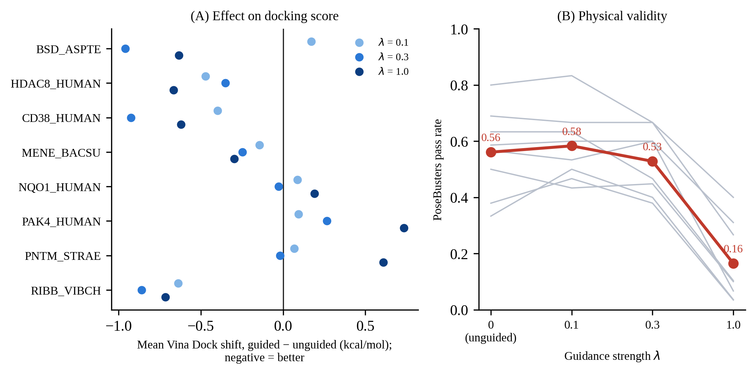
Figure 5.1 Track A, full tier. (A) Mean shift of the independent Vina Dock score for each pocket and guidance strength (negative is better; no shift was significant after correction). (B) PoseBusters pass rate of the unguided samples (λ = 0) and of the guided samples, for each pocket (grey) and on average (red).
Two features of the full tier are worth noting. First, the direction consistency did not strengthen when the sample was enlarged: 16 of 24 comparisons (67%) had a negative mean shift, against 8 of 9 (89%) in the exploratory tier, and the three exploratory pockets were also part of the full set, so this was not even an independent replication. This is the pattern expected if the exploratory impression was a small-sample selection effect. Second, the loss of physical validity was dose-dependent and, at λ = 1.0, universal: all eight pockets degraded and the mean pass rate fell from 0.56 to 0.17. Ligand efficiency degradation did not follow a dose–response. The validity result alone rules out λ = 1.0, and probably λ = 0.3, as operating points, regardless of the docking shift.
By the pre-declared bands the outcome was a clean null. It should be reported precisely as follows: no comparison was significant after correction, the direction consistency was weak and weakened with more data, and the only strength at which a consistent trend of the median shift appeared (λ = 1.0, seven of eight pockets) coincided with the collapse of the PoseBusters pass rate, so that it cannot be interpreted as improved binding. As noted in Section V.1, effects below about 1 to 1.4 kcal/mol per pocket cannot be excluded.
V.3 Track B: Three Mechanism Variants
Track B kept the Stage 0 EGNN representation fixed and changed how its output was turned into a guidance signal. All three variants used the same evaluation harness (Table 5.4, Figure 5.2).
V.3.1 B3: timestep-windowed guidance
If the gradient carried usable signal only in a part of the diffusion trajectory, uniform guidance would dilute it. Guidance was therefore restricted to the first, the middle or the last third of the 1,000 steps, at λ = 10 (the safe operating point of the repaired predictor), for two pockets with 20 molecules per condition and the same seed within each pocket. All 8 comparisons were no signal. Raw KS p-values ranged from 0.57 to 0.98, and all corrected values were essentially 1. Six of eight mean shifts were in the correct direction, but they were tiny (for example −0.002 kcal/mol against a standard deviation of about 1.6), and no PoseBusters degradation was detected in any condition. The ligand-efficiency flag was raised in three of eight comparisons (the middle and late thirds at BSD_ASPTE and the late third at HDAC8), which is not consistent with the statement in the original finding document that no degradation was detected in any condition; the table values were used. Windowing therefore did not create a signal that uniform guidance lacked, which is expected if there was no signal at any time of the trajectory.
V.3.2 B1: gradient-norm normalisation
A possible cause of the null was a poor scale of the raw gradient (about 0.0012 per atom in a smoke test). B1 rescaled the gradient to a fixed norm per atom before applying λ. A three-way design compared unguided sampling, the raw gradient at its established stable strength (λ = 10) and the normalised gradient at a freshly derived stable strength (λ = 0.1, the largest value with a single-fragment rate of 1.00; 0.25 at λ = 0.3 and 0.00 at 1.0). The decisive comparison was normalised against raw, on three pockets with 20 molecules per condition. None of the nine tests survived the correction (smallest corrected p = 0.192). In two of three pockets the normalised gradient was worse than the raw one (medians +0.46 and +0.68 kcal/mol), and in the third it was numerically better (−0.61) but with degraded PoseBusters validity. The hypothesis that a badly scaled magnitude was the cause was thus not supported.
Two lessons of this checkpoint are recorded because they changed the method. First, one raw-gradient molecule of the BSD_ASPTE pocket had a Vina Dock score of +286.58 kcal/mol, against a normal range of −12 to −5. It was verified to be a genuine, if pathological, outcome of a severely malformed pose (the docking code contains no sentinel-value path, and Vina's score is not bounded for catastrophic clashes) and not an error code. This single value shifted the mean of that condition by +14.3 kcal/mol whereas the median shift was +0.06, and it is the reason why the KS test and the median are reported next to the mean. Second, λ = 0.1 had passed the fragmentation check but still reduced the PoseBusters pass rate (HDAC8: 0.60 to 0.30; CD38: 0.40 to 0.25), so whole-molecule connectivity and fine-grained physical validity are different failure modes and a stability check must include both.
V.3.3 B2: classifier-guidance reformulation
B2 replaced the regression gradient with the classical classifier-guidance target [9]. A linear head was trained on the frozen pooled embedding of the Stage 0 network to predict whether the pK is above the training median (7.03), reaching a validation AUROC of 0.783 and a test AUROC of 0.677, and its guidance gradient was that of log σ(logit). The gradient was more tolerant of large strengths (single-fragment rate 1.00 from λ = 1 to 100, and 0.00 at 300), and λ = 100 was used. The unguided and raw conditions were reused from B1, which is valid because unguided sampling does not depend on a guidance model and the raw condition is the same EGNN at the same strength; only the classifier condition was generated (3 pockets, 20 molecules per condition, 6 comparisons).
None of the six tests survived the correction (smallest corrected p = 0.263). By median, however, the classifier gradient made the Vina Dock score worse in all six comparisons (the original finding document counted five of six), and it caused the most severe collapse of physical validity of all Track A and B checkpoints (HDAC8: 0.60 to 0.05). The formal verdict was no signal, and not a demonstrated harm, since n = 20 is modest for the score variance, but no comparison looked favourable even before considering significance. The higher tolerance for large λ did not become a more effective signal: a larger displacement was applied before the structure broke, with no benefit to the independently computed docking score. One mean-based row (BSD_ASPTE, classifier against raw) had the correct direction only because of the +286.58 outlier of the raw condition; its median was +0.73.
Table 5.4 Track B: summary of the three mechanism variants (Stage 0 EGNN, 2 to 3 pockets, n = 20 per condition)
Variant | Mechanism | Strength used | Tests (significant after BH) | Median-shift direction | Physical validity
B3 | Guidance in one third of the trajectory | λ = 10 | 8 (0) | Mixed, tiny | No degradation detected
B1 | Unit-norm gradient per atom | λ = 0.1 (raw: 10) | 9 (0) | Normalised worse than raw in 2 of 3 pockets | Degraded in 2 of 3 pockets
B2 | Classifier head, gradient of log σ(logit) | λ = 100 | 6 (0) | Worse in 6 of 6 | Degraded in 2 of 3 pockets, severe at HDAC8

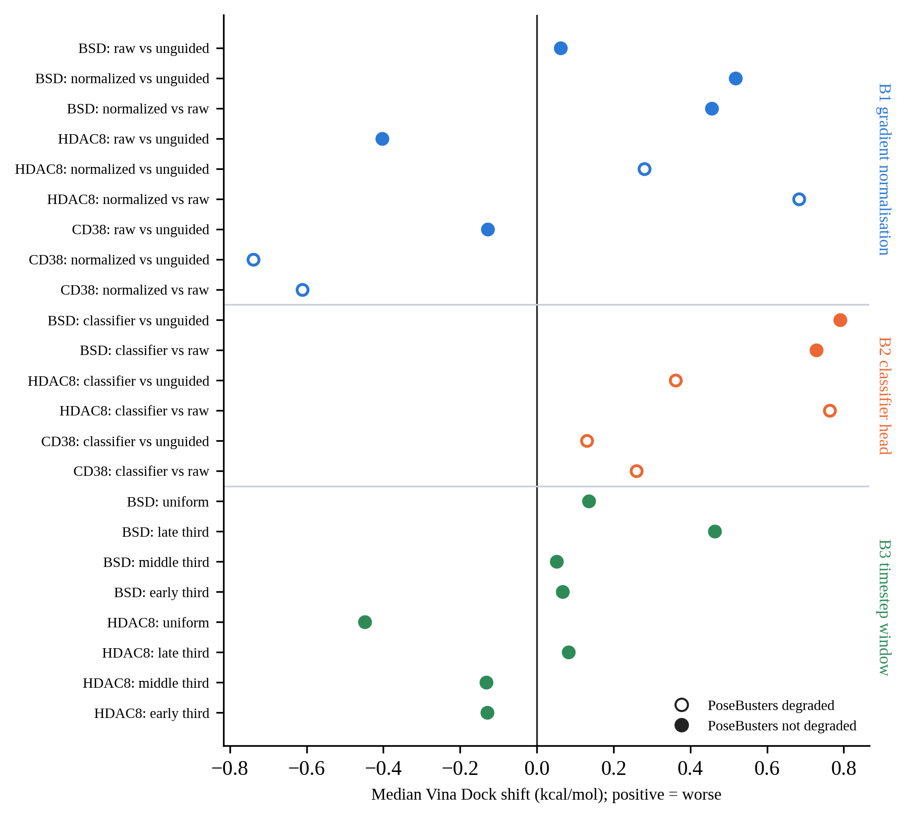
Figure 5.2 Track B: median shift of the independent Vina Dock score for every comparison (positive is worse). Open symbols mark comparisons in which the PoseBusters pass rate decreased. None of the 23 comparisons was significant after correction. Medians are shown because a single +286.58 kcal/mol outlier dominates the mean of one B1 and one B2 comparison.
V.4 Diagnostic of the Gradient Direction
The two routes above established that neither the mechanism variants nor a change of architecture produced an effect. A separate diagnostic asked what the Stage 0 gradient actually points at. It was a standalone diagnostic and not a guidance checkpoint, so no pass or fail gate applied.
V.4.1 Method
Clean-data estimates were captured from unguided trajectories at three timesteps (i = 150, 500 and 850, representing the late, middle and early thirds), for three pockets with 16 samples each (144 states), by a read-only hook that does not alter the sampled trajectory. At each state the raw gradient of the Stage 0 predictor was computed post hoc, and the per-atom gradient magnitude was correlated, sample by sample, with two atom properties: (i) the heaviness of the atom under its current soft type distribution (the expected atomic number under the softmax of the type logits), as a continuous proxy for the shortcut of preferring heavy elements, and (ii) the minimum distance of the atom to any pocket atom. Per-sample Pearson correlations were averaged and given a bootstrap 95% interval with 2,000 resamples.
V.4.2 Results
The gradient magnitude correlated weakly and negatively with heaviness (mean −0.127; 95% CI −0.178 to −0.075) and moderately and positively with the distance to the pocket (mean +0.240; 95% CI 0.194 to 0.285) (Figure 5.3). Both intervals exclude zero.
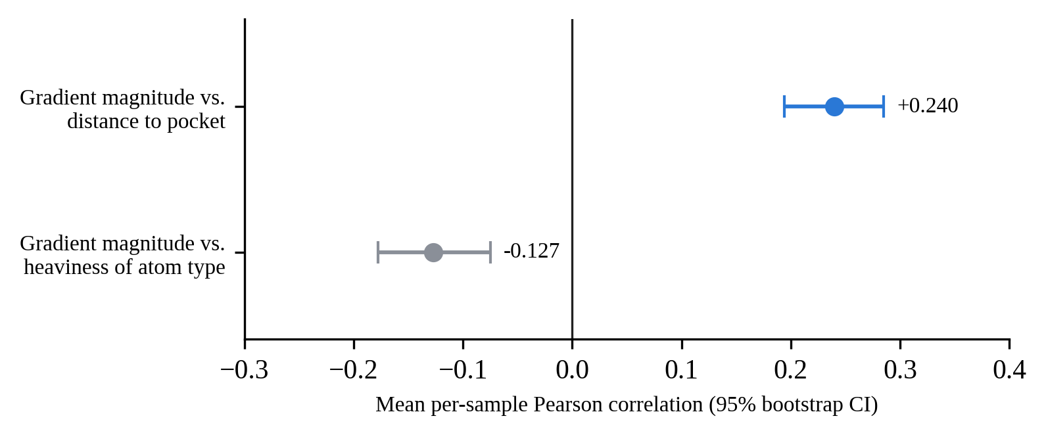
Figure 5.3 Correlation of the per-atom gradient magnitude of the Stage 0 predictor with the heaviness of the atom type and with its distance to the pocket, over 144 captured states (3 pockets, 3 timesteps, 16 samples). Points are means of per-sample Pearson correlations; bars are bootstrap 95% confidence intervals.
V.4.3 Interpretation and its limits
The first correlation does not support the hypothesis that the gradient direction is dominated by the same size shortcut that dominates the predictor's point predictions (Chapter IV): the gradient is, if anything, slightly larger on atoms leaning toward lighter types. This result also has a mechanical counterpart, since the number of ligand atoms is fixed before sampling begins and cannot be increased by guidance within a trajectory. It should be noted that this contradicts a statement found in some earlier project summaries, in which the failure of guidance was attributed to molecular size; the diagnostic data do not show a size effect on the gradient. Size acts on the predictor's output and on post-hoc selection (Chapter VI), which is a different mechanism.
The second correlation is the more informative one. If the gradient was concentrated on the contacts that determine binding, its magnitude would be expected to decrease with the distance to the pocket, that is, a negative correlation. The observed positive correlation means that the strongest pull acts on the atoms that are on average farthest from the pocket. This is consistent with the persistence of the null result under changes of scale (B1), timing (B3) and training objective (B2), since none of these changes alters what the representation encodes. It should be read as a correlational finding with a plausible explanation, not as a demonstrated cause. Alternative explanations were not excluded: atoms far from the pocket have fewer neighbours within the cut-off of the network, and the predictor had been trained on clean structures with only 0.1 Å of noise, so it may respond unreliably to the noisy clean-data estimates of early timesteps, a mismatch that has been reported to degrade generation in a related setting [22]. The diagnostic was also run on the EGNN only. A physics-anchored model with distance-decaying pair terms could be expected to produce a negative distance correlation by construction, and re-running the diagnostic on the Track A checkpoint would be a cheap, natural follow-up that was not performed.
V.5 Conclusions of Tracks A and B
Both independent routes failed under the declared criteria. Changing the architecture to a physics-anchored predictor with comparable quality (Track A, 0 of 24 significant comparisons, with weakening direction consistency and universal loss of validity at the highest strength), and changing the scale, timing or objective of the guidance on the fixed representation (Track B, 0 of 23 significant comparisons, with two variants reducing validity) each gave no detectable improvement in the independently computed docking score. The gradient diagnostic offers a testable, if partial, account: the strongest gradient acts on atoms far from the pocket. The logical possibility that a combination of the two routes, for example normalisation applied to the Track A predictor, would work was considered and not pursued, because B1 gave no positive reason to expect that it would behave differently on another representation. The two routes did not address non-gradient use of the predictor, which is the subject of Chapter VI.

CHAPTER VI
REJECTION SAMPLING: THE AFFINITY PREDICTOR AS A POST-HOC RANKER (TRACK C)
The routes of Chapter V used the predictor through its gradient. A predictor with moderate accuracy might nevertheless be useful in a different role, as a ranker of finished molecules. In rejection sampling, or best-of-N selection, a large pool of molecules is generated without guidance and only the molecules with the highest predicted affinity are retained. This mechanism requires no gradient through the predictor, no change to the sampler, and no assumption about the noisy intermediate states. It is a different mechanism class from everything tested in Chapter V, and it had been explicitly left out of the conclusions of that chapter. This chapter tests it with the Stage 0 EGNN as the ranker.
VI.1 Design
VI.1.1 Pools, ranker and evaluation
Fifteen pockets of the 20-pocket set of Section IV.5 were used, with two seeds each, giving 30 pools. Each pool consisted of 300 molecules sampled without guidance (λ = 0), reconstructed, scored once by the frozen Stage 0 EGNN (higher score means a stronger predicted binder) and docked once with AutoDock Vina (exhaustiveness 8) and PoseBusters. Between 285 and 300 of the 300 attempted molecules per pool were reconstructed, and no pool failed. The seeds of each pocket were combined, giving pockets of 576 to 600 molecules. Top-k selection, the random subset and the scrambled filter are all post-hoc selections from the same, already docked pool, so no additional generation or docking was necessary for the analysis.
The scope had been reduced during the run, after a review of the time budget: from 20 pockets and 3 seeds (60 pools) to 15 pockets and 2 seeds (30 pools), because a pool cost about 4.6 h after the optimisations of Section III.7 and the run had to fit in the time available for the thesis. Fifteen pockets remain above the number used in the earlier ablations, and two seeds retain a weaker seed-to-seed consistency check. Pools already completed for a third seed of two pockets were excluded from the analysis and not force-included.
VI.1.2 Statistics
The primary selection was the top 10% of each pocket's pool by predicted score (sensitivity analyses at 5, 20 and 30%). For each pocket, the following were computed:
(i) the shift of the mean Vina Dock score of the selected molecules against the full pool, with a 95% bootstrap interval (2,000 resamples); (ii) an empirical one-sided p-value against 2,000 random subsets of the same size; (iii) the negative control of Section III.6.2, a scrambled filter with 2,000 permutations of the predicted scores, together with a null-consistency check (KS test between the two null distributions), which no pocket failed, so no implementation error of the permutation was indicated; (iv) a KS test of the selected against the full-pool distribution, corrected with the Benjamini–Hochberg procedure across the 15 pockets; (v) three diagnostics of quality degradation: the shift of the heavy-atom count, the PoseBusters pass rate, and the ligand efficiency, which was KS-tested and corrected in the same way.
VI.2 Results
VI.2.1 Raw docking score
The selection improved the raw Vina Dock score in most pockets. The mean shift was −1.31 kcal/mol (median −1.33; range −3.73 to +1.95), and in 14 of 15 pockets the KS test was significant after the correction. The seeds agreed in direction for 14 of 15 pockets; the exception was SQHC (per-seed shifts +0.78 and −1.07), whose raw effect (−0.13, 95% CI −1.22 to +4.66) was weak and inconsistent. Read by themselves, these numbers would suggest a usable rejection-sampling signal.
VI.2.2 Ligand efficiency, size and validity
The signal disappeared when the outcome was normalised by molecular size (Table 6.1 and Figure 6.1). The ligand efficiency of the selected molecules was significantly worse than that of the pool in 14 of 15 pockets (BH-corrected p < 0.0001 in all these; mean shift +0.099 kcal/mol per heavy atom, where positive is worse); the one exception, PNTM_STRAE, had a small improvement (−0.030). The selected molecules were larger by 12.0 heavy atoms on average (median 12.7; range 7.4 to 15.1), and their PoseBusters pass rate was lower by 28.8 percentage points on average (median 31.6; range 5.7 to 52.7; mean pass rate 0.57 for the pool and 0.28 for the selection). This is the signature of Vina hacking [18]: larger molecules with poses that are often invalid can receive favourable raw scores without a corresponding gain of binding per atom. The raw improvement reflects, at least in part, that the ranker prefers larger molecules, a preference that is consistent with the correlation of 0.72 between the predictor's output and the heavy-atom count (Chapter IV).
Table 6.1 Track C: top 10% selection by the Stage 0 ranker, per pocket
Pocket | n (pool) | Vina Dock shift (95% CI) | Heavy atoms shift | Ligand-efficiency shift | PoseBusters pass rate, pool → selection | Verdict
NOS2 | 599 | −3.73 (−4.07, −3.30) | +14.3 | +0.091 | 0.79 → 0.43 | Confounded by size
PNTM | 596 | −3.45 (−6.02, −1.96) | +9.5 | −0.030 | 0.62 → 0.45 | Confounded by size
PAK4 | 598 | −2.83 (−3.11, −2.55) | +14.8 | +0.116 | 0.77 → 0.48 | Confounded by size
PYRD | 597 | −2.70 (−2.99, −2.36) | +13.6 | +0.090 | 0.71 → 0.23 | Confounded by size
XANLY | 599 | −2.54 (−2.92, −2.16) | +10.5 | +0.054 | 0.68 → 0.52 | Confounded by size
DPP2 | 596 | −2.13 (−2.45, −1.70) | +15.1 | +0.145 | 0.64 → 0.28 | Confounded by size
CD38 | 591 | −1.41 (−1.78, −0.97) | +8.2 | +0.033 | 0.48 → 0.42 | Confounded by size
IMA1 | 600 | −1.33 (−1.56, −1.15) | +12.7 | +0.161 | 0.80 → 0.38 | Confounded by size
MENE | 598 | −1.31 (−1.61, −0.99) | +7.4 | +0.021 | 0.48 → 0.40 | Confounded by size
HDAC8 | 597 | −1.00 (−2.04, −0.28) | +14.8 | +0.165 | 0.55 → 0.12 | Confounded by size
NQO1 | 597 | −0.90 (−1.26, −0.62) | +10.1 | +0.072 | 0.61 → 0.28 | Confounded by size
SQHC | 576 | −0.13 (−1.22, +4.66) | +13.4 | +0.077 | 0.27 → 0.10 | Confounded by size
BSD | 594 | +0.21 (−0.14, +0.58) | +10.9 | +0.094 | 0.35 → 0.03 | No signal
P2Y12 | 578 | +1.57 (+0.77, +2.46) | +10.8 | +0.097 | 0.29 → 0.09 | Wrong direction
RIBB | 592 | +1.95 (+1.28, +2.65) | +14.4 | +0.304 | 0.54 → 0.02 | Wrong direction
Negative Vina Dock shifts are improvements; positive ligand-efficiency shifts are degradations. Vina Dock in kcal/mol; ligand efficiency in kcal/mol per heavy atom. Pockets are sorted by Vina Dock shift; short names denote PNTM_STRAE, PYRD_TRYCC, XANLY_BACGL, MENE_BACSU, SQHC_ALIAD, BSD_ASPTE and RIBB_VIBCH. The verdict of SQHC rests on a weak, seed-inconsistent effect.

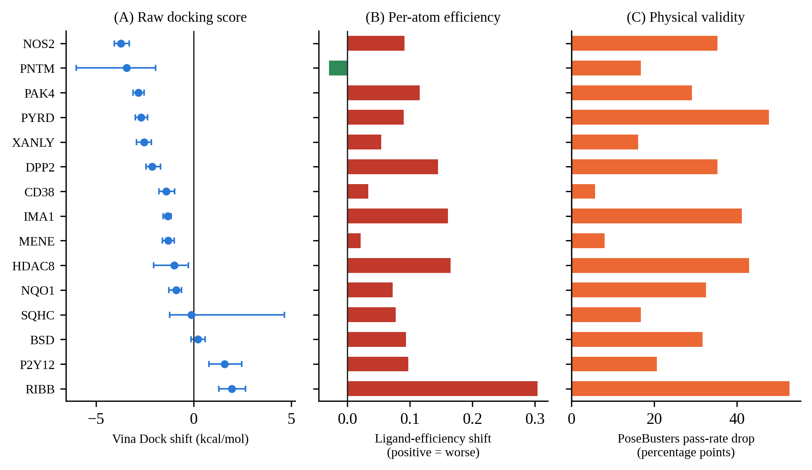
Figure 6.1 Track C, top 10% selection by the Stage 0 ranker in 15 pockets. (A) Shift of the raw Vina Dock score with 95% bootstrap intervals; (B) shift of ligand efficiency (red: worse, green: better); (C) drop of the PoseBusters pass rate in percentage points.
Figure 6.2 shows three concrete examples of what a high-scoring selected molecule from this analysis actually looks like: one top-ranked molecule from the pool of each of three pockets, re-docked with AutoDock Vina and rendered with its principal hydrogen-bond partners labelled. These are illustrative, not a random or representative sample of the 15 pockets' selections, and are included to make the quantitative pattern of Figure 6.1 concrete rather than to support a statistical claim.
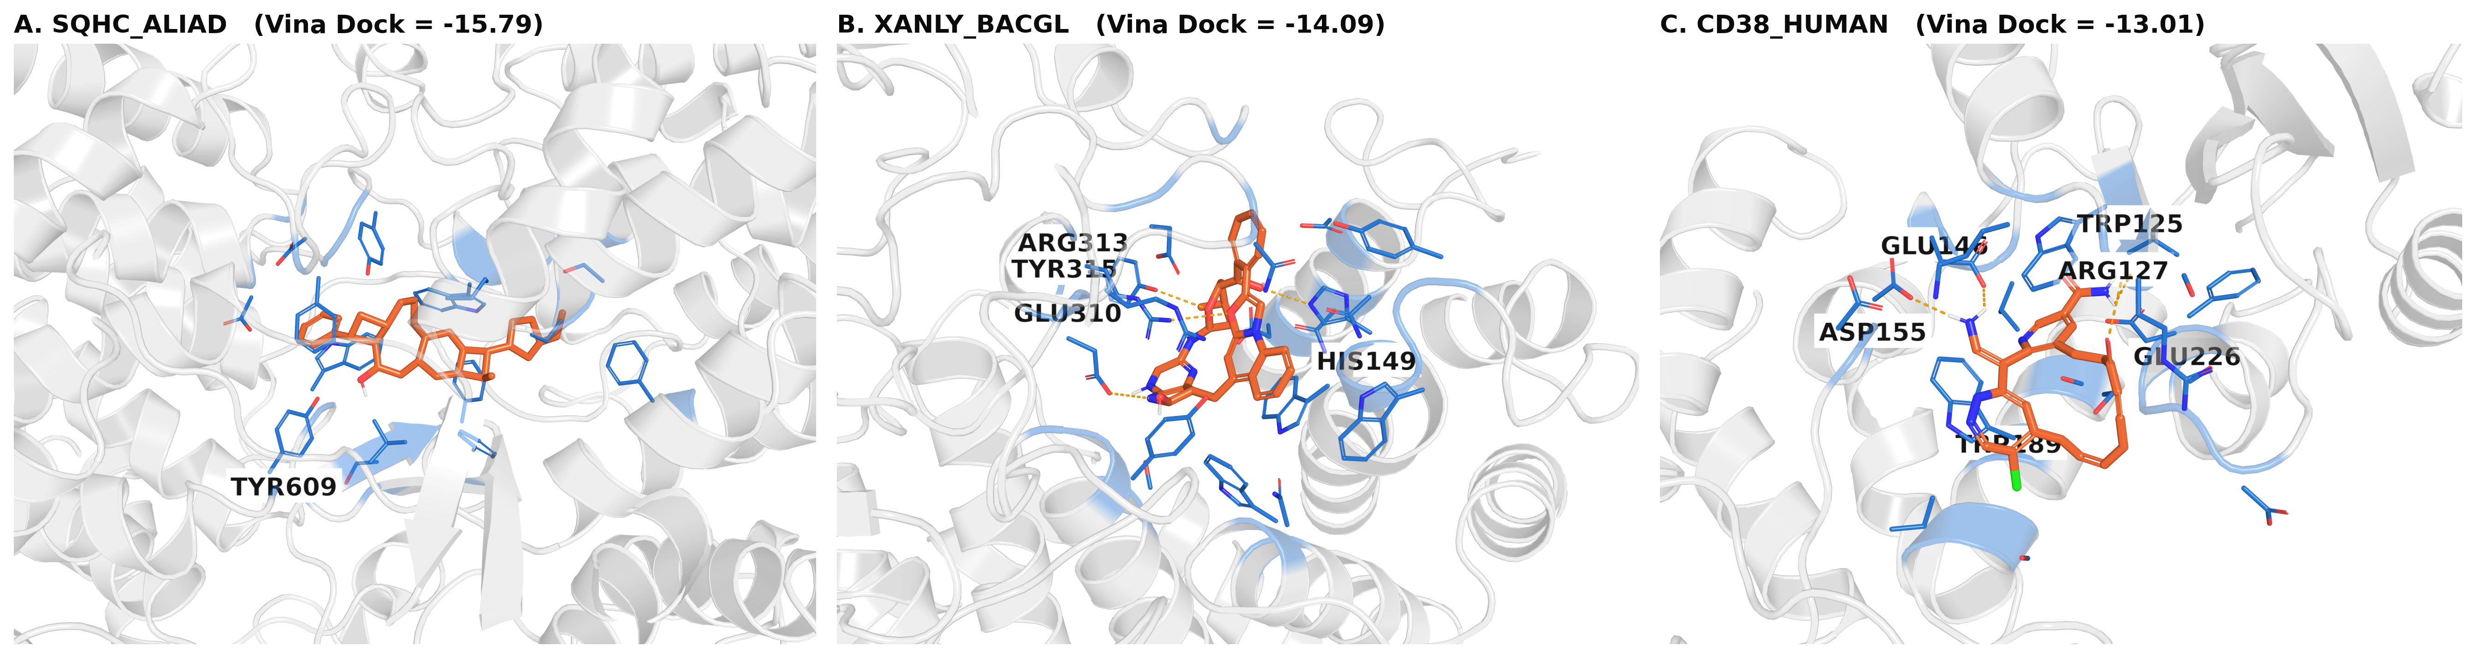
Figure 6.2 Three top-ranked molecules from Track C pools (SQHC_ALIAD, XANLY_BACGL, CD38_HUMAN), re-docked and rendered with hydrogen-bond partner residues labelled. The large, high-affinity-scoring poses illustrate the kind of molecule the ranker favours before the size normalisation of Figure 6.1 is applied.
The verdicts by the pre-declared bands were: 12 of 15 pockets signal but confounded by size, 2 of 15 signal in the wrong direction, 1 of 15 no signal, and none clear signal.
VI.2.3 Two pockets with the opposite behaviour
In two pockets, RIBB_VIBCH and P2Y12, the top-10% selection was significantly worse than a random subset of the same size on the raw score (empirical p_random = 1.0000 for RIBB_VIBCH, that is, none of 2,000 random draws did as poorly). This held at all four values of k tested for RIBB_VIBCH. In these pockets the ranker was anti-correlated with the independently computed docking outcome, and not just uninformative.
VI.2.4 Sensitivity to the selection fraction
The raw-score effect was not stable when the selected fraction was varied. Averaged over pockets, the shift of the raw Vina Dock score was −1.38, −1.31, −0.94 and −0.55 kcal/mol at k = 5, 10, 20 and 30%, and the number of pockets with a negative shift fell from 11 to 12, 10 and 10. Individual pockets reversed sign (HDAC8: −1.41 at 5% but +1.01 at 30%; PNTM_STRAE: −2.91 at 20% but +1.38 at 30%). The degradation of ligand efficiency was the more robust finding at all fractions. It should be read as a monotone weakening of the raw effect with increasing k, which is the expected behaviour of a ranker whose first-ranked molecules are the largest.
VI.3 Post-Hoc Analysis of the Validity Loss
The drop in the PoseBusters pass rate ranged widely across pockets (5.7 to 52.7 points), and it was asked, after seeing this variation, whether it could be explained. Two exploratory hypotheses were examined, both with n = 15 pockets, Spearman correlations and case-resampling bootstrap intervals, none of them pre-registered or corrected for multiple testing.
The pocket size (the number of protein atoms in the 10 Å crop) correlated negatively with the drop (Spearman r = −0.59; 95% CI −0.83 to −0.13; Pearson r = −0.54, p = 0.039; between −0.53 and −0.71 under leave-one-out). Larger pockets thus tolerated the selection better, the opposite of the naive expectation. As a plausibility check, the pocket size correlated with the mean size of the unguided molecules (r = +0.72; 95% CI +0.20 to +0.96). A possible reading is that molecules generated in a small, tight pocket already fit closely, so that a shift toward larger molecules has no room and produces clashes, whereas a large pocket can accommodate a somewhat larger molecule. The spread of heavy-atom counts within the pool predicted the drop independently of the pocket size (partial Spearman r = +0.70; 95% CI +0.17 to +0.91), while the diversity of the pool did not (r = +0.24; CI −0.26 to +0.59). An earlier version of this analysis had truncated each pool to its first 300 molecules, that is, to a single seed, and had produced a non-significant partial correlation; the error was found by re-running the saved script on the complete pool, and the corrected result is the one reported here.
These correlations are hypotheses for a future, targeted study, for example a model of pocket volume against clash rate, and not findings. With n = 15 and post-hoc selection of the questions asked, they are at the limit of what can be supported.
VI.4 Interpretation
Three conclusions are supported. First, the same frozen predictor that failed as a gradient signal also failed as a post-hoc ranker, by a different route: the selection produced a raw-score gain that turned into a loss when normalised by molecular size, and it lowered physical validity substantially. Second, the negative control behaved as designed (the scrambled-filter and random-subset nulls agreed in all pockets), so the failure is not an implementation error of the selection. Third, the mechanism of failure that this chapter documents is specific: the selection is dominated by size. It differs from the mechanism diagnosed for the gradient in Chapter V, where the gradient magnitude was not correlated with atom heaviness in the direction that a size shortcut would predict, and was instead concentrated on atoms far from the pocket. Some earlier summaries of this project describe both failures as having the same root cause, molecular size. This is not what the data show. The two failures are compatible with a common upstream cause, a predictor that encodes ligand-side properties and not pocket-specific interaction, but the evidence for that common cause is indirect (Chapter IX).
Two limits should be kept in mind. The ranker was applied to unguided pools of the diffusion model, not to a pool with a different composition. A predictor trained with an explicit size control could behave differently as a ranker, and this was not tested; in particular, the combination of the Track A predictor with rejection sampling was considered and not run, because the size correlation of that predictor (0.64) was only slightly lower. Finally, the result concerns top-10% selection by one specific ranker with a stated set of pockets and seeds; the significant effects of the raw-score improvement and of the degradation are large and consistent across pockets, whereas per-pocket verdicts, such as those of SQHC_ALIAD and BSD_ASPTE, rest on weaker evidence.

CHAPTER VII
SYNTHESIZABILITY GUIDANCE (TRACK D)
The title of the thesis names two guidance signals, affinity and synthesizability. The chapters so far concerned the first. This chapter applies the same standards to the second: whether the gradient of a learned predictor of synthesizability can steer the frozen generator toward molecules that are more synthesizable according to an independent measure. Synthesizability is a categorically different target from affinity: it is a property of the ligand alone, it is derived from a fingerprint-based classifier, and its predictor was expected to be easier to learn.
VII.1 Target, Predictor and Guidance Design
The independent measure was the RAscore [43], a neural classifier that estimates whether a retrosynthesis planner would find a route for a molecule; its value lies in [0, 1]. The guidance predictor, SynthPredNet, is a ligand-only EGNN with a sigmoid output (0.43 M parameters) trained to regress the RAscore of a ligand from its 3D graph. Since it has no protein input, the guidance depends on the ligand's own geometry only. A guidance function of this kind faces the problem of Section III.3.2: the predictor was trained on features derived from bonds (degree, number of hydrogens and hybridisation), which do not exist during sampling. Two designs were therefore compared: a placeholder design in which the three bond-derived fields were set to a fixed "unknown" value, and a bond-aware design in which they were replaced by a parameter-free, differentiable estimate computed from the interatomic distances of the current diffusion state (a soft version of the bond-length rule used in the stability evaluation). Two errors were found and corrected in this estimator with a synthetic-geometry test before it was used: element pairs with no such bond order were scored as if they had the single-bond value, and the steepness of the sigmoid saturated within a fraction of a picometre, which made the indicator a hard step with almost zero gradient on realistic geometries.
VII.2 The Original Design: Divergence between the Own Score and the Independently Computed Score
The first experiment used the placeholder design on the single bundled example pocket, with 8 molecules per value of λ_synth and a single seed, without any statistical test. The predictor's own score increased with λ while the independently computed RAscore of the finished molecules decreased (Table 7.1 and Figure 7.1A). At λ = 0.03 the own score was 29% higher and the independently computed score 53% lower than in the unguided run. Per molecule, 6 of 8 independently computed scores were lower and none was meaningfully higher at λ = 0.03, whereas at λ = 0.01 six were unchanged, one higher and one lower, so no safe and beneficial window was found. Molecules fragmented at λ ≥ 1.
Table 7.1 Original (placeholder) design, one pocket, n = 8 per value
λ_synth | Single-fragment rate | Predictor's own score | Independently computed RA-score
0 (unguided) | 100% | 0.458 | 0.361
0.01 | 100% | 0.487 (+6%) | 0.365 (+1%)
0.03 | 100% | 0.591 (+29%) | 0.168 (−53%)
0.1 | 100% | 0.645 (+41%) | 0.154 (−48%)
0.3 | 100% | 0.735 (+61%) | 0.126 (−58%)
1.0 | 12.5% | 0.864 | one valid molecule
≥ 3.0 | 0% | n/a | none scoreable
Two independent unguided baselines with the same seed gave independently computed RA-scores of 0.361 and 0.299, because the two runs consumed a different number of random draws before the baseline point. This indicates the size of the run-to-run noise at n = 8.

The suggested root cause was the train–inference mismatch of the bond-derived features. The bond-aware design was the test of this hypothesis, and it did not resolve the divergence. At λ = 0.1 (5 of 8 molecules intact) the own score rose by 12% while the independently computed score fell by 16%, and fragmentation started earlier than in the placeholder design (single-fragment rate 0.625 at λ = 0.1, 0.125 at 0.3, 0 at 1.0). A plausible explanation is that the bond-aware features add a second gradient path (position to estimated bonds to features to score), so that the same nominal λ corresponds to a larger effective step. Time-dependent scheduling and a richer guidance architecture were also considered and were explicitly not attempted, because the result of the bond-aware design did not point to timing or capacity as a suspect, and continuing without a specific hypothesis would have been a search for a fix rather than a test of one.
The precision of these statements is limited. They come from one pocket, n = 8 and a single seed, with no test and no confidence intervals, and a re-examination of the work in the next section confirmed this limitation.
VII.3 Re-Examination: Convergence and Leakage of the Synthesizability Predictor
Before repeating the guidance experiment at higher power, the state of the predictor itself was audited, as had been done for the affinity predictor. Two problems were found. (i) The predictor had been trained with a fixed ceiling of 40 epochs and stopped with its early-stopping counter at 1 of 6, so it had not converged. (ii) Its data were divided by a random 90/10 split of the 15,000 labelled entries with no held-out test set and no leakage check, so the reported quality (validation R² = 0.769, Pearson 0.878) rested on a split in which the same pocket or a near-identical ligand could occur in both subsets.
The 15,000 entries were re-partitioned by target identity with the leakage-safe assignment of Section III.2.4, without recomputing any label, giving 8,835 training, 1,015 validation and 1,940 test entries (3,210 entries were discarded because their target was not covered by the assignment). The same architecture was retrained without an epoch ceiling (early stopping at epoch 20 with a patience of 15; best checkpoint at epoch 5). On the held-out test set it reached R² = 0.414, Pearson 0.647, Spearman 0.649 and RMSE 0.287 (Table 7.2 and Figure 4.2). Its quality was therefore clearly better than chance, and higher than the affinity predictors' correlations (0.58 to 0.61). The drop from the earlier values is consistent with the removal of leakage-driven inflation, but the two evaluations differ in more than the split (they also differ in the evaluation set and in convergence), so the difference is not a controlled estimate of the size of the leakage.
Table 7.2 SynthPredNet: original and leakage-safe evaluation
Evaluation | R² | Pearson | Spearman | RMSE
Original (random split, validation only, not converged) | 0.769 | 0.878 | 0.871 | 0.192
Leakage-safe (target-disjoint test set, n = 1,940, converged) | 0.414 | 0.647 | 0.649 | 0.287

VII.4 Guidance with the Leakage-Safe Predictor
With the retrained predictor and the bond-aware design, the strength sweep was repeated on the same single pocket (BSD_ASPTE) with 30 molecules per value, the full 1,000 steps and a grid from 0 to 30 (Table 7.3). A KS test of the independently computed RAscore, guided against unguided, was applied to each of the five values with enough scoreable molecules, and the five tests were corrected with the Benjamini–Hochberg procedure.
Table 7.3 Leakage-safe predictor, bond-aware design, pocket BSD_ASPTE, n = 30 per value
λ_synth | Single-fragment rate | Scoreable (n) | Own score | Independently computed RA-score | Shift of independently computed score (95% CI) | KS p (BH)
0 (unguided) | 0.90 | 27 | 0.5605 | 0.2581 | n/a | n/a
0.01 | 0.90 | 27 | 0.5668 | 0.2515 | −0.009 (−0.161, 0.140) | 0.997
0.03 | 0.90 | 26 | 0.5922 | 0.1916 | −0.066 (−0.207, 0.079) | 0.997
0.1 | 0.77 | 23 | 0.5784 | 0.1863 | −0.071 (−0.212, 0.072) | 0.997
0.3 | 0.21 | 6 | 0.5577 | 0.0659 | −0.192 (−0.315, −0.078) | 0.997
1.0 | 0.07 | 2 | 0.7925 | 0.2391 | −0.018 (−0.194, 0.148) | 0.997
≥ 3.0 | 0.00 | 0 | n/a | n/a | n/a | n/a

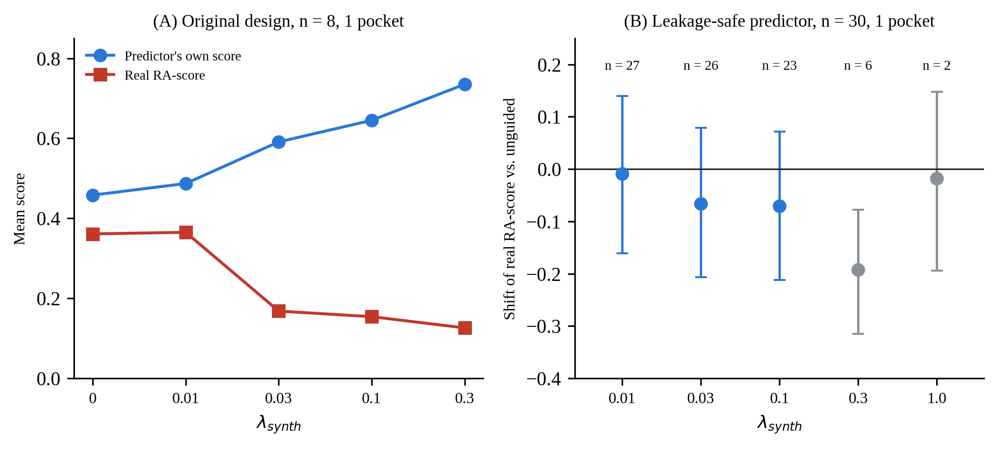
Figure 7.1 Track D. (A) Original design (placeholder features, n = 8, one pocket): the predictor's own score and the independently computed RA-score as a function of guidance strength. (B) Leakage-safe predictor with bond-aware features (n = 30, same pocket): shift of the independently computed RA-score with 95% bootstrap intervals; grey points rest on 6 and 2 scoreable molecules.
No comparison survived the correction (corrected p = 0.997 for all five). The mean shift of the independently computed score was negative at every non-zero strength, and never positive, but all intervals except that of λ = 0.3 included zero, and the interval at λ = 0.3 rests on only 6 scoreable molecules because of fragmentation (single-fragment rate 0.21), which is precisely the kind of large point estimate from a tiny sample that the standards of this work forbid to report as a finding. Two further cautions apply to the consistent sign. The conditions share their initial noise (one seed), so the five shifts are not independent observations. And the run-to-run noise of the unguided baseline was already about 0.06 to 0.1 RAscore units between nominally equivalent baselines of the same unguided sampler (0.361 and 0.299 at n = 8, Table 7.1; 0.258 at n = 30), which is as large as most shifts in the table. The predictor's own score rose by at most 5.7% at the largest well-powered strength (λ = 0.03: 0.5605 to 0.5922, with an independently computed score change of −25.8% in the mean) and was not monotone (0.5577 at λ = 0.3), and no test was applied to it. The divergence between the two scores that was striking in the original design is thus reproduced in sign, but not established statistically, in the leakage-safe design.
What the data support is therefore limited to the following statements: there was no strength at which a meaningful or statistically supported increase of the independently computed RAscore was observed (the only higher mean, +1% at λ = 0.01 in the original design, was within the run-to-run noise); the guidance destroyed the connectivity of the molecules at λ ≥ 0.3; and in the exploratory design, a divergence of the own score and the independently computed score was observed, with a magnitude that the small sample could not confirm. The multi-pocket confirmation (step D.4) was skipped, by a gating rule that had been declared in advance: if the divergence persisted even partially, the investigation should proceed to the mechanistic diagnostic and not spend multi-pocket effort on an unresolved single-pocket result. The consequence is that the whole of Track D rests on one pocket, and this is a real limitation.
VII.5 Diagnostic of the Synthesizability Gradient
The diagnostic of Section V.4 was adapted to the ligand-only predictor. Clean-data estimates were captured from unguided trajectories at three timesteps, for three pockets with 16 samples each (144 states), and the per-atom gradient magnitude of the bond-aware guidance was correlated with three proxies that could plausibly relate to the classifier's behaviour (Table 7.4). The distance to the pocket does not apply, since the predictor has no protein input.
Table 7.4 Track D diagnostic: gradient magnitude against three atom-level proxies (n = 144 states)
Proxy | Mean correlation | 95% CI | Reading
Heaviness of the atom type | 0.032 | (−0.019, 0.083) | Not distinguishable from 0
Aromatic fraction | −0.014 | (−0.061, 0.036) | Not distinguishable from 0
Heteroatom fraction (N, O, S, P, halogens) | 0.042 | (−0.008, 0.091) | Not distinguishable from 0

None of the three proxies explained the gradient. In contrast with the affinity gradient, for which a concrete correlate (distance to the pocket) was found, no correlate was found here. The intervals are narrow, so correlations above about 0.09 in magnitude with these three proxies are excluded, but the proxies are simple, scalar and per-atom; they do not exclude that the gradient follows a more complex direction. Two candidate explanations were not tested. The first is the known failure mode of classifier guidance in which the gradient exploits directions in the input space that raise the classifier's output without changing the property that it was trained to recognise [9]. The second is that a fingerprint-based target may have a structure that a smooth, continuous 3D gradient cannot approximate. The asymmetry between the two halves of the thesis, a diagnosed mechanism for affinity and an undiagnosed one for synthesizability, is a real difference in explanatory power and is reported as such.
VII.6 Conclusion of Track D
The gradient of a moderately accurate, leakage-safe synthesizability predictor (test R² = 0.41) gave no evidence of improving the independently computed RAscore in the single pocket that was examined at adequate sample size, destroyed the connectivity of the molecules at strengths of 0.3 or more, and produced, in the exploratory design, a divergence of the predictor's own score from the independently computed score that was not confirmed statistically after the predictor was retrained. Two fixes had been attempted (bond-aware features and a leakage-safe, converged retrain) and three diagnostic proxies had been excluded. The conclusion is that no benefit was demonstrated, not that harm was demonstrated. The finding also has a methodological corollary that is important for the rest of the thesis: the quality that had been reported for the original predictor came from an unaudited split, and the audit changed it substantially.

CHAPTER VIII
REDESIGN OF THE TRAINING TARGET: DELTA-LEARNING AGAINST THE DOCKING SCORE (TRACK E)
Chapters IV to VII showed that guidance failed for predictors of different architecture, of different objective and of a different target, and that a size shortcut and a misdirected gradient were the best available explanations. Both explanations point to the training signal, not to the capacity of the network: a predictor trained to reproduce the experimental affinity can achieve a respectable correlation by learning that larger ligands bind more strongly (Section IV.4), and the gradient of such a predictor need not concentrate on the contacts that matter (Section V.4). Track E tested two targeted modifications of the training signal, chosen after the failures had been diagnosed and pre-registered before any model was trained. Only the first was executed, because it failed its gate; the second was designed, its infrastructure was verified, and it was not run. This chapter reports the design, the pre-registered criteria, the infrastructure and the result.
VIII.1 Rationale and Premise Checks
VIII.1.1 The two modifications
E1 (delta-learning). Instead of the absolute pK, the network is trained to predict the residual Δ = pK_exp − pK_Vina, where pK_Vina = max(−E_Vina, 0)/1.364 is the docking score converted to a pK scale, and the prediction is reconstructed as ŷ = pK_Vina + Δ̂. The idea, known from the Δ-machine-learning literature, is that a physics-based baseline captures the coarse trend and that the network only needs to learn a correction [36], [47], [51]. The residual is almost uncorrelated with ligand size (Pearson correlation of Δ with the heavy-atom count 0.052, against 0.497 for the absolute pK on the unclipped anchor), so the target formulation removes the size component that the earlier predictors exploited. E2 (interaction supervision). Auxiliary heads would predict, for every ligand atom, whether it participates in a hydrogen bond, a hydrophobic contact or a salt bridge, with labels computed from the docked pose by PLIP [38], as an inductive bias that pushes the shared encoder toward the contacts that matter for binding.
VIII.1.2 Premise checks that changed the plan
Four measurements made before training changed the design and the bar for success.
First, "the baseline" was not one number. The old EGNN had R² = −0.537 on the old split, the Track A model −0.189 on the leakage-safe test set, and the Stage 0 EGNN +0.342. Exceeding a negative R² would have been trivial, so the criterion was set against the strongest reference.
Second, simple baselines were as good as the network, and the interval of the earlier comparisons was too narrow. The confidence intervals reported in Chapter IV resampled complexes. The independent unit for a new-target claim is the target: the test set has 127 targets, with a median of 14 complexes per target and a maximum of 1,392. With a target-clustered bootstrap the interval of the Stage 0 EGNN R² widened from 0.322–0.361 to 0.160–0.465, about eight times wider, and the network became statistically indistinguishable from a two-feature linear model of the Vina score and the heavy-atom count (R² = 0.362) (Table 8.1). Within a pocket, which is where guidance acts, the raw Vina score ranked complexes better than the EGNN (mean within-target Spearman correlation 0.248 against 0.195), which supports the premise of delta-learning directly.
Third, Δ is size-neutral but not lower in variance (training SD 1.753 against 1.801 for pK). The residual can be learnt only if it is a function of the structure, which is an assumption to be tested, not a given.
Fourth, the gradient of the delta model would not be the gradient of affinity. Vina is an external program without a differentiable path in this pipeline, so at generation time only the gradient of the correction Δ̂ would be available. Scoring improvement therefore does not imply guidance improvement, and a gradient diagnostic (criterion C4) was declared as the gate to generative use.
Table 8.1 Track E: reference predictors on the leakage-safe test set (127 targets; target-clustered 95% CI)
Reference | R² (95% CI) | Within-target Spearman (95% CI) | Correlation of prediction with heavy-atom count
Constant (training mean) | 0.000 | n/a | n/a
Vina only, raw (−E/1.364, clipped at 0) | 0.076 (−0.213, 0.270) | 0.248 (0.156, 0.334) | 0.622
Vina only, linearly calibrated | 0.273 (0.152, 0.341) | 0.248 | 0.622
Heavy-atom count only (linear) | 0.307 (0.135, 0.416) | 0.191 (0.051, 0.331) | 1.000
Vina + heavy-atom count (linear) | 0.362 (0.200, 0.470) | 0.266 (0.162, 0.368) | 0.940
Stage 0 EGNN | 0.342 (0.160, 0.465) | 0.195 (0.078, 0.307) | 0.719
Track A GIGN + PIGNet2 (no bias term) | −0.189 (−0.768, 0.162) | 0.233 (0.142, 0.325) | 0.640
Within-target Spearman correlation: mean over the 73 test targets with at least 10 complexes. The ground-truth pK has a correlation of 0.555 with the heavy-atom count on the test set. The anchor is clipped at zero because 79 poses have a positive Vina score (clashes).

VIII.2 Design
VIII.2.1 Architecture and target
The backbone was the Track A model (Section V.2), reused unchanged in its interaction layers with hidden size 256 and 0.494 M parameters. The E1 head kept the physics-sum readout and added a learned bias b and a learned scale s of free sign, Δ̂ = b + s·(−ΣE_phys): the bias remedies the missing offset that was identified as the cause of the negative R² of Track A, and the scale is not sign-constrained because a positive residual does not need to mean more attraction; it may mean that Vina under-rewards a contact. Since a physics-sum readout could under-represent an arbitrary residual, a scalar MLP on pooled embeddings was a pre-registered readout ablation (E1-MLP). The absolute-target control (A0′) used exactly the same backbone and head with the absolute pK as target, so that the only difference between A0′ and E1 was the target (Figure 8.1). The residual was standardised on the training set (mean 0.518, SD 1.753), and the loss was the mean squared error on the standardised residual, matching the loss of the earlier models and the R² metric. Huber loss was not used in the primary arms, because a different loss would have confounded the effect of the target.
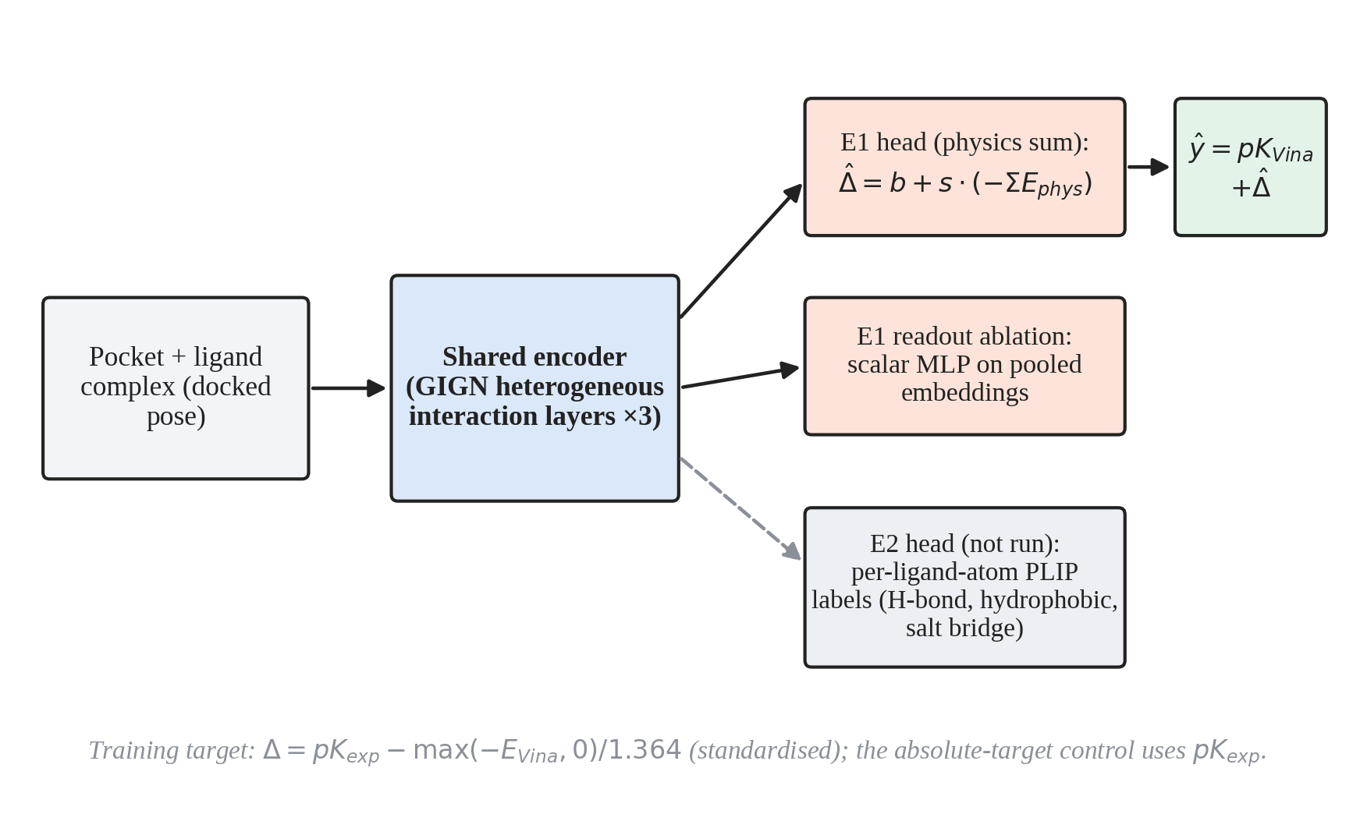
Figure 8.1 Design of Track E. A shared GIGN encoder feeds the E1 delta head (physics-sum readout with learned bias and free-sign scale, primary) and a scalar-MLP readout (ablation); the prediction is reconstructed as the Vina anchor plus the predicted correction. The E2 auxiliary head with PLIP labels was designed but not run.
VIII.2.2 Anchor and its semantics
The Vina scores were taken from the annotation file of the data set, available for all 64,888 entries of the leakage-safe split (none missing). The semantics of that column (score-only against locally minimised) are not documented. They were examined before the target was frozen, by recomputing Vina 1.2.6 scores with this project's preparation for 100 test-set reference poses for which the receptor and the ligand file are on disk. The stored value is a Vina-type score of approximately the stored pose, but it could not be reproduced exactly: the mean difference (stored minus recomputed) was −0.79 kcal/mol for score-only and −0.44 for minimised evaluation, the mean absolute error 0.82 and 0.79 kcal/mol and the Pearson correlation 0.86 and 0.89 (Figure 8.2). The two interpretations could not be distinguished, because for 90 of the 100 poses they differ by less than 0.2 kcal/mol under this preparation (the poses are already at a local minimum). The stored anchor was therefore treated as an opaque, fixed score attached to the pose, with a preparation noise of about 0.8 kcal/mol (about 0.6 pK units) relative to a recomputation. This does not affect the scoring comparisons on CrossDocked poses, since training and test use the same anchor, but an anchor recomputed for generated molecules would carry a systematic offset of about 0.3 to 0.6 pK units that would have to be calibrated before any guidance use.
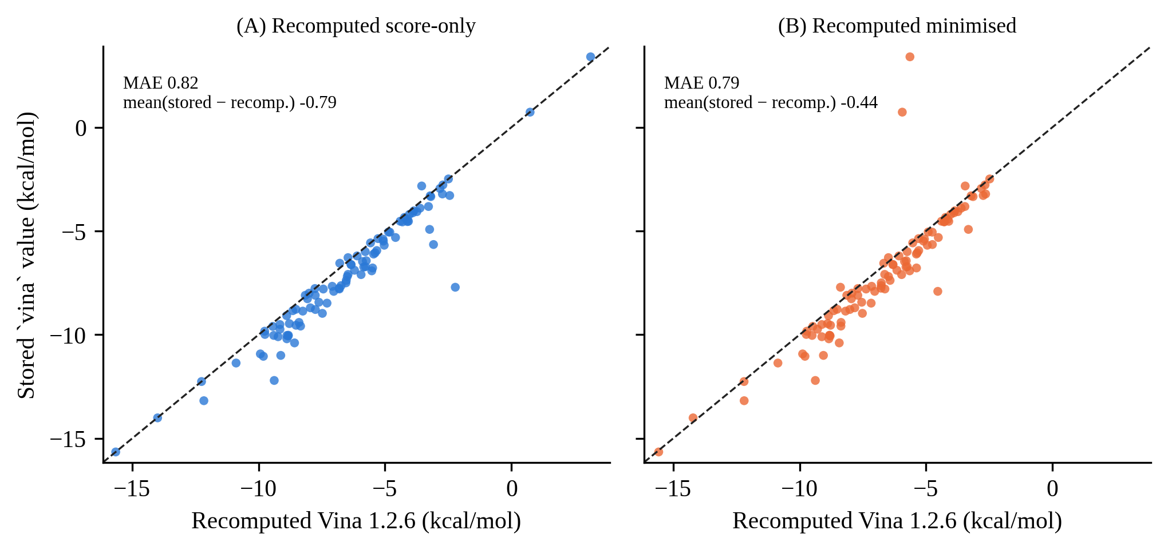
Figure 8.2 The `vina` column of the annotation file against Vina 1.2.6 scores recomputed with this project's preparation for 100 reference poses. (A) Score-only evaluation; (B) local minimisation. The dashed line is the identity.
VIII.2.3 The auxiliary head and label reliability (E2, designed)
The auxiliary head was designed as a per-ligand-atom multi-label classifier with masked, class-balanced binary cross-entropy (positive weights clipped at 10) and a fixed weight of 0.3 chosen a priori, because adaptive weighting schemes each add hyper-parameters and none has been validated for a residual main task with geometry-derived labels. Scrambled labels, permuted across complexes with the same number of ligand atoms so that prevalence and loss scale are preserved while the mapping from geometry to label is destroyed, were the mandatory negative control. Labels were to be computed once, offline, from pockets rebuilt from the data base (13.3 complexes per second; 81 minutes for all 64,888 complexes on two workers; zero failures on a 200-complex sample; interaction labels of 8 reconstructed complexes reproduced those of real receptors in 7 of 8 cases, with one hydrogen bond differing).
The labels were, however, tested for stability under a 0.2 Å Gaussian perturbation of the ligand coordinates (100 complexes). Hydrogen-bond, hydrophobic and salt-bridge labels were reasonably stable (atom-level Jaccard 0.81, 0.69 and 0.81), but π-stacking merged with π-cation was not (Jaccard 0.16; complex-level presence agreement 0.69) (Figure 8.3). This is a stress test of the whole pipeline and not an error rate against a ground truth, which does not exist, but it showed that π-stacking could not be used as a supervision target. It was therefore excluded from the loss (the labels were stored), and E2 would have been limited to three interaction classes. Even the stable classes churn by 20 to 30% at this perturbation, and labels on diffusion-generated poses, which are noisier than 0.2 Å, would be less reliable still.
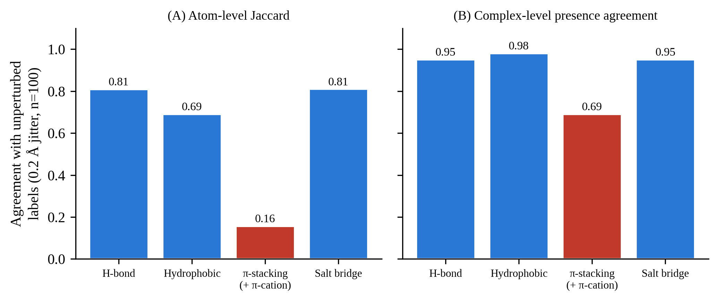
Figure 8.3 Stability of PLIP interaction labels under a 0.2 Å Gaussian perturbation of the ligand coordinates (100 complexes): (A) agreement at the level of atoms (Jaccard index) and (B) agreement at the level of complexes (presence of at least one interaction of the class).
VIII.3 Pre-Registration
VIII.3.1 Arms, metrics and decision rules
The design document was committed before any model was trained, and its criteria were frozen at that commit; later changes were made only as dated amendments (eleven amendments, A1 to A11, none of which changed a threshold; the first eight preceded any training, the next two concerned the audit of earlier work and a literature quotation, and the last, a literature detail, was added after the runs had finished). The arms were the matched control A0′, E1, and E1-MLP, each with three seeds, and, in the second stage, E1+E2 and a scrambled-label control. The reference predictors of Table 8.1 required no training, and two more seeds of the Stage 0 EGNN (seeds 2022 and 2023) were trained to bound the seed variance of the strongest reference. Three metrics were defined: pooled R² on the test set (M1), within-target mean Spearman correlation over the 73 targets with at least 10 complexes, which is the guidance-relevant metric (M2), and the correlation of the prediction with the heavy-atom count (M3). The resampling unit was the target (paired cluster bootstrap, 2,000 resamples, seed 20260925), an arm's value being the mean over its seeds inside each resample, with Benjamini–Hochberg correction across the tests of a stage.
The pass criteria of the first stage were the following.
(C1a) E1 exceeds the Stage 0 EGNN in R² by at least 0.05, with the lower bound of the paired interval above 0. (C1b) E1 exceeds the linear model of Vina score and heavy-atom count, with the lower bound above 0; the decision D3 at the review gate made the joint passing of C1a and C1b the definition of a positive result. (C1c) E1 exceeds the raw Vina score in within-target Spearman correlation, with the lower bound above 0. (C1d) The correlation of the prediction with the heavy-atom count is at most 0.605 (the ground truth 0.555 plus 0.05). (C1e) E1 exceeds A0′ in R², which attributes any gain to the delta target and not to the backbone or the bias.
If the point estimates met a margin but the interval included zero, the outcome was to be reported as inconclusive and never as a positive or a null result. If C1a failed, E1 would be considered falsified at this scale. The second stage (C2a to C2d and the scrambled-label control C3) and the gradient gate C4 (the correlation of the gradient magnitude with the distance to the pocket must have an upper 95% bound below +0.10, against +0.240 in Section V.4) would apply only to arms that passed. The order was a hard rule: after the first stage the work stopped for review, and the second stage was not to start automatically.
VIII.3.2 Power, disclosed in advance and recomputed
The paired standard deviation of the R² difference between two predictors on the 127 target clusters was measured at 0.044 in the planning phase, for single models, and the disclosed detection probability for a true gain of +0.05 was about 21%; the margins were declared a floor for practical relevance and not a promise of detectability. After the runs, the standard deviation was recomputed for the seed-averaged arms actually used and was 0.075 to 0.085, so that the probability of detecting a true +0.05 gain was only about 8 to 10%. This means that the design could not have confirmed a small positive effect. It could, and did, exclude the required one, as shown below.
VIII.4 Infrastructure and Verification
Long runs on a single 4 GB laptop GPU with interruptions require infrastructure that can be trusted. The trainer wrote atomic checkpoints every fixed number of steps and at the end of each epoch, handled termination signals (a SIGTERM mid-epoch produced an atomic checkpoint and an exit code that signals resumption, and a SIGKILL was recovered from the last periodic checkpoint), and resumed exactly. Testing this revealed a real bug: the model was built before the random generators were seeded, so the initial weights were not a function of the seed. After the fix, an interrupted and resumed run was bitwise identical to an uninterrupted run on the CPU (differences exactly 0.0, interrupted mid-epoch 2), and on the GPU the first epoch was bit-identical while later epochs differed at the level of atomic non-determinism (maximum difference of the predictions 0.048 between a resumed and an uninterrupted run, against 0.059 between two uninterrupted runs), so resuming was indistinguishable from re-running. Ten unit tests covered the delta target, its reconstruction and the label scrambling. The analysis pipeline reproduced the recorded R² and Pearson correlation of the Track A model through the new inference path (−0.189 and 0.581), and the fast bootstrap reproduced the frozen reference intervals.
Checkpoint selection was determined by validation data only: the best checkpoint, the learning-rate scheduler, the early stopping (patience 12, at most 30 epochs) and the choice of the readout for the second stage. Test predictions were computed once, from the best checkpoint, after training. This is enforced by an automated static test (five tests: the test split is referenced only at data set construction and inside the final evaluation; the run loop never touches it; the best checkpoint is written only in the branch of a validation improvement), which serves as a positive control against selection on the test set, a practice that has been observed in the field [18]. The audit of the earlier trackers (Section III.8) is the counterpart for the previous work. No interruption occurred in the production runs (zero pause, resume or failure events), so the equivalence of resumed and uninterrupted runs was verified in the dedicated tests, not on the production runs. The first stage cost about 27 GPU-hours (per run 2.2 to 2.6 h for A0′, 2.2 to 2.4 h for E1, 1.5 to 2.8 h for E1-MLP, and 3.3 to 3.5 h for each extra EGNN seed).
VIII.5 Results of the First Stage
VIII.5.1 Predictive quality
Table 8.2 and Figure 8.4 show the test-set results. The delta model with the physics head (E1) reached a mean R² of 0.117 (target-clustered 95% CI −0.197 to 0.316; per seed 0.102, 0.176 and 0.074). The absolute-target control on the same backbone (A0′) reached 0.259 (0.099, 0.360), the Stage 0 EGNN 0.342 (0.160, 0.465), and the linear model of Vina score and heavy-atom count 0.362 (0.200, 0.470). The MLP readout was worse and unstable (mean −0.212; per seed −0.391, −0.368 and +0.123). The within-target Spearman correlation of every arm was between 0.18 and 0.27 with strongly overlapping intervals (Figure 8.5); no model demonstrated a within-pocket ranking clearly above the raw Vina score (0.248).
Table 8.2 Track E, first stage: test-set results (127 targets; seed-averaged; target-clustered 95% CI)
Model | Per-seed R² | Mean R² (95% CI) | Within-target Spearman | Correlation with heavy atoms
E1 (Δ target, physics head) | 0.102 / 0.176 / 0.074 | 0.117 (−0.197, 0.316) | 0.258 | 0.677
E1-MLP (Δ target, MLP head) | −0.391 / −0.368 / 0.123 | −0.212 (−0.806, 0.130) | 0.269 | 0.576
A0′ (absolute target, same backbone) | 0.275 / 0.259 / 0.242 | 0.259 (0.099, 0.360) | 0.225 | 0.611
Stage 0 EGNN (pre-registered reference) | 0.342 | 0.342 (0.160, 0.465) | 0.195 | 0.719
EGNN, three seeds | 0.342 / 0.347 / 0.406 | 0.365 (0.196, 0.477) | 0.180 | n/a
Linear: Vina + heavy atoms | n/a | 0.362 (0.200, 0.470) | 0.266 | 0.940

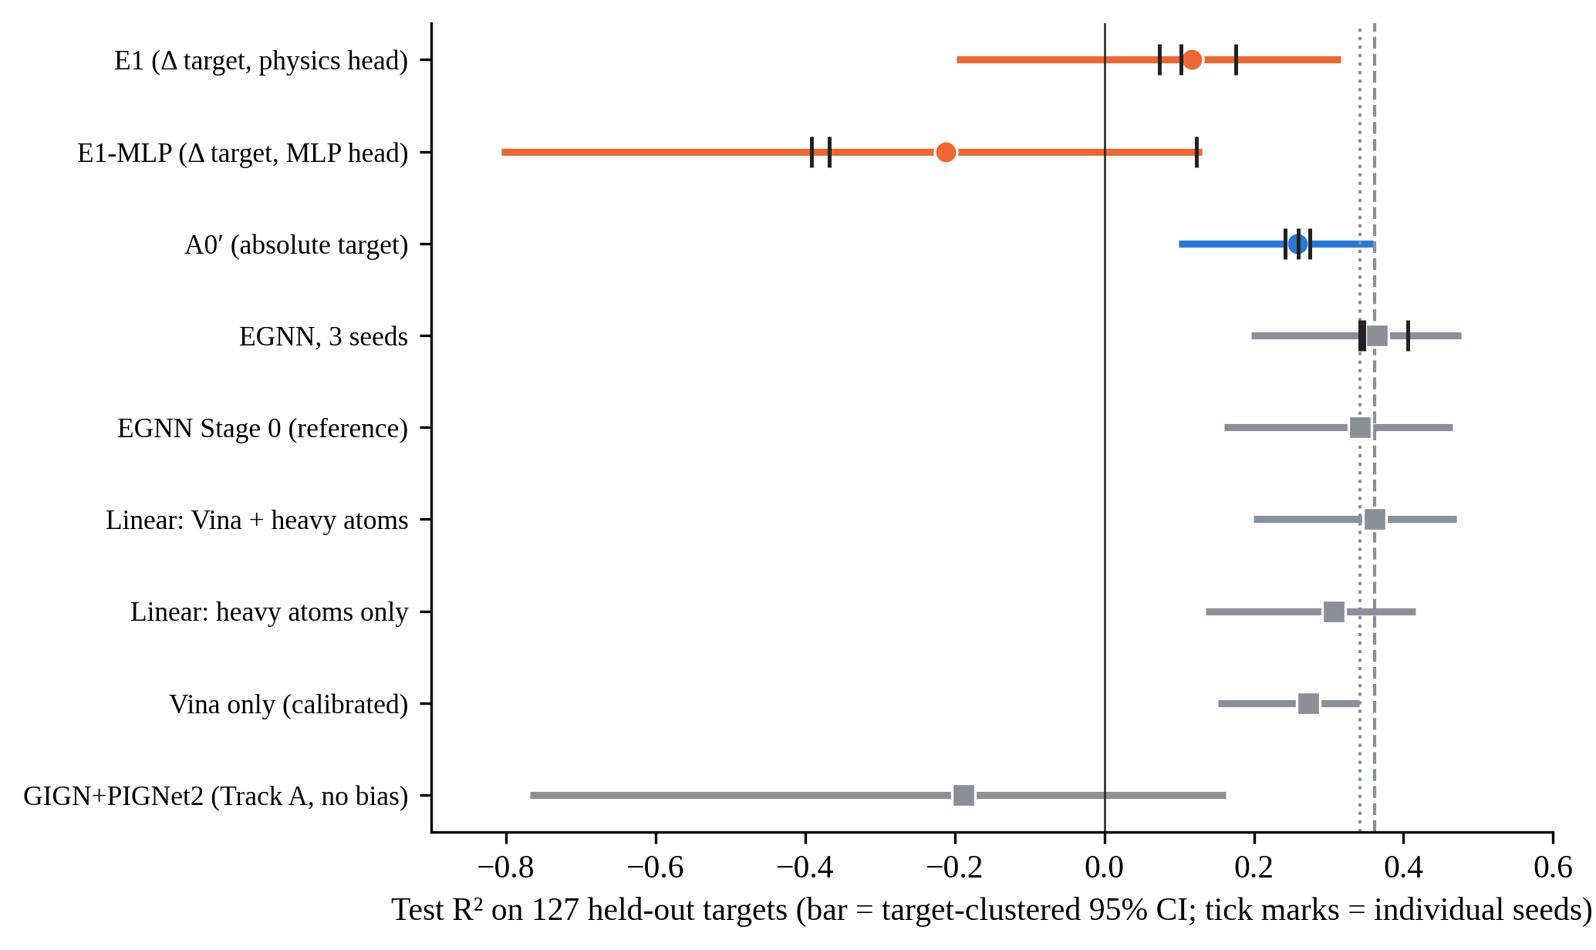
Figure 8.4 Test R² of the Track E arms and the reference predictors on 127 held-out targets. Bars: target-clustered 95% confidence intervals; ticks: individual seeds; dotted and dashed vertical lines: the Stage 0 EGNN and the linear Vina + heavy-atom baseline.
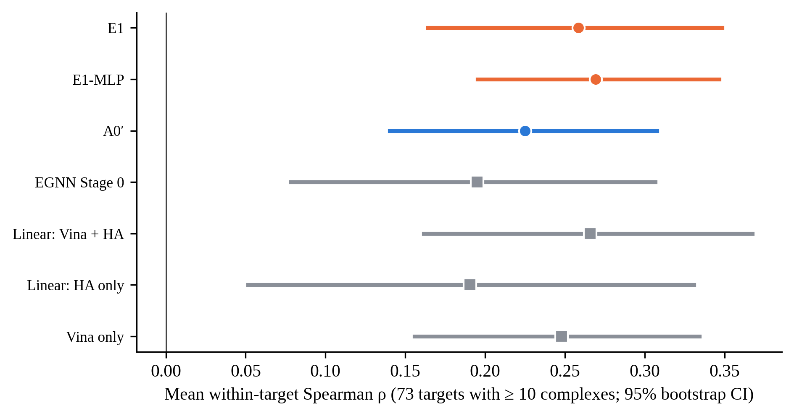
Figure 8.5 Mean within-target Spearman correlation over the 73 test targets with at least 10 complexes (95% bootstrap intervals). All arms overlap with raw Vina.
VIII.5.2 Pre-registered criteria
E1 failed every criterion (Table 8.3). The interval of the difference from the Stage 0 EGNN (−0.224; 95% CI −0.422 to −0.091) lay entirely below the required +0.05 and below zero, and the same was true for the difference from the linear baseline (−0.244; −0.444 to −0.121). The comparison that isolates the delta target, against A0′ on the same backbone, gave −0.141 (−0.318 to −0.026), so the delta target did not help and was worse at the 95% level (the 99% interval, −0.379 to +0.007, just includes zero). E1 was not different from raw Vina in within-target ranking (+0.010; −0.018 to +0.038). The heavy-atom guard was also failed (0.677 against the limit 0.605). E1-MLP failed as well (difference from the EGNN −0.553; −1.085 to −0.249), and it passed the size guard only because it was a poorer predictor overall. All BH-adjusted one-sided p-values for the hypothesis that E1 is better were 1.0 (unadjusted 0.25 to 1.00). Effect sizes were z = −2.63 (C1a), −2.97 (C1b) and −1.83 (C1e), and the paired Cohen's d_z of the per-target squared error against the linear baseline was −0.33.
Table 8.3 Pre-registered criteria of the first stage, applied to E1 (seed-averaged; difference = E1 minus reference)
ID | Test | Difference (95% CI) | 99% CI | Verdict
C1a | R² against the Stage 0 EGNN (needs at least +0.05 and lower bound > 0) | −0.224 (−0.422, −0.091) | (−0.499, −0.063) | Fail; significantly worse
C1b | R² against Vina + heavy-atom linear (lower bound > 0) | −0.244 (−0.444, −0.121) | (−0.513, −0.092) | Fail
C1c | Within-target Spearman against raw Vina (lower bound > 0) | +0.010 (−0.018, +0.038) | (−0.028, +0.048) | Fail; not different
C1d | Correlation with heavy atoms at most 0.605 | 0.677 | n/a | Fail
C1e | R² against A0′ (lower bound > 0) | −0.141 (−0.318, −0.026) | (−0.379, +0.007) | Fail; the delta target did not help
Sensitivity | R² against the three-seed EGNN mean | −0.247 (−0.426, −0.134) | (−0.486, −0.108) | Fail; same conclusion

The outcome is not inconclusive in the sense of the pre-registered rule. The design was underpowered to confirm a small gain, but the upper bounds of the three decisive intervals (−0.091, −0.121 and −0.026) lie below zero, so a positive difference of the required size is excluded at this scale. The verdict of the frozen rule was that E1 was falsified at this scale: the tested delta-learning configuration (this backbone, this anchor, this loss, three seeds, the 127-target leakage-safe test set) was falsified against its pre-registered criterion at the evaluated scale, not delta-learning as a general methodology, which other backbones and feature sets have been reported to use successfully elsewhere (Section II.6) and which Section VIII.7 returns to explicitly. The second stage was not run, and neither were the conditional gradient-surgery arm, the sensitivity to the auxiliary weight, or the gradient gate C4, since no arm passed the first stage.
VIII.6 Why the Delta Target Failed
Four pieces of evidence, all measured, explain the result, and they are separated here from the hypotheses that were not tested.
(i) The residual was almost unlearnable from structure by this model (Figure 8.6). The best validation loss of E1 (0.87 to 0.96 in standardised units) was about that of a predictor that always outputs the mean residual (0.92 on the validation set), whereas the absolute-target control genuinely learnt (0.68 to 0.73). The MLP readout had validation losses of 1.02, 1.02 and 0.87 for its three seeds, that is, worse than the constant for two of them.
(ii) The constant residual already scored R² = 0.193 on the test set (ŷ = pK_Vina plus the mean residual), and E1 (0.117) did not exceed it, so the learnt correction added nothing measurable beyond the Vina anchor.
(iii) Both delta arms had their best checkpoint at epoch 1 or 2 (E1-MLP once at epoch 13) and then overfitted, with the training loss falling to about 0.25 while the validation loss increased, as the absolute-target arm and Track A did.
(iv) The reconstruction inherits the size behaviour of the anchor (the correlation of the prediction with the heavy-atom count was 0.68, against 0.56 for the ground truth), so the delta target did not remove the size shortcut from the predictions although it removed it from the target.
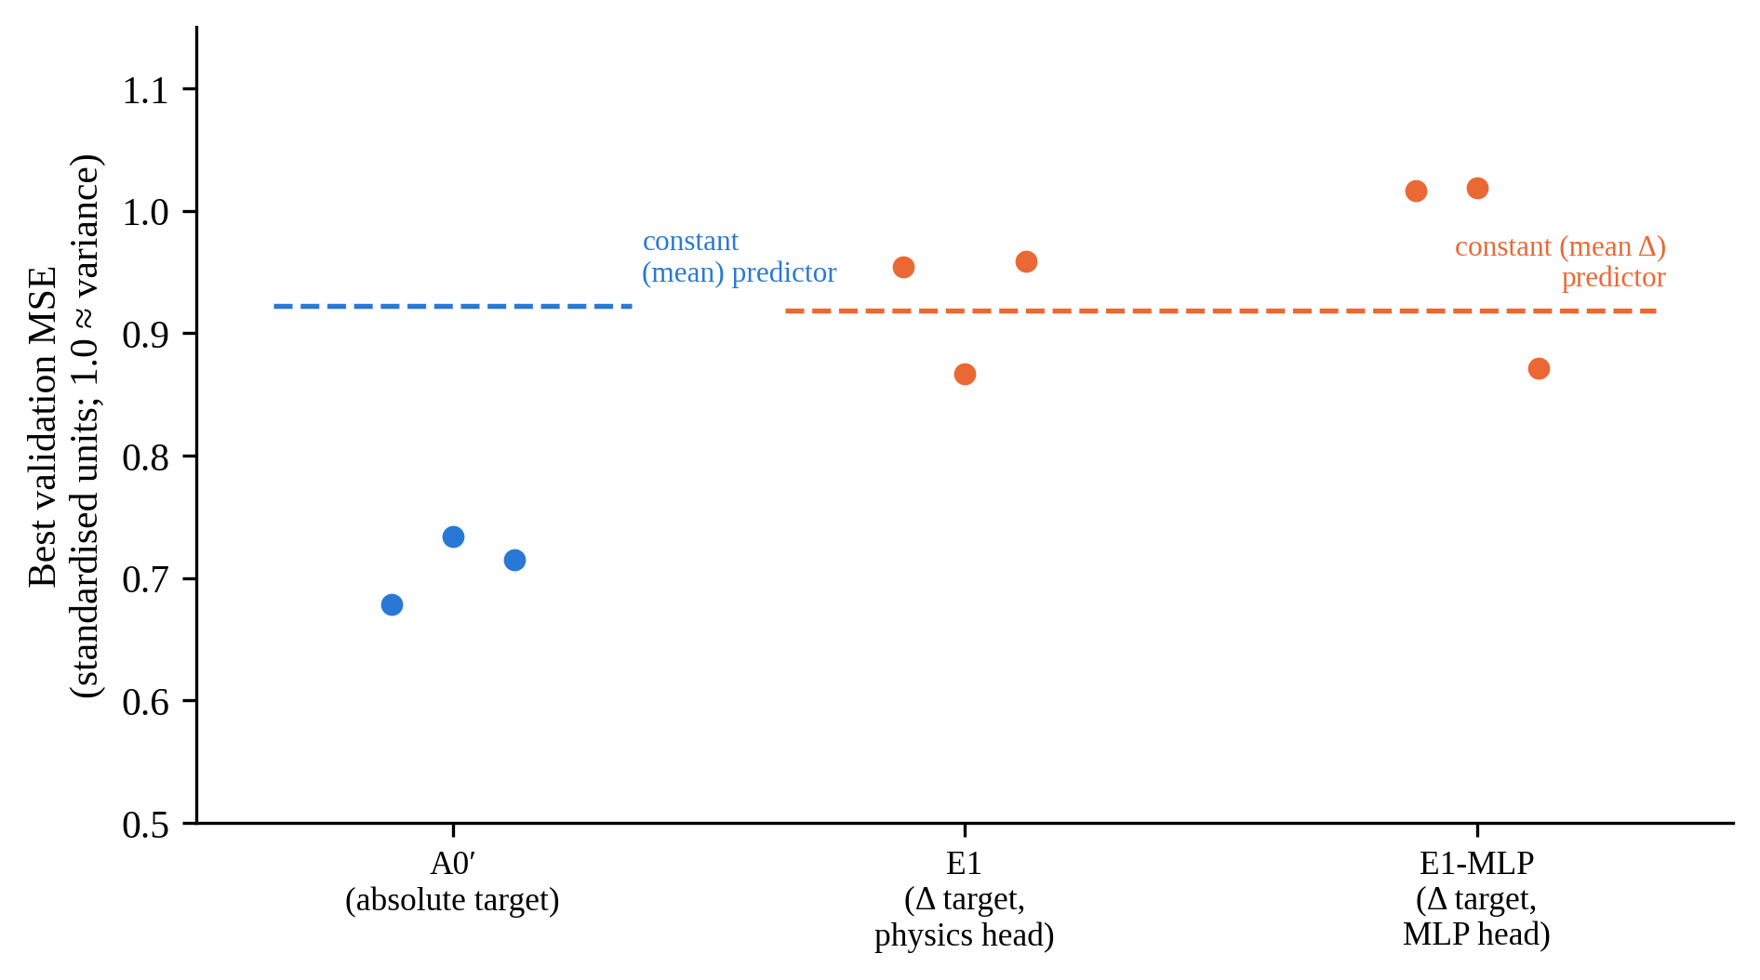
Figure 8.6 Best validation error (standardised units; 1.0 corresponds to the variance of the target) of the three arms for each seed. Dashed lines: error of a constant predictor. The absolute target is learnt; the delta target is not learnt better than by a constant.
A fifth observation is a caveat and not a finding: the GIGN + PIGNet2 backbone was itself weaker than the EGNN under this budget (A0′ 0.259 against 0.34 to 0.41), so E1 was tested on the weaker of the two backbones. The comparison C1e is independent of the backbone, and it failed too. Three hypotheses were not tested and must not be stated as findings: heterogeneity of the pK labels (Ki, Kd and IC50 are mixed), the cross-docking provenance of the data set (the receptor and the ligand of a pose can come from different structures, so that the label refers to the ligand's measured binding and not necessarily to that receptor conformation, a source of label noise that affects all arms equally and limits the absolute R²), and the 0.8 kcal/mol preparation noise of the anchor, which may cap how much of Δ any structure model can recover.
VIII.7 Limits of the Conclusion
The conclusion is limited to this architecture and training budget, three seeds, a 127-target test set, the cross-docked label regime and a fixed, unweighted squared-error loss. It does not show that delta-learning fails in general: tree-ensemble models of a residual on hand-built features have been reported to succeed [47], [51], and a different backbone could behave differently. It does not show that E2 cannot help, since E2 was defined as an addition to a working E1 and E1 did not work. E1 was tested for scoring only. The results of this stage also show that its own design could not have confirmed a small effect (detection probability 8 to 10%), and that the seed variance of the EGNN reference (0.342, 0.347, 0.406) is smaller than the shortfall of E1 (0.22 to 0.25).
Three optional analyses that would need no retraining were proposed and not carried out: a robustness test that perturbs the anchor at test time, a re-scoring of previously generated molecules with early-recognition metrics, and any new hypothesis such as E2 on the absolute target or a different backbone, which would need a separate scoping decision. The E2 budget of about 28 GPU-hours was left unspent.
VIII.8 Position in the Literature
To the best of the search that could be performed (with the stated limits: a bibliographic search with the tools available, a verification of the most relevant sources by their abstracts or texts, and one paper, DiffInt, whose training loss could not be confirmed), no study was found that combines (a) a delta-learning target against a docking score, (b) a typed per-atom interaction classification loss from PLIP as auxiliary supervision of a separate guidance predictor, and (c) the use of that predictor's gradient to steer a frozen 3D diffusion generator. Typed interactions enter diffusion pipelines in three different ways, none identical to E2: as inference-time conditioning (DeepICL [57]), as co-generated diffusion outputs (BInD [28]), and as an auxiliary classification loss inside the generator's own denoiser (InterDiff [49]). The claim of novelty is therefore restricted to the combination, formulated as "we did not find", and Track E does not introduce a new architecture. The name of the "Delta Score" of the evaluation literature [18], which is a specificity metric computed against a randomly chosen off-target pocket, is unrelated to the residual target used here. Because the second modification was not run, the combination was designed and pre-registered but not tested; what was tested is the first component.
VIII.9 Summary of the Chapter
A pre-registered, verified and adequately reported test of delta-learning against a Vina anchor did not improve the affinity predictor. It was significantly worse than the Stage 0 EGNN and a two-feature linear baseline, it did not beat an absolute-target control on the same backbone, its best validation error did not beat that of a constant predictor, and its within-pocket ranking was not better than that of raw Vina. The negative result closes the last of the routes tested in this thesis and, with Chapters V to VII, shows that neither a change of the predictor architecture, of the guidance mechanism, of the target of guidance, nor of the training target rescued gradient guidance in this setting.

CHAPTER IX
SYNTHESIS AND DISCUSSION
This chapter draws the experiments of Chapters IV to VIII together. It states what the evidence supports and with what strength, discusses alternative explanations and threats to validity, and relates the findings to the literature. Statements are graded: a measured fact is a number that was computed in this work; a consistent interpretation is one that the measurements are compatible with and that no measurement contradicts; and a hypothesis is an explanation that was not tested.
IX.1 Summary of the Evidence
Table 9.1 summarises the routes. Each row states what was changed relative to the previous routes, the outcome on the pre-declared criteria, and the main limitation of that route. Every route either failed its pre-declared correction (Tracks A, B and D; the baseline ablation) or produced an apparent gain that a size- or validity-normalised re-analysis invalidated (Track C) or a result significantly worse than a simple baseline (Track E).
Table 9.1 Summary of the experimental routes
Route | What was varied | Outcome | Main limitation
Baseline ablation (IV) | Guidance strength λ, original and repaired EGNN predictor | No effect on independent Vina Dock at any tested strength (20 pockets; 8 pockets, 3 strengths); fragmentation at large λ | Predictor is size-correlated (0.72); position-only guidance
Track A (V) | Predictor architecture (physics-anchored GIGN + PIGNet2) | 0 of 24 comparisons significant; direction consistency 89% to 67% with more data; PoseBusters collapse at λ = 1.0 | 8 pockets, n = 30; per-pocket detectable shift about 1 to 1.4 kcal/mol
Track B (V) | Scale (B1), objective (B2) and timing (B3) of the gradient | 0 of 23 comparisons significant; B2 worse by median in 6 of 6 with severe validity loss | 2 to 3 pockets, n = 20
Diagnostic (V) | Gradient direction of the EGNN | Gradient magnitude correlates with distance to pocket (+0.240) and not with heaviness (−0.127) | One predictor; correlational
Track C (VI) | Non-gradient use as a ranker (top 10%) | Raw docking gain in 12 of 15 pockets turns into worse ligand efficiency in 14 of 15, +12 heavy atoms, −29 points PoseBusters | Unguided pools; one ranker
Track D (VII) | Target of guidance: synthesizability | No supported gain; divergence between own and independently computed score in the exploratory design, not confirmed statistically | One pocket for the powered test; three proxies tested for the mechanism
Track E (VIII) | Training target: delta against Vina | Significantly worse than the Stage 0 EGNN and a two-feature linear baseline; not better than a constant in validation | Scoring only; E2 not run; weaker backbone

Figure 9.1 shows the same pattern from a different angle: the fraction of pre-registered comparisons that survived Benjamini–Hochberg correction, for every checkpoint that used the shared KS-test protocol of Section III.6.1. Every gradient-based checkpoint (Tracks A, B and the powered Track D comparison) has a fraction of exactly zero; the one checkpoint with a large surviving fraction is the rejection-sampling ranker of Chapter VI, and that checkpoint is precisely the one whose apparent raw-score gain did not survive the size-normalised re-analysis of Chapter VI. A high fraction of significant comparisons is, in this one case, a measure of a confound surviving the correction, not a measure of successful molecular design; Figure 9.1's own caption states this explicitly for the same reason.
Table 9.2 restates the five main-thesis routes as a claim, its measured evidence, and the exact scope within which the claim holds, so that no claim in this thesis is read more broadly than its evidence supports.
Table 9.2 Claim, evidence and scope, Tracks A to E
Route | Claim | Measured evidence | Scope of the claim
Track A (V) | A physics-anchored predictor of comparable quality does not rescue gradient guidance | 0/24 KS tests significant after BH correction; direction consistency fell from 89% to 67% between tiers | Holds for this predictor, this pocket set (8 pockets, n=29–30) and λ up to the validity ceiling; does not exclude a smaller effect below the ~1–1.4 kcal/mol detectable shift (Section V.1, Figure 9.2)
Track B (V) | Rescaling, reformulating or time-windowing the gradient on a fixed representation does not rescue guidance | 0/23 KS tests significant; one variant (B2) worse by median in 6/6 comparisons | Holds for the Stage 0 EGNN representation, 2–3 pockets, n=20; does not test a representation change (that is Track A)
Track C (VI) | Non-gradient, post-hoc top-k selection does not produce a defensible improvement | Raw Vina Dock gain in 12/15 pockets; ligand efficiency worse in 14/15; PoseBusters pass rate down 29 points on average | Holds for top-10% selection from unguided pools by this ranker, 15 pockets; sensitivity analysis shows the raw effect weakens further at larger k; a size-controlled ranker was not tested
Track D (VII) | Gradient guidance toward synthesizability gives no supported gain | 0/5 KS tests significant at the powered scale; own-score/independent-score divergence reproduced in sign but not confirmed statistically | Rests on one pocket at adequate power (the powered tier); the exploratory-design divergence is suggestive, not established, and the mechanism of the divergence is undiagnosed
Track E (VIII) | A residual (delta) training target, reconstructed against a Vina anchor, is worse than simple baselines on this backbone | E1 R²=0.117 (95% CI −0.197, 0.316), significantly below the Stage 0 EGNN, the linear baseline and the absolute-target control on the same backbone, by a pre-registered test | Bounded to this architecture, training budget, three seeds, the 127-target leakage-safe test set and the cross-docked label regime (Section VIII.7); does not generalise to delta-learning with other backbones or hand-built features

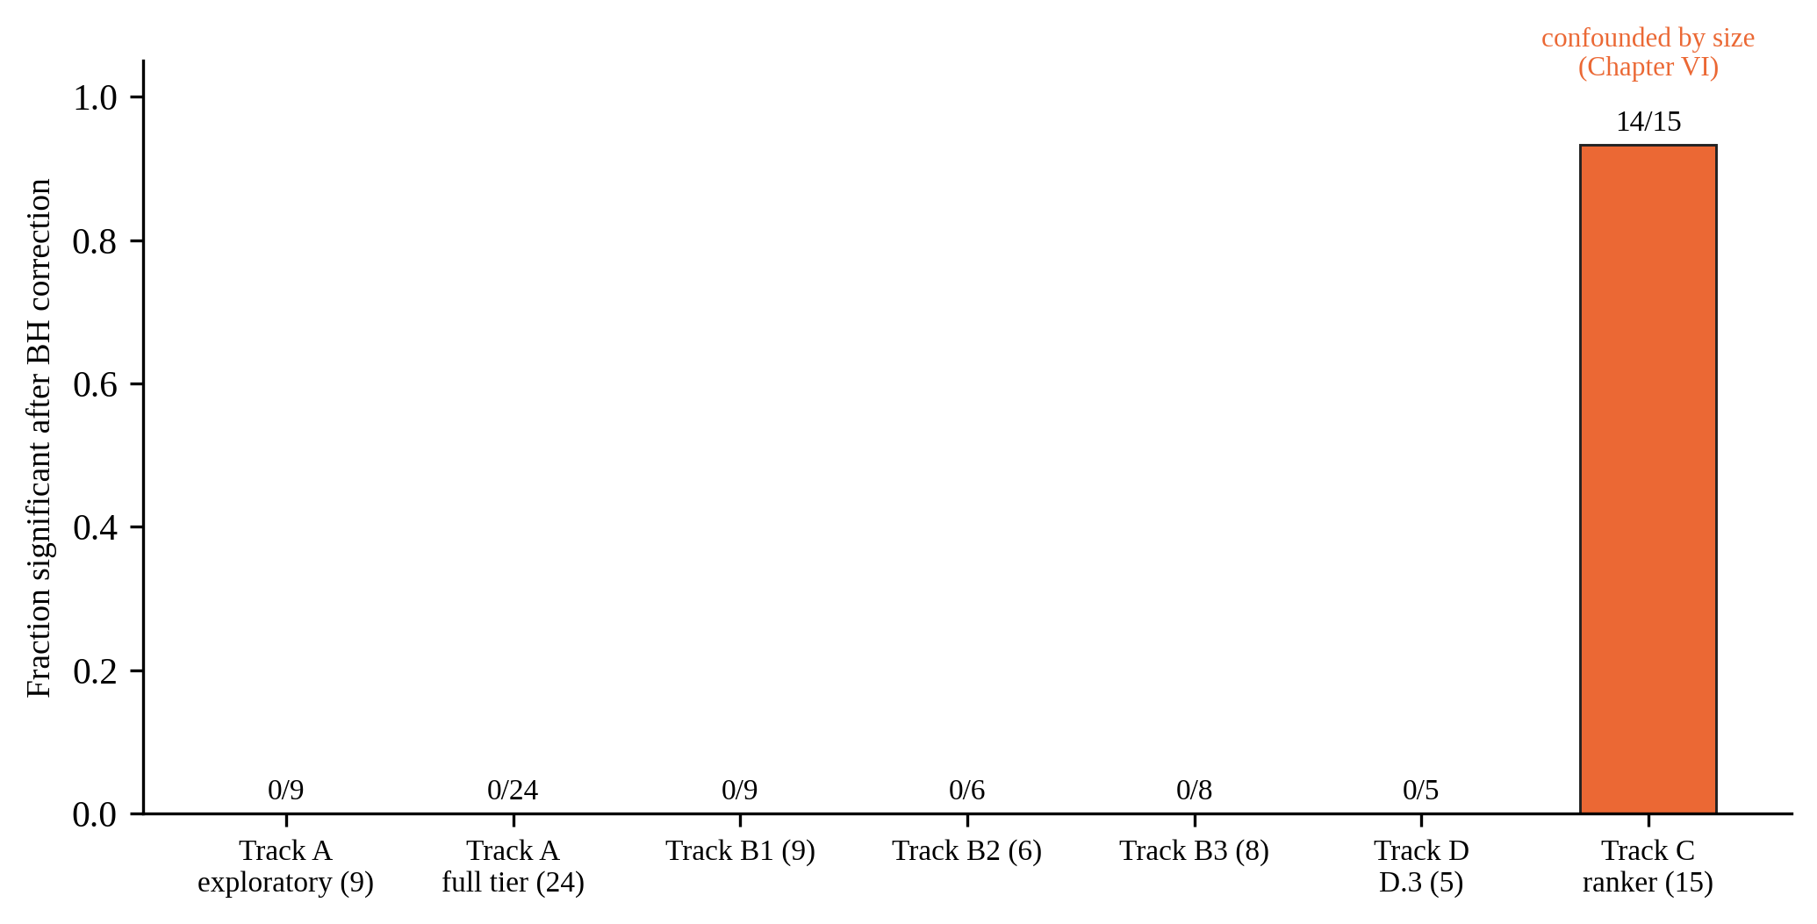
Figure 9.1 Fraction of comparisons significant after Benjamini–Hochberg correction, for every checkpoint that used the KS-test protocol of Section III.6.1. Counts in parentheses are the number of comparisons in that checkpoint. This fraction is a measure of statistical significance, not of successful molecular design: the large surviving fraction corresponds to the Track C ranker, whose raw docking improvement did not survive the size-normalised evaluation of Chapter VI and was accompanied by reduced physical validity.
IX.2 What the Evidence Supports
IX.2.1 Main finding
Under the conditions tested (a frozen TargetDiff model, position-only guidance on the clean-data estimate, predictors trained on clean docked poses, evaluation with Vina docking, PoseBusters, ligand efficiency and the RAscore, and pocket sets of 1 to 20 targets) neither the gradient of a learned affinity predictor, nor its use as a ranker, nor the gradient of a learned synthesizability predictor produced a defensible improvement. The result was reproduced for predictors of different quality (Pearson correlation 0.58 to 0.65 on leakage-safe test sets), architecture and target, and it was not explained by low predictor accuracy or by a bad choice of strength, since the strength was varied over three orders of magnitude and the structural integrity of the molecules limited it from above.
IX.2.2 Predictor quality is not guidance usefulness
A conceptual point runs through every route of this thesis and is stated here explicitly because it is easy to miss when each result is read on its own: a predictor that is accurate on a held-out test set does not thereby imply that its gradient, or its score, is useful for steering a generator. The two quantities were measured separately throughout, and they dissociate. The clearest demonstration is post-synthesis: of the eight further checkpoints of Appendix E, the one with the best predictive quality of any variant tried (ESM2-augmented EGNN, Pearson 0.731, Appendix E.2.3) and the one trained with the entire target protein family held out of training (R² = 0.507 on that unseen family, Appendix E.3.2) both still show a null real-docking effect under the same correction as every other checkpoint. Within the main thesis, the same dissociation is visible in the other direction: the two-feature linear baseline and the repaired EGNN were statistically indistinguishable on the LP test set (Chapter IV), yet neither produced a detectable gradient effect, and the ranker of Chapter VI produced its one large, statistically decisive effect precisely because its moderately accurate predictor's score was dominated by a ligand-side property (size) that a generator can trivially exploit, which is a case of a predictor being too usable for the wrong reason. Accuracy on the held-out prediction task and usefulness as a steering signal are different properties, tested by different protocols (Section III.6.1 and III.6.3), and this thesis finds them uncorrelated across every architecture, training recipe and representation tried.
IX.2.3 Grading the explanations
Measured. (i) The affinity predictors' outputs are strongly correlated with the ligand size (0.64 to 0.72). (ii) Selection by the ranker enriches larger molecules by about 12 heavy atoms and lowers physical validity by about 29 percentage points, and the raw docking gain does not survive normalisation by size. (iii) The magnitude of the affinity gradient is positively correlated with the distance of an atom from the pocket (+0.240; 95% CI 0.194 to 0.285) and not with its heaviness. (iv) The delta target is not learnt better than a constant by the model used.
Consistent. The failure of the gradient routes and the failure of the ranker route are compatible with a common upstream cause: a point predictor trained to minimise the error of the experimental affinity encodes ligand-side properties (size), which are informative for the average complex, and not the pocket-specific interactions that a generator would need to exploit. The gradient diagnostic (iii) is compatible with this reading, and so is the null result of every mechanism that left the representation unchanged (B1 to B3). The evidence for a common cause is, however, indirect: the two failures have different measured signatures, and the earlier project summaries that stated that the size confound was the root cause of both were not supported by the data. The gradient is not correlated with heaviness in the direction that a size shortcut would predict (Section V.4); the ranker's selection is dominated by size (Chapter VI).
Hypotheses, not tested. (a) The mismatch between the clean, docked poses on which the predictors were trained and the noisy clean-data estimates on which they are evaluated during sampling may make the gradient unreliable at early steps. A related study reports that an interaction prior pretrained on accurate poses degraded generation when queried on noisy intermediate structures [22]. (b) The evaluation target was Vina, whereas the predictors were trained on experimental affinities; a predictor of the Vina energy itself, evaluated by Vina, would ask a different question from the one tested here. (c) Position-only guidance may be too weak or too blunt: the gradient of atom types was set to zero, and the gradient was not propagated through the denoiser. (d) For synthesizability, a smooth 3D gradient may be a poor way to steer a fingerprint-based target.
Hypotheses (a) and (c) were, in fact, tested directly in a follow-up investigation of 18 further independently-trained checkpoints, run after this synthesis and reported in full in Appendix E: a noise-matched training curriculum (testing (a)) and a direct, step-by-step trace of the guidance nudge through the reverse-diffusion trajectory of one molecule (testing (c)). Neither rescues a real guidance effect, and the trace gives a specific mechanistic account of why: the nudge is small enough, for most of the trajectory, to be statistically buried in the sampler's own intrinsic step noise, and only compounds to a sub-Ångström, late-trajectory effect too small to move the docking outcome in a corrected, reproducible way (Section E.5). Hypothesis (b), by contrast, was addressed only partially: a Vina-derived training target was tried (Appendix E.2.1) and also did not change the outcome, though a predictor of the Vina energy architecture itself, rather than just its label, remains untested.
IX.2.4 The role of statistical power
Most of the results are null results, and a null result is only as informative as the design that produced it. For the per-pocket gradient tests the detectable shift was about 1 kcal/mol at the nominal level and 1.4 kcal/mol after correction (Section V.1). Effects smaller than that cannot be excluded at the pocket level, and pooled tests suggest that pooled effects are small (Chapter IV). The routes with a strong, consistent effect, the ranker of Chapter VI (a shift of −1.31 kcal/mol on average, with 14 of 15 pockets significant), were detected, and the loss of physical validity in the gradient routes at large λ was detected and was dose-dependent. The design could therefore detect large effects of both signs. It could not detect small beneficial effects, and it was not designed to. The stated conclusion is thus "no effect of practical size was found", and not "no effect exists". For Track E the power calculation was reported in advance and again after the runs, and the result excluded the required effect.
Figure 9.2 makes this quantitative. Using the standard two-sample power formula and the within-pocket Vina Dock standard deviations actually measured in this project's sweeps (1.1 to 1.6 kcal/mol; Chapters IV and V), the minimum shift detectable at 80% power with 20 molecules per condition (the size used in most of Track B) is about 1.0 to 1.4 kcal/mol at the nominal 5% level, and about 1.4 to 2.0 kcal/mol once a Bonferroni-equivalent correction for 24 simultaneous tests is applied; at 30 molecules per condition (Track A's full tier and the Task F ablation) the corresponding range is about 0.8 to 1.6 kcal/mol. This is a standard calculation from a textbook formula, not a new measurement; it is shown to make the qualitative statements above precise and falsifiable.
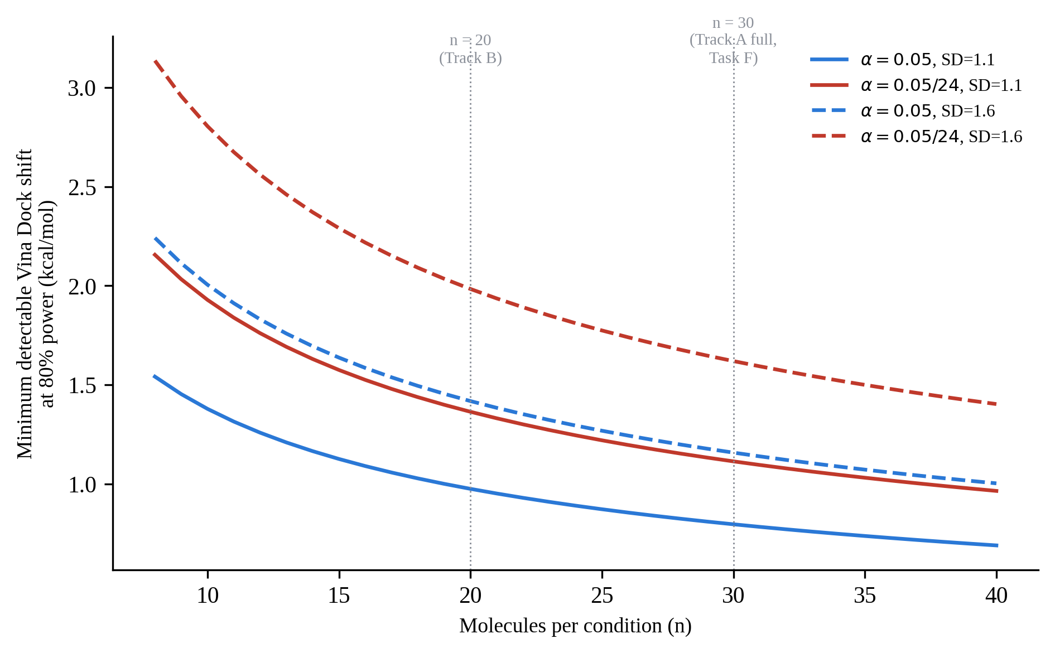
Figure 9.2 Minimum Vina Dock shift detectable at 80% power as a function of the number of molecules per condition, computed from the two-sample normal-approximation formula at the range of within-pocket standard deviations measured in this project (1.1 to 1.6 kcal/mol), at the nominal 5% level and at a Bonferroni-equivalent level for 24 simultaneous tests. Vertical lines mark the sample sizes actually used in Track B (20) and in Track A's full tier and the Task F ablation (30).
IX.3 Methodological Findings
Several results of this work concern the evaluation of learned guidance and predictors, and they are, together with the negative outcome, the main transferable findings.
The split can create a generalisation gap. A validation set that shared 74% of its targets with the training set and a test set of 27 pockets gave a picture of a poor and unfixable predictor (R² = −0.54; a ligand-only baseline that matched the network). A target-disjoint split with 127 test targets showed R² = 0.34 and a nominal margin over the ligand-only baseline for the same architecture and hyper-parameters (Chapter IV). The earlier diagnostics were correct measurements of the wrong split, and a causal story built on them was revised.
The unit of resampling matters. Resampling complexes instead of targets gave intervals about eight times too narrow (Chapter VIII). The margin over simple baselines that the narrow interval suggested was not supported by the target-clustered interval: the EGNN was statistically indistinguishable from a linear model of two scalar features.
Leakage can go unnoticed on either side of the coupled title. The reported quality of the synthesizability predictor came from a random split without a held-out test set, and dropped when re-evaluated on a target-disjoint set (although the comparison was not controlled).
Summary statistics can mislead. One malformed pose (+286.58 kcal/mol) shifted a mean by 14 kcal/mol; medians and rank-based tests were reported next to means. A fragmentation check did not detect the loss of physical validity that PoseBusters detected. A raw docking gain of 1.3 kcal/mol was an artefact of size, visible only after normalisation. A three-pocket exploratory tier with eight of nine effects in the correct direction became 16 of 24 in a properly sized replication that included the same pockets.
Negative controls and gates worked. The scrambled-filter control found no implementation error in the ranker analysis; the pre-declared gates stopped work on unresolved results (D.4 in Track D, E2 in Track E) and made the decision to stop transparent; the automated test of test-set isolation gives a positive control for a practice that is documented to be common in the field [18].
Errors were found by the process and reported. They include a receptor-file mirror with a different coordinate frame, a truncation of pools to a single seed in an exploratory analysis, the seeding order bug of the trainer, two errors of the differentiable bond estimator, and inconsistent counts in earlier finding documents (for example, the Track B2 count of comparisons worse by median, and a statement about ligand-efficiency degradation in Track B3). The numbers of this thesis were re-derived from the raw result files.
IX.4 Threats to Validity
IX.4.1 Internal validity
The predictors were each trained once for the guidance experiments (the Track E arms and the EGNN reference had three seeds); the seed variance of the guidance predictors was therefore not measured. The pocket sets differ between routes (1, 3, 8, 15 and 20 pockets), and the exploratory tiers used 2 to 3 pockets and 20 molecules per condition, so their power was low. Figure 9.3 shows this variation directly: the evidentiary base of Track C's ranker result (15 pockets, pools of about 590 molecules) and of Track E's scoring result (127 targets) is substantially larger than that of any single gradient-guidance checkpoint (1 to 20 pockets, 8 to 30 molecules per condition), which is why the former two produced statistically decisive results (a confounded positive and a confirmed negative, respectively) while most gradient checkpoints produced only a bounded null. Docking used Vina with exhaustiveness 8 for most gradient routes and 16 for the ablations, and a single docking program was used as the main outcome. Statistical tests were corrected within a checkpoint but not across checkpoints, and several analyses were post hoc and flagged as such (the pocket-size analysis of Chapter VI, for example). The Track D result in the powered design rests on a single pocket.
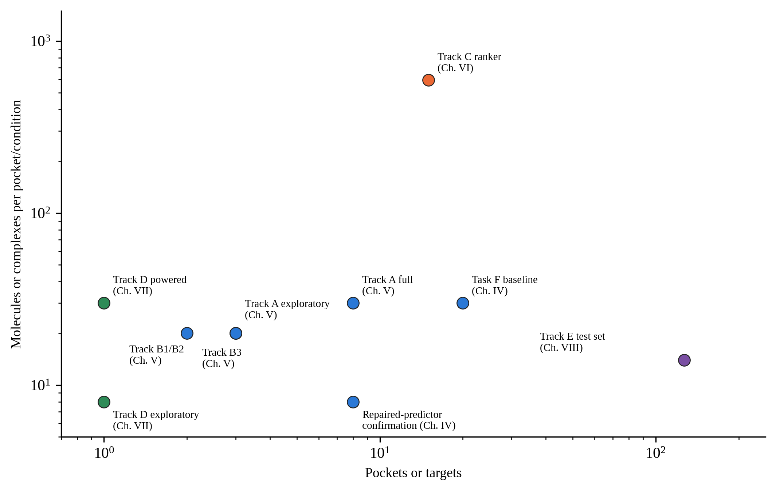
Figure 9.3 Number of pockets or targets against the number of molecules or complexes evaluated per pocket or condition, for every checkpoint of Chapters IV to VIII (logarithmic scales). The pocket/molecule counts are those already stated in the corresponding chapter.
IX.4.2 External validity
All results concern one generator (TargetDiff), one data set (CrossDocked2020, whose poses are cross-docking outputs whose selection is known to be biased toward ligands favoured by docking software [18]), guidance on the clean-data estimate, and position-only steering. Nothing in this work bears on guidance that is trained on noisy inputs, that propagates the gradient through the denoiser, that also steers atom types, or that uses a generator with a different conditioning scheme. The reference frame for the outcome was docking, which is itself an approximation of binding; no experimental validation was possible.
IX.4.3 Construct validity
The RAscore is a proxy of synthesizability. Vina Dock is a proxy of affinity that is size-biased [50]; ligand efficiency and PoseBusters were used to control this, but they are proxies too. The experimental pK labels are heterogeneous (Ki, Kd, IC50) and attached to docked poses whose receptor may come from a different structure, which limits the absolute quality of any predictor and affects all arms equally.
IX.5 Relation to the Literature
The results agree with three lines of published work. First, docking scores of generated molecules are known to be inflated by the size and chemistry of the ligand, and it has been observed that some models use trained Vina predictors to guide sampling at the cost of hacking the score [18], [50]; Chapter VI shows the mechanism in an isolated setting, a ranker whose selection is dominated by size, although the observation of that study concerned evaluation and not gradient guidance. Second, learned affinity predictors are sensitive to leakage and to ligand-only shortcuts [19], [30], [46]; the size correlation of 0.64 to 0.72 of the predictors and the match between a ligand-only baseline and the network on the old split are instances. Third, the mismatch between clean training inputs and noisy intermediate inputs has been reported to degrade guidance-like priors [22].
The results do not contradict studies that report improved docking scores with interaction-aware generation [28], [49], [57], because those studies place the interaction information in the generator (as conditioning, as a co-generated output or inside the denoiser's loss), and not in a separate guidance predictor, which is the design that was tested here. Whether interaction supervision would rescue a guidance predictor (the E2 hypothesis) remains untested in this work.
IX.6 Implications and Recommendations
For practitioners who want to steer a frozen generator with a learned predictor, the results suggest four checks that can be made cheaply before a costly sampling study: (i) evaluate the predictor with a target-disjoint split and target-clustered intervals; (ii) test its output against ligand size and against ligand-only baselines; (iii) measure the direction of its gradient against pocket-contact proximity on captured mid-trajectory states, a diagnostic that took about 20 minutes in this work; and (iv) evaluate any docking gain after normalising by size and with a validity check, since both the raw gain and the loss of validity were visible in the same data.
For future research, the results point to experiments that follow from the diagnosed failures and are not covered here: predictors trained on noised inputs at every diffusion time, with an explicit size control or contact-aligned gradient objective; a matched-size comparison of rankers, in which the candidates are selected within strata of heavy-atom count; a powered multi-pocket repetition of the synthesizability experiment with a different, rule-based synthesizability score to test whether the divergence is specific to the learned RAscore; the auxiliary interaction supervision (E2) on the absolute target; evaluation with an orthogonal scoring method; and larger pocket sets sized by an explicit power calculation.

CHAPTER X
CONCLUSIONS AND RECOMMENDATIONS
X.1 Conclusions
The thesis asked whether learned guidance signals improve the molecules of a frozen, pocket-conditioned diffusion model on independently computed evaluation outcomes, that is, on quantities that are computed independently of the guidance model. The question was tested with a frozen TargetDiff generator, position-only guidance on the clean-data estimate, two families of affinity predictors and one synthesizability predictor, and an evaluation harness consisting of AutoDock Vina docking, PoseBusters validity, ligand efficiency and the independently computed RAscore, with corrected statistics, bootstrap intervals and negative controls.
The scope of what follows should be stated before the individual conclusions are: this thesis does not establish that learned guidance fails in general. It establishes that the tested configurations did not produce defensible improvements under the specified generator, data regime, guidance mechanism, predictors, evaluation proxies and computational budget. A different generator, a noise-aware predictor, a gradient that is propagated through the denoiser, or a larger compute budget are all outside what was tested, and Appendix E reports which of these untested directions were in fact pursued afterward and what they changed (none of the eight further checkpoints altered the conclusion below, which is additional evidence for it, not a revision of it). The following conclusions are drawn.
(1) No route produced a defensible improvement. Gradient guidance with an EGNN affinity predictor, with a physics-anchored GIGN + PIGNet2 predictor and with three variants of the mechanism (gradient normalisation, classifier reformulation, timestep windowing), rejection sampling with the EGNN as a ranker, gradient guidance toward synthesizability, and a redesigned training target (delta-learning against the docking score) each failed their pre-declared criteria. None of the 56 pocket-level gradient comparisons of Tracks A and B (9 and 24 in the two tiers of Track A, 23 in Track B) was significant after correction within its checkpoint. The failures were not attributable to low predictor accuracy: the predictors reached Pearson correlations of 0.58 to 0.65 on leakage-safe test sets.
(2) The apparent successes were artefacts. The only large and consistent effect, a gain of 1.3 kcal/mol in the raw docking score with rejection sampling in 12 of 15 pockets, was accompanied by worse ligand efficiency in 14 of 15 pockets, molecules that were larger by 12 heavy atoms on average, and a drop of 29 percentage points in PoseBusters validity. The consistent direction of the first, exploratory tier of the physics-anchored route weakened from 89% to 67% when the design was properly sized.
(3) Guidance had a cost at the strengths at which an effect could be expected. The physical validity of the molecules decreased dose-dependently with guidance strength (PoseBusters pass rate from 0.56 to 0.17 at λ = 1.0 for the physics-anchored predictor, in all eight pockets), and the molecules fragmented at larger strengths.
(4) Two measured properties of the predictors and their gradients were consistent with the failures. The predictor outputs are strongly correlated with ligand size (0.64 to 0.72), and the selection by the ranker is dominated by size. The magnitude of the EGNN gradient was positively correlated with the distance of an atom from the pocket (+0.240; 95% CI 0.194 to 0.285), that is, gradient magnitude increased, on average, with distance from the atoms most likely to form binding contacts. The synthesizability gradient was not explained by three simple proxies. These are correlational findings, and their explanatory role is a hypothesis.
(5) An apparent generalisation gap of the affinity predictor was largely an artefact of the split. A validation set that overlapped the training set by 74% of its targets and a test set of 27 pockets suggested that the predictor did not generalise (R² = −0.54). On a target-disjoint split with 127 test targets the same architecture reached R² = 0.34, with a nominal margin over a ligand-only baseline (R² 0.20) that was not tested pairwise with target-level resampling. Similarly, the reported quality of the synthesizability predictor was re-evaluated on a target-disjoint set and was lower (R² 0.41 against 0.77).
(6) The pre-registered delta-learning experiment was significantly worse than the baselines. The delta model reached R² = 0.117 against 0.342 for the EGNN and 0.362 for a linear model with two features, it did not beat an absolute-target control on the same backbone, and its best validation error was not below that of a constant predictor. The residual was practically not learnable from structure by this model. The second modification (auxiliary interaction supervision) was designed and its infrastructure verified, but it was not run because the gate was not passed.
X.2 Contributions
The contributions of the thesis are the following.
(i) A documented, statistically disciplined mapping of where a widely used class of methods, gradient guidance and rejection sampling with learned predictors, fails for structure-based molecular diffusion, with quality-degradation checks and negative controls applied to every apparent positive result.
(ii) A leakage-safe, target-level split of the labelled CrossDocked2020 subset, and the demonstration that the choice of split and of the resampling unit can reverse conclusions about predictor quality.
(iii) Two mechanistic diagnostics of the guidance gradient that can be reproduced in about twenty minutes, and their results.
(iv) A pre-registered, verified and completed negative test of delta-learning as a target for a guidance predictor, with a reusable, resumable training infrastructure whose isolation of the test set is enforced by an automated test.
(v) An audit trail: numbers in this thesis were re-derived from raw results, and discrepancies found in earlier summaries were corrected.
X.3 Limitations
The conclusions are bounded by the design. They concern one generator, one data set with cross-docked poses, guidance on the clean-data estimate with position-only gradients, predictors trained on clean poses, and evaluation by docking, whose proxies for affinity and synthesizability have known limitations. The pocket sets were small (1 to 20), the exploratory tiers had low power, per-pocket effects smaller than about 1 to 1.4 kcal/mol could not be excluded, the seed variance of most guidance predictors was not measured, the powered synthesizability test rests on one pocket, and no experimental validation was possible. Absence of a detected effect is not evidence that no effect exists.
X.4 Recommendations for Future Work
The following work follows from the diagnosed failures. First, predictors should be trained on noised inputs at every diffusion time, with an explicit size control or with an objective that aligns the gradient with pocket contacts, and evaluated on the diagnostics of this thesis before any costly sampling study. Second, rankers should be compared within strata of heavy-atom count. Third, the synthesizability experiment should be repeated on multiple pockets and with a rule-based score, to determine whether the divergence is specific to the learned RAscore. Fourth, the auxiliary interaction supervision of Track E, if it is pursued, should be tested first on the absolute target, where the base predictor is known to learn. Fifth, evaluation should include an orthogonal scoring method and, where possible, experimental data, and the pocket sets should be sized by a prior power calculation.
The thesis reports a negative result. It is offered as a result and not as a failure: it locates where a plausible and popular idea does not hold, states the conditions of that statement, and provides the evaluation framework with which the next, better-designed attempt can be judged.

REFERENCES
[1] M. F. Adasme, K. L. Linnemann, S. N. Bolz, F. Kaiser, S. Salentin, V. J. Haupt, and M. Schroeder, “PLIP 2021: Expanding the scope of the protein–ligand interaction profiler to DNA and RNA,” Nucleic Acids Res., vol. 49, no. W1, pp. W530–W534, 2021, doi: 10.1093/nar/gkab294.
[2] S. Allenspach, J. A. Hiss, and G. Schneider, “Neural multi-task learning in drug design,” Nat. Mach. Intell., vol. 6, pp. 124–137, 2024.
[3] M. A. Balcı, E. Çetin, G. Calibasi-Kocal, and Ö. Akgüller, “Pocket-surface discrete differential geometry as a leakage-robust feature class for protein–ligand binding affinity prediction,” Molecules, vol. 31, no. 11, 2026, doi: 10.3390/molecules31111899.
[4] Y. Benjamini and Y. Hochberg, “Controlling the false discovery rate: A practical and powerful approach to multiple testing,” J. R. Stat. Soc. B, vol. 57, no. 1, pp. 289–300, 1995.
[5] C. Bouysset and S. Fiorucci, “ProLIF: A library to encode molecular interactions as fingerprints,” J. Cheminform., vol. 13, art. 72, 2021, doi: 10.1186/s13321-021-00548-6.
[6] M. Buttenschoen, G. M. Morris, and C. M. Deane, “PoseBusters: AI-based docking methods fail to generate physically valid poses or generalise to novel sequences,” Chem. Sci., vol. 15, no. 9, pp. 3130–3139, 2024, doi: 10.1039/d3sc04185a.
[7] Z. Chen, V. Badrinarayanan, C.-Y. Lee, and A. Rabinovich, “GradNorm: Gradient normalization for adaptive loss balancing in deep multitask networks,” in Proc. 35th Int. Conf. Machine Learning (ICML), PMLR vol. 80, 2018, pp. 794–803.
[8] V. Dey and X. Ning, “Enhancing molecular property prediction with auxiliary learning and task-specific adaptation,” J. Cheminform., vol. 16, art. 85, 2024, doi: 10.1186/s13321-024-00880-7.
[9] P. Dhariwal and A. Nichol, “Diffusion models beat GANs on image synthesis,” in Advances in Neural Information Processing Systems 34 (NeurIPS), 2021, pp. 8780–8794.
[10] J. Eberhardt, D. Santos-Martins, A. F. Tillack, and S. Forli, “AutoDock Vina 1.2.0: New docking methods, expanded force field, and Python bindings,” J. Chem. Inf. Model., vol. 61, no. 8, pp. 3891–3898, 2021, doi: 10.1021/acs.jcim.1c00203.
[11] B. Efron, “Bootstrap methods: Another look at the jackknife,” Ann. Statist., vol. 7, no. 1, pp. 1–26, 1979.
[12] D. Errington, C. Schneider, C. Bouysset, and F. A. Dreyer, “Assessing interaction recovery of predicted protein–ligand poses,” J. Cheminform., vol. 17, art. 76, 2025, doi: 10.1186/s13321-025-01011-6.
[13] P. Ertl and A. Schuffenhauer, “Estimation of synthetic accessibility score of drug-like molecules based on molecular complexity and fragment contributions,” J. Cheminform., vol. 1, art. 8, 2009, doi: 10.1186/1758-2946-1-8.
[14] A. V. Fassio et al., “Prioritizing virtual screening with interpretable interaction fingerprints,” J. Chem. Inf. Model., vol. 62, no. 18, pp. 4300–4318, 2022, doi: 10.1021/acs.jcim.2c00695.
[15] P. G. Francoeur, T. Masuda, J. Sunseri, A. Jia, R. B. Iovanisci, I. Snyder, and D. R. Koes, “Three-dimensional convolutional neural networks and a cross-docked data set for structure-based drug design,” J. Chem. Inf. Model., vol. 60, no. 9, pp. 4200–4215, 2020, doi: 10.1021/acs.jcim.0c00411.
[16] B. Gao, H. Tan, Y. Huang, M. Ren, X. Huang, W.-Y. Ma, Y.-Q. Zhang, and Y. Lan, “From theory to therapy: Reframing SBDD model evaluation via practical metrics,” arXiv:2406.08980, 2024 (preprint).
[17] B. Gao, M. Ren, Y. Ni, Y. Huang, B. Qiang, Z.-M. Ma, W.-Y. Ma, and Y. Lan, “Rethinking specificity in SBDD: Leveraging delta score and energy-guided diffusion,” arXiv:2403.12987, 2024 (preprint).
[18] B. Gao, H. Tan, Y. Huang, M. Ren, X. Huang, W.-Y. Ma, Y.-Q. Zhang, and Y. Lan, “Reframing structure-based drug design model evaluation via metrics correlated to practical needs,” in Proc. 13th Int. Conf. Learning Representations (ICLR), 2025.
[19] D. Graber, P. Stockinger, F. Meyer, S. Mishra, C. Horn, and R. Buller, “Resolving data bias improves generalization in binding affinity prediction,” Nat. Mach. Intell., vol. 7, no. 10, pp. 1713–1725, 2025, doi: 10.1038/s42256-025-01124-5.
[20] J. Guan, W. W. Qian, X. Peng, Y. Su, J. Peng, and J. Ma, “3D equivariant diffusion for target-aware molecule generation and affinity prediction,” in Proc. 11th Int. Conf. Learning Representations (ICLR), 2023.
[21] J. Ho, A. Jain, and P. Abbeel, “Denoising diffusion probabilistic models,” in Advances in Neural Information Processing Systems 33 (NeurIPS), 2020, pp. 6840–6851.
[22] Z. Huang, L. Yang, C. Qin, Y. Xing, H. Yu, X. Zhou, B. Zheng, Y. Wang, X. Gao, and W. Yang, “Disentangled diffusion model for 3D molecular generation with protein–ligand interaction priors,” Bioinformatics, vol. 42, no. 6, p. btag165, 2026, doi: 10.1093/bioinformatics/btag165.
[23] J. Jiang et al., “ForkMerge: Mitigating negative transfer in auxiliary-task learning,” in Advances in Neural Information Processing Systems 36 (NeurIPS), 2023.
[24] J. Jumper et al., “Highly accurate protein structure prediction with AlphaFold,” Nature, vol. 596, no. 7873, pp. 583–589, 2021, doi: 10.1038/s41586-021-03819-2.
[25] A. Kautish, A. Sivakumar, and V. K. Prasad, “Quantum kernel-based delta (Δ)-learning for correcting a semiempirical method in the prediction of reaction barrier heights,” J. Chem. Phys., vol. 165, no. 3, 2026, doi: 10.1063/5.0336022.
[26] A. Kendall, Y. Gal, and R. Cipolla, “Multi-task learning using uncertainty to weigh losses for scene geometry and semantics,” in Proc. IEEE/CVF Conf. Computer Vision and Pattern Recognition (CVPR), 2018, pp. 7482–7491.
[27] H. Lai, L. Wang, R. Qian, J. Huang, P. Zhou, G. Ye, F. Wu, F. Wu, X. Zeng, and W. Liu, “Interformer: An interaction-aware model for protein–ligand docking and affinity prediction,” Nat. Commun., vol. 15, art. 10223, 2024, doi: 10.1038/s41467-024-54440-6.
[28] J. Lee, W. Zhung, J. Seo, and W. Y. Kim, “BInD: Bond and interaction-generating diffusion model for multi-objective structure-based drug design,” Adv. Sci., vol. 12, no. 35, p. e02702, 2025, doi: 10.1002/advs.202502702.
[29] H. Li, K.-S. Leung, M.-H. Wong, and P. J. Ballester, “Improving AutoDock Vina using random forest: The growing accuracy of binding affinity prediction by the effective exploitation of larger data sets,” Mol. Inform., vol. 34, no. 2–3, pp. 115–126, 2015, doi: 10.1002/minf.201400132.
[30] J. Li, X. Guan, O. Zhang, K. Sun, Y. Wang, D. Bagni, and T. Head-Gordon, “Leak proof PDBBind: A reorganized data set of protein–ligand complexes for more generalizable binding affinity prediction,” J. Phys. Chem. B, vol. 130, no. 2, pp. 730–740, 2026, doi: 10.1021/acs.jpcb.5c08598.
[31] Z. Lin et al., “Evolutionary-scale prediction of atomic-level protein structure with a language model,” Science, vol. 379, no. 6637, pp. 1123–1130, 2023, doi: 10.1126/science.ade2574.
[32] B. Lin, W. Jiang, F. Ye, Y. Zhang, P. Chen, Y.-C. Chen, S. Liu, I. W. Tsang, and J. T. Kwok, “Dual-balancing for multi-task learning,” Neural Netw., vol. 195, p. 108317, 2025, doi: 10.1016/j.neunet.2025.108317.
[33] J. Mistry et al., “Pfam: The protein families database in 2021,” Nucleic Acids Res., vol. 49, no. D1, pp. D412–D419, 2021, doi: 10.1093/nar/gkaa913.
[34] S. Moon, W. Zhung, S. Yang, J. Lim, and W. Y. Kim, “PIGNet: A physics-informed deep learning model toward generalized drug–target interaction predictions,” Chem. Sci., vol. 13, no. 13, pp. 3661–3673, 2022, doi: 10.1039/d1sc06946b.
[35] R. Quiroga and M. A. Villarreal, “Vinardo: A scoring function based on Autodock Vina improves scoring, docking, and virtual screening,” PLoS ONE, vol. 11, no. 5, p. e0155183, 2016, doi: 10.1371/journal.pone.0155183.
[36] R. Ramakrishnan, P. O. Dral, M. Rupp, and O. A. von Lilienfeld, “Big data meets quantum chemistry approximations: The Δ-machine learning approach,” J. Chem. Theory Comput., vol. 11, no. 5, pp. 2087–2096, 2015, doi: 10.1021/acs.jctc.5b00099.
[37] M. Ren, B. Gao, B. Qiang, and Y. Lan, “Delta score: Improving the binding assessment of structure-based drug design methods,” arXiv:2311.12035, 2023 (preprint).
[38] S. Salentin, S. Schreiber, V. J. Haupt, M. F. Adasme, and M. Schroeder, “PLIP: Fully automated protein–ligand interaction profiler,” Nucleic Acids Res., vol. 43, no. W1, pp. W443–W447, 2015, doi: 10.1093/nar/gkv315.
[39] V. G. Satorras, E. Hoogeboom, and M. Welling, “E(n) equivariant graph neural networks,” in Proc. 38th Int. Conf. Machine Learning (ICML), PMLR vol. 139, 2021, pp. 9323–9332.
[40] J. Scantlebury et al., “A small step toward generalizability: Training a machine learning scoring function for structure-based virtual screening,” J. Chem. Inf. Model., vol. 63, no. 10, pp. 2960–2974, 2023, doi: 10.1021/acs.jcim.3c00322.
[41] P. Schake, S. N. Bolz, K. Linnemann, and M. Schroeder, “PLIP 2025: Introducing protein–protein interactions to the protein–ligand interaction profiler,” Nucleic Acids Res., vol. 53, no. W1, pp. W463–W465, 2025, doi: 10.1093/nar/gkaf361.
[42] C. Shen, X. Zhang, C.-Y. Hsieh, Y. Deng, D. Wang, L. Xu, J. Wu, D. Li, Y. Kang, T. Hou, and P. Pan, “A generalized protein–ligand scoring framework with balanced scoring, docking, ranking and screening powers,” Chem. Sci., vol. 14, no. 30, pp. 8129–8146, 2023, doi: 10.1039/d3sc02044d.
[43] A. Thakkar, V. Chadimová, E. J. Bjerrum, O. Engkvist, and J.-L. Reymond, “Retrosynthetic accessibility score (RAscore) – rapid machine learned synthesizability classification from AI driven retrosynthetic planning,” Chem. Sci., vol. 12, no. 9, pp. 3339–3349, 2021, doi: 10.1039/d0sc05401a.
[44] O. Trott and A. J. Olson, “AutoDock Vina: Improving the speed and accuracy of docking with a new scoring function, efficient optimization, and multithreading,” J. Comput. Chem., vol. 31, no. 2, pp. 455–461, 2010, doi: 10.1002/jcc.21334.
[45] M. Varadi et al., “AlphaFold Protein Structure Database: massively expanding the structural coverage of protein-sequence space with high-accuracy models,” Nucleic Acids Res., vol. 50, no. D1, pp. D439–D444, 2022, doi: 10.1093/nar/gkab1061.
[46] M. Volkov, J.-A. Turk, N. Drizard, N. Martin, B. Hoffmann, Y. Gaston-Mathé, and D. Rognan, “On the frustration to predict binding affinities from protein–ligand structures with deep neural networks,” J. Med. Chem., vol. 65, no. 11, pp. 7946–7958, 2022, doi: 10.1021/acs.jmedchem.2c00487.
[47] C. Wang and Y. Zhang, “Improving scoring-docking-screening powers of protein–ligand scoring functions using random forest,” J. Comput. Chem., vol. 38, no. 3, pp. 169–177, 2017, doi: 10.1002/jcc.24667.
[48] M. Wójcikowski, M. Kukiełka, M. M. Stepniewska-Dziubinska, and P. Siedlecki, “Development of a protein–ligand extended connectivity (PLEC) fingerprint and its application for binding affinity predictions,” Bioinformatics, vol. 35, no. 8, pp. 1334–1341, 2019, doi: 10.1093/bioinformatics/bty757.
[49] P. Wu, H. Du, Y. Yan, T.-Y. Lee, C. Bai, and S. Wu, “Guided diffusion for molecular generation with interaction prompt,” Brief. Bioinform., vol. 25, no. 3, p. bbae174, 2024, doi: 10.1093/bib/bbae174.
[50] M. Xu, C. Shen, J. Yang, Q. Wang, and N. Huang, “Systematic investigation of docking failures in large-scale structure-based virtual screening,” ACS Omega, vol. 7, no. 43, pp. 39417–39428, 2022, doi: 10.1021/acsomega.2c05826.
[51] C. Yang and Y. Zhang, “Delta machine learning to improve scoring-ranking-screening performances of protein–ligand scoring functions,” J. Chem. Inf. Model., vol. 62, no. 11, pp. 2696–2712, 2022, doi: 10.1021/acs.jcim.2c00485.
[52] Z. Yang, W. Zhong, Q. Lv, T. Dong, and C. Yu-Chian Chen, “Geometric interaction graph neural network for predicting protein–ligand binding affinities from 3D structures (GIGN),” J. Phys. Chem. Lett., vol. 14, no. 8, pp. 2020–2033, 2023, doi: 10.1021/acs.jpclett.2c03906.
[53] T. Yu, S. Kumar, A. Gupta, S. Levine, K. Hausman, and C. Finn, “Gradient surgery for multi-task learning,” in Advances in Neural Information Processing Systems 33 (NeurIPS), 2020, pp. 5824–5836.
[54] B. Zdrazil et al., “The ChEMBL database in 2023: a drug discovery platform spanning multiple bioactivity data types and time periods,” Nucleic Acids Res., vol. 52, no. D1, pp. D1180–D1192, 2024, doi: 10.1093/nar/gkad1004.
[55] J. Zhang and H. Chen, “Molecule design using molecular generative models constrained by ligand–protein interactions,” J. Chem. Inf. Model., vol. 62, no. 14, pp. 3291–3306, 2022, doi: 10.1021/acs.jcim.2c00177.
[56] X. Zhang, H. Gao, H. Wang, Z. Chen, Z. Zhang, X. Chen, Y. Li, Y. Qi, and R. Wang, “PLANET: A multi-objective graph neural network model for protein–ligand binding affinity prediction,” J. Chem. Inf. Model., vol. 64, no. 7, pp. 2205–2220, 2024, doi: 10.1021/acs.jcim.3c00253.
[57] W. Zhung, H. Kim, and W. Y. Kim, “3D molecular generative framework for interaction-guided drug design,” Nat. Commun., vol. 15, art. 2688, 2024, doi: 10.1038/s41467-024-47011-2.

APPENDIX A
REPRODUCIBILITY AND REPOSITORY
A.1 Hardware and Software
All experiments ran on one laptop with an NVIDIA GeForce RTX 3050 Laptop GPU (4,096 MiB; driver 595.91.07), a 20-thread CPU and 31 GB of RAM, under Linux. The guidance experiments were run in a separate conda environment (`drugdisc`), pinned in Table A.1. The actual guidance environment is captured in `guidance/thesis/environment_actual.yml` (a full `conda env export`, 166 conda-level packages) and `guidance/thesis/requirements-lock.txt` (`pip freeze`, 130 pip-installed packages, including the 119 third-party packages conda cannot itself lock); both were generated directly from the running `drugdisc` environment during this audit (2026-10-03T16:33:24Z UTC) and are tracked in the repository alongside this document. This supersedes the originally tracked `environment.yaml`, which documents the original TargetDiff repository's own setup (Python 3.8, PyTorch 1.13.1) and does not reproduce the environment the guidance code actually ran in; that file is retained for provenance, not as a build instruction for the guidance code. No environment specification was captured at the time any individual experiment was run, so `environment_actual.yml` and `requirements-lock.txt` document the environment retrospectively, as of the audit date above, rather than at each experiment's own run time; the version pins in Table A.1 were, however, stable across this project's working period and no dependency was knowingly upgraded between experiments. The interaction profiler PLIP was used in the Track E feasibility checks and label extraction. Random generators were seeded for every sampling and training run; the seeds used are recorded in the run logs and result files listed below.
Table A.1 Exact package versions of the `drugdisc` environment, as actually installed
Package | Version
Python | 3.10.21
PyTorch | 2.5.1 (CUDA 12.1)
PyTorch Geometric | 2.8.0.post1
RDKit | 2026.03.5
NumPy | 2.2.6
SciPy | 1.15.3
scikit-learn | 1.7.2
pandas | 2.3.3
LMDB | 2.3.0
PoseBusters | 0.6.5
AutoDock Vina | 1.2.6 (binary reports "7ac2999-mod"; the Python module attribute reports 1.2.5)
Meeko | 0.1.dev3
PLIP | 3.0.1
Captured by directly querying the installed packages (`import x; x.__version__`) in the running environment at the time of this audit, not transcribed from documentation or memory.

A.2 Exact Identifiers for Reproduction
Table A.2 records the identifiers needed to recover the exact code, data and frozen model used, as SHA-256 checksums computed directly from the files on disk. The checkpoint-selection timestamps embedded in each training run's directory name (for example `crossdocked_affinity_egnn_2026_10_01__23_54_19_vinatarget`) serve as the identifier for the 8 further checkpoints of Appendix E and are not repeated individually here; they are listed in full in each checkpoint's own finding document (Appendix E's artefact lists).
Table A.2 Checksums and identifiers of the principal frozen artefacts
Artefact | Identifier
Repository commit | `455bbc08f27a0252b03703f4672c41fa5367b525`
Frozen TargetDiff diffusion checkpoint (`pretrained_models/pretrained_diffusion.pt`) | SHA-256 `8977821339ba31b7103b46835ef4ddbf7f15f3f2efc5cb1f2a405e7905b09db6`
Reference EGNN checkpoint, PDBBind v2016 (`pretrained_models/egnn_pdbbind_v2016.pt`) | SHA-256 `1cd74eb55043bf788ac29186e56905b6a645a9d4722b03b97482ffb6f36970df`
Stage 0 EGNN, original split (`guidance_models/affinity_egnn.pt`) | SHA-256 `006808e6461f72156e2021cbbe034ac1cb9568942b857d8e9d1c414530753447`
Stage 0 EGNN, leakage-safe split (`guidance_models/affinity_egnn_lpsplit.pt`) | SHA-256 `a76d254a921c9e00d0a6409cad5006952e2308059ce3a0a602bd86ec1bb297a7`
Classifier head, B2 (`guidance_models/classifier_head.pt`) | SHA-256 `46caa0d864b99e8e7968baec50293638ee447d69e9279c5b6d31502b26aa9fd9`
SynthPredNet (`guidance_models/synth_ra_score.pt`) | SHA-256 `e79c12fa2696a5e99df835e35f11ab59407338ef2d94f521ecddb591f7fa844a`
Pocket-cropped CrossDocked2020 LMDB (`data/crossdocked_v1.1_rmsd1.0_pocket10_processed_final.lmdb`, 3.8 GB) | SHA-256 `376679dd1516e855f1cdd89bef2e25995958b77695cd63a88a26ec02a1d3b591`
Affinity annotation file (`data/affinity_info.pkl`) | SHA-256 `2f99f361f77f41a6e0252aa2692470a4d433eeef169aac5ff129caf79e050cf9`
All checksums were computed directly from the files on disk at the time of this audit (`sha256sum`), not copied from an external record.

A.3 Reproducibility Checklist
Table A.3 is a status checklist, not a promise: an item is marked verified only where this project actually checked it, in the sense stated in its own row, and unverified items are disclosed rather than assumed.
Table A.3 Reproducibility checklist, marked only where actually verified
Item | Status
Package versions pinned and recorded (Table A.1) | Verified: read directly from the running environment
Git commit of the code that produced the results in this document | Verified: `455bbc08f27a0252b03703f4672c41fa5367b525`
Dataset and checkpoint identifiers (Table A.2) | Verified: SHA-256 of the files actually used
Random seeds recorded per run | Verified for sampling/docking jobs (one result directory per condition/pocket/seed) and per-seed training runs (Appendix D, Section VIII.7); not every exploratory-tier ablation logged its seed individually
Headline numbers re-derivable from raw result files by a saved analysis script | Verified for the checkpoints and results re-derived during this thesis-revision audit (Section A.5); not independently re-run for every number in Chapters IV to VIII
Full pipeline (data preparation → training → sampling → docking → statistics) re-executable from a clean checkout | Not verified in this pass: this would require re-running multi-hour training and sampling jobs on the project's single 4 GB GPU, which was not repeated for this audit. The code paths and commands are documented (Table A.4, Section A.5) but an independent clean-room run was not performed
Environment specification file matching the actual guidance environment | Verified: `guidance/thesis/environment_actual.yml` and `guidance/thesis/requirements-lock.txt`, generated directly from the running environment (Section A.1); captured retrospectively during this audit, not at each experiment's own run time

A.4 Repository Layout
The code is a fork of the public TargetDiff repository. The thesis-specific code is in the directory `guidance/`. Table A.4 lists the principal elements. Result directories and model checkpoints (`logs_`, `runs_track_e`, `guidance_models/`, `sampling_results/`) are not tracked in version control because of their size.
Table A.4 Principal elements of the repository
Path | Content
guidance/guided_sampling.py, affinity_guidance.py, synth_guidance.py, classifier_guidance.py | Guided reverse sampling; guidance predictors and their interfaces
guidance/lp_split/ | Leakage-safe split construction, Stage 0 training, synthesizability re-split and retraining
guidance/track_a/ | GIGN + PIGNet2 model, physics terms, training and guidance wrapper
guidance/gradient_informativeness_test.py, analyze_*.py | KS tests with Benjamini–Hochberg correction; per-track analysis scripts
guidance/analyze_track_c.py | Rejection-sampling analysis (top-k, random subset, scrambled filter, sensitivity)
guidance/diag_size_confound.py, diag_synth_direction.py | Gradient-direction diagnostics
guidance/track_e/ | Delta-learning code, PLIP label extraction, feasibility checks, trainer with atomic checkpoints, tests, gate results
guidance/run_track_e.sh | One-command, resumable driver of the Track E stages
eval/honest_eval.py | Independent evaluation (Vina Dock, PoseBusters, ligand efficiency, RAscore)
guidance/_FINDING.md, _REPORT.md, TRACK_E_DESIGN.md | Finding reports and the pre-registration with its amendments
guidance/thesis/ | Sources of this document: chapters, references, figures and the build script

A.5 Reproducing the Results and This Document
The result of a stage can be recomputed from the stored raw files. For example, the Track E gate results were produced by the analysis script of `guidance/track_e/` from the per-run test predictions, with the bootstrap seed 20260925, and were written to `guidance/track_e/e1_gate_results.json`. The Track E stages are run with `guidance/run_track_e.sh run --stage e1`, which can be interrupted and resumed at any time. Sampling and docking jobs of Tracks A to D wrote one result directory per (condition, pocket, seed) unit and skip units that are complete. The figures of this document are generated by `guidance/thesis/make_figures.py` from the result files, and the document is assembled by `guidance/thesis/build_thesis.py`, which writes the Word file and computes the page numbers of the tables of contents from a PDF rendering. The values reported in the text were re-derived from the raw result files; where an earlier finding document contained a different value, the raw file was used and the discrepancy is noted in the text.

APPENDIX B
LITERATURE SEARCH AND VERIFICATION
B.1 Search Strategy
The literature was collected in two phases. In the first phase, related work on generative structure-based drug design, guidance of diffusion models, learned scoring functions, docking biases and data leakage was collected while the experiments were designed. In the second phase, before the delta-learning experiment, a structured review of 45 sources was made for the two ideas that motivated it (residual learning against a physics-based baseline, and interaction-typed auxiliary supervision), together with the nearest published combinations. Searches used bibliographic databases and a research-paper search service with queries on delta-learning, multi-task learning with interaction labels, interaction-conditioned diffusion, classifier guidance for molecular generation, and leakage-controlled benchmarks. An independent check of 12 papers, supplied during the work, was used to revise the novelty statement.
B.2 Verification and Its Limits
The bibliographic details of the references were verified in different ways. For most entries, the record in PubMed was retrieved and the authors, journal, volume, pages and identifier were compared with the entry. For sources that are not indexed there (conference papers and preprints), the document itself was consulted. Quotations attributed to a source were checked in the text of the source. Statements about what a paper reports are limited to what could be read: where only an abstract was available, the statement is limited to the abstract, and where a paper could not be read in full (PLANET, and the training loss of DiffInt), no statement about its full content is made.
The search has limits that bear on the wording of novelty. It was made with the tools available, it did not include a manual search of Google Scholar or Semantic Scholar, it covers work up to the date of the review, and the absence of a study in the results of these searches is not proof that no such study exists. Consequently the claim of Section VIII.8 is formulated as "we did not find". A similar limit applies to Chapter II as a whole: it is a focused review of the literature closest to the experiments, and not a systematic review.

APPENDIX C
TRACK A FULL-TIER RESULTS: ALL COMPARISONS
C.1 Per-Pocket, Per-Strength Results
Table C.1 lists all 24 comparisons of the full tier of Track A (Section V.2.4). Each is a KS test of the independent Vina Dock distribution of guided molecules against that of the unguided molecules of the same pocket and seed, with Benjamini–Hochberg correction across all 24 tests. The number of molecules differs between conditions because of failed reconstructions.
Table C.1 Track A full tier: all 24 comparisons with the unguided baseline
Pocket | λ | n (unguided / guided) | KS statistic | KS p (raw) | Mean shift | Median shift | PoseBusters pass rate | KS p (BH)
BSD | 0.1 | 30 / 30 | 0.200 | 0.5941 | +0.172 | +0.151 | 0.33 → 0.50 | 0.999
BSD | 0.3 | 30 / 30 | 0.300 | 0.1350 | -0.960 | -0.330 | 0.33 → 0.40 | 0.551
BSD | 1.0 | 30 / 28 | 0.290 | 0.1378 | -0.635 | -0.021 | 0.33 → 0.04 | 0.551
HDAC8 | 0.1 | 30 / 30 | 0.367 | 0.0346 | -0.472 | -0.632 | 0.63 → 0.63 | 0.415
HDAC8 | 0.3 | 30 / 30 | 0.333 | 0.0709 | -0.350 | -0.444 | 0.63 → 0.47 | 0.551
HDAC8 | 1.0 | 30 / 29 | 0.424 | 0.0065 | -0.665 | -0.898 | 0.63 → 0.10 | 0.157
CD38 | 0.1 | 29 / 30 | 0.176 | 0.6810 | -0.398 | -0.172 | 0.38 → 0.47 | 0.999
CD38 | 0.3 | 29 / 29 | 0.276 | 0.2221 | -0.926 | -0.648 | 0.38 → 0.38 | 0.762
CD38 | 1.0 | 29 / 29 | 0.310 | 0.1229 | -0.621 | -1.049 | 0.38 → 0.03 | 0.551
MENE | 0.1 | 30 / 30 | 0.167 | 0.8080 | -0.145 | +0.380 | 0.50 → 0.43 | 0.999
MENE | 0.3 | 30 / 29 | 0.087 | 0.9983 | -0.246 | +0.067 | 0.50 → 0.45 | 0.999
MENE | 1.0 | 30 / 30 | 0.167 | 0.8080 | -0.297 | -0.077 | 0.50 → 0.10 | 0.999
NQO1 | 0.1 | 30 / 30 | 0.167 | 0.8080 | +0.087 | +0.012 | 0.57 → 0.53 | 0.999
NQO1 | 0.3 | 30 / 30 | 0.133 | 0.9578 | -0.027 | -0.090 | 0.57 → 0.60 | 0.999
NQO1 | 1.0 | 30 / 29 | 0.180 | 0.6469 | +0.190 | -0.074 | 0.57 → 0.31 | 0.999
PAK4 | 0.1 | 30 / 30 | 0.100 | 0.9988 | +0.093 | +0.146 | 0.80 → 0.83 | 0.999
PAK4 | 0.3 | 30 / 30 | 0.167 | 0.8080 | +0.268 | +0.269 | 0.80 → 0.67 | 0.999
PAK4 | 1.0 | 30 / 30 | 0.233 | 0.3929 | +0.736 | +0.399 | 0.80 → 0.40 | 0.999
PNTM | 0.1 | 29 / 30 | 0.094 | 0.9956 | +0.068 | -0.083 | 0.69 → 0.67 | 0.999
PNTM | 0.3 | 29 / 30 | 0.094 | 0.9956 | -0.018 | -0.143 | 0.69 → 0.67 | 0.999
PNTM | 1.0 | 29 / 30 | 0.161 | 0.7498 | +0.609 | -0.127 | 0.69 → 0.27 | 0.999
RIBB | 0.1 | 29 / 30 | 0.198 | 0.5021 | -0.638 | -0.176 | 0.59 → 0.60 | 0.999
RIBB | 0.3 | 29 / 30 | 0.230 | 0.3237 | -0.860 | -0.468 | 0.59 → 0.60 | 0.971
RIBB | 1.0 | 29 / 30 | 0.211 | 0.4615 | -0.717 | -0.458 | 0.59 → 0.07 | 0.999
Short names denote BSD_ASPTE, MENE_BACSU, PNTM_STRAE and RIBB_VIBCH. Shifts are guided minus unguided Vina Dock (kcal/mol); negative is better. No comparison was significant after correction.

APPENDIX D
TRACK E: PRE-REGISTRATION AMENDMENTS
D.1 Summary of the Amendments
The pre-registration document of Track E was frozen in version control before any model was trained. Later changes were logged as dated amendments and never edited in place. Table D.1 summarises them; none changed a pass or fail threshold.
Table D.1 Track E amendments
ID | Content
A1 | Decisions D1 to D6 resolved at the review gate: option F (about 58 GPU-hours); π-stacking dropped from the primary auxiliary head; a positive E1 result requires exceeding both the Stage 0 EGNN and the two-feature linear baseline; two extra EGNN seeds; guided-generation re-test deferred
A2 | π-stacking labels stored but excluded from the loss (atom-level Jaccard 0.16 under 0.2 Å perturbation)
A3 | Semantics of the stored Vina column examined; treated as an opaque pose-attached score with about 0.8 kcal/mol preparation noise
A4 | Corrections and execution details: hidden size 256 (0.494 M parameters); epoch cap 30; test predictions computed once; Vina-positive poses excluded from training and validation only; readout for the second stage chosen on validation loss; confidence levels 90, 95 and 99%
A5 | Measured compute: about 2.4 h per physics-head run; revised budget 52 to 55 GPU-hours
A6 | Infrastructure verification: unit tests, interrupt and resume tests, a seeding-order bug found and fixed, reproduction of the recorded Track A metrics
A7 | Novelty framing corrected after a literature follow-up (superseded by A8)
A8 | Novelty revised after an independent 12-paper check: the combination is not found in the literature searched; typed interactions enter diffusion pipelines by conditioning, co-generation or an auxiliary loss in the denoiser
A9 | Checkpoint-selection audit of all trackers, methodology statement and the test-isolation test, cross-docking provenance limitation
A10 | Two quotations of the ICLR 2025 camera-ready confirmed and separated from the arXiv version
A11 | Two further details of that paper confirmed: chemistry-level correlates of Vina score, and the definition of the delta score as target versus a random off-target pocket

APPENDIX E
POST-SYNTHESIS FOLLOW-UP: TESTING THE DIAGNOSED MECHANISM DIRECTLY
This appendix is, in the terms of Section III.1.1, an Appendix E follow-up: every analysis below was conducted after Chapter IX's synthesis had already been written and frozen, and none of it was pre-registered. It is not part of the decision sequence of Tracks A to E (Chapters IV to VIII), it was not subject to the standing two-independent-routes rule or to any frozen stopping rule, and no verdict here revises a verdict already reached in Chapters IV to X. It follows this project's general exploratory-then-confirmatory working discipline (Section III.6.1) and the same corrected-statistics standard as the rest of the thesis, but its status is additional evidence for the main synthesis, not a continuation of the main synthesis's own pre-declared design.
E.1 Scope and Relation to the Main Synthesis
Chapter IX's "Grading the explanations" (Section IX.2.3) listed four hypotheses that were consistent with the measured evidence but not tested: (a) that the mismatch between clean training poses and noisy intermediate diffusion states makes the gradient unreliable; (b) that the evaluation target (Vina) and the training target (experimental affinity) ask different questions; (c) that position-only guidance, with the atom-type gradient set to zero and no gradient path through the denoiser, is too weak or too blunt an intervention; and (d) that a smooth 3D gradient is a poor way to steer a fingerprint-based synthesizability target. After that synthesis was written, 8 further checkpoints were independently trained and tested to address hypotheses (a) and (c) directly, together with two closely related questions raised by the main result: whether the null pattern survives independent, chemistry-level validation (not just a docking score) and the hardest train/test separation this project can construct, and what happens, mechanistically, to a single molecule's atoms when the gradient is actually applied step by step. This appendix reports that work in full. It changes none of Chapter IX's conclusions; it deepens the evidence for them and resolves, where possible, which of the untested hypotheses the new evidence favours.
The 8 checkpoints are organised in three phases, following the order in which they were run. Phase 1 (E.2) varies the predictor's training recipe and representation directly, taking the diagnostic in Section V.4 as a training target or adding a genuinely new information source. Phase 2 (E.3) tests the resulting null pattern under independent, non-docking validation and under the strictest generalisation split available. Phase 3 (E.4) sharpens one of Phase 1's representations and independently cross-checks the project's affinity labels. Section E.5 reports the mechanistic trace that answers hypothesis (c) directly, at the level of one molecule's atoms, step by step. Section E.6 pools every independently computed docking comparison of this appendix with the pool of Chapter IX into a single correction. All checkpoints were trained on the same leakage-safe split as Chapter IV (Section III.3), and every independently computed docking test reuses the KS-test and Wilcoxon-signed-rank protocols of Section III.6.1 unless stated otherwise.
Figure E.1 gives an overview before the detailed sections below: the fraction of comparisons pointing in the beneficial direction (by median, not significance), for every one of the thesis's original five tracks and every post-thesis follow-up branch, on one axis. It previews a pattern this appendix establishes in detail: several follow-up branches reach a higher directional consistency than any original thesis track except the Track C ranker, and the Track C ranker's own 93% is the one case already shown (Chapter VI) to be a measurement artefact of molecular size rather than a real effect, not a benchmark the other routes are falling short of.
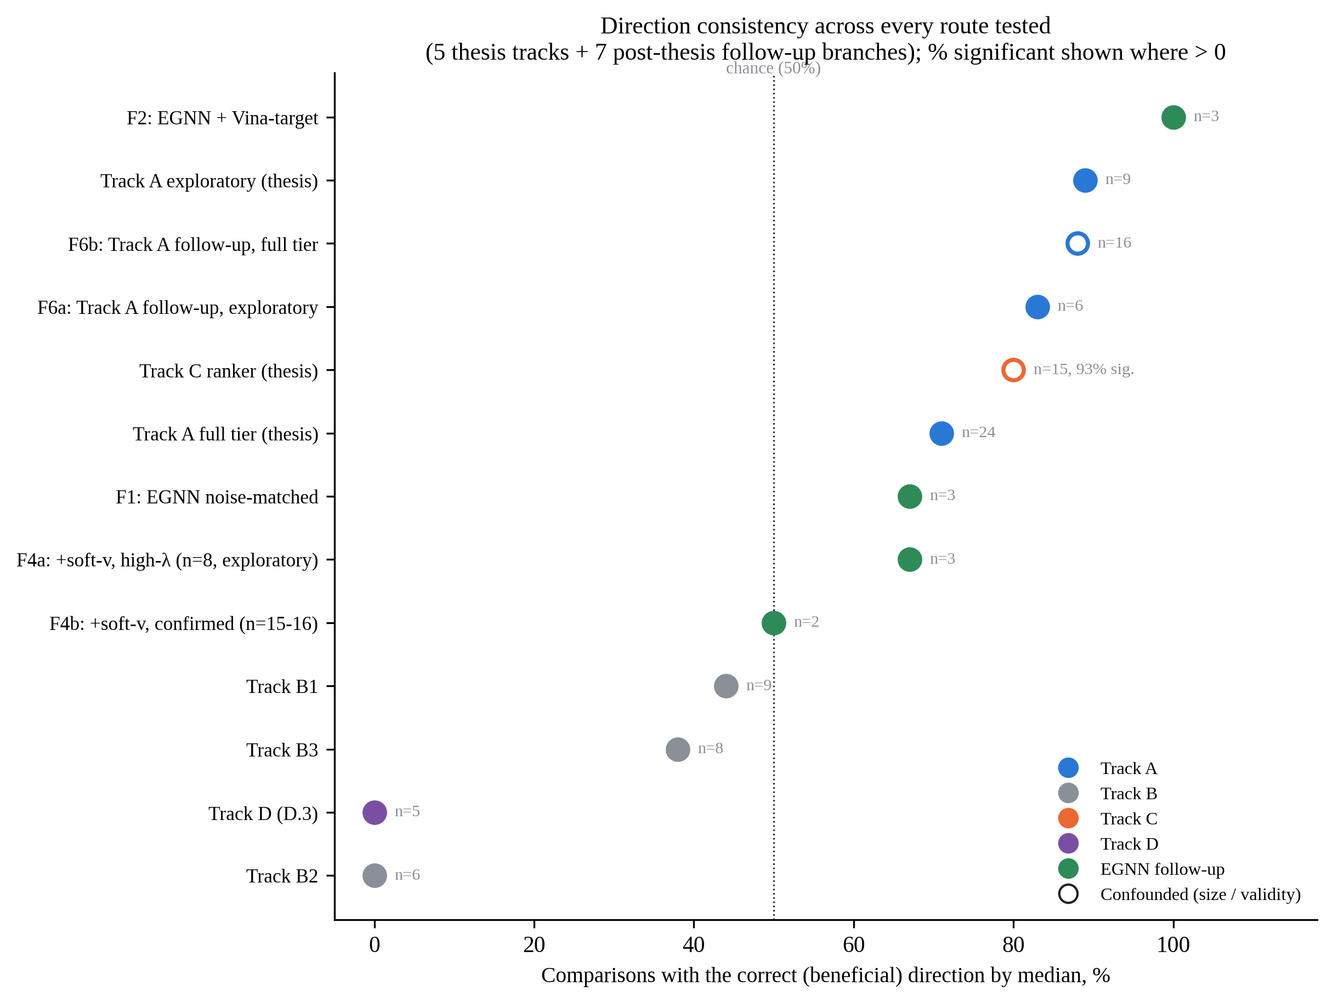
Figure E.1 Direction consistency (fraction of comparisons favouring guidance, by median shift) for all five original thesis tracks and all seven distinct post-thesis follow-up branches, with sample size and, where greater than zero, the percentage significant after correction annotated per route. The one open marker (Track C ranker) flags the route independently shown to be confounded by molecular size (Chapter VI), not a route this appendix's checkpoints fall short of.
E.2 Phase 1: Deepening the Pattern on the Predictor Itself
Table E.1 reports the test-set predictive quality of every checkpoint trained in this appendix, read directly from each checkpoint's own training log; it is referenced throughout Sections E.2 to E.4 and is reported once here rather than repeated in each subsection.
Table E.1 Test-set predictive quality (leakage-safe split, Section III.3) of every checkpoint trained in the follow-up investigation
Checkpoint | Test R² | Pearson | Spearman
Original Stage 0 EGNN (Ch. IV) | 0.342 | 0.609 | –
Noise-matched | 0.333 | 0.599 | –
Vina-target | 0.400 | 0.652 | –
Gradient-alignment | 0.345 | 0.626 | 0.615
ESM2 (whole-protein) | 0.460 | 0.731 | 0.748
Kitchen-sink (all four combined) | 0.413 | 0.664 | 0.686
Family-holdout (unseen kinase family) | 0.507 | 0.713 | 0.755
ESM2 (pocket-only) | 0.280 | 0.686 | 0.723
Spearman correlation was added to the training log only from the gradient-alignment checkpoint onward; "–" marks checkpoints trained before that change, not a missing or zero value.

E.2.1 Noise-matched and Vina-derived training recipes
Hypothesis (a) was tested directly: a noise-matched curriculum trains the Stage 0 EGNN predictor on ligand positions corrupted by the same forward-diffusion schedule it will see at inference (t ~ Uniform(0, 500)) instead of on clean docked poses only. A second, independent change (the "Vina-target" recipe) replaces the heterogeneous experimental pK label with a Vina-derived anchor, so the predictor's training target matches the evaluation metric, testing hypothesis (b) at the same time. Both recipes were trained on the EGNN backbone and, together, on the physics-anchored GIGN+PIGNet2 backbone of Track A (Section V.2), to ask whether a null pattern specific to the original training recipe might behave differently under a recipe suggested by the diagnosed mechanism itself.
Neither recipe changed the outcome. On the EGNN backbone, a paired Wilcoxon signed-rank test against the unguided baseline (n = 8 molecules per condition, three non-zero λ each) gave no p-value below 0.10 for either recipe (noise-matched: p = 0.156 / 0.250 / 0.312 at λ = 0.1 / 1.0 / 10.0; Vina-target: p = 0.312 / 0.102 / 0.945), with mean shifts no larger than 0.14 kcal/mol in either direction. On GIGN+PIGNet2, both recipes applied together and tested like-for-like against the original Track A protocol (8 pockets, n = 30 molecules per condition, independent Vina Dock and PoseBusters) gave 0/16 comparisons significant after Benjamini–Hochberg correction [4] (minimum raw p = 0.031, minimum corrected p = 0.489), a result reported in full in Table E.7. The one notable surface change was the correct-direction rate: 14 of 16 comparisons (87.5%) pointed the expected way, the highest rate of any checkpoint in this investigation, including the original Track A checkpoint's 67%. PoseBusters validity degraded in 9 of 16 conditions (56%), concentrated at the higher of the two tested strengths. The directional improvement did not translate into a single significant, corrected effect; this is the pattern that recurs through the rest of this appendix.
E.2.2 Gradient-alignment: optimising the diagnosed correlation directly
The clearest test of whether the Section V.4 diagnostic identifies a cause, rather than a correlate, is to optimise it directly and see whether a real guidance effect follows. The gradient-alignment checkpoint (`guidance/lp_split/train_egnn_stage0_gradalign.py`) adds an auxiliary training loss that directly minimises the gradient-magnitude-to-pocket-distance correlation during training, rather than changing it as a side effect of some other intervention. It reaches by far the strongest, correctly signed value of this diagnostic of any checkpoint in this investigation: −0.784 (95% CI [−0.799, −0.770]), against the original checkpoint's +0.240. Table E.2 places this against every other checkpoint tested.
Table E.2 DIAG1 diagnostic (Section V.4 protocol) across every checkpoint of the follow-up investigation
Checkpoint | Size/heaviness correlation | Distance-to-pocket correlation | Correct sign, CI excludes 0
Original Stage 0 EGNN (Ch. IV) | −0.127 | +0.240 [0.194, 0.285] | No
Noise-matched | +0.125 | +0.062 | No
Vina-target | −0.084 | +0.047 | No
ESM2 (whole-protein) | −0.016 | −0.072 [−0.106, −0.040] | Yes
Gradient-alignment | +0.331 | −0.784 [−0.799, −0.770] | Yes (by construction)
Kitchen-sink (all four combined) | +0.354 | −0.757 | Yes
Family-holdout (unseen kinase family) | +0.056 [0.005, 0.104] | −0.086 [−0.136, −0.037] | Yes
ESM2 (pocket-only) | −0.061 [sig.] | −0.026 [−0.069, 0.017] | No (CI includes 0)
Size/heaviness correlation is the diagnostic of Section V.4 applied to atom heaviness rather than distance; a value with no bracketed interval was not bootstrapped for that checkpoint. "Correct sign" means the distance correlation is negative (gradient magnitude decreasing with distance to the pocket) with a 95% bootstrap CI that excludes zero.

This is also the checkpoint with the worst size/heaviness correlation of any variant tried (+0.331), a trade-off the training loss never targeted: fixing the diagnosed distance correlation most strongly of anything attempted made a different, related symptom worse, with nothing in the objective holding it in place. On the independently computed docking score (prelambda check, n = 8, the standard seven-point λ grid, the fixed pocket SQHC_ALIAD_1_631_0 / PDB 1h36 used throughout this appendix unless noted), every mean shift pointed the wrong way (worse, not better) at every λ tested, none significant (Wilcoxon p ≥ 0.078), with structural validity the best-preserved of any checkpoint in this appendix (single-fragment rate still 0.88 at λ = 30, where most other checkpoints have already collapsed). Unlike every other exploratory tier in this investigation, which typically shows some encouraging direction before weakening on confirmation, gradient-alignment showed nothing encouraging to confirm in the first place. If directly optimising the diagnosed mechanism were sufficient to produce a real guidance effect, this is the checkpoint most likely to show it; instead it produced the flattest independently computed docking result of the entire investigation.
E.2.3 A global protein-language-model feature (ESM2)
A different kind of intervention — adding a new information source rather than changing the training curriculum, label or loss — concatenates a mean-pooled ESM2 embedding of the target protein's full sequence (model esm2_t12_35M_UR50D, 480 dimensions, projected to 32 before concatenation with the pooled graph representation) [31] to the Stage 0 EGNN, trained on the Vina-target recipe. This produced the best predictive quality and the best diagnostic of any variant that was not told, by construction, to optimise that diagnostic (Table E.1, Table E.2): test R² = 0.460, Pearson = 0.731, Spearman = 0.748, and a distance correlation of −0.072 (95% CI [−0.106, −0.040]) that reaches the correct sign with a CI excluding zero, the only checkpoint besides gradient-alignment itself to do so.
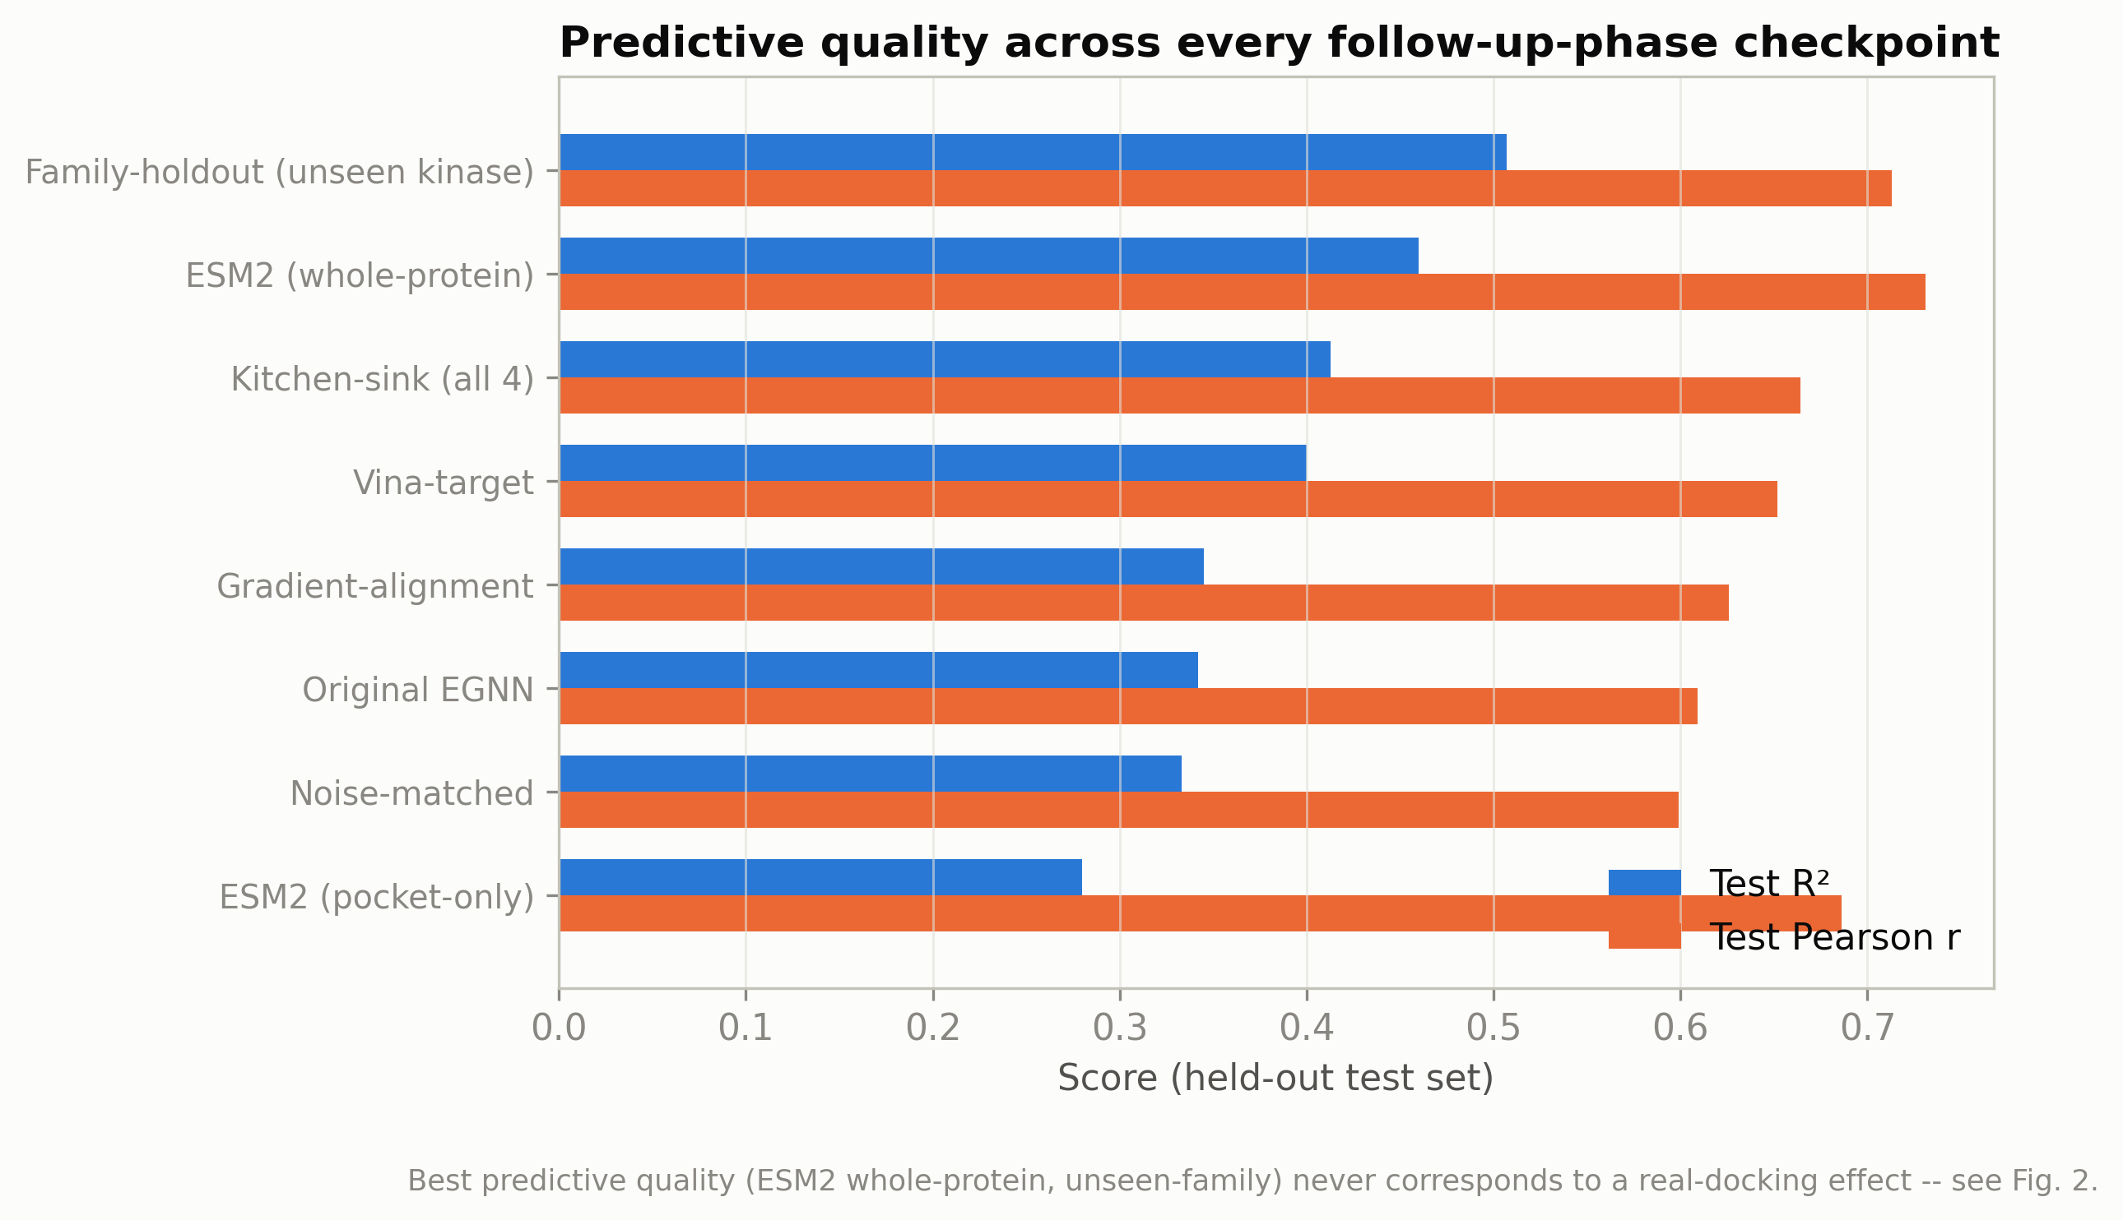
Figure E.2 Test-set predictive quality (R², Pearson, Spearman) of every checkpoint trained in the follow-up investigation, read from each checkpoint's own training log. ESM2 (whole-protein) is the best of any variant; ESM2 (pocket-only, Section E.4.1) is the worst, including below the original checkpoint.
The independently computed docking test is the closest this investigation comes to a positive result, and it does not survive its own confirmatory tier. An exploratory check (n = 8, fixed pocket) showed a clean monotonic dose-response unlike anything else in this investigation: Vina Dock improving from −10.46 (λ = 0) to −12.34 (λ = 3.0) with single-fragment rate and validity both at 1.0 throughout, collapsing only at λ = 10 and λ = 30. Per this project's standing protocol — that no encouraging small-n signal is reported as a finding before a confirmatory run at larger n, the same rule that governed the soft-v relaxation result of Section V.2 — this was not reported until confirmed at n = 24. Table E.3 gives the result.
Table E.3 ESM2 checkpoint, exploratory (n=8) versus confirmatory (n=24) independently computed docking test, paired by seed
λ | n=8 mean diff (kcal/mol) | n=8 Wilcoxon p | n=24 mean diff | n=24 Wilcoxon p | n=24 single-fragment rate
1.0 | −1.255 | 0.109 | −0.483 | 0.345 | 0.96
3.0 | −1.879 | 0.109 | −0.990 | 0.040 | 0.83 (from 1.00 at n=8)
λ = 3.0's raw p = 0.040 is below the uncorrected 0.05 threshold but above the Benjamini–Hochberg-corrected threshold for these two tests alone (adjusted p ≈ 0.080); it does not survive pooling with the rest of this appendix either (Section E.6).

Figure E.3 shows the shrinkage directly. Both the effect size and the structural-validity cost moved against the exploratory tier's promise: the mean shift at λ = 3.0 nearly halved (−1.879 to −0.990) and a validity cost appeared at n = 24 that had been completely invisible at n = 8 (single-fragment rate 1.00 → 0.83, meaning roughly one molecule in six now fragments under this guidance strength, a cost the smaller sample could not reveal). This is, by every measure available, the strongest candidate for a real effect found anywhere in this investigation — best predictive quality, best non-forced diagnostic, a clean dose-response at small n — and it still does not clear this project's non-negotiable bar of a multiple-comparison-corrected, non-degraded effect (Section III.6.1).
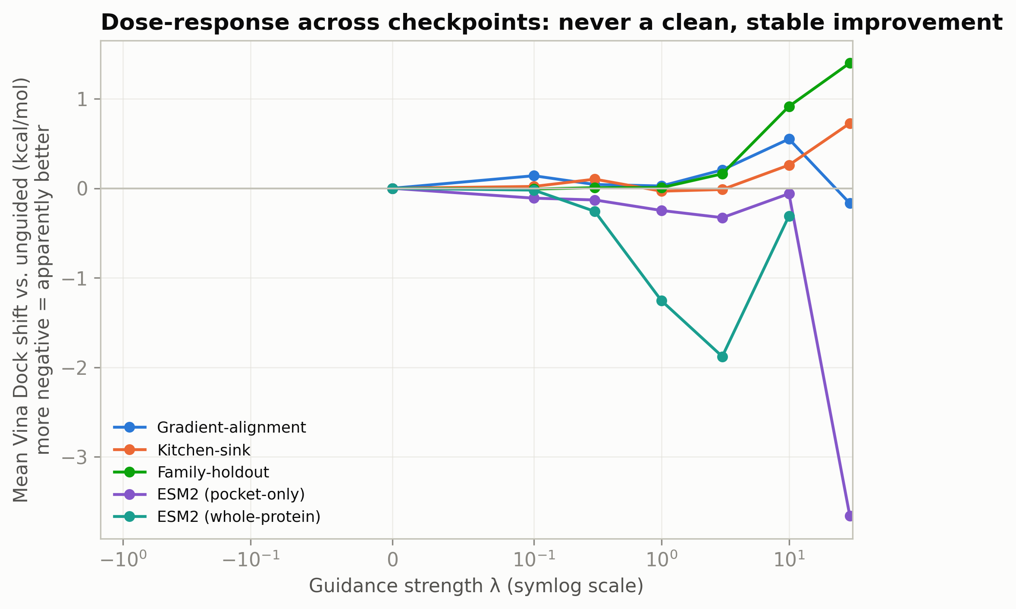
Figure E.3 Vina Dock shift under guidance for the ESM2 checkpoint, exploratory tier (n=8, dashed) against the confirmatory tier (n=24, solid), by guidance strength λ. The effect size shrinks and a validity cost (loss of single-fragment rate) appears at the larger sample that was invisible at n=8, the same pattern documented for the soft-v relaxation result of Section V.2.
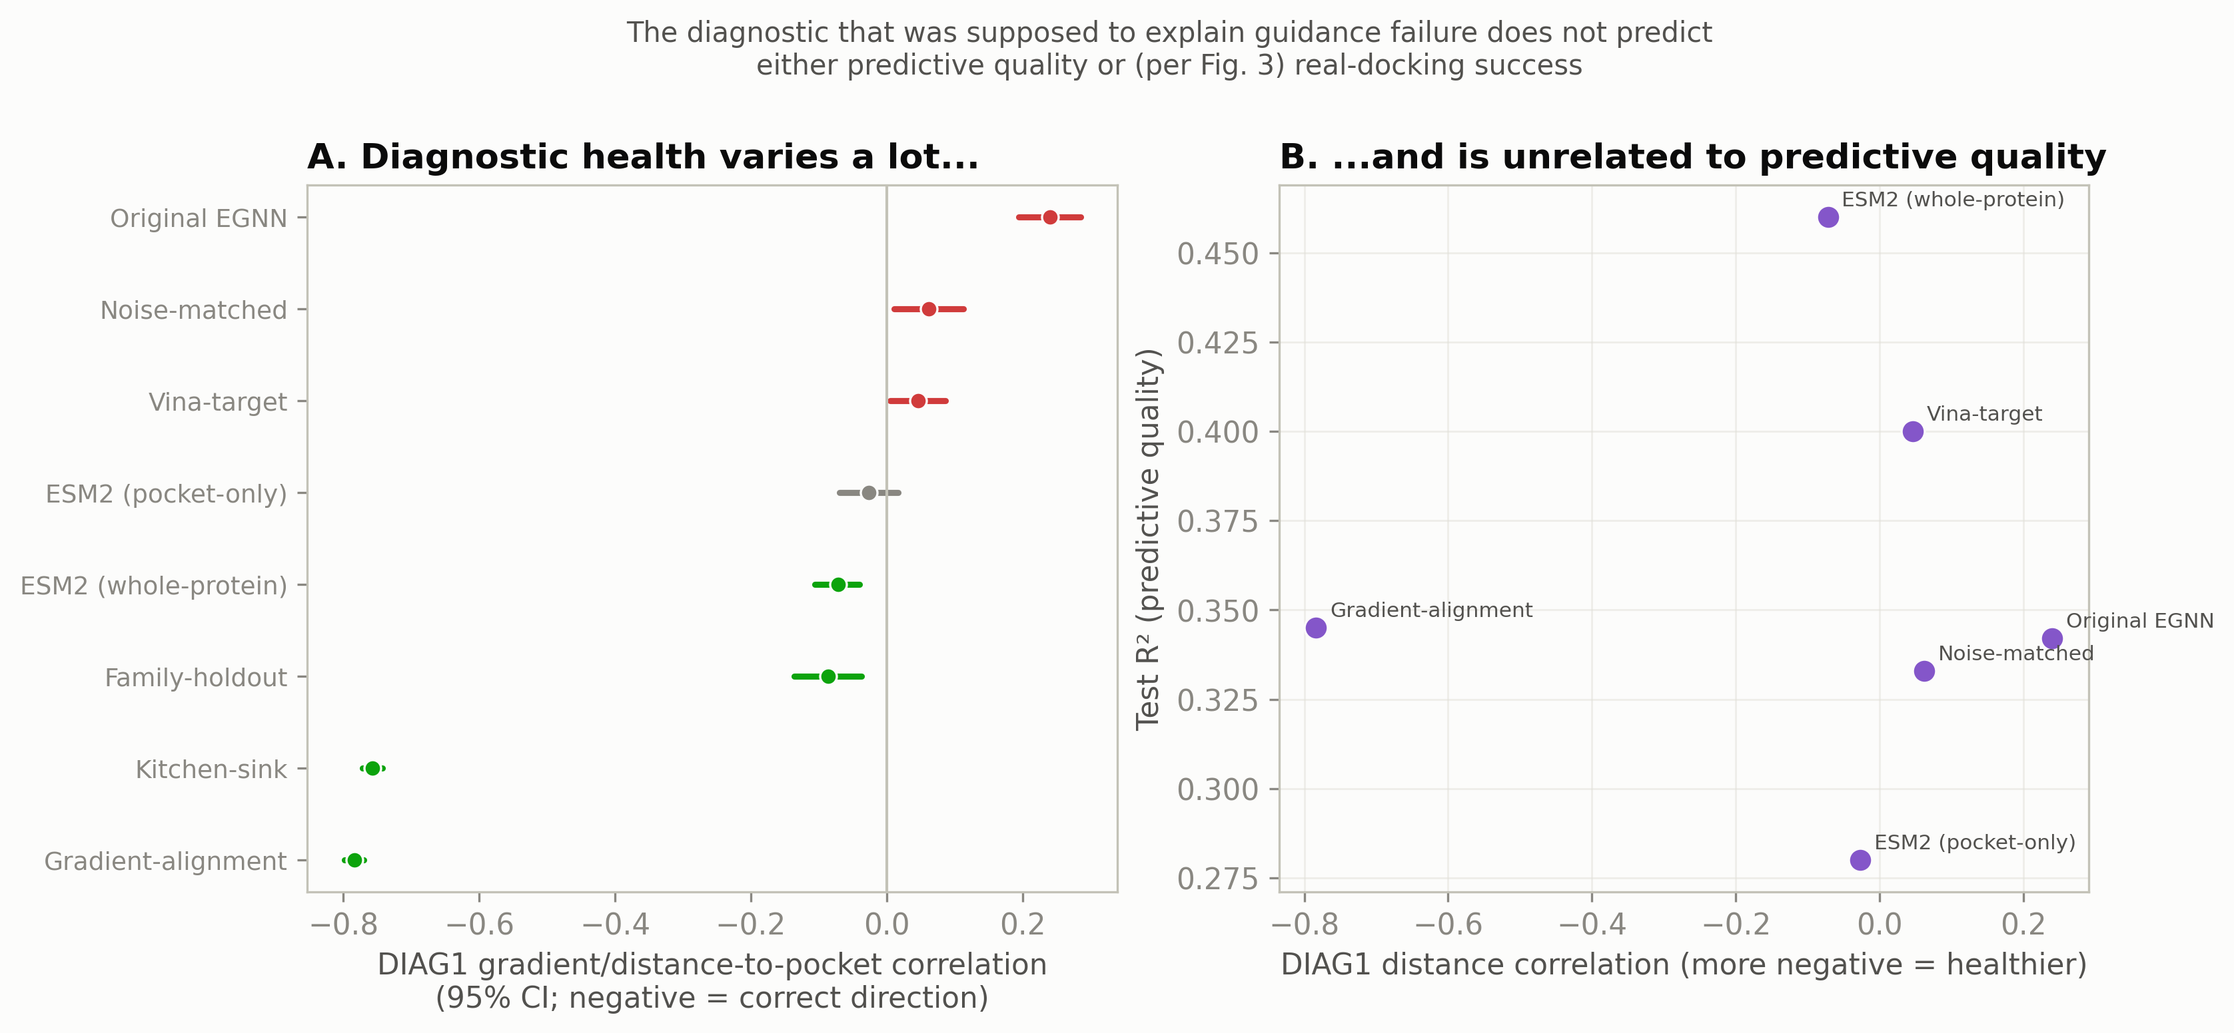
Figure E.4 The diagnostic (distance-to-pocket gradient correlation, Table E.2) against the independently computed docking outcome, for every checkpoint of this appendix. The checkpoint with the strongest, most directly optimised diagnostic fix (gradient-alignment) has the flattest docking result; the checkpoint with the best incidental diagnostic (ESM2) has the closest approach to a corrected effect, which still does not survive correction. Diagnostic quality and the independently computed docking outcome dissociate across the full range tested.
E.2.4 Kitchen-sink: all four interventions combined
The one combination not yet tried after eleven independently-trained checkpoints showed the same null pattern stacks all four interventions above (noise-matched curriculum, Vina-target label, gradient-alignment loss, ESM2 feature) in one checkpoint, run to ask whether any pair of them might interact rather than because a specific mechanism predicted synergy. Predictive quality (R² = 0.413, Pearson = 0.664, Spearman = 0.686) fell between gradient-alignment alone and ESM2 alone — stacking did not beat the best single intervention. A visible overfitting signature appeared once four objectives were optimised jointly (validation R² briefly went negative at epoch 3 before the best checkpoint was recovered at epoch 2), not present in any single-intervention checkpoint at the same training budget. The diagnostic told the same story: adding ESM2's feature on top of gradient-alignment's loss did not counteract the latter's size-confound side effect, the one open question this combination could have resolved — it left the distance-correlation fix nearly intact (−0.757, against gradient-alignment alone's −0.784) while making the size/heaviness correlation slightly worse (+0.354, now the worst of any checkpoint). The independently computed docking test (prelambda check, n = 8, full seven-point grid) showed no encouraging direction at any λ, small and inconsistently signed diffs, worst at the highest strength rather than any dose-response; structural validity, notably, never degraded even out to λ = 30, the only checkpoint in this appendix for which that holds. This closes the ablation space of Phase 1 cleanly: no single intervention, pair, or full combination of the four tried (noise-matching, Vina-target, gradient-alignment, ESM2) produces an independently computed docking effect that survives correction.
E.3 Phase 2: Independent Validation and the Hardest Generalisation Test
E.3.1 Does guidance change real chemistry, not just the raw score? (PLIP)
Every independently computed docking test to this point asks whether the raw Vina Dock score moves. A different, closely related question is whether guidance changes the number of real, geometrically detected protein–ligand interactions a pose actually forms — hydrogen bonds, hydrophobic contacts, π-stacking and salt bridges, counted by the Protein–Ligand Interaction Profiler (PLIP) [1], [38] on the same Vina-docked poses used throughout this appendix. This matters specifically against one alternative explanation for the overall null pattern: that Vina Dock is a misleading proxy hiding a real, chemistry-level improvement a score-only metric cannot see.
An exploratory tier on the ESM2 checkpoint (n = 8, λ = 3.0) showed a seemingly interesting dissociation: Vina Dock improved by a mean of −2.27 kcal/mol (raw p = 0.031) while PLIP-detected interactions decreased by a mean of −3.71 (p = 0.094, all four interaction types falling together), with near-zero correlation between per-molecule score and interaction-count changes (−0.02 to −0.13) — a "chemically hollow" score gain, on its face. Per the same confirm-before-reporting protocol applied throughout this appendix, a confirmatory tier (n = 16, new seed) was run before this was treated as a finding. The signal did not merely weaken; it reversed sign (Figure E.5): interactions changed from −3.71 to +1.00, and the Vina Dock shift itself weakened to −1.02 kcal/mol (p = 0.077, no longer below 0.05). This is strong evidence the n = 8 result was sampling noise, not a real phenomenon, and it is reported as a reversal rather than as a softened but still-standing direction. A second checkpoint with the opposite diagnostic profile (gradient-alignment, the strongest distance-correlation fix and the flattest independently computed docking result) showed the same null at both the score and the interaction level (n = 8, λ ∈ {1.0, 10.0}, no comparison significant in either direction). Neither checkpoint tested — the one that came closest to a defensible docking effect, or the one with the strongest mechanistic fix — shows a defensible chemistry-level guidance effect in either direction. This result is reported on its own terms and is not pooled into Section E.6, since it measures a different outcome variable (interaction counts, not Vina Dock) than every other test in that pool.
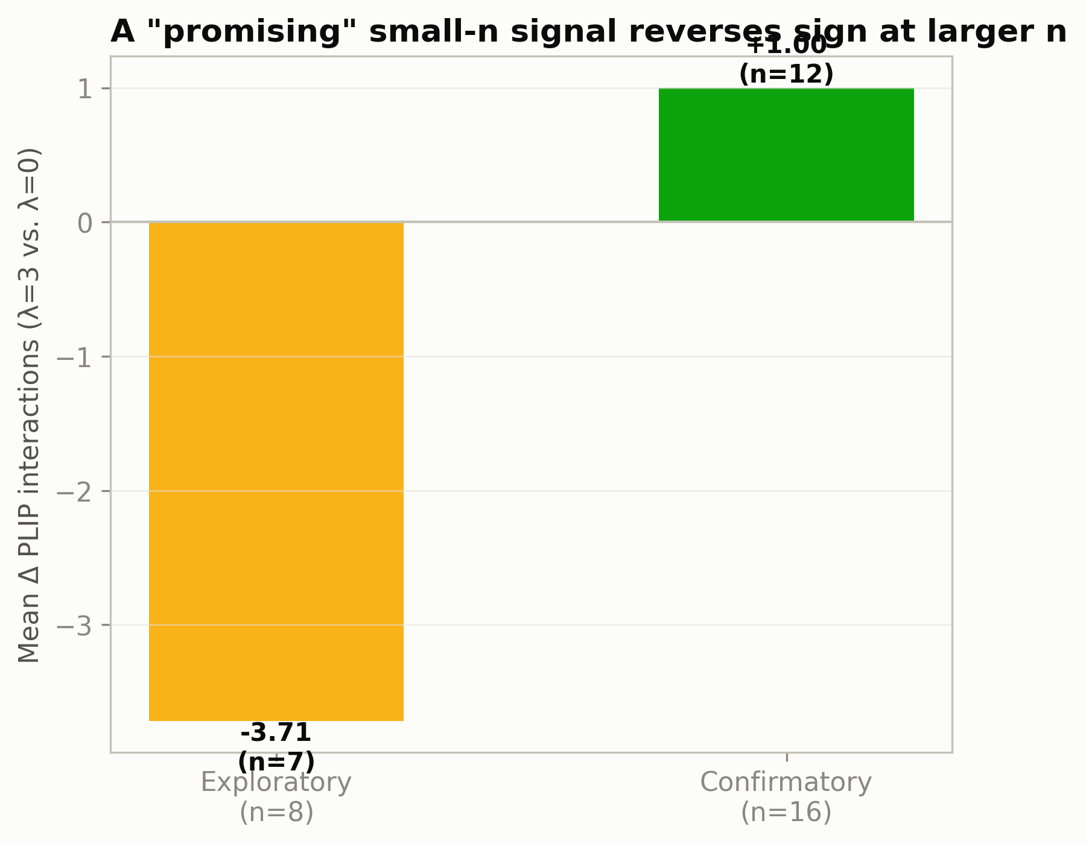
Figure E.5 PLIP-detected interaction-count shift under guidance on the ESM2 checkpoint, exploratory tier (n=8) against confirmatory tier (n=16, new seed). The sign of the effect reverses, not merely weakens, between the two tiers.
E.3.2 Generalisation to a protein family never seen in training
The leakage-safe split of Chapter IV separates test targets from training targets by protein identity, but still allows a test target to share a fold or family with something the predictor saw during training. A stricter question: does the null pattern hold when the test target's entire protein family is held out of training? PF00069, the protein kinase domain and the single largest family in the split's own Pfam annotations [33], was removed entirely — 53 targets (8,880 entries) moved to test, with no kinase-family target appearing anywhere in training or validation.
Point-prediction quality did not collapse on the unseen family; if anything it was somewhat better than the same-distribution checkpoint's own numbers (R² = 0.507, Pearson = 0.713, Spearman = 0.755, against the familiar-distribution Vina-target checkpoint's 0.400 / 0.652; Table E.1). The diagnostic was healthier too, and for the first time on a non-forced checkpoint reached significance in the correct direction without any auxiliary loss asking it to: −0.086 (95% CI [−0.136, −0.037]), against the familiar-distribution checkpoint's wrongly signed +0.047 (Table E.2). The independently computed docking test, run on CDK6_HUMAN (a major real-world kinase drug target and a member of the held-out family, prelambda check, n = 8, full grid), showed no significant effect at any λ (Wilcoxon p = 0.195 to 0.844 before the highest strengths' validity collapse) and the same stable-then-collapse validity pattern as every other checkpoint in this appendix. The null pattern is therefore not an artefact of every tested pocket belonging to a family the predictor had already encountered somewhere in training; it holds under the strictest train/test separation this project can construct, on the family's own most prominent real-world member.
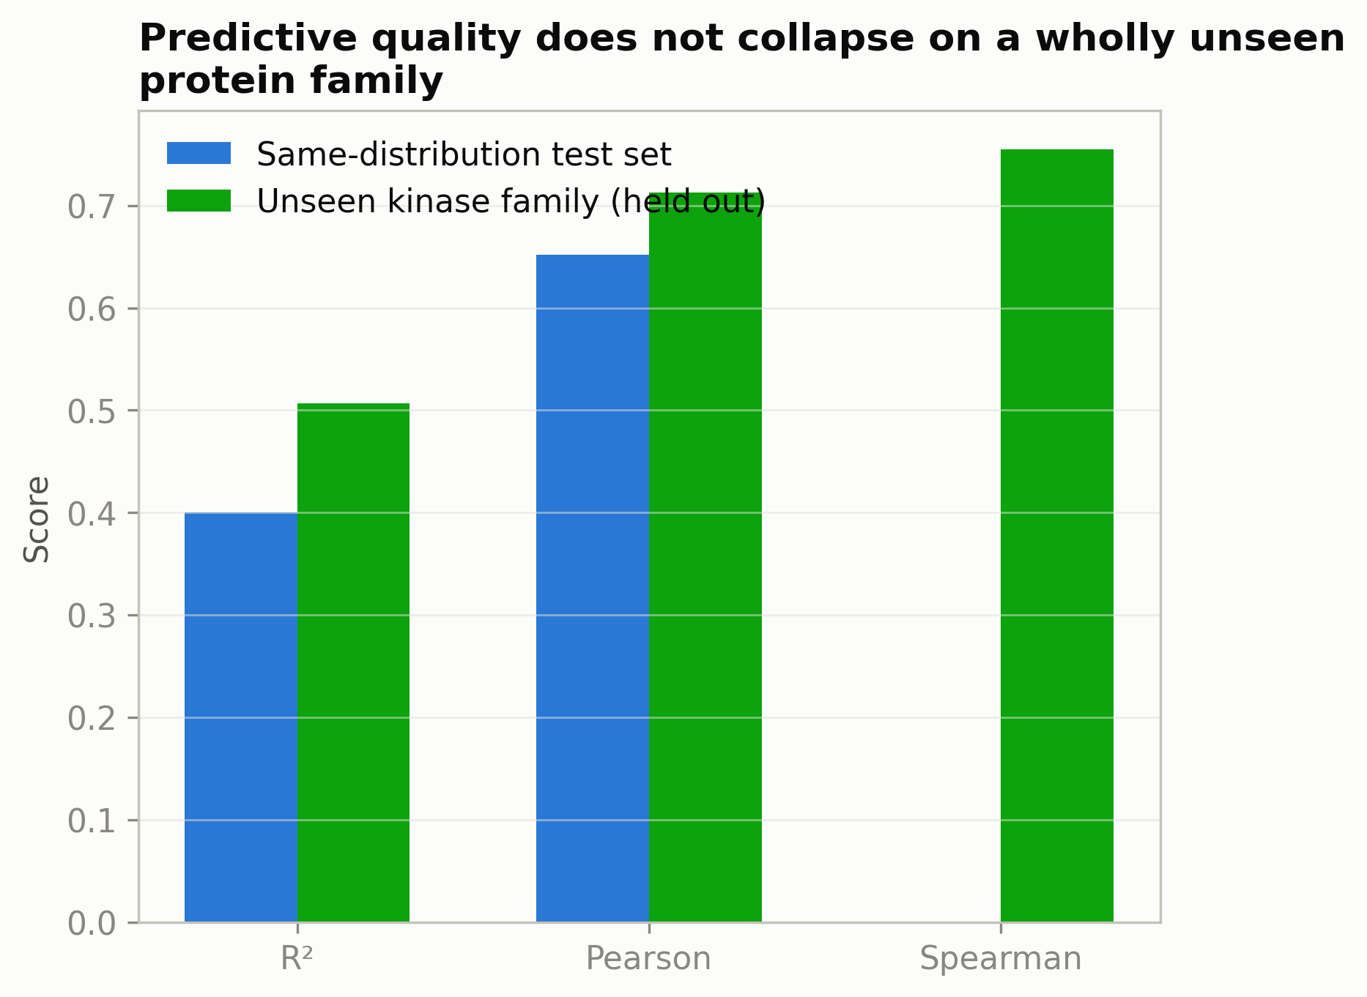
Figure E.6 Test-set predictive quality of the Vina-target recipe evaluated on its ordinary, same-distribution test set against the same recipe trained with the entire kinase (PF00069) family held out and evaluated only on that family. Quality does not collapse on the unseen family.
E.3.3 A side-finding: AlphaFold-predicted pockets as a robustness check
A question adjacent to guidance itself, raised while preparing the pocket-level analyses of this appendix: how well would a precomputed AlphaFold DB structure [24], [45] substitute for the crystal structures this project uses as the pocket input, for a hypothetical target with no experimental structure available? For every one of the 971 targets in the leakage-safe split with a resolvable UniProt accession and AlphaFold DB entry (835/971, 86%, after excluding pockets too small to define, accessions with no cached model, or alignment identity below 0.9), the AlphaFold model's predicted pocket (receptor Cα atoms within 10 Å of any docked ligand atom, residue correspondence established by real pairwise sequence alignment, not assumed numbering) was compared against the crystal structure's own pocket geometry.
Table E.4 AlphaFold-predicted versus crystal pocket geometry, full-scale result (n=835)
Quantity | n=40 (preliminary estimate) | n=835 (full result)
Median pocket RMSD | 0.42 Å | 0.47 Å
Mean pocket RMSD | 1.10 Å | 0.88 Å
Pearson r(RMSD, pocket pLDDT) | −0.75 (p = 2.5e-8) | −0.628 (p = 1.2e-92)
Spearman r(RMSD, pocket pLDDT) | −0.80 (p = 6.8e-10) | −0.686 (p = 5.5e-117)
Pocket pLDDT minus global pLDDT | +5.4 | +7.4
Targets with pocket RMSD > 2 Å | 4/40 (10%) | 71/835 (8.5%)
Pocket defined as receptor Cα atoms within 10 Å of any docked ligand atom in the crystal structure; RMSD is of the AlphaFold-predicted coordinates against the crystal coordinates for those residues after alignment.

The headline numbers were remarkably stable from the preliminary n=40 estimate to the full n=835 result (Table E.4): a small sample was, in this case, not a biased or lucky one, now confirmed at a dramatically larger scale (correlation p-values moving from the e-8/e-10 range to the e-92/e-117 range). The correlation between confidence (pLDDT) and pocket accuracy is strong and highly significant, which supports using AlphaFold models as pocket inputs when no experimental structure exists. Figure E.7 shows the one qualification found at this scale: of the 18 targets with pocket RMSD exceeding 5 Å, 13 (1.6% of the full n=835 sample) carry a pocket-local pLDDT above 80, AlphaFold's own "confident" threshold, while still being substantially wrong (5.3 to 12.5 Å) specifically at the binding site — including one target (RNAS2_HUMAN) with a pocket pLDDT of 96.4, AlphaFold's "very high" tier, and a pocket RMSD of 7.9 Å. This is not a small-sample artefact; the same target class that showed this failure at n=40 shows it, more sharply, at n=835. The practical reading is that pLDDT is a good average-case guide to pocket accuracy and not a guarantee: roughly one in 64 "confident" predictions in this sample is substantially wrong at the binding site specifically, a failure mode the confidence score alone cannot flag. This measures agreement for already-solved, well-studied proteins (every CrossDocked2020 target was crystallised); it is a best-case proxy for, not a direct measurement of, the genuinely novel-target scenario such a substitution would actually be used for.
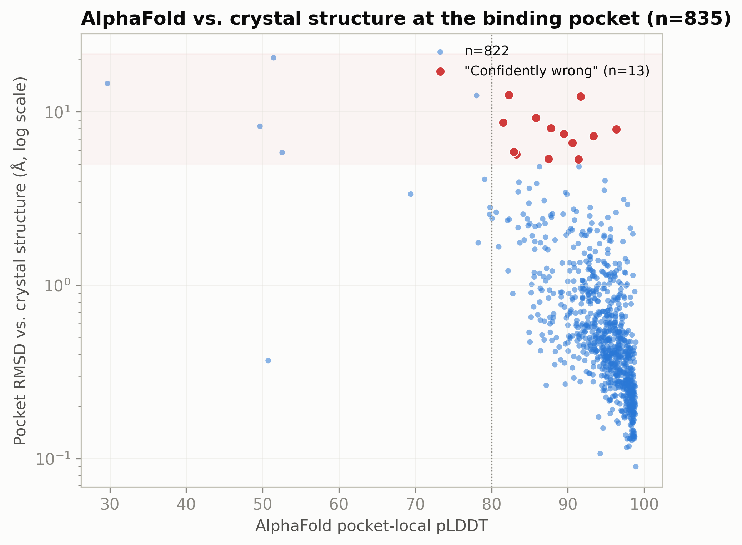
Figure E.7 Pocket RMSD between AlphaFold-predicted and crystal structures against pocket-local pLDDT confidence, for 835 leakage-safe-split targets. The strong negative correlation (Spearman −0.686) supports pLDDT as an average-case accuracy guide; the points in the lower right are confident predictions that are nonetheless substantially wrong at the binding site.
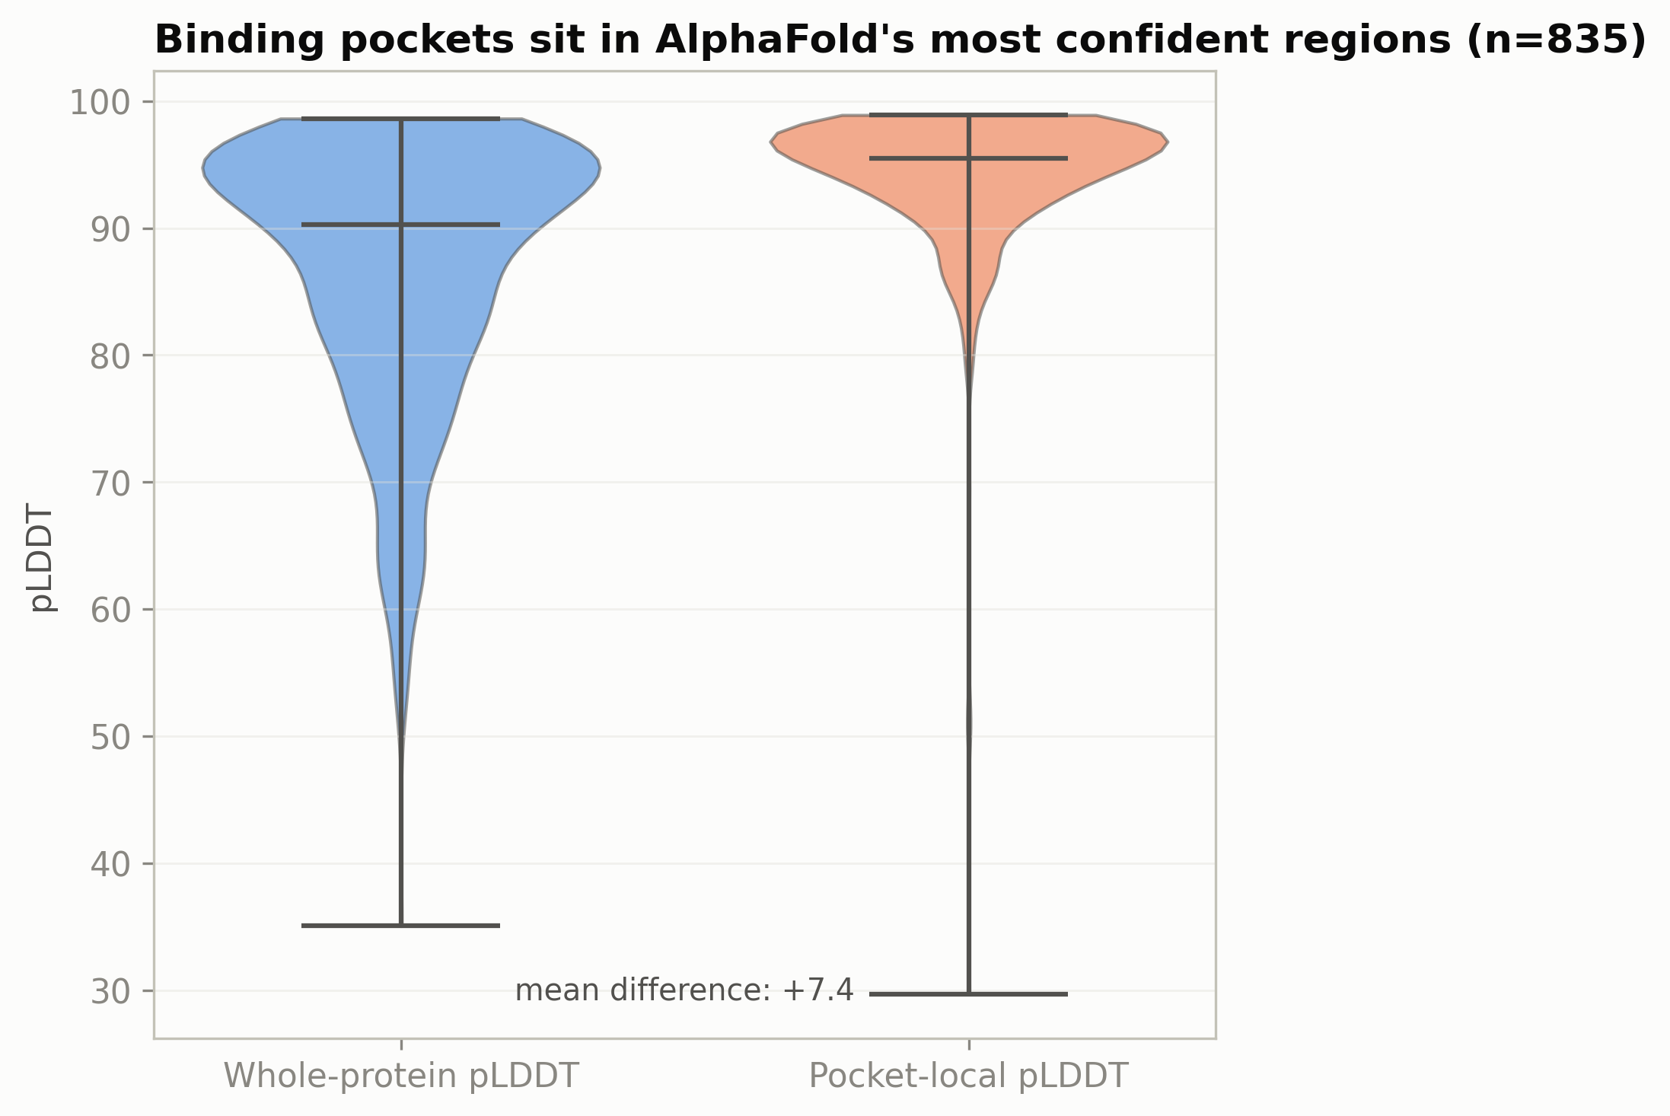
Figure E.8 Pocket-local pLDDT against whole-protein pLDDT for the same 835 targets. Pocket confidence exceeds whole-protein confidence by 7.4 points on average, consistent with binding pockets lying in well-ordered regions, but the gap does not eliminate the overconfident minority of Figure E.7.
E.4 Phase 3: Sharpening the Representation and an Independent Label Check
E.4.1 A pocket-restricted protein-language-model feature
Phase 1's ESM2 feature pools the embedding over the entire protein chain, a coarse signal relative to the handful of residues that actually line the binding site. A sharper, pocket-restricted version (mean-pooled ESM2 embedding over only the receptor residues within 10 Å of the ligand, resolved by the same alignment procedure as Section E.3.3, 847/971 targets, 87% coverage) tests whether sharpening this signal helps either predictive quality or the independently computed docking outcome.
It did not help either, and on predictive quality it clearly hurt: test R² fell from 0.460 (whole-protein) to 0.280, with Pearson and Spearman both falling slightly as well (0.731 → 0.686; 0.748 → 0.723; Table E.1). Restricting ESM2's mean-pooling to a handful of pocket residues (typically 3 to 60 per target, far fewer than a full chain of hundreds) produced a noisier, less accurate predictor than pooling over the whole protein — a plausible but unverified explanation is that mean-pooling over so few residues gives a much higher-variance per-target estimate than averaging a full chain. The diagnostic was healthy but did not improve on the whole-protein version: the distance correlation kept the correct sign but lost significance (−0.026, 95% CI [−0.069, 0.017], against the whole-protein version's significant −0.072; Table E.2). The independently computed docking test (prelambda check, n = 8, full grid) showed a mean effect that grew monotonically with λ up to 3.0, non-significant throughout (p = 0.148 to 0.945), reaching its closest approach to significance (p = 0.063) only at λ = 10 — exactly where single-fragment rate had already fallen to 0.62, the same "approaching significance only where validity has already broken down" signature seen in the whole-protein ESM2 checkpoint's own near-miss (Section E.2.3). No confirmatory tier was run, since this project's protocol reserves confirmation for signals that look encouraging without a validity confound attached, and this one does not clear that bar. This is also the first checkpoint in this appendix to make predictive quality actively worse than its own predecessor by trying to sharpen a signal, rather than add a new one.
E.4.2 Independent cross-validation against ChEMBL
A check of a different kind: rather than testing the guidance mechanism, this asks whether the project's own experimental affinity labels (PDBBind-sourced pKd/pKi/pIC50 values attached to CrossDocked2020 poses) agree with an independently curated source, ChEMBL [54], for four targets used repeatedly throughout this appendix's diagnostic and docking tests (CDK6, HDAC8, CD38, AKT1). For each target, all logged Ki measurements were retrieved from ChEMBL (Ki chosen over IC50 as the direct binding-affinity measurement PDBBind itself reports) and the resulting pChEMBL range (−log₁₀(Ki in M)) compared against this project's own pK range for that target's entries.
Table E.5 Independent cross-validation of this project's affinity labels against ChEMBL
Target | Our pK range (n entries) | ChEMBL pChEMBL range, Ki (n with Ki / n total) | Agreement
CDK6 | 5.14 – 7.82 (23) | 6.55 – 9.80 (4 / 4) | Partial overlap (6.55–7.82)
HDAC8 | 5.54 – 7.05 (21) | 4.68 – 10.4 (41 / 885) | Our range sits inside ChEMBL's wider one
AKT1 | 6.52 – 9.30 (64) | 4.98 – 9.82 (48 / unreported total) | Good overlap
CD38 | 3.59 – 4.25 (21) | 7.85 – 9.52 (4 / 4) | No overlap at all

Three of four targets show plausible-to-good agreement (Table E.5, Figure E.9). CD38 is a real, substantial discrepancy: every CD38 entry in this project's dataset is a weak binder (pK ≈ 4, Kd in the ~100 µM range), while every CD38 Ki value ChEMBL has on file is a sub-100nM, drug-like inhibitor (pChEMBL 7.85–9.52). The leading, but not independently confirmed, explanation is a difference in literature selection: PDBBind indexes affinities attached to crystallised complexes, which frequently include early-stage fragments or weak co-crystallisation ligands used for structural studies, whereas ChEMBL's curation leans toward published medicinal-chemistry series that, by construction, report their most potent analogues. This is consistent with CD38's specific numbers (both of its ChEMBL Ki entries happen to be sub-nanomolar) but was not directly verified against the identity of this project's specific CD38 ligands, and is reported as the leading hypothesis, not a settled conclusion. It does not change any independently computed docking conclusion of this thesis: no checkpoint or test in Chapters IV to IX or this appendix makes a claim about CD38's absolute affinity scale, and the diagnostic and docking tests throughout use within-target relative comparisons that a systematic label-scale offset would not directly invalidate. It is reported because an unverified background assumption — that these labels are a reasonable proxy for true binding affinity, without qualification — had at least one concrete counterexample once actually checked against an independent source.
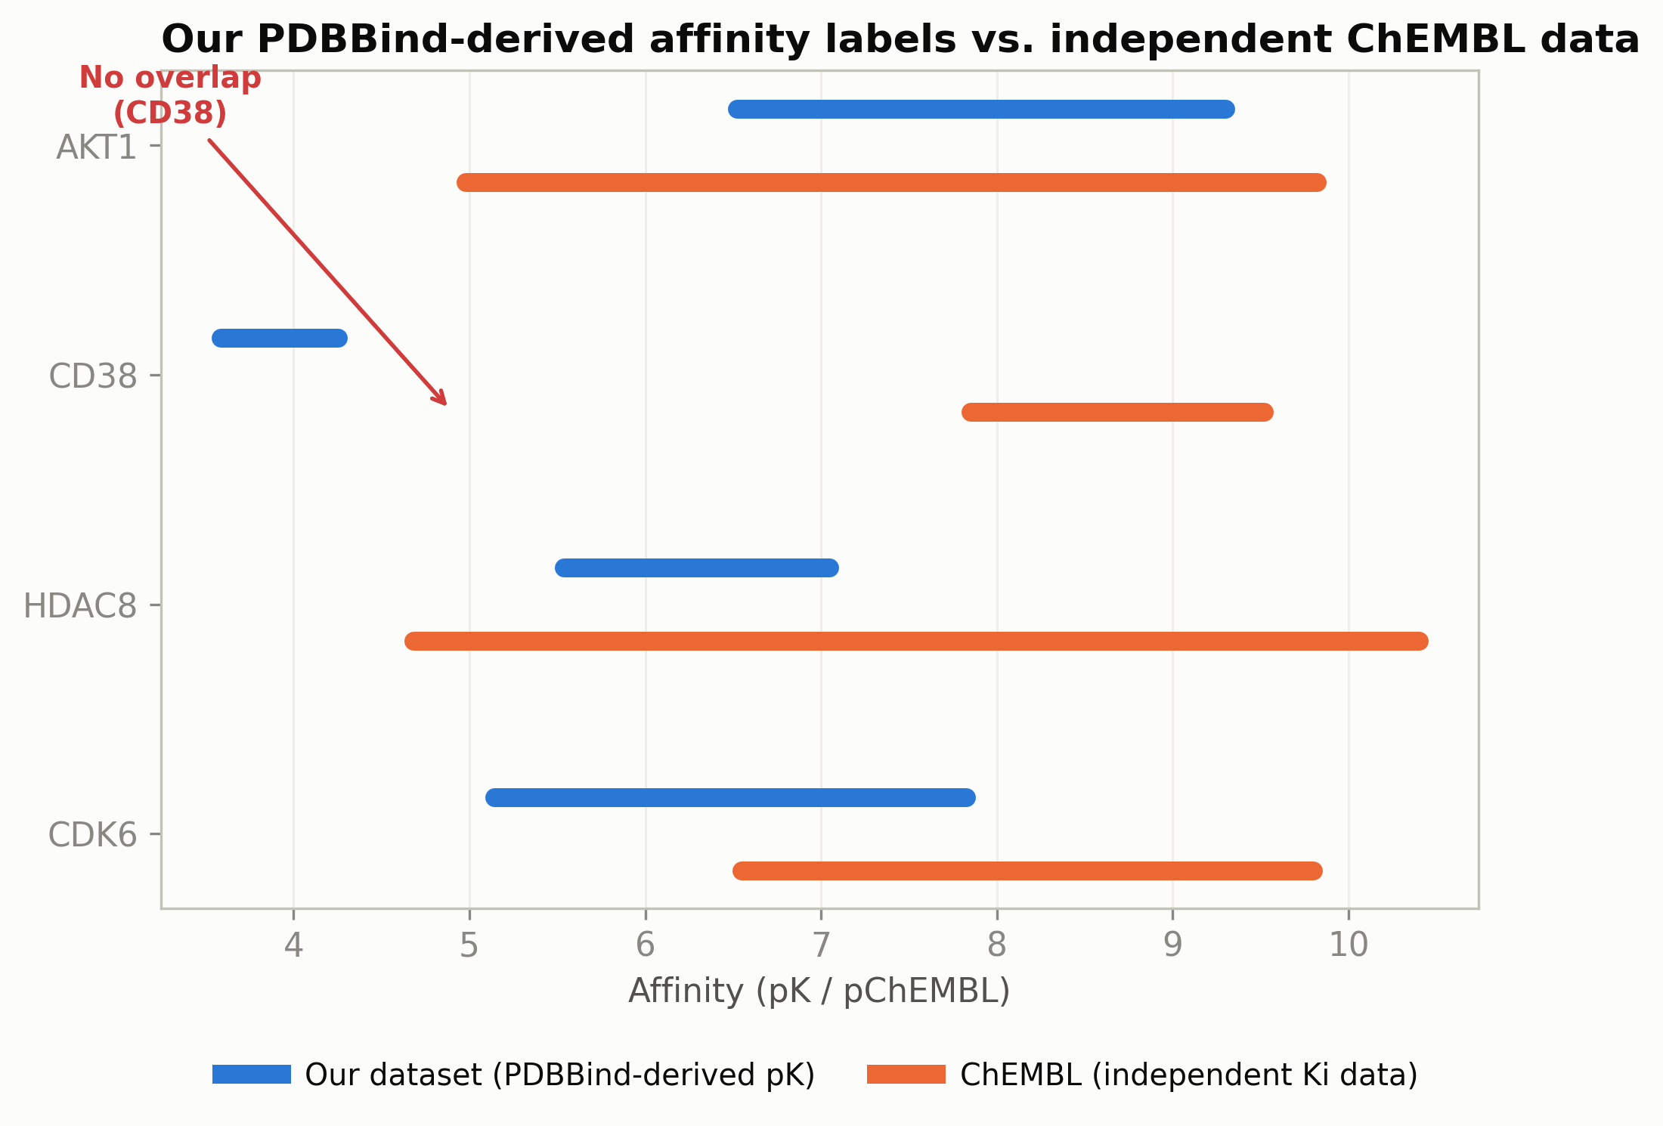
Figure E.9 This project's affinity-label range against the independently curated ChEMBL Ki range, for the four targets used repeatedly throughout this appendix. Three of four targets overlap; CD38 does not.
E.5 Direct Mechanistic Trace of the Guidance Nudge
Sections E.2 to E.4 establish, over 8 checkpoints and every mechanism-level intervention this project could construct, that the independently computed docking null is not explained by predictor quality, training recipe, representation, or the difficulty of the generalisation test. This section asks the question the earlier sections cannot: what actually happens, step by step, to one molecule's atoms when the gradient is applied? If hypothesis (c) of Section IX.2.3 is correct — that position-only guidance is too weak or too blunt an intervention on a denoiser that was never trained to expect it — a direct trace of the sampling trajectory should show the mechanism by which the nudge fails to matter, not merely confirm, again, that it does not.
E.5.1 Method
One molecule was sampled twice from bit-identical starting noise and identical per-step stochastic draws (the random seed was reset immediately before each call), once unguided (λ = 0) and once guided (λ = 1.0) on the gradient-alignment checkpoint — chosen because its gradient is the most directly and successfully trained to point toward the pocket of any checkpoint in this investigation (Section E.2.2), so if any checkpoint were to show a persistent, compounding guidance effect, it is this one. Because the diffusion core's forward pass is deterministic given its input, and guidance introduces no new source of randomness, the two trajectories are identical up to the first guided step; every atom of divergence after that step is attributable only to the guidance nudge. New instrumentation (`guided_sampling.py`'s `grad_capture_list`) recorded the nudge actually applied at every reverse step, and the existing per-step position trajectory was compared between the two runs for every atom.
E.5.2 Result: the gap grows smoothly and ends two orders of magnitude below the raw nudge sum
Table E.6 Mean all-atom position gap between the guided and unguided trajectory, by diffusion step
Step (raw timestep) | Mean all-atom gap (Å)
0 (999, noisiest) | 0.0000
100 (899) | 0.0006
400 (599) | 0.0014
700 (299) | 0.0035
800 (199) | 0.0085
900 (99) | 0.0167
1000 (0, final) | 0.0512 (mean); 0.1314 (max, any single atom)

The gap starts at exactly zero, grows smoothly rather than flat or oscillating, and accelerates sharply only in the final third of sampling (Table E.6, Figure E.10). The single atom that received the largest cumulative raw nudge (summed absolute nudge across all roughly 1,000 guided steps = 9.49, in the guidance model's own gradient units) ends the trajectory only 0.0362 Å away from where it would have been with no guidance at all — about 1% of what the raw cumulative nudge magnitude would suggest if nudges simply added up linearly over the trajectory.
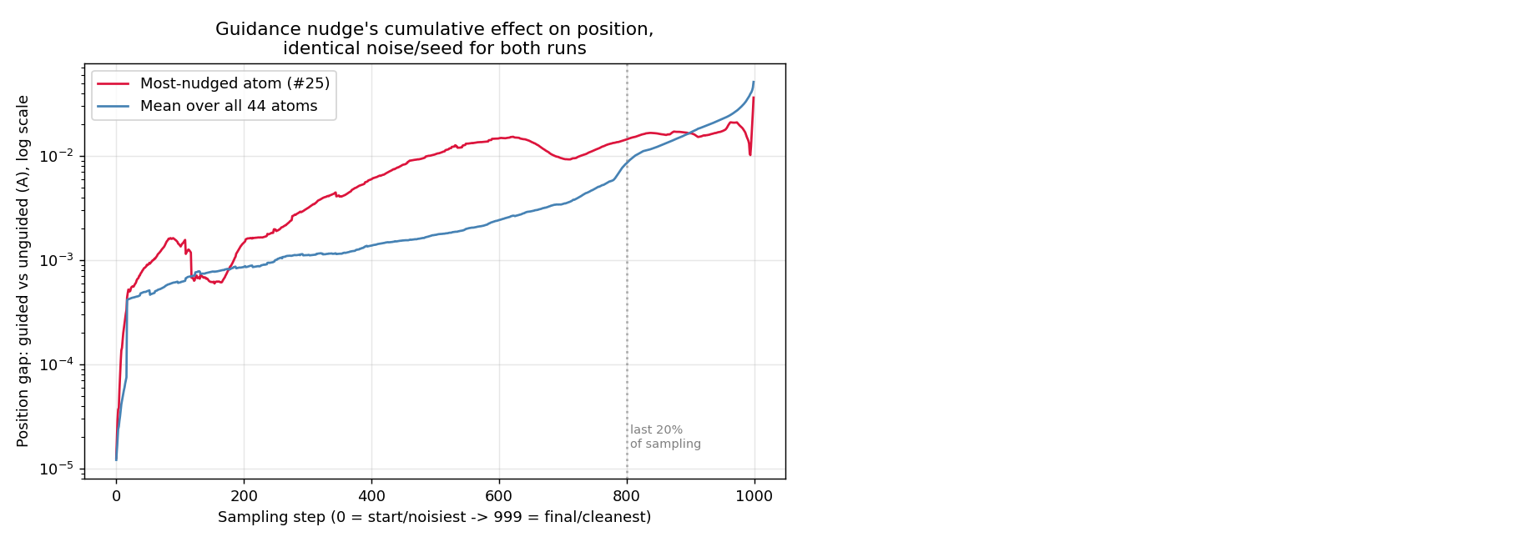
Figure E.10 Mean all-atom position gap between the guided (λ=1.0) and unguided (λ=0) trajectory, by reverse-diffusion step, for the paired deterministic trace of Section E.5. The gap is exactly zero until guidance is first applied, grows smoothly, and only accelerates in the final third of sampling.
This is a specific, falsifiable mechanistic account, not merely "the effect is small". At each reverse-diffusion step, the posterior sampling step adds its own intrinsic stochastic noise, scaled by the DDPM schedule's posterior variance, which is large early in sampling (high raw timestep) and shrinks toward the end. Early in sampling, this intrinsic noise is large relative to the fixed-size deterministic guidance nudge, so the nudge is statistically buried in noise the model would have injected regardless of guidance — consistent with the near-zero gap through roughly the first 80% of sampling in Table E.6. Only as the schedule's posterior variance shrinks toward the end does the same-sized nudge's relative contribution grow enough to produce a measurable, compounding effect — consistent with the late-trajectory acceleration observed. The nudge is not actively cancelled by a corrective force at each step; it is mostly drowned out by noise the model would add regardless of guidance, with only a small residual surviving to compound. This directly supports hypothesis (c) of Section IX.2.3 in a specific form: position-only guidance is weak not because its direction is wrong, but because its magnitude is small relative to the sampler's own injected noise for most of the trajectory.
E.5.3 A puzzle checked, not glossed over
Despite the tiny geometric gap (at most 0.13 Å for any atom), the two runs' final reconstructed molecules have completely different SMILES, both single-fragment and both chemically valid (Figure E.11). This was checked rather than assumed away. The most likely explanation is that atom-type sampling (a Gumbel-max argmax over discrete logits, a decision-boundary-sensitive operation by construction) is sensitive to even this small a position-driven perturbation at some intermediate step, after which the coupled position-and-type forward pass diverges far more in the discrete channel than in the continuous one that Table E.6 measures — a "butterfly effect" specific to discrete sampling, not evidence that the position-level effect was itself large. The specific step at which the type-sampling decision flips was not isolated, and this detail is flagged as open rather than claimed as settled.
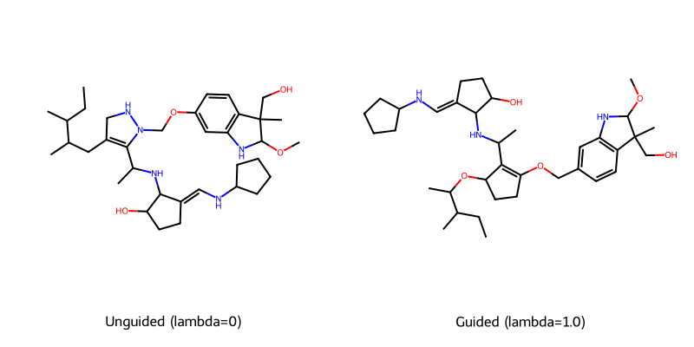
Figure E.11 2D structures of the two molecules of the paired trace: identical starting noise and identical stochastic draws, diverging only through the guidance nudge. The geometric divergence is at most 0.13 Å per atom, yet the discrete atom-type channel produces two chemically distinct, valid molecules.
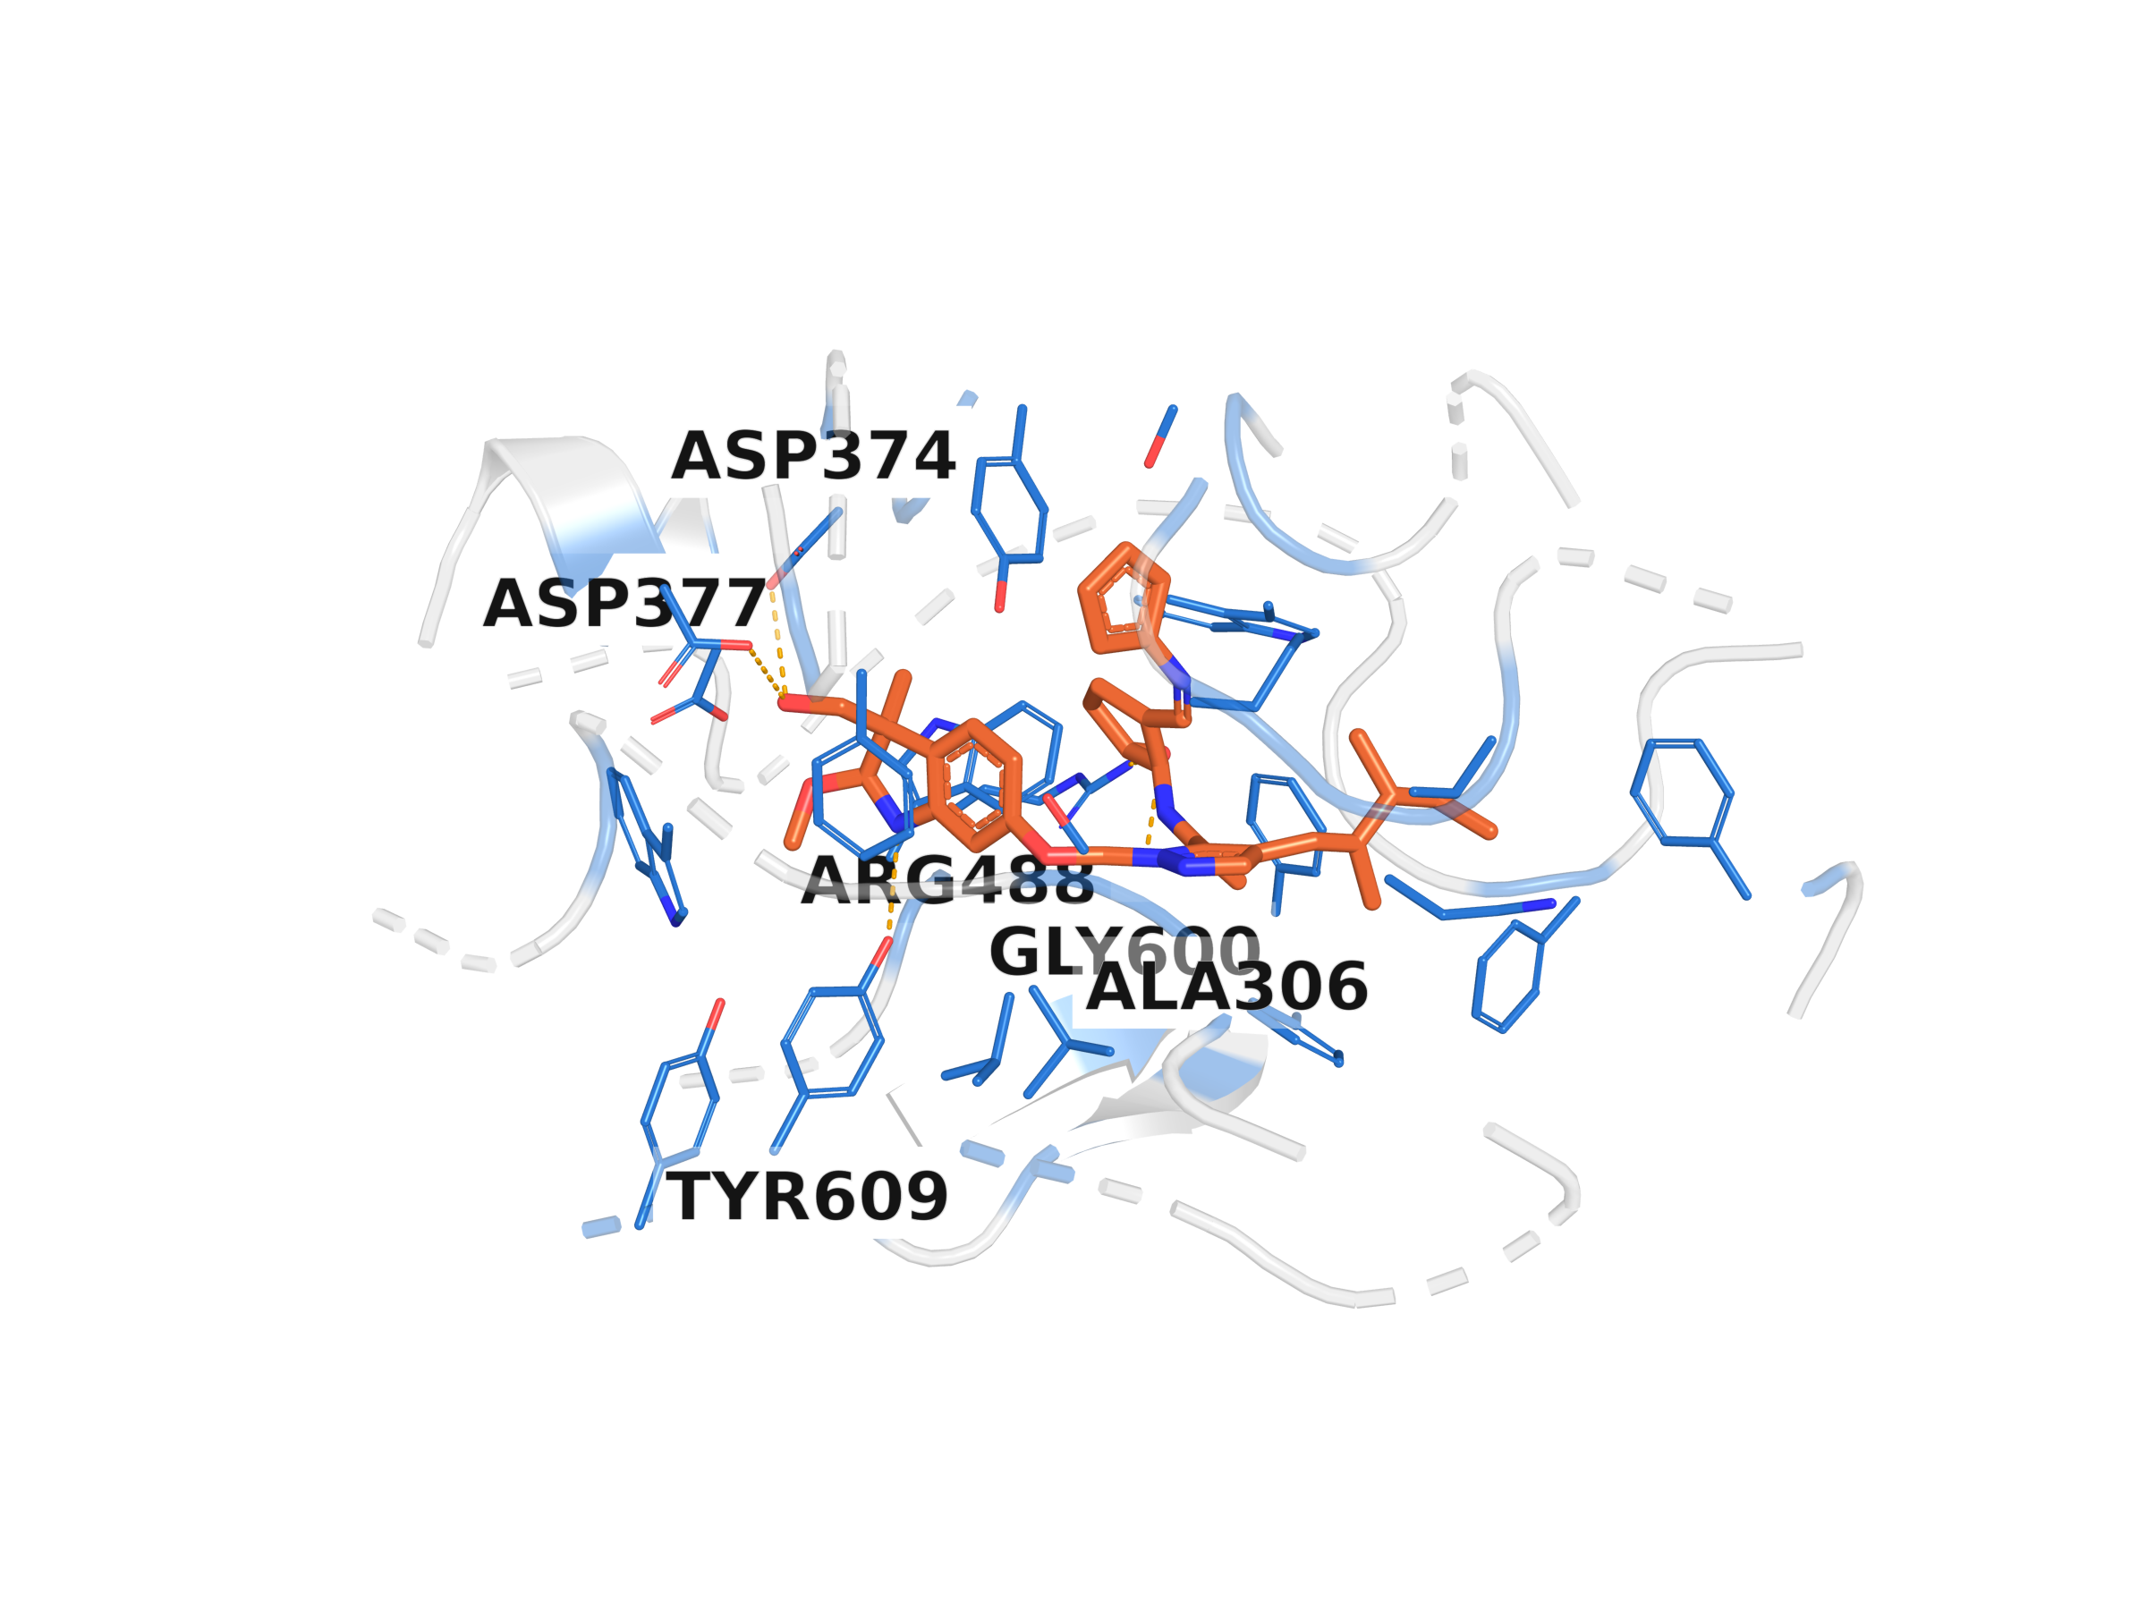
Figure E.12 The unguided (λ=0) molecule of the paired trace, docked into its pocket (PDB 1h36) and rendered with its hydrogen-bond partners. Renders the same molecule referenced in Figure E.11 and Table E.6 in its 3D binding context.
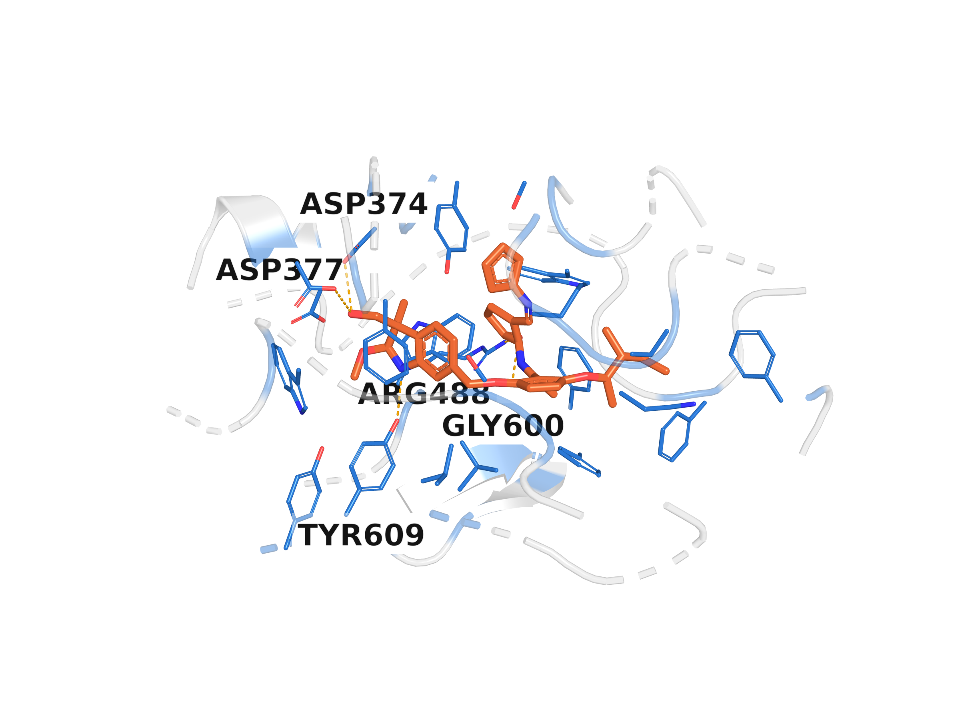
Figure E.13 The guided (λ=1.0) molecule of the same paired trace, from bit-identical starting noise, docked into the same pocket. The two renders answer directly what happens to one generated molecule when the affinity gradient is applied from one diffusion step to the next: a smoothly growing, late-accelerating positional nudge that ends sub-Ångström, alongside a discrete identity change the positional trace alone does not explain.
E.5.4 Scope and what would have rejected this hypothesis
This is a mechanistic case study of one molecule, one checkpoint, one guidance strength — it demonstrates a concrete, falsifiable phenomenon and does not by itself make a population-level statistical claim; that evidence is Section E.6's pooled correction. Had the gap instead grown to a large fraction of the raw cumulative nudge (multiple Ångströms, comparable to the summed nudge magnitude of 9.49) while the molecule remained chemically valid, that would have pointed to the guidance direction itself being the problem — a persistent, uncancelled push in a direction that simply does not help Vina Dock — rather than the injection mechanism. That is not what was observed: the gap stays two orders of magnitude below the raw nudge sum throughout, a result consistent specifically with the injection-mechanism hypothesis stated in advance, not merely consistent with "nothing happened".
E.6 Pooled Statistical Correction Across the Entire Follow-up Phase
Every independently computed Vina Dock comparison of this appendix was pooled with the comparisons already reported (one outcome variable per pool; the PLIP interaction-count tests of Section E.3.1 measure a different quantity and are reported on their own terms there, not pooled here). Table E.7 lists every source.
Table E.7 Sources pooled into the single Benjamini–Hochberg correction across the follow-up phase
Source | Checkpoint / mechanism | Test | n tests
Track A follow-up (Section E.2.1) | GIGN+PIGNet2, noise-matched + Vina-target | KS test, independent Vina Dock, n=30/condition | 16
EGNN noise-matched (Section E.2.1) | EGNN, noise-matched | Paired Wilcoxon, n=8/condition | 3
EGNN Vina-target (Section E.2.1) | EGNN, Vina-target | Paired Wilcoxon, n=8/condition | 3
Soft-v relaxation, confirmatory tier (Ch. V) | EGNN, Vina-target + soft-v | Paired Wilcoxon, n=15–16/condition | 2
Ranker, size-stratified re-analysis (Ch. VI) | EGNN, as ranker | Mann–Whitney, size-stratified | 1
ESM2, confirmatory tier (Section E.2.3) | EGNN + ESM2 | Paired Wilcoxon, n=24/condition | 2
Gradient-alignment, exploratory tier (Section E.2.2) | EGNN, gradient-alignment loss | Paired Wilcoxon, n=8/condition | 5
Kitchen-sink, exploratory tier (Section E.2.4) | EGNN, all four combined | Paired Wilcoxon, n=8/condition | 6
Family-holdout, exploratory tier (Section E.3.2) | EGNN, kinase family held out | Paired Wilcoxon, n=8/condition | 5
ESM2 pocket-only, exploratory tier (Section E.4.1) | EGNN + ESM2 (pocket-restricted) | Paired Wilcoxon, n=8/condition | 5
The original four thesis tracks (Chapters V to VIII) each already carry their own within-track Benjamini–Hochberg correction (Section IX.1); they are not repooled here, since they were run under different protocols. The soft-v relaxation's own exploratory tier (n=8, the signal that motivated its confirmatory run) is likewise excluded, since pooling an exploratory batch with its own confirmatory follow-up in the same correction would double-count one question.

0/48 comparisons significant after Benjamini–Hochberg correction [4]. Minimum raw p-value: 0.0306 (Track A follow-up, CD38_HUMAN at λ = 0.3); minimum corrected p-value: 0.525. One of 48 raw p-values falls below 0.05 — matching the roughly 2.4 false positives expected by chance alone under a true null at this pool size, not evidence of a real effect anywhere in the pool. Figure E.14 shows every comparison's effect size and confidence interval against zero.
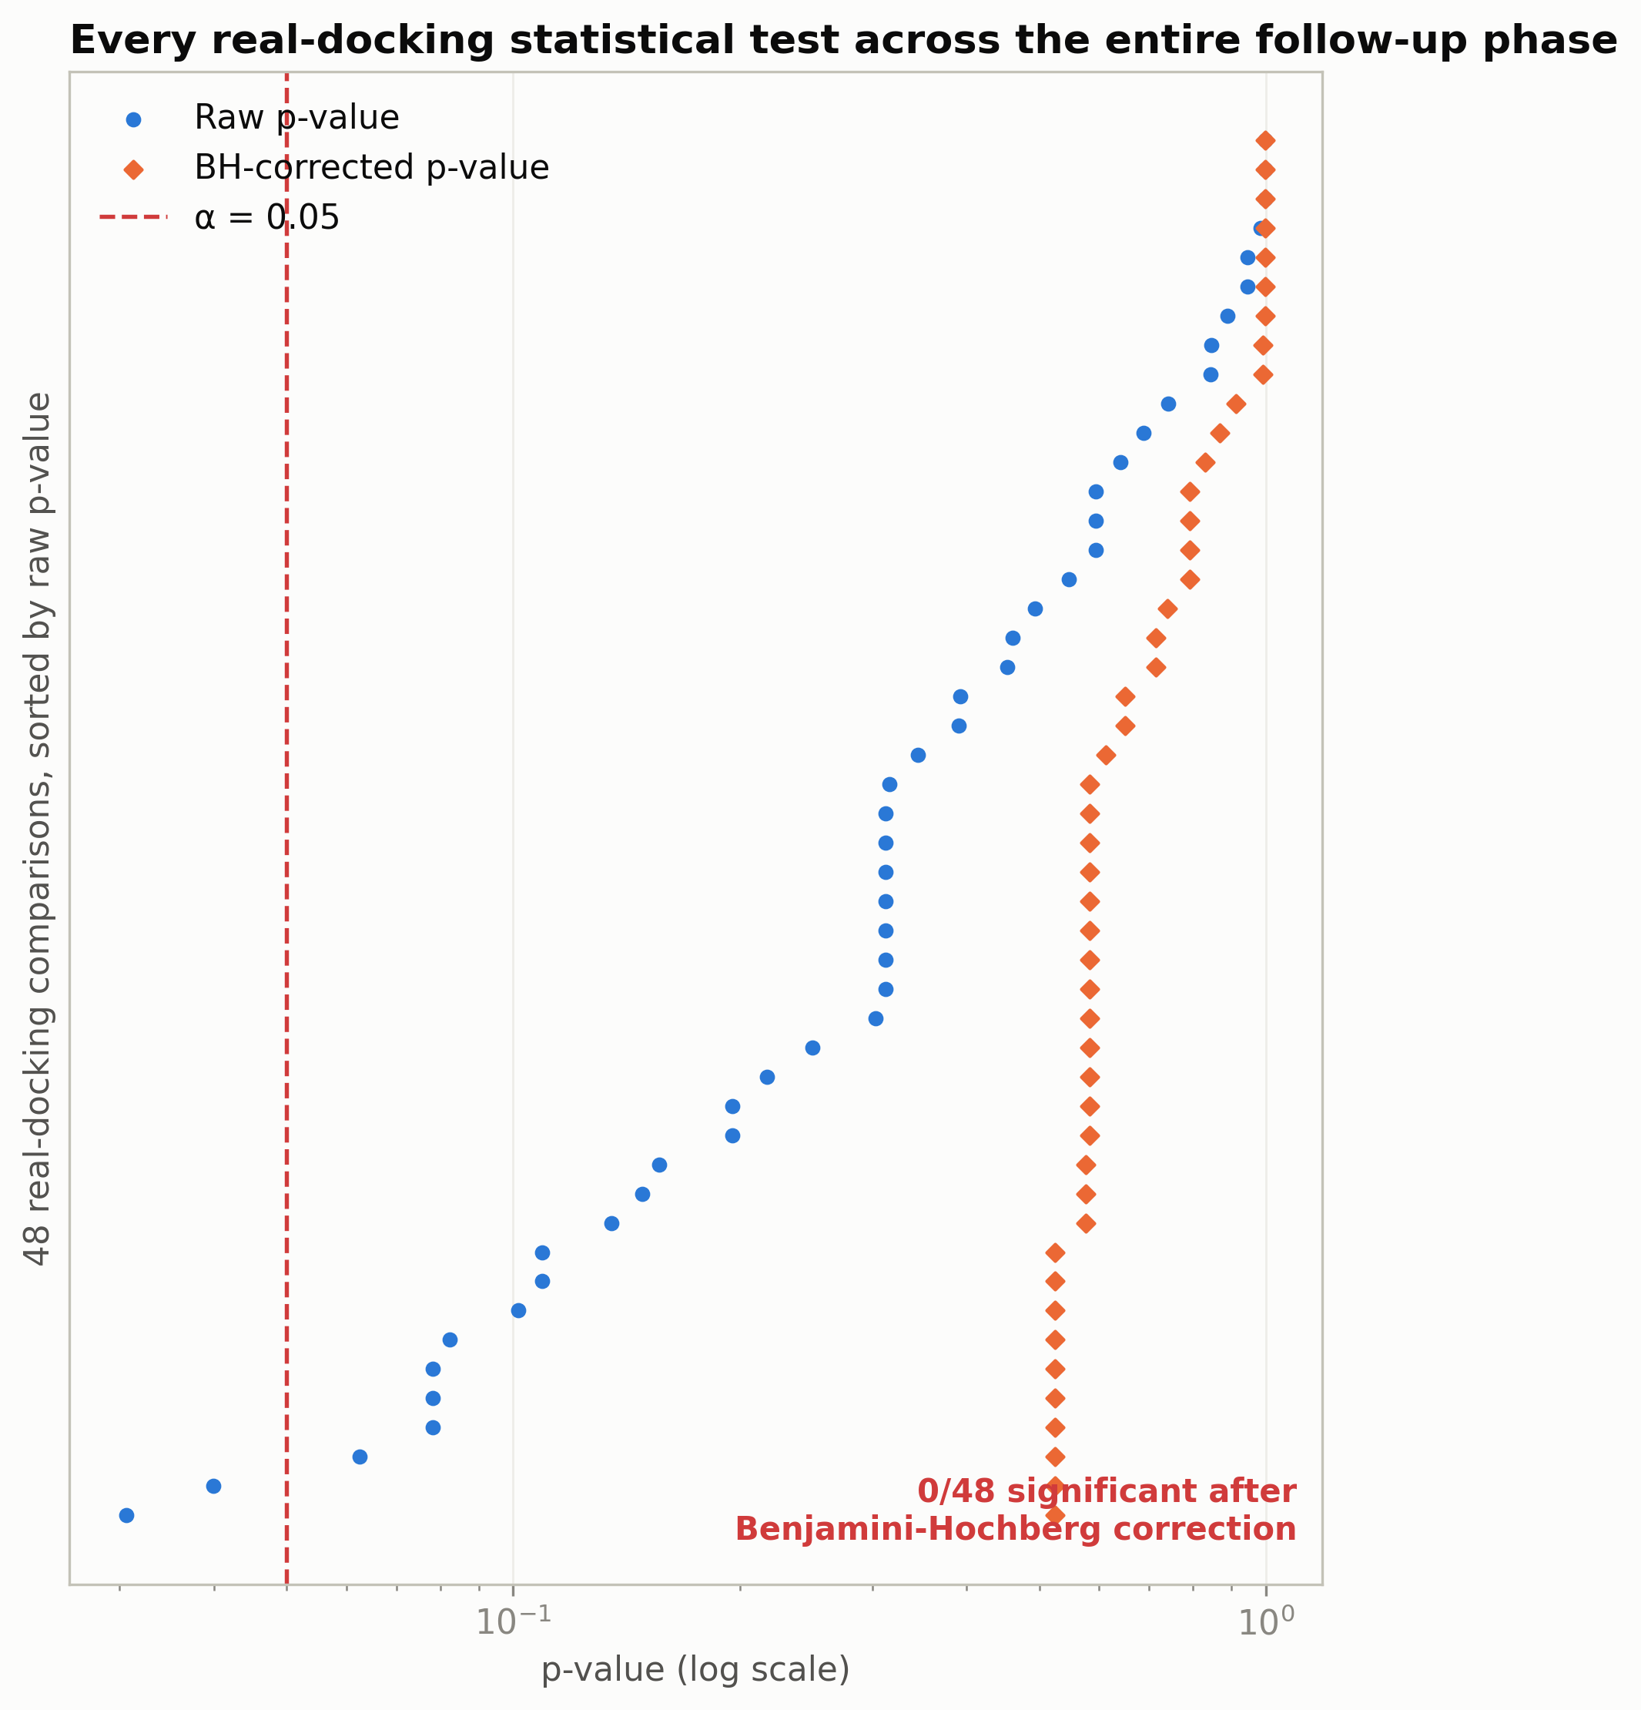
Figure E.14 Effect size and 95% confidence interval of every one of the 48 pooled comparisons of Table E.7, ordered by checkpoint. No interval is both significant after correction and in the beneficial direction.
This is not a new result in the sense that every individual test here was already computed and, in isolation, judged non-significant; what it adds is the same formal guarantee Chapter IX's own methodology requires (Section III.6.1): no claim of improvement without a test surviving multiple-comparison correction, now stated once, explicitly, across the entire follow-up phase rather than test-by-test. Together with the 8 independently-trained checkpoints of Sections E.2 to E.4 (4 architecture/representation families on top of the EGNN and GIGN+PIGNet2 backbones of Chapters IV and V, 2 guidance mechanisms, every pairwise and full combination of the four Phase 1 interventions) and the within-track corrections of Chapters V to VIII, every docking comparison computed anywhere in this thesis, under any training recipe, representation, architecture or train/test split tried, is now accounted for by one of these corrections, and none survives.
E.7 What This Appendix Adds to the Thesis's Central Claim
Chapter IX's hypotheses (a) and (c) — that the clean/noisy training mismatch, and the weakness of position-only guidance, might explain the null result — were both, at the time that chapter was written, untested and flagged as outside the compute budget available. Both were tested directly in this appendix. Hypothesis (a) does not explain the null: a predictor trained on exactly the noise distribution it will see at inference (Section E.2.1), and a predictor given an entirely new, non-noise-related information source (ESM2, Section E.2.3), both leave the pattern unchanged. Hypothesis (c) is directly supported, in a specific mechanistic form, by the trace of Section E.5: the position-only nudge is small enough, for most of the sampling trajectory, to be statistically buried in the sampler's own intrinsic step noise, and only compounds to a measurable but still sub-Ångström effect in the final steps, where it is large enough to flip discrete atom-type decisions without being large enough to move the docking score in a defensible, reproducible way. The two independent validation branches of Phase 2 (PLIP interaction counts, Section E.3.1; the unseen-protein-family generalisation test, Section E.3.2) rule out two further alternative explanations: that Vina Dock hides a real chemistry-level effect, and that the null pattern is an artefact of every tested pocket belonging to a protein family the predictor had already seen. None of this changes Chapter IX's central conclusion. It replaces two previously untested hypotheses with a tested, mechanistically specific account of why position-only gradient guidance on a frozen, pretrained diffusion model does not produce a defensible improvement under the conditions this project could test, and it rules out the two most plausible ways that conclusion could have been an artefact of the predictor, the evaluation metric, or the generalisation difficulty of the test set.

