Kubernetes (KodeKloud hand-on lab)

Lab1: Introduction to Kubectl

1. How many nodes are part of the cluster? (Ans: 1)

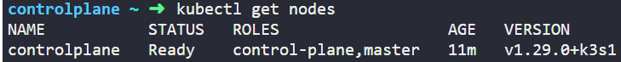

1. What is the version of the cluster running of? (Ans: v1.29.0+k3s1)
2. What is the flavor and version of Operating System on which the Kubernetes nodes are running? (Ans: Alpine Linux 3.16)  
   A computer screen shot of a program

   Description automatically generated



Lab2: Pods with YAML

1. How many pods exist on the system? (Ans: 0)

1. Create a new pod with the “nginx” image

1. How many pods are created now? (Ans: 4)

1. What is the image used to create the new pod? (Ans: busybox)



1. Which node are these pods placed on? (Ans: controlplane)
2. How many containers are part of the pod webapp? (Ans: 2)

1. What images are used in the new webapp pod? (Ans: nginx&agentx)



1. What is the state of the container agentx in the pod webapp? (Ans: Error or waiting)
2. Why do you think the container agentx in the pod webapp is an error? (Ans: A docker instance of this container doesn’t exist on Docker hub)

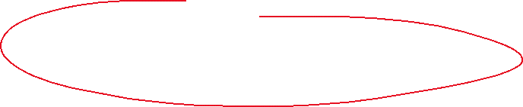

1. What does the READY column in the output of the kubectl get pods command indicate? (Ans: Running containers / Total containers in POD)

1. Delete the webapp Pod.



1. Create a new pod with the name redis and the image redis123

(or kubectl run redis –image=redis123 –dry-run -o yaml)



1. Change the image on this pod to ‘redis’  
   A screenshot of a computer program

   Description automatically generated

vi redis.yaml  
