PlugNPay Payment Module Release Notes
Version: 1.1

Date: 24.01.08

(The following section to be included with all versions of the report.)
Project Name: | PlugNPay Payment Module | Project Number: | Version 1.1
Project Manager: | Rahul Mitha, Vitthal Bhapkar
Project Sponsor:
Prepared/  Revised By: | Sandip Bhagwat | Date Prepared/  Revised: | 24th -Jan-2008
Revision Reason: |  | Revision Control#:
(The following section to be included with the final version of the report, to provide signature authorization for approval to proceed to next phase.)
AUTHORIZATION TO PROCEED
Approved By:-  Name: Ashutosh Kumar Dubey |  | January 24, 2008  Date: January 25, 2008
 | (Customer Sponsor)
 | (Customer Management)
 | (<Client Name> Sponsor)

PlugNPay, David Price
(<Client Name> Group Manager)
 | (Senior <Client Name> Management)
 | (Steering Committee Member)
 | (Steering Committee Member)
 | (Steering Committee Member)
 | (Steering Committee Member)

Table of Contents

1. Introduction 4
2. Minimum Requirements for PlugNPay 5
3. API Configuration 6
4. Module Setup 9
5. Issues and Bug fixes 12

Introduction
This document describes the configuration and use of the module itself, and assumes the reader has a familiarity with the use of the Miva Merchant administration and runtime interfaces.

In versions of Miva Merchant below 4.14 the non-compiled plugnpay.mv file should be used, in versions of Miva Merchant 4.14 and above the compiled plugnpay.mvc file should be used.

PlugNPay Payment Module is the recommended module of submitting transactions to the payment gateway. This module allows a merchant’s server to securely connect directly to the payment gateway to submit transaction data. The merchant retains full control of the payment data collection and the user experience. This module requires merchants to be able to initiate and manage different payment methods.

How does PlugNPay Payment Module Works: -

When using plugnpay, transactions flow in the following way:
- The Customers browser connects securely to the Merchants server to transmit payment information.
- The Merchants server initiates a secure connection to the payment gateway and then initiates HTTPS post of the transaction data to the gateway server.
- The payment gateway receives and processes the transaction data.
- The payment gateway then generates and submits the transaction response to the Merchants server.
- The merchant server receives and processes the response.
- Finally, the merchant’s server communicates the success or failure of the authorization to the customer browser.

Minimum Requirements for PlugNPay
Following is the minimum set of Name/Value pairs that must be submitted to the payment gateway for each transaction.

Variable | Required | Max Size | Value | Notes
publisher-name | Mandatory | NA | pnpdemo | Username issued at time of sign-up.
publisher-password | Mandatory | NA | pnpdemo | Password issued at time of sign-up.
mode | Mandatory | NA |  | If the 'mode' field is left blank or is not included, 'auth' is assumed.

API Configuration
- Following are the parameters to be sent for the Credit Card transaction

Variable | Required | Max Size | Notes
paymethod | Mandatory | NA | Name of the payment method.
card-amount | Mandatory | 10 | No '$' – Total amount to be charged.  Format: 1234.56.
card-name | Mandatory | 39 | Name as it appears on credit card (aka-the customer's name).
card-address1 | Optional | 39 | Billing Street Address Line 1.
card-address2 | Optional | 39 | Billing Street Address Line 2.  (see note 1)
card-city | Optional | 39 | Billing City Address.
card-state | Optional | 2 | Billing State Address – 2 Char. State Code – see Appendix for details.
card-prov | Optional | 39 | Billing International Province. For international provinces outside of US & Canada, set the 'card-state' field's value to 'ZZ' & include the province name here.
card-zip | Optional | 10 | Billing Zip Address.
card-country | Optional | 2 | Billing 2 Character Country Code – see Appendix for country code listing.
card-number | Mandatory | 16 | Credit Card # - Numeric characters only.  Format: 4111111111111111.
card-exp | Mandatory | 5 | Credit Card Expiration Date. Format: MM/YY.

- Following are the parameters to be sent for the Electronic Check transaction

Variable | Required | Max Size | Notes
paymethod | Mandatory | NA | Name of the payment method.
card-amount | Mandatory | 10 | No "$" - Total amount of the order.
bankname | Mandatory | NA | Value need to be set to the Bank Name.
accountnum | Mandatory | NA | Value set to the Bank account number.
accountname | Optional | NA | Value set to the name of account holder.
accttype | Mandatory | NA | There are two account types; Checking and Saving
routingnum | Mandatory | NA | Value set to the 9 digit Routing number.
checknum | Mandatory | NA | Value set to the 9 digit check number.

- Following are the parameters to be sent for the Mocapay transaction

Variable | Required | Max Size | Value | Notes
paymethod | Mandatory | NA | Mocapay | Name of the payment method.
client | Mandatory | NA | Miva | Merchant/Client name.
card-number | Mandatory | NA | Mocapay code | Mocapay code is the 4 digit transaction key code which is response from Mocapay on mobile.
Card-amount | Mandatory | 10 |  | No '$' – Total amount to be charged.  Format: 1234.56.
phone | Mandatory | NA | Cell number | Registered cell/telephone number.

- Following are the parameters to be sent for the Mercury Payment Gift Card transaction

To submit a Gift Card payment transaction there are two options:
- When you know the Gift Card has sufficient balance, you may fund the purchase with the Gift Card number only.
- When you know ahead of time or suspect that the value on the card is insufficient, fund the purchase with the Gift Card number and Credit Card data.

Mercury Payment Gift Card - Authorization - Full Gift Card Amount
When you know the Gift Card has sufficient balance to fund the entire purchase; you can submit only the Gift Card number.
Variable | Required | Max Size | Notes
card-amount | Mandatory | 10 | No "$" - Total amount of the order.
mpgiftcard | Mandatory | 20 | Value need to be set to the gift card number.
card-name | Mandatory | 39 | Name as it appears on credit card (aka - the customer's name).
card-address1 | Optional | 39 | Billing Street Address Line 1.
card-address2 | Optional | 39 | Billing Street Address Line 2.
card-city | Optional | 39 | Billing City Address.
card-state | Optional | 2 | Billing State Address – 2 Char. State Code – see Appendix for details.
card-prov | Optional | 39 | Billing International Province. For international provinces outside of US & Canada, set the 'card-state' field's value to 'ZZ' & include the province name here.
card-zip | Optional | 10 | Billing Zip Address.
card-country | Optional | 2 | Billing 2 Character Country Code – see Appendix for country code listing.

Mercury Payment GiftCard - Authorization - Unsure/Partial Gift Card Amount
When you know ahead of time or if you suspect that the value on the GiftCard is insufficient, you should submit both the Gift card number & the customer's Credit Card data.
Variable | Required | Max Size | Value | Notes
card-amount | Mandatory | 10 |  | No "$" - Total amount of the order.
mpgiftcard | Mandatory | 20 |  | Value need to be set to the gift card number.
card-number | Mandatory | 16 |  | Credit Card # - Numeric characters only.  Format: 4111111111111111.
card-exp | Mandatory | 5 |  | Credit Card Expiration Date. Format: MM/YY.
card-cvv | Optional/Fraud | 4 |  | Credit Card CVV Number. Mandatory for fraud protection.
card-name | Mandatory | 39 |  | Name as it appears on credit card (aka - the customer's name).
card-address1 | Optional | 39 |  | Billing Street Address Line 1.
card-address2 | Optional | 39 |  | Billing Street Address Line 2.
card-city | Optional | 39 |  | Billing City Address.
card-state | Optional | 2 |  | Billing State Address – 2 Char. State Code – see Appendix for details.
card-prov | Optional | 39 |  | Billing International Province. For international provinces outside of US & Canada, set the 'card-state' field's value to 'ZZ' & include the province name here.
card-zip | Optional | 10 |  | Billing Zip Address.
card-country | Optional | 2 |  | Billing 2 Character Country Code – see Appendix for country code listing.

Module Setup

Use the following procedure to add plugnpay.mvc payment modules to your Miva Merchant domain.
Miva Merchant 4.14 and above: Miva Merchant is compiled. Any added module must also be compiled. The .mvc identifies compiled Miva Merchant applications and modules.

- Click the triangle next to Modules.
- Click Add Module.

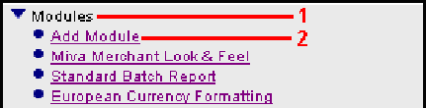

If you know the module name, enter it and go to step 5.
If you do not know the module name, click the Upload File button.

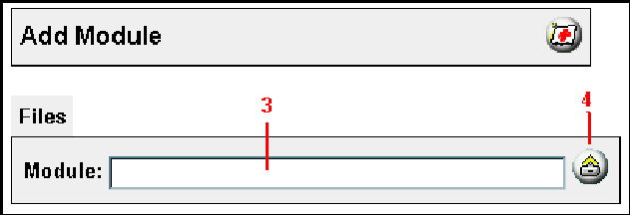

The Upload File screen is displayed.
a. Use the Browse... button to find the module on your system.
b. You are uploading a new module that is not in your Miva Merchant domain.
Therefore, you do not need to click the Overwrite check box.
c. Click the Upload button to return to the Add Module form.

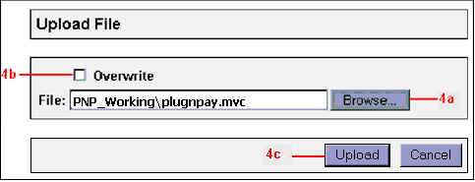

In the Add Module screen, click the Add button.
To undo your steps, click the Reset button to delete the module from the Domain.

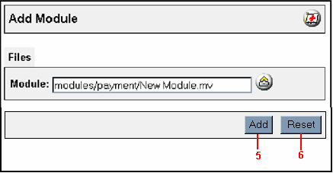
After you click the Add button, the module (A New Payment Module in the sample below) is added to the module list as the last item.
The module is enabled at the store level by checking the box next to Plug & Pay Technologies Inc. v1.0 and passing the update button.

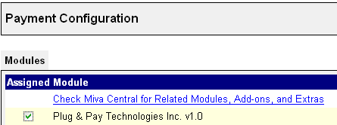

9) Once the module has been enabled a new tab will appear called “Plug & Pay Technologies Inc. v1.0”.

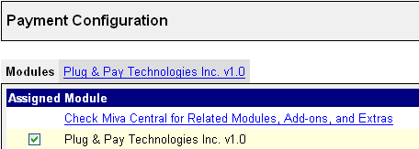

This new tab is where you will find all the configuration options for the module.

Issues and Bug fixes

Release 1.1

Known issue
Following are the transaction types which are not tested with real time data:
  - Gift Card Transactions
  - Mocapay Transactions

