Definition

Provide an interface for creating families of related or dependent objects without specifying their concrete classes.

Frequency of use:

http://dofactory.com/images/use_high.gif

High

UML class diagram

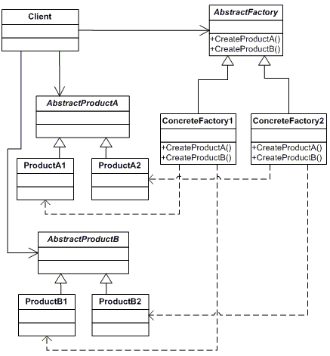

Participants

    The classes and objects participating in this pattern are:

* **AbstractFactory**  **(ContinentFactory)**
  + declares an interface for operations that create abstract products
* **ConcreteFactory**   **(AfricaFactory, AmericaFactory)**
  + implements the operations to create concrete product objects
* **AbstractProduct**   **(Herbivore, Carnivore)**
  + declares an interface for a type of product object
* **Product**  **(Wildebeest, Lion, Bison, Wolf)**
  + defines a product object to be created by the corresponding concrete factory
  + implements the AbstractProduct interface
* **Client**  **(AnimalWorld)**
  + uses interfaces declared by AbstractFactory and AbstractProduct classes