Definition

Convert the interface of a class into another interface clients expect. Adapter lets classes work together that couldn't otherwise because of incompatible interfaces.

Frequency of use:

http://dofactory.com/images/use_medium_high.gif

Medium high

UML class diagram

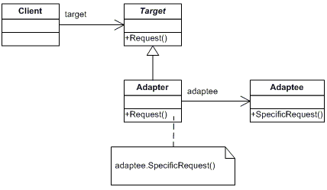

Participants

    The classes and objects participating in this pattern are:

* **Target**  **(ChemicalCompound)**
  + defines the domain-specific interface that Client uses.
* **Adapter**  **(Compound)**
  + adapts the interface Adaptee to the Target interface.
* **Adaptee**  **(ChemicalDatabank)**
  + defines an existing interface that needs adapting.
* **Client**  **(AdapterApp)**
  + collaborates with objects conforming to the Target interface.