Definition

Decouple an abstraction from its implementation so that the two can vary independently.

Frequency of use:

http://dofactory.com/images/use_medium.gif

Medium

UML class diagram

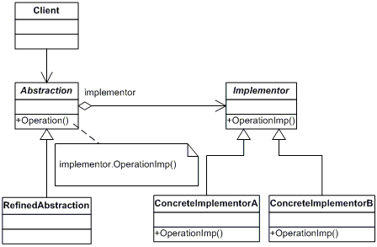

Participants

    The classes and objects participating in this pattern are:

* **Abstraction**  **(BusinessObject)**
  + defines the abstraction's interface.
  + maintains a reference to an object of type Implementor.
* **RefinedAbstraction**  **(CustomersBusinessObject)**
  + extends the interface defined by Abstraction.
* **Implementor**  **(DataObject)**
  + defines the interface for implementation classes. This interface doesn't have to correspond exactly to Abstraction's interface; in fact the two interfaces can be quite different. Typically the Implementation interface provides only primitive operations, and Abstraction defines higher-level operations based on these primitives.
* **ConcreteImplementor**  **(CustomersDataObject)**
  + implements the Implementor interface and defines its concrete implementation.