Definition

Separate the construction of a complex object from its representation so that the same construction process can create different representations.

Frequency of use:

http://dofactory.com/images/use_medium_low.gif

Medium low

UML class diagram

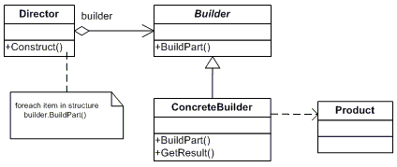

Participants

    The classes and objects participating in this pattern are:

* **Builder**  **(VehicleBuilder)**
  + specifies an abstract interface for creating parts of a Product object
* **ConcreteBuilder**  **(MotorCycleBuilder, CarBuilder, ScooterBuilder)**
  + constructs and assembles parts of the product by implementing the Builder interface
  + defines and keeps track of the representation it creates
  + provides an interface for retrieving the product
* **Director**  **(Shop)**
  + constructs an object using the Builder interface
* **Product**  **(Vehicle)**
  + represents the complex object under construction. ConcreteBuilder builds the product's internal representation and defines the process by which it's assembled
  + includes classes that define the constituent parts, including interfaces for assembling the parts into the final result