Definition

Avoid coupling the sender of a request to its receiver by giving more than one object a chance to handle the request. Chain the receiving objects and pass the request along the chain until an object handles it.

Frequency of use:

http://dofactory.com/images/use_medium_low.gif

Medium low

UML class diagram

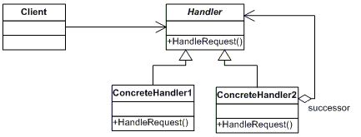

Participants

    The classes and objects participating in this pattern are:

* **Handler**  **(Approver)**
  + defines an interface for handling the requests
  + (optional) implements the successor link
* **ConcreteHandler**  **(Director, VicePresident, President)**
  + handles requests it is responsible for
  + can access its successor
  + if the ConcreteHandler can handle the request, it does so; otherwise it forwards the request to its successor
* **Client**  **(ChainApp)**
  + initiates the request to a ConcreteHandler object on the chain