Definition

Encapsulate a request as an object, thereby letting you parameterize clients with different requests, queue or log requests, and support undoable operations.

Frequency of use:

http://dofactory.com/images/use_medium_high.gif

Medium high

UML class diagram

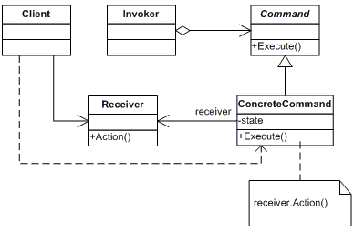

Participants

    The classes and objects participating in this pattern are:

* **Command**  **(Command)**
  + declares an interface for executing an operation
* **ConcreteCommand**  **(CalculatorCommand)**
  + defines a binding between a Receiver object and an action
  + implements Execute by invoking the corresponding operation(s) on Receiver
* **Client**  **(CommandApp)**
  + creates a ConcreteCommand object and sets its receiver
* **Invoker**  **(User)**
  + asks the command to carry out the request
* **Receiver**  **(Calculator)**
  + knows how to perform the operations associated with carrying out the request.