Definition

Compose objects into tree structures to represent part-whole hierarchies. Composite lets clients treat individual objects and compositions of objects uniformly.

Frequency of use:

http://dofactory.com/images/use_medium_high.gif

Medium high

UML class diagram

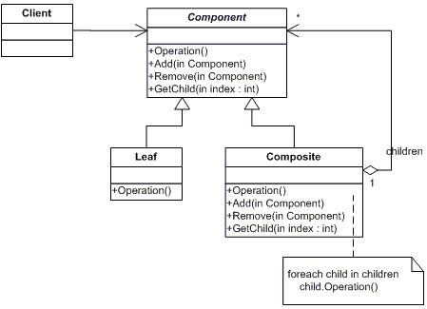

Participants

    The classes and objects participating in this pattern are:

* **Component**  **(DrawingElement)**
  + declares the interface for objects in the composition.
  + implements default behavior for the interface common to all classes, as appropriate.
  + declares an interface for accessing and managing its child components.
  + (optional) defines an interface for accessing a component's parent in the recursive structure, and implements it if that's appropriate.
* **Leaf**  **(PrimitiveElement)**
  + represents leaf objects in the composition. A leaf has no children.
  + defines behavior for primitive objects in the composition.
* **Composite**  **(CompositeElement)**
  + defines behavior for components having children.
  + stores child components.
  + implements child-related operations in the Component interface.
* **Client**  **(CompositeApp)**
  + manipulates objects in the composition through the Component interface.