Definition

Attach additional responsibilities to an object dynamically. Decorators provide a flexible alternative to subclassing for extending functionality.

Frequency of use:

http://dofactory.com/images/use_medium.gif

Medium

UML class diagram

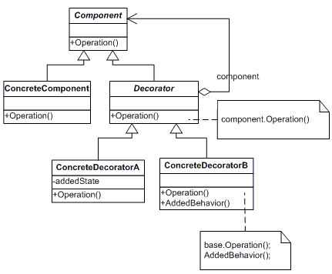

Participants

    The classes and objects participating in this pattern are:

* **Component**  **(LibraryItem)**
  + defines the interface for objects that can have responsibilities added to them dynamically.
* **ConcreteComponent**  **(Book, Video)**
  + defines an object to which additional responsibilities can be attached.
* **Decorator**  **(Decorator)**
  + maintains a reference to a Component object and defines an interface that conforms to Component's interface.
* **ConcreteDecorator**  **(Borrowable)**
  + adds responsibilities to the component.