Definition

Provide a unified interface to a set of interfaces in a subsystem. Façade defines a higher-level interface that makes the subsystem easier to use.

Frequency of use:

http://dofactory.com/images/use_high.gif

High

UML class diagram

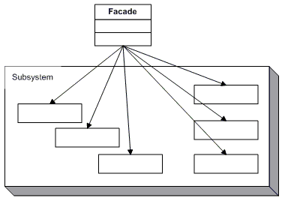

Participants

    The classes and objects participating in this pattern are:

* **Facade**  **(MortgageApplication)**
  + knows which subsystem classes are responsible for a request.
  + delegates client requests to appropriate subsystem objects.
* **Subsystem classes**  **(Bank, Credit, Loan)**
  + implement subsystem functionality.
  + handle work assigned by the Facade object.
  + have no knowledge of the facade and keep no reference to it.