Definition

Define an interface for creating an object, but let subclasses decide which class to instantiate. Factory Method lets a class defer instantiation to subclasses.

Frequency of use:

http://dofactory.com/images/use_high.gif

High

UML class diagram

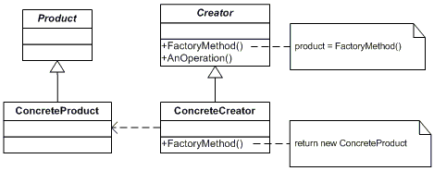

Participants

    The classes and objects participating in this pattern are:

* **Product**  **(Page)**
  + defines the interface of objects the factory method creates
* **ConcreteProduct**  **(SkillsPage, EducationPage, ExperiencePage)**
  + implements the Product interface
* **Creator**  **(Document)**
  + declares the factory method, which returns an object of type Product. Creator may also define a default implementation of the factory method that returns a default ConcreteProduct object.
  + may call the factory method to create a Product object.
* **ConcreteCreator**  **(Report, Resume)**
  + overrides the factory method to return an instance of a ConcreteProduct.