Definition

Provide a way to access the elements of an aggregate object sequentially without exposing its underlying representation.

Frequency of use:

http://dofactory.com/images/use_high.gif

High

UML class diagram

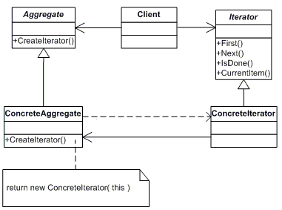

Participants

    The classes and objects participating in this pattern are:

* **Iterator**  **(AbstractIterator)**
  + defines an interface for accessing and traversing elements.
* **ConcreteIterator**  **(Iterator)**
  + implements the Iterator interface.
  + keeps track of the current position in the traversal of the aggregate.
* **Aggregate**  **(AbstractCollection)**
  + defines an interface for creating an Iterator object
* **ConcreteAggregate**  **(Collection)**
  + implements the Iterator creation interface to return an instance of the proper ConcreteIterator