Definition

Define an object that encapsulates how a set of objects interact. Mediator promotes loose coupling by keeping objects from referring to each other explicitly, and it lets you vary their interaction independently.

Frequency of use:

http://dofactory.com/images/use_medium_low.gif

Medium low

UML class diagram

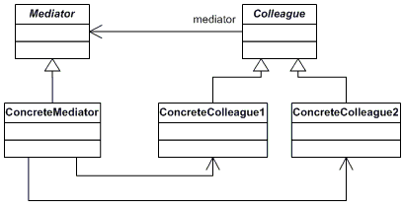

Participants

    The classes and objects participating in this pattern are:

* **Mediator**  **(IChatroom)**
  + defines an interface for communicating with Colleague objects
* **ConcreteMediator**  **(Chatroom)**
  + implements cooperative behavior by coordinating Colleague objects
  + knows and maintains its colleagues
* **Colleague classes**  **(Participant)**
  + each Colleague class knows its Mediator object
  + each colleague communicates with its mediator whenever it would have otherwise communicated with another colleague