Definition

Define a one-to-many dependency between objects so that when one object changes state, all its dependents are notified and updated automatically.

Frequency of use:

http://dofactory.com/images/use_high.gif

High

UML class diagram

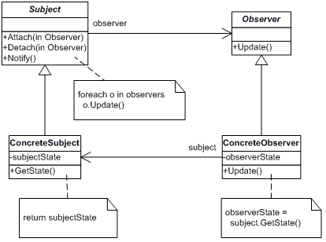

Participants

    The classes and objects participating in this pattern are:

* **Subject**  **(Stock)**
  + knows its observers. Any number of Observer objects may observe a subject
  + provides an interface for attaching and detaching Observer objects.
* **ConcreteSubject**  **(IBM)**
  + stores state of interest to ConcreteObserver
  + sends a notification to its observers when its state changes
* **Observer**  **(IInvestor)**
  + defines an updating interface for objects that should be notified of changes in a subject.
* **ConcreteObserver**  **(Investor)**
  + maintains a reference to a ConcreteSubject object
  + stores state that should stay consistent with the subject's
  + implements the Observer updating interface to keep its state consistent with the subject's