Definition

Specify the kind of objects to create using a prototypical instance, and create new objects by copying this prototype.

Frequency of use:

http://dofactory.com/images/use_medium.gif

Medium

UML class diagram

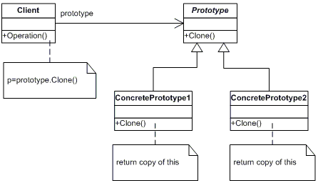

Participants

    The classes and objects participating in this pattern are:

* **Prototype**  **(ColorPrototype)**
  + declares an interface for cloning itself
* **ConcretePrototype**  **(Color)**
  + implements an operation for cloning itself
* **Client**  **(ColorManager)**
  + creates a new object by asking a prototype to clone itself