Definition

Provide a surrogate or placeholder for another object to control access to it.

Frequency of use:

http://dofactory.com/images/use_medium_high.gif

Medium high

UML class diagram

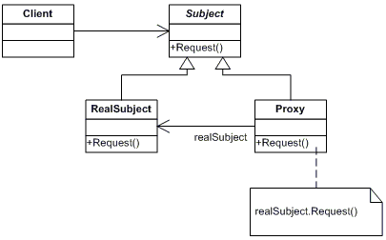

Participants

    The classes and objects participating in this pattern are:

* **Proxy**  **(MathProxy)**
  + maintains a reference that lets the proxy access the real subject. Proxy may refer to a Subject if the RealSubject and Subject interfaces are the same.
  + provides an interface identical to Subject's so that a proxy can be substituted for for the real subject.
  + controls access to the real subject and may be responsible for creating and deleting it.
  + other responsibilites depend on the kind of proxy:
    - *remote proxies* are responsible for encoding a request and its arguments and for sending the encoded request to the real subject in a different address space.
    - *virtual proxies* may cache additional information about the real subject so that they can postpone accessing it. For example, the ImageProxy from the Motivation caches the real images's extent.
    - *protection proxies* check that the caller has the access permissions required to perform a request.
* **Subject**  **(IMath)**
  + defines the common interface for RealSubject and Proxy so that a Proxy can be used anywhere a RealSubject is expected.
* **RealSubject**  **(Math)**
  + defines the real object that the proxy represents.