Definition

Ensure a class has only one instance and provide a global point of access to it.

Frequency of use:

http://dofactory.com/images/use_medium_high.gif

Medium high

UML class diagram

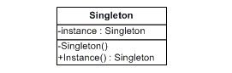

Participants

    The classes and objects participating in this pattern are:

* **Singleton**  **(LoadBalancer)**
  + defines an Instance operation that lets clients access its unique instance. Instance is a class operation.
  + responsible for creating and maintaining its own unique instance.