Definition

Allow an object to alter its behavior when its internal state changes. The object will appear to change its class.

Frequency of use:

http://dofactory.com/images/use_medium.gif

Medium

UML class diagram

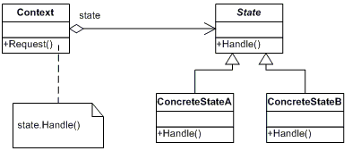

Participants

    The classes and objects participating in this pattern are:

* **Context**  **(Account)**
  + defines the interface of interest to clients
  + maintains an instance of a ConcreteState subclass that defines the current state.
* **State**  **(State)**
  + defines an interface for encapsulating the behavior associated with a particular state of the Context.
* **Concrete State**  **(RedState, SilverState, GoldState)**
  + each subclass implements a behavior associated with a state of Context