Definition

Define a family of algorithms, encapsulate each one, and make them interchangeable. Strategy lets the algorithm vary independently from clients that use it.

Frequency of use:

http://dofactory.com/images/use_medium_high.gif

Medium high

UML class diagram

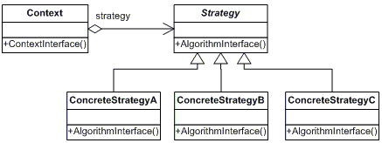

Participants

    The classes and objects participating in this pattern are:

* **Strategy**  **(SortStrategy)**
  + declares an interface common to all supported algorithms. Context uses this interface to call the algorithm defined by a ConcreteStrategy
* **ConcreteStrategy**  **(QuickSort, ShellSort, MergeSort)**
  + implements the algorithm using the Strategy interface
* **Context**  **(SortedList)**
  + is configured with a ConcreteStrategy object
  + maintains a reference to a Strategy object
  + may define an interface that lets Strategy access its data.