Bevis, Tony (2012-11-01). C# Design Pattern Essentials. Ability First Limited.

How this book is organised

Part I introduces the idea of design patterns, and lays the foundation for some simple core classes that comprise the common theme used throughout this book.

Part II describes the five creational patterns, that is, those that help manage the instantiation of objects.

Part III describes the seven structural patterns, that is, those that help manage how classes are organised and interrelate.

Part IV describes the eleven behavioural patterns, that is, those that help manage what the classes actually do.

Part V describes four additional patterns you should find useful in practical applications.

Part VI contains a single chapter that develops a simple 3-tier application that uses some of the more commonly used design patterns.

Part VII contains the appendixes, which includes a brief explanation of the Unified Modeling Language (UML) diagram formats for those unfamiliar with UML, and a quick reference for each of the 23 main patterns.

Conventions used in this book

C# code that you need to enter, or results that are shown as output, is shown in a fized-width font as follows:

anObject.DoSomething();

anotherObject.DoThis();

Often, a piece of additional or modified code is provided, and the parts that are new or changed are indicated in bold:

anObject.DoSomething**ElseInstead**();

**anObject.AlsoDoThis();**

anotherObject.doThis();

Names of classes, objects or C# statements will appear in the text using a fixed-width font such as MyClass or someObject, for example. For reasons of brevity, using and namespace statements are omitted from most of the code samples in this book.

The book’s resources You can also download all of the C# source code from this book from our website:

http://www.abilityfirst.co.uk/books

# Part I. Introduction

1. What are Design Patterns?

Imagine that you have just been assigned the task of designing a software system. Your customer tells you that he needs to model the Gadgets his factory makes and that each Gadget comprises the same component parts but those parts are a bit different for each type of Gadget. And he also makes Gizmos (a gadget, especially one whose name the speaker does not know or cannot recall), where each Gizmo comes with a selection of optional extras any combination of which can be chosen. And he also needs a unique sequential serial number stamped on each item made.

Just how would you go about designing these classes?

The chances are that no matter what problem domain you are working in, somebody else has had to design a similar solution in the past. Not necessarily for Gadgets and Gizmos of course, but conceptually similar in terms of objectives and structure. In other words there's a good chance that a generic solution or approach already exists, and all you need to do is to apply that approach to solve your design conundrum.

This is what Design Patterns are for. They describe generic solutions to software design problems. Once versed in patterns, you might think to yourself "those Gadgets could be modelled using the Abstract Factory pattern, the Gizmos using the Decorator pattern, and the serial number generation using the Singleton pattern."

How this book uses patterns

This book gives worked examples for each of the 23 patterns described in the classic reference work Design Patterns: Elements of Reusable Object-Oriented Software (Gamma, 1995) plus four additional useful patterns, including Model-View-Controller (MVC).

Each of the worked examples in this book uses a common theme drawn from the business world, being that of a fictional vehicle manufacturer called the Foobar Motor Company. The company makes a range of cars and vans together with the engines used to power the vehicles. You should therefore familiarise yourself with the classes described in this introduction.

The class hierarchy looks like this:

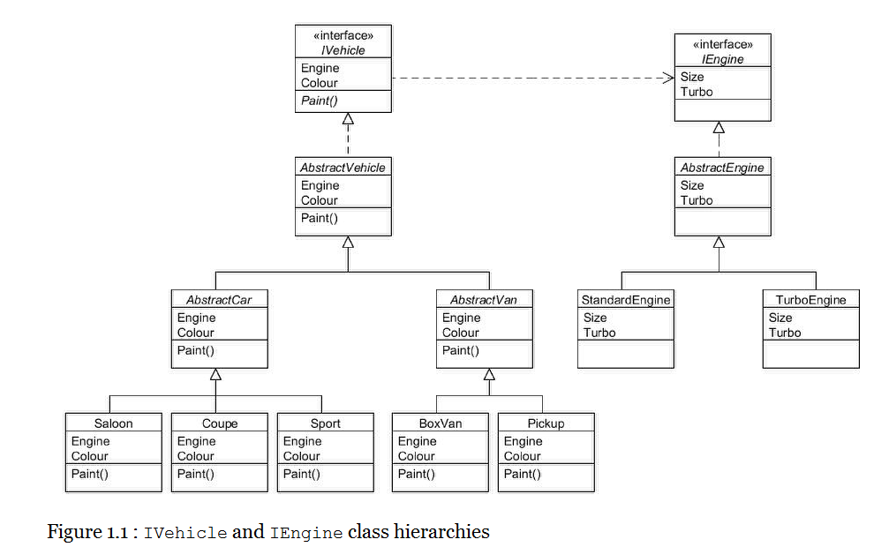

IVehicle and IEngine are the root interfaces of the hierarchies, with each vehicle object requiring a reference to an IEngine object. AbstractVehicle is an abstract class that implements the IVehicle interface, and AbstractEngine likewise implements the IEngine interface. For vehicles, we also have AbstractCar and AbstractVan together with concrete subclassses Saloon, Coupe and Sport as types of cars. AbstractVan has the concrete subclasses BoxVan and Pickup as types of van.

The concrete subclasses of AbstractEngine are StandardEngine and TurboEngine.

Despite there being several classes in the hierarchies the code for each has been kept deliberately simple so you can focus on understanding the patterns rather than having to decipher complex code. To illustrate this, here is the source code for the IEngine interface:

public interface IEngine

{

int Size { get; }

bool Turbo { get; }

}

This simple interface merely requires property getters to return the engine size (in cubic centimetres) and whether it is turbocharged. The AbstractEngine class looks like this:

public abstract class AbstractEngine : IEngine

{

private int size;

private bool turbo;

public AbstractEngine(int size, bool turbo)

{

this.size = size;

this.turbo = turbo;

}

public virtual int Size

{

get

{

return size;

}

}

public virtual bool Turbo

{

get

{

return turbo;

}

}

public override string ToString()

{

return this.GetType().Name + " (" + size + ")";

}

}

This simplified implementation of an engine requires the appropriate attributes to be supplied in the constructor. The ToString() method has been implemented to produce output in this format:

StandardEngine (1300) TurboEngine (2000)

The Equals() and GetHashCode() methods will inherit from object and therefore use object identity. This makes sense, since for example, two separate 1300cc Standard engines are logically different entities and so should be treated as such (one engine would go into one vehicle and the other engine into a different vehicle).

The concrete subclasses are trivially simple:

public class StandardEngine : AbstractEngine

{

public StandardEngine(int size)

: base(size, false)

{

// not turbocharged

}

}

public class TurboEngine : AbstractEngine

{

public TurboEngine(int size)

: base(size, true)

{

// turbocharged

}

}

Now that you have seen the IEngine hierarchy we can look at the IVehicle interface:

public interface IVehicle

{

IEngine Engine { get; }

VehicleColour Colour { get; }

void Paint(VehicleColour colour);

}

A supporting enum called VehicleColour defines the possible colours that each IVehicle object could be:

public enum VehicleColour

{

Unpainted, Blue, Black, Green,

Red, Silver, White, Yellow

}

This is how the AbstractVehicle class implements IVehicle:

public abstract class AbstractVehicle : IVehicle

{

private IEngine engine;

private VehicleColour colour;

public AbstractVehicle(IEngine engine)

: this(engine, VehicleColour.Unpainted)

{

}

public AbstractVehicle(IEngine engine, VehicleColour colour)

{

this.engine = engine;

this.colour = colour;

}

public virtual IEngine Engine

{

get

{

return engine;

}

}

public virtual VehicleColour Colour

{

get

{

return colour;

}

}

public virtual void Paint(VehicleColour colour)

{

this.colour = colour;

}

public override string ToString()

{

return this.GetType().Name + " (" + engine + ", " + colour + ")";

}

}

The overloaded constructors in AbstractVehicle require an IEngine object and optionally a vehicle colour to be supplied. The output of calls to ToString() will be in this format:

Saloon (StandardEngine (1300), Red)

BoxVan (TurboEngine (2200), White)

The AbstractCar and AbstractVan classes just forward to the constructors (obviously real classes would define whatever is different between cars and vans):

public abstract class AbstractCar : AbstractVehicle

{

public AbstractCar(IEngine engine)

: this(engine, VehicleColour.Unpainted)

{

}

public AbstractCar(IEngine engine, VehicleColour colour)

: base(engine, colour)

{

}

}

public abstract class AbstractVan : AbstractVehicle

{

public AbstractVan(IEngine engine)

: this(engine, VehicleColour.Unpainted)

{

}

public AbstractVan(IEngine engine, VehicleColour colour)

: base(engine, colour)

{

}

}

The concrete subclasses also just forward to the constructors:

public class Saloon : AbstractCar

{

public Saloon(IEngine engine)

: this(engine, VehicleColour.Unpainted)

{

}

public Saloon(IEngine engine, VehicleColour colour)

: base(engine, colour)

{

}

}

public class Coupe : AbstractCar

{

public Coupe(IEngine engine)

: this(engine, VehicleColour.Unpainted)

{

}

public Coupe(IEngine engine, VehicleColour colour)

: base(engine, colour)

{

}

}

public class BoxVan : AbstractVan

{

public BoxVan(IEngine engine)

: this(engine, VehicleColour.Unpainted)

{

}

public BoxVan(IEngine engine, VehicleColour colour)

: base(engine, colour)

{

}

}

public class Pickup : AbstractVan

{

public Pickup(IEngine engine)

: this(engine, VehicleColour.Unpainted)

{

}

public Pickup(IEngine engine, VehicleColour colour)

: base(engine, colour)

{

}

}

Many of the patterns in this book utilise one or more of the above classes in some way, often adding additional functionality or classes for the purposes of explaining the pattern in question. You will also frequently see reference to a Client class; this just refers to whatever class is making use of the pattern under discussion.

## How patterns are categorised

Each of the patterns described in this book fall under one of three categories; Creational, Structural or Behavioural:

* Creational patterns provide approaches to object instantiation. Where you place the new keyword affects how tightly or loosely coupled your classes are;
* Structural patterns provide approaches for combining classes and objects to form larger structures. Deciding whether to use inheritance or composition affects how flexible and adaptable your software is;
* Behavioural patterns provide approaches for handling communication between objects.

## Common principles in design patterns

Experience has shown that some object-oriented approaches are more flexible than others. Here is a summary of the main principles that the patterns in this book strive to adhere to:

1. **Program to an interface, not an implementation**. By "interface" is meant the general concept of abstraction, which could refer to a C# interface or an abstract class. To accomplish this, use the most general type (e.g. interface) possible when declaring variables, constructor and method arguments, etc. Doing so gives extra flexibility as to the actual types that are used at run-time.
2. **Prefer object composition over inheritance**. Where a class is related to another in some way, you should distinguish between "is a" (or "is a type of") and "has a" relationships. In the IVehicle and IEngine hierarchies described earlier, it is true to say that AbstractCar "is a" IVehicle, and that Saloon "is a" AbstractCar. But it would not be true to say that IVehicle "is a" IEngine, but rather that an IVehicle "has a" IEngine. Therefore, inheritance is legitimately used for AbstractCar and Saloon, but object composition is used between IVehicle and IEngine. Do not be tempted to use inheritance just to save having to write some methods. Sometimes using a "has a" relationship is more flexible even when an "is a" relationship seems the natural choice. You will see an example of this in the Decorator pattern.
3. **Keep objects loosely-coupled**. Ideally, classes should model just one thing, and only be composed of other objects that are genuinely required (such as a IVehicle requiring an IEngine). Ask yourself what would happen if you wanted to use a class you have written in a completely different application; what "baggage" (i.e. other classes) would also need to be copied? By keeping this to a minimum, you make your class more re-usable. A good example of a pattern that uses loose-coupling is Observer.
4. **Encapsulate the concept that varies**. If you've written a class in which some parts are the same for each instance but another part of the class varies for each instance, consider extracting the latter into a class of its own, which is referenced by the original class. An example pattern that uses this principle is Strategy.

## Some general advice

The principles listed above will become more apparent as we explore the patterns in detail. You should also note that the patterns described in this book give a general approach to a particular problem. It is quite acceptable for you to modify or adapt them to better fit your particular problem. And it is very common for multiple patterns to be combined to solve complex problems.

However, do remember that you should strive to keep things simple. It is easy, after reading a book such as this, to think that you have to find a pattern to solve a particular problem when an even simpler solution might be available. One of the mantras of Extreme Programming (XP) is "You aren't going to need it", the idea being that you should avoid adding features before they are required, and this philosophy could also be applied to patterns; beware of adding an unnecessary feature just so you can apply a pattern. Patterns are not a "magic bullet", just another set of tools in your toolkit, albeit an indispensable set.

Use your knowledge and experience to judge whether a pattern should be applied to your circumstances, and if so to what extent you need to adapt it. A good example of when applying patterns may be beneficial is when you are "refactoring" existing code. Refactoring is when you are changing the structure of some software but not its behaviour, to improve its maintainability and flexibility. This provides a good opportunity to examine your code to see if a pattern might provide a better structure, such as replacing conditionals, or defining factory classes to aid object instantiation.

Patterns have been applied to many programming languages besides C#, particularly object-oriented languages, and indeed other fields, having originated by being applied to architectural design. And new patterns are being developed and applied on a regular basis, so you may view this book as merely a starting point in the subject.

# Part II. Creational Patterns

This part describes the five creational patterns, that is, those that help manage the instantiation of objects.

* Abstract Factory: Provide an interface for creating families of related or dependent objects without specifying their concrete classes;
* Builder: Separate the construction of a complex object from its representation so that the same construction process can create different representations;
* Factory Method: Define an interface for creating an object, but let subclasses decide which class to instantiate;
* Prototype: Specify the kinds of objects to create using a prototypical instance, and create new objects by copying the prototype;
* Singleton: Ensure a class allows only one object to be created, providing a single point of access to it.

### Abstract Factory

Type: Creational

Purpose: Provide an interface for creating families of related or dependent objects without specifying their concrete classes.

The Foobar Motor Company makes cars and vans, which when being built comprises (among lots of other things) a body shell, a chassis and glassware for the windows. Although both cars and vans need all of the same types of components, the specifics of each type differ depending upon whether it is being used for a car or a van.

In other words:

* A car's body shell is different from a van's body shell;
* A car's chassis is different from a van's chassis;
* A car's glassware is different from a van's glassware.

Therefore, when we need to build a vehicle we can think of the components as coming from different 'families'; that is, when we build a car we use one family of components and when we build a van we use a different family of components.

We can thus model the components into simple hierarchies, as illustrated in the following figure:

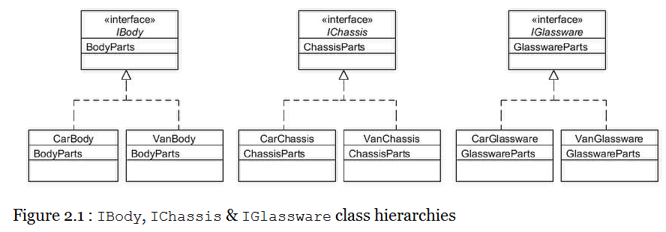

As you can see, there is an interface for IBody having implementations of CarBody and VanBody. Likewise we have similar separate hierarchies for IChassis and IGlassware.

The code for the IBody hierarchy is very simple:

public interface IBody

{

string BodyParts { get; }

}

public class CarBody : IBody

{

public virtual string BodyParts

{

get

{

return "Body shell parts for a car";

}

}

}

public class VanBody : IBody

{

public virtual string BodyParts

{

get

{

return "Body shell parts for a van";

}

}

}

The code for the IChassis hierarchy is almost identical:

public interface IChassis

{

string ChassisParts { get; }

}

public class CarChassis : IChassis

{

public virtual string ChassisParts

{

get

{

return "Chassis parts for a car";

}

}

}

public class VanChassis : IChassis

{

public virtual string ChassisParts

{

get

{

return "Chassis parts for a van";

}

}

}

And likewise the code for the IGlassware hierarchy:

public interface IGlassware

{ string GlasswareParts { get; } }

public class CarGlassware : IGlassware

{

public virtual string GlasswareParts

{

get

{

return "Window glassware for a car";

}

}

}

public class VanGlassware : IGlassware

{

public virtual string GlasswareParts

{

get

{

return "Window glassware for a van";

}

}

}

Now we need a way of getting the correct family of parts (either for a car or for a van) but without having to explicitly instantiate the specific type in client programs each time we require them. To accomplish this, we shall define "factory" classes that will do this for us:

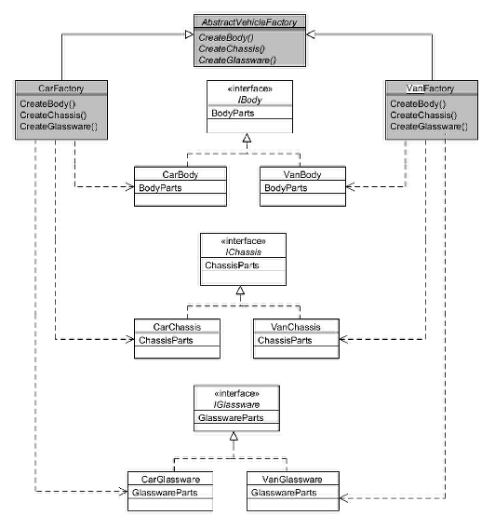

Figure 2.2 : Abstract Factory pattern

The AbstractVehicleFactory class is an abstract class that defines the abstract methods CreateBody(), CreateChassis() and CreateGlassware(), returning an IBody, IChassis and IGlassware object respectively:

public abstract class AbstractVehicleFactory

{

public abstract IBody CreateBody();

public abstract IChassis CreateChassis();

public abstract IGlassware CreateGlassware();

}

The concrete subclass CarFactory returns the objects specific for the car family:

public class CarFactory : AbstractVehicleFactory

{

public override IBody CreateBody()

{

return new CarBody();

}

public override IChassis CreateChassis()

{

return new CarChassis();

}

public override IGlassware CreateGlassware()

{

return new CarGlassware();

}

}

The concrete subclass VanFactory returns the objects specific for the van family:

public class VanFactory : AbstractVehicleFactory

{

public override IBody CreateBody()

{

return new VanBody();

}

public override IChassis CreateChassis()

{

return new VanChassis();

}

public override IGlassware CreateGlassware()

{

return new VanGlassware();

}

}

Now it just remains for client programs to instantiate the appropriate 'factory' after which it can obtain the correct parts without having to specify whether they are for a car or a van:

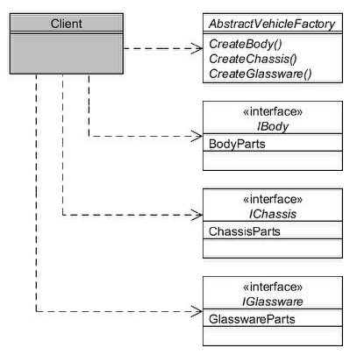

Figure 2.3 : How clients use Abstract Factory

static void Main(string[] args)

{

string whatToMake = "car"; // or "van"

AbstractVehicleFactory factory = null;

// Create the correct 'factory'...

if (whatToMake.Equals("car"))

{

factory = new CarFactory();

}

else

{

factory = new VanFactory();

}

// Create the vehicle's component parts...

// These will either be all car parts or all van parts

IBody vehicleBody = factory.CreateBody();

IChassis vehicleChassis = factory.CreateChassis();

IGlassware vehicleWindows = factory.CreateGlassware();

// Show what we've created...

Console.WriteLine(vehicleBody.BodyParts);

Console.WriteLine(vehicleChassis.ChassisParts);

Console.WriteLine(vehicleWindows.GlasswareParts);

Console.Read();

}

Therefore your client program needs to know if it is making a car or a van, but once it has instantiated the correct factory all the methods to create the parts can be done using an identical set of method calls.

The main disadvantage of the Abstract Factory pattern arises if you need to add additional 'products'. For example, if we now need to include lights in the family of components, we would need to amend AbstractVehicleFactory, CarFactory and VanFactory, in addition to creating a new ILights hierarchy (CarLights and VanLights).

### Builder

Type: Creational

Purpose: Separate the construction of a complex object from its representation so that the same construction process can create different representations.

The Foobar Motor Company makes cars and vans, and the construction process of each differs in detail; for example, the body shell of a van comprises a cab area and a large reinforced storage area, whereas a saloon car comprises a passenger area and a luggage area (i.e. boot). And of course there a number of complex steps that have to be undertaken regardless of what type of vehicle is being built.

The Builder pattern facilitates the construction of complex objects by separating the individual steps into separate methods in a Builder hierarchy, and then using a Director object to specify the required steps in the correct order. Finally, the finished product is retrieved from the Builder.

The following diagram shows these relationships:

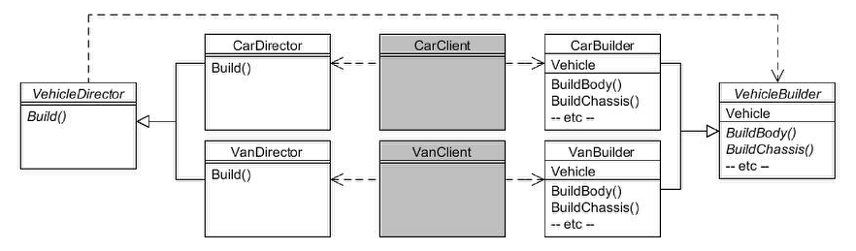 Figure 3.1 : Builder pattern

We start off with the abstract VehicleBuilder class:

public abstract class VehicleBuilder

{

public virtual void BuildBody() {}

public virtual void BuildBoot() {}

public virtual void BuildChassis() {}

public virtual void BuildPassengerArea() {}

public virtual void BuildReinforcedStorageArea() {}

public virtual void BuildWindows() {}

public abstract IVehicle Vehicle {get;}

}

Note how this class defines all possible 'build' methods for both cars and vans, and provides empty implementations for each as a default. The abstract Vehicle property getter is for returning the finished vehicle.

The CarBuilder class inherits from VehicleBuilder and overrides the appropriate methods:

public class CarBuilder : VehicleBuilder

{

private AbstractCar carInProgress;

public CarBuilder(AbstractCar car)

{

carInProgress = car;

}

public override void BuildBody()

{

Console.WriteLine("building car body");

}

public override void BuildBoot()

{

Console.WriteLine("building car boot");

}

public override void BuildChassis()

{

Console.WriteLine("building car chassis");

}

public override void BuildPassengerArea()

{

Console.WriteLine("building car passenger area");

}

public override void BuildWindows()

{

Console.WriteLine("building car windows");

}

public override IVehicle Vehicle

{

get

{

return carInProgress;

}

}

}

Note that the BuildReinforcedStorageArea() method was not overridden since it is not applicable to cars. The VanBuilder class overrides the appropriate methods to build a van:

public class VanBuilder : VehicleBuilder

{

private AbstractVan vanInProgress;

public VanBuilder(AbstractVan van)

{

vanInProgress = van;

}

public override void BuildBody()

{

Console.WriteLine("building van body");

}

public override void BuildChassis()

{

Console.WriteLine("building van chassis");

}

public override void BuildReinforcedStorageArea()

{

Console.WriteLine("building van storage area");

}

public override void BuildWindows()

{

Console.WriteLine("building van windows");

}

public override IVehicle Vehicle

{

get

{

return vanInProgress;

}

}

}

Note that the BuildBoot() and BuildPassengerArea() methods were not overridden since they are not applicable to vans.

The VehicleDirector abstract class requires a VehicleBuilder object passed to its Build() method for implementation by subclasses:

public abstract class VehicleDirector

{

public abstract IVehicle Build(VehicleBuilder builder);

}

The CarDirector class inherits from VehicleDirector and provides the step-by-step process for building a car:

public class CarDirector : VehicleDirector

{

public override IVehicle Build(VehicleBuilder builder)

{

builder.BuildChassis();

builder.BuildBody();

builder.BuildPassengerArea();

builder.BuildBoot();

builder.BuildWindows();

return builder.Vehicle;

}

}

The VanDirector class provides the step-by-step process for building a van:

public class VanDirector : VehicleDirector

{

public override IVehicle Build(VehicleBuilder builder)

{

builder.BuildChassis();

builder.BuildBody();

builder.BuildReinforcedStorageArea();

builder.BuildWindows();

return builder.Vehicle;

}

}

As an example of how to use the above classes, let's assume we want to build a Saloon car:

static void Main(string[] args)

{

AbstractCar car = new Saloon(new StandardEngine(1300));

VehicleBuilder builder = new CarBuilder(car);

VehicleDirector director = new CarDirector();

IVehicle v = director.Build(builder);

Console.WriteLine(v);

Console.Read();

}

You can see the required Builder object is constructed and passed to the required Director object, after which we invoke the method to build the product and then retrieve the finished article. The output should show:

Building car chassis

Building car body

Building car passenger area

Building car boot

Building car windows

Saloon (StandardEngine (1300), Unpainted)

### Factory Method

Type: Creational

Purpose: Define an interface for creating an object, but let subclasses decide which class to instantiate.

You will recall from the introduction the following class hierarchy for the vehicles made by the Foobar Motor Company:

(Screenshot in Page 2)

When we need to instantiate a particular type of vehicle (such as a Coupe) it is often more flexible to define a separate class whose responsibility it is to manage the instantiation. This separate class is known as a Factory.

The Factory Method pattern defines an abstract class which serves as the 'factory' and that has an abstract method within to determine what product (in our case vehicle) to instantiate. Concrete subclasses of the factory make that determination. Here is how the Factory Method pattern could be used with the IVehicle class hierarchy:

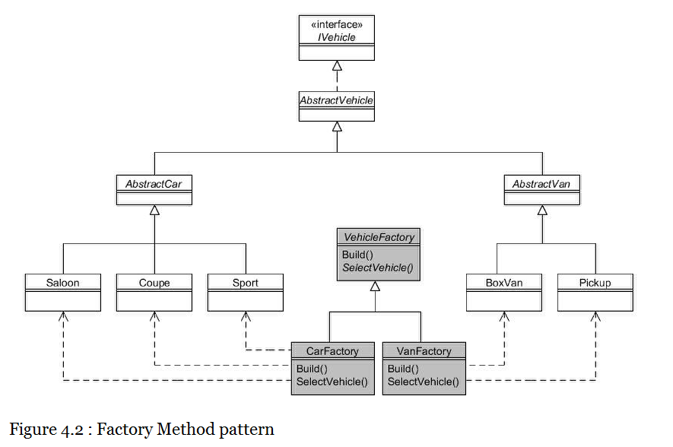

In the above diagram we can see that we have created an abstract VehicleFactory class which has two concrete subclasses, CarFactory and VanFactory. Let us look at how VehicleFactory is defined:

public abstract class VehicleFactory

{

public enum DrivingStyle

{

Economical, Midrange, Powerful

}

public virtual IVehicle Build(DrivingStyle style, VehicleColour colour)

{

IVehicle v = SelectVehicle(style);

v.Paint(colour);

return v;

}     // This is the "factory method"

protected internal abstract IVehicle SelectVehicle(DrivingStyle style);

}

VehicleFactory contains the public method Build() that takes as arguments the driving style (Economical, Midrange or Powerful) and the colour that the vehicle should be painted. The Build() method calls the protected abstract SelectVehicle() method, which is the "factory method" after which the pattern is named. The implementation of SelectVehicle() is therefore delegated to the subclasses such that each subclass determines the specific type of vehicle to instantiate. The method is protected because we only want subclasses to utilise it; it is not intended to be invoked by clients.

Here is the CarFactory concrete subclass:

public class CarFactory : VehicleFactory

{

protected internal override IVehicle SelectVehicle(DrivingStyle style)

{

if (style == DrivingStyle.Economical)

{

return new Saloon(new StandardEngine(1300));

}

else if (style == DrivingStyle.Midrange)

{

return new Coupe(new StandardEngine(1600));

}

else

{

return new Sport(new TurboEngine(2000));

}

}

}

As you can see, the SelectVehicle() method is implemented such that it works out from the supplied arguments exactly which type of car should be instantiated and returned.

The VanFactory is similar, using the argument to decide which van to instantiate and return:

public class VanFactory : VehicleFactory

{

protected internal override IVehicle SelectVehicle(DrivingStyle style)

{

if ((style == DrivingStyle.Economical) || (style == DrivingStyle.Midrange))

{

return new Pickup(new StandardEngine(2200));

}

else

{

return new BoxVan(new TurboEngine(2500));

}

}

}

Client programs instantiate the required factory and call its Build() method:

static void Main(string[] args)

{

// I want an economical car, coloured blue...

VehicleFactory carFactory = new CarFactory();

IVehicle car = carFactory.Build(DrivingStyle.Economical,

VehicleColour.Blue);

Console.WriteLine(car);

// I am a "white van man"...

VehicleFactory vanFactory = new VanFactory();

IVehicle van = vanFactory.Build(DrivingStyle.Powerful,

VehicleColour.White);

Console.WriteLine(van);

Console.Read();

}

You should see the following output:

Saloon (StandardEngine (1300), Blue)

BoxVan (TurboEngine (2500), White)

Using static factory methods

A common and useful variation is to define a static factory method. Let's assume we define the following additional enum in the VehicleFactory class:

public enum Category

{

Car, Van

}

Now we can define the following static Make() method also in VehicleFactory that works out which subclass to instantiate:

public static IVehicle Make(Category cat,

DrivingStyle style,

VehicleColour colour)

{

VehicleFactory factory;

if (cat == Category.Car)

{

factory = new CarFactory();

}

else

{

factory = new VanFactory();

}

return factory.Build(style, colour);

}

Using the static Make() method is very straightforward:

// USING STATIC FACTORY

// Create a red sports car...

IVehicle sporty = VehicleFactory.Make(Category.Car,

DrivingStyle.Powerful,

VehicleColour.Red);

Console.WriteLine(sporty);

This should give the following output:

Sport (TurboEngine (2000), Red)

### Prototype

Type: Creational

Purpose: Specify the kinds of objects to create using a prototypical instance, and create new objects by copying the prototype.

We shall assume in this chapter that instantiating car and van objects is a time-consuming process, and we therefore need to find a way of speeding up instantiation time whenever we need a new vehicle object. Here is a reminder of the IVehicle class hierarchy:

(Screenshot in Page 2)

One approach that may improve instantiation time is to utilise the C# cloning facilities. We will therefore specify that the IVehicle interface extends ICloneable and define the method Clone(). Code to perform the cloning will then be defined in AbstractVehicle. This chapter thus uses a modified version of the IVehicle interface and AbstractVehicle class as listed below, where the additional code is indicated in bold:

public interface IVehicle : **ICloneable**

{

IEngine Engine { get; }

VehicleColour Colour { get; }

void Paint(VehicleColour colour);

}

public abstract class AbstractVehicle : IVehicle

{

**public virtual object Clone()**

**{**

**return this.MemberwiseClone();**

**}**

}

The clone() method invokes the C# MemberwiseClone() method to perform the cloning of the receiving object. None of the car or van subclasses needs to change since they inherit from IVehicle at the root of the hierarchy. We will now define a VehicleManager class that will create the initial vehicles from which we can obtain clones:

public class VehicleManager

{

private IVehicle saloon, coupe, sport, boxVan, pickup;

public VehicleManager()

{

// For simplicity all vehicles use same engine type...

saloon = new Saloon(new StandardEngine(1300));

coupe = new Coupe(new StandardEngine(1300));

sport = new Sport(new StandardEngine(1300));

boxVan = new BoxVan(new StandardEngine(1300));

pickup = new Pickup(new StandardEngine(1300));

}

public virtual IVehicle CreateSaloon()

{

return (IVehicle)saloon.Clone();

}

public virtual IVehicle CreateCoupe()

{

return (IVehicle)coupe.Clone();

}

public virtual IVehicle CreateSport()

{

return (IVehicle)sport.Clone();

}

public virtual IVehicle CreateBoxVan()

{

return (IVehicle)boxVan.Clone();

}

public virtual IVehicle CreatePickup()

{

return (IVehicle)pickup.Clone();

}

}

Client programs can use VehicleManager as follows:

static void Main(string[] args)

{

VehicleManager manager = new VehicleManager();

IVehicle saloon1 = manager.CreateSaloon();

IVehicle saloon2 = manager.CreateSaloon();

IVehicle pickup1 = manager.CreatePickup();

}

A drawback of VehicleManager as coded is that it always instantiates at least one vehicle of each type as part of the construction process. If not all types of vehicles will be needed, a more efficient technique would be to lazy-load by only instantiating the first time each is needed. This is illustrated in the modified version of the class (which we will call VehicleManagerLazy) below:

public class VehicleManagerLazy

{

private IVehicle saloon, coupe, sport, boxVan, pickup;

public VehicleManagerLazy()

{

}

public virtual IVehicle CreateSaloon()

{

if (saloon == null)

{

saloon = new Saloon(new StandardEngine(1300));

}

return (IVehicle)saloon.Clone();

}

public virtual IVehicle CreateCoupe()

{

if (coupe == null)

{

coupe = new Coupe(new StandardEngine(1300));

}

return (IVehicle)coupe.Clone();

}

public virtual IVehicle CreateSport()

{

if (sport == null)

{

sport = new Sport(new StandardEngine(1300));

}

return (IVehicle)sport.Clone();

}

public virtual IVehicle CreateBoxVan()

{

if (boxVan == null)

{

boxVan = new BoxVan(new StandardEngine(1300));

}

return (IVehicle)boxVan.Clone();

}

public virtual IVehicle CreatePickup()

{

if (pickup == null)

{

pickup = new Pickup(new StandardEngine(1300));

}

return (IVehicle)pickup.Clone();

}

}

Before a clone is returned, a check is made to ensure that the 'prototype' object exists, and it will be instantiated if necessary. From then on it just clones the previously instantiated object. Client programs can use VehicleManagerLazy in the same way as before:

VehicleManager**Lazy** manager = new VehicleManager**Lazy**();

IVehicle saloon1 = manager.CreateSaloon();

IVehicle saloon2 = manager.CreateSaloon();

IVehicle pickup1 = manager.CreatePickup();

Singleton

Type: Creational

Purpose: Ensure a class allows only one object to be created, providing a single point of access to it.

The Foobar Motor Company, in common with all vehicle manufacturers, needs to stamp a unique serial number on all vehicles they produce. They want to model this requirement ensuring that there is just one easy place where the next available serial number can be obtained. If we were to have more than one object that generates the next number there is a risk that we could end up with separate numbering sequences, so we need to prevent this.

The Singleton pattern provides a way of ensuring that only one instance of a particular class can ever be created. So how can we stop other objects from just invoking new multiple times? There are several ways of accomplishing this, and the "traditional" approach that you may often encounter is to make your constructor private but provide a public static getter method that returns a static instance of the Singleton class. This is how it could look:

public class SerialNumberGenerator

{

// static members

private static volatile SerialNumberGenerator instance;

private static object synchronizationRoot = new Object();

public static SerialNumberGenerator Instance

{

get

{

if (instance == null)

{

lock (synchronizationRoot)

{

if (instance == null)

{

instance = new SerialNumberGenerator();

}

}

}

return instance;

}

}

// instance variables

private int count;

// private constructor

private SerialNumberGenerator()

{

}

// instance methods

public virtual int NextSerial

{

get

{

return ++count;

}

}

}

Note that the Instance getter will only instantiate the object once and so the same instance will always be returned. The constructor is private to prevent client programs from calling new, thus enforcing the fact that only one object can ever be created, since they can only go through the Instance getter. The singleton could be used thus:

SerialNumberGenerator generator = SerialNumberGenerator.Instance;

Console.WriteLine("next serial: " + SerialNumberGenerator.Instance.NextSerial);

Console.WriteLine("next serial: " + SerialNumberGenerator.Instance.NextSerial);

Console.WriteLine("next serial: " + SerialNumberGenerator.Instance.NextSerial);

Console.Read();

**Part III. Structural Patterns**

This part describes the seven structural patterns, that is, those that help manage how classes are organised and interrelate.

* Adapter: Convert the interface of a class into the interface clients expect, letting classes work together that couldn’t otherwise because of incompatible types;
* Bridge: Decouple an abstraction from its implementation so that each may vary independently;
* Composite: Compose objects into tree structures to represent part-whole hierarchies, letting client objects treat individual objects and compositions uniformly;
* Decorator: Attach additional responsibilities to an object dynamically; Façade: Provide a uniform interface to a set of interfaces in a subsystem, by defining a higher-level interface that makes the subsystem easier to use;
* Flyweight: Use sharing to support large numbers of fine-grained objects efficiently;
* Proxy: Provide a surrogate or place-holder for another object to control access to it.

### Adapter

Type: Structural

Purpose: Convert the interface of a class into another interface clients expect. Adapter lets classes work together that couldn't otherwise because of incompatible interfaces.

You will recall from the introduction that the Foobar Motor Company makes the engines for their vehicles. Here is a reminder of the IEngine hierarchy:

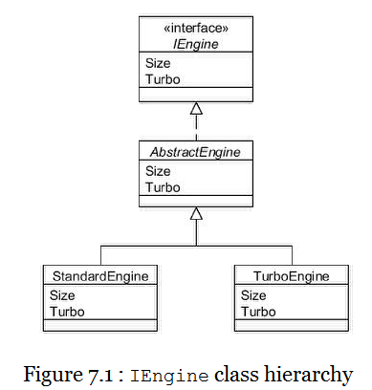

And here is a reminder of the code of the abstract AbstractEngine class:

public abstract class AbstractEngine : IEngine

{

private int size;

private bool turbo;

public AbstractEngine(int size, bool turbo)

{

this.size = size;

this.turbo = turbo;

}

public virtual int Size

{

get

{

return size;

}

}

public virtual bool Turbo

{

get

{

return turbo;

}

}

public override string ToString()

{

return this.GetType().Name + " (" + size + ")";

}

}

Let's say our client program takes engines stored in a collection and loops through them one at a time displaying the engine size and type:

static void Main(string[] args)

{

IList<IEngine> engines = new List<IEngine>();

engines.Add(new StandardEngine(1300));

engines.Add(new StandardEngine(1600));

engines.Add(new TurboEngine(2000));

foreach (IEngine engine in engines)

{

Console.WriteLine(engine);

}

Console.Read();

}

Running the above code would result in the following display:

StandardEngine (1300)

StandardEngine (1600)

TurboEngine (2000)

For this chapter we will assume that in addition to the two concrete subclasses (StandardEngine and TurboEngine) Foobar have decided to use a further engine class named SuperGreenEngine which is made by a different manufacturer. Because the SuperGreenEngine class is provided by a third-party it does not implement our IEngine interface. Furthermore, Foobar do not have access to the C# source code and can therefore not modify it, but the following class details are known from the documentation:

* The class extends object;
* The constructor takes one argument for the engine size;
* There is an EngineSize property getter that returns the engine size as an int;
* These types of engines are never turbocharged;
* The ToString() method returns a string in the format: **SUPER ENGINE nnnn** (where nnnn is the engine size).

We can therefore see that SuperGreenEngine uses a different method name to access the engine size and there is no method related to whether it is turbocharged, and that it is not within the IEngine hierarchy. As it stands it would not be possible to add instances of SuperGreenEngine to the reporting collection and even if you could the method names are different.

The Adapter pattern provides an approach to resolve this through the definition of a new class that 'adapts' the class we want to use into the format existing classes require. For our purposes, therefore, we shall create a SuperGreenEngineAdapter class:

The code for the adapter is as follows:

public class SuperGreenEngineAdapter : AbstractEngine

{

public SuperGreenEngineAdapter(SuperGreenEngine greenEngine)

: base(greenEngine.EngineSize, false)

{

}

}

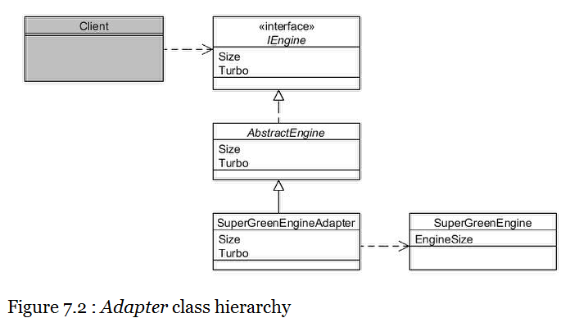

Note the following from the above code:

* We extend the class we are adapting **to**;
* We accept a reference in the constructor to the class we are adapting **from**;
* The constructor obtains the necessary state from the referenced object and passes it to the superclass constructor.

Now we are in a position to include SuperGreenEngine objects in our reporting collection (additional code indicated in bold):

static void Main(string[] args)

{

IList<IEngine> engines = new List<IEngine>();

engines.Add(new StandardEngine(1300));

engines.Add(new StandardEngine(1600));

engines.Add(new TurboEngine(2000));

**// "Adapt" the new engine type**

**SuperGreenEngine greenEngine = new SuperGreenEngine(1200);**

**engines.Add(new SuperGreenEngineAdapter(greenEngine));**

foreach (IEngine engine in engines)

{

Console.WriteLine(engine);

}

Console.Read();

}

The output should now be:

StandardEngine (1300)

StandardEngine (1600)

TurboEngine (2000)

SuperGreenEngineAdapter (1200)

Note how the output made use of the ToString() method as inherited from AbstractEngine rather than that of SuperGreenEngine.

**Variations for implementing adapters**

We were somewhat fortunate in that the design of the AbstractEngine and SuperGreenEngine classes made it easy for the adapter class to do the work inside its constructor.

Often however, we need to take a few additional steps inside the code of the adapter class, so here is a general formula to apply:

1. Extend the class you are adapting to (or implement it, if it's an interface);
2. Specify the class you are adapting from in the constructor and store a reference to it in an instance variable;
3. For each method in the class you are extending (or interface you are implementing), override it to delegate to the corresponding method of the class you are adapting from.

Here is a generic example adapter class:

public class ObjectAdapter : ClassAdaptingTo

{

private ClassAdaptingFrom fromObject;

public ObjectAdapter(ClassAdaptingFrom fromObject)

{

this.fromObject = fromObject;

}

//Overriden method

public override void MethodInToClass()

{

fromObject.MethodInFromClass();

}

}

#### Bridge

Type: Structural

Purpose: Decouple an abstraction from its implementation so that each may vary independently.

The Foobar Motor Company manufactures engines for its vehicles. Here is a reminder of the IEngine class hierarchy:

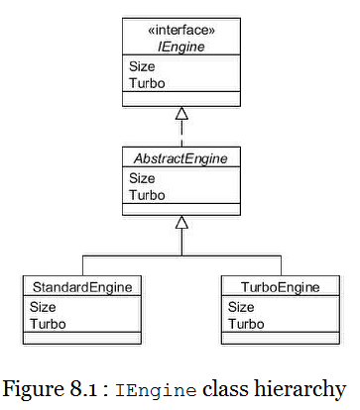

The implementation of the AbstractEngine class as detailed in the introduction, merely stores the engine size (e.g. 1600cc) and whether it is turbocharged. For the purposes of this chapter this class will be enhanced to enable the engine to be started and stopped and for the power to the engine to be increased or decreased. The modified version of the IEngine interface and AbstractEngine class is listed below with the changes marked in bold:

public interface IEngine

{

int Size { get; }

bool Turbo { get; }

**void Start();**

**void Stop();**

**void IncreasePower();**

**void DecreasePower();**

}

public abstract class AbstractEngine : IEngine

{

private int size;

private bool turbo;

**private bool running;**

**private int power;**

public AbstractEngine(int size, bool turbo)

{

this.size = size;

this.turbo = turbo;

**running = false;**

**power = 0;**

}

public virtual int Size

{

get

{

return size;

}

}

public virtual bool Turbo

{

get

{

return turbo;

}

}

**public virtual void Start()**

**{**

**running = true;**

**}**

**public virtual void Stop()**

**{**

**running = false;**

**power = 0;**

**}**

**public virtual void IncreasePower()**

**{**

**if ((running) && (power < 10))**

**{**

**power++;**

**}**

**}**

**public virtual void DecreasePower()**

**{**

**if ((running) && (power > 0))**

**{**

**power--;**

**}**

**}**

public override string ToString()

{

return this.GetType().Name + " (" + size + ")";

}

}

Within a vehicle, the driver controls the functions of the engine indirectly by means of various hand and foot controls, such as the ignition switch, accelerator pedal and brake pedal. To retain flexibility, it is important to design the connection between the engine and the controls so that each can vary independently of the other. In other words:

* A new engine can be designed and plugged into a vehicle without needing any driver controls to be changed; and
* New driver controls (for example, to assist disabled drivers) can be designed and plugged into a vehicle without needing the engines to change.

The Bridge pattern addresses this requirement by separating the 'abstraction' from the 'implementation' into two separate but connected hierarchies such that each can vary independently of the other. In our example, the 'abstraction' is the driver controls and the 'implementation' is the engine.

The following diagram shows this relationship:

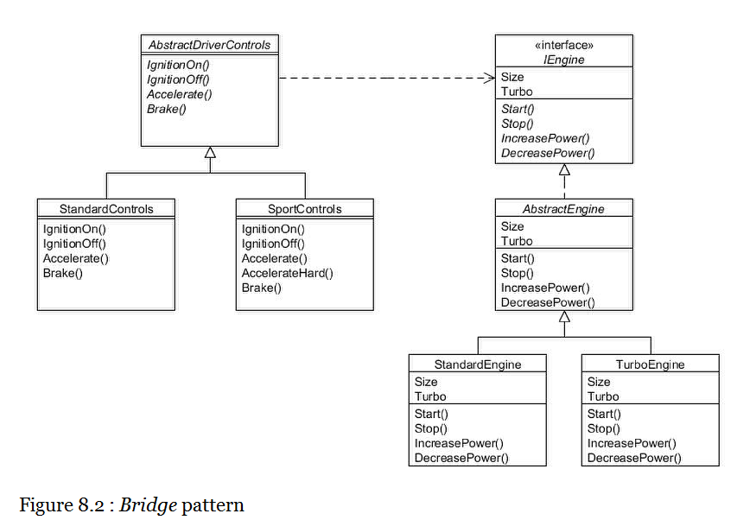

As the above figure shows, there is an abstract AbstractDriverControls class with two concrete subclasses; StandardControls and SportControls:

The AbstractDriverControls class requires an Engine object passed to its constructor and then delegates to the engine for each of its methods:

public class AbstractDriverControls

{

private IEngine engine;

public AbstractDriverControls(IEngine engine)

{

this.engine = engine;

}

public virtual void IgnitionOn()

{

engine.Start();

}

public virtual void IgnitionOff()

{

engine.Stop();

}

public virtual void Accelerate()

{

engine.IncreasePower();

}

public virtual void Brake()

{

engine.DecreasePower();

}

}

Subclasses of AbstractDriverControls can either use the superclass methods as-is or define additional functionality. The StandardControls class uses AbstractDriverControls as-is:

public class StandardControls : AbstractDriverControls

{

public StandardControls(IEngine engine)

: base(engine)

{

}

// No extra functions

}

Whereas the SportControls class defines an additional method:

public class SportControls : AbstractDriverControls

{

public SportControls(IEngine engine)

: base(engine)

{

}

public virtual void AccelerateHard()

{

Accelerate();

Accelerate();

}

}

The important point to note from the above is that the additional method is coded in terms of the superclass 'abstraction' and not the 'implementation' (engine). So in the above example the AccelerateHard() method invokes the Accelerate() method as defined in AbstractDriverControls. It is this approach that allows the abstraction and the implementation to vary independently if needed.

Thus we could incorporate a brand-new type of engine without modifying the driver controls classes, provided the engine adheres to the IEngine contract. Conversely we could develop a new set of driver controls (such as enabling voice activation) without having to modify anything in the IEngine hierarchy.

Client programs can use the bridge as follows:

static void Main(string[] args)

{

IEngine engine = new StandardEngine(1300);

AbstractDriverControls controls = new StandardControls(engine);

controls.IgnitionOn();

controls.Accelerate();

controls.Brake();

controls.IgnitionOff();

// Can use a different engine without changing the driver controls

IEngine turbo = new TurboEngine(1300);

controls = new SportControls(turbo);

controls.IgnitionOn();

controls.Accelerate();

controls.Brake();

controls.IgnitionOff();

Console.Read();

}

Composite

Type: Structural

Purpose : Compose objects into tree structures to represent part-whole hierarchies. Composite lets clients treat individual objects and compositions of objects uniformly.

In the Foobar Motor Company workshop they build various items from component parts such as nuts, bolts, panels, etc. Each individual component item has an associated description and unit cost, and when items are assembled into larger items the cost is therefore the sum of its component parts.

The Composite pattern enables us to treat both individual parts and assemblies of parts as if they are the same, thus enabling them to be processed in a consistent manner, simplifying code. The class hierarchy looks like this:

Figure 9.1 : Composite pattern

The abstract Item class defines all possible methods for both parts and assemblies of parts:

public abstract class Item

{

private string description;

private int cost;

public Item(string description, int cost)

{

this.description = description;

this.cost = cost;

}

public virtual string Description

{

get

{

return description;

}

}

public virtual int Cost

{

get

{

return cost;

}

}

public abstract void AddItem(Item item);

public abstract void RemoveItem(Item item);

public abstract Item[] Items { get; }

public override string ToString()

{

return description + " (cost " + Cost + ")";

}

}

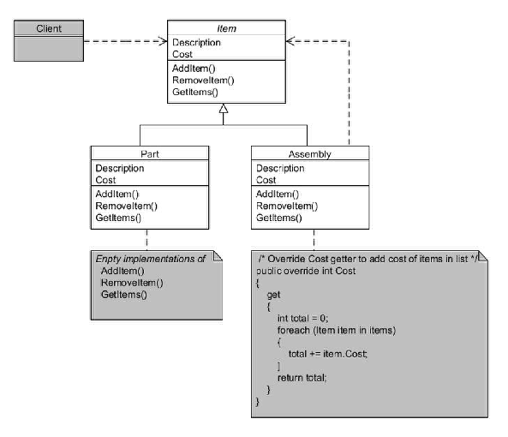

The above class provides default implementations for Description and Cost getters, and defines the abstract methods AddItem(), RemoveItem() and an Items property getter.

Individual parts are modelled using the Part subclass:

public class Part : Item

{

public Part(string description, int cost)

: base(description, cost)

{

}

// Empty implementations for unit parts...

public override void AddItem(Item item)

{

}

public override void RemoveItem(Item item)

{

}

public override Item[] Items

{

get

{

return new Item[0];

}

}

}

As you can see, the methods related to managing assemblies of items have empty implementations since a 'part' is the smallest unit possible, and therefore unable to have sub-parts, unlike 'assemblies'.

Assemblies of parts are modelled using the Assembly subclass:

public class Assembly : Item

{

private IList<Item> items;

public Assembly(string description)

: base(description, 0)

{

items = new List<Item>();

}

public override void AddItem(Item item)

{

items.Add(item);

}

public override void RemoveItem(Item item)

{

items.Remove(item);

}

public override Item[] Items

{

get

{

return items.ToArray();

}

}

// Also have to override getCost() to accumulate cost of all items in list

public override int Cost

{

get

{

int total = 0;

foreach (Item item in items)

{

total += item.Cost;

}

return total;

}

}

}

For assemblies, we have implemented the abstract methods to add other Item objects into an internal List collection. We have also overridden the Cost getter to loop through the collection to sum the cost of all contained items within this assembly.

All types of Item objects can now be used in a uniform manner:

Item nut = new Part("Nut", 5);

Item bolt = new Part("Bolt", 9);

Item panel = new Part("Panel", 35);

Item gizmo = new Assembly("Gizmo");

gizmo.AddItem(panel);

gizmo.AddItem(nut);

gizmo.AddItem(bolt);

Item widget = new Assembly("Widget");

widget.AddItem(gizmo);

widget.AddItem(nut);

In the above extract, nuts, bolts and panels are defined as individual parts, a "Gizmo" is assembled from one nut, one bolt and one panel, and a "Widget" is assembled from one "Gizmo" and another nut. Displaying the objects would result in this output:

Nut (cost 5)

Bolt (cost 9)

Panel (cost 35)

Gizmo (cost 49)

Widget (cost 54)

The assemblies have computed the total cost without the client program needing to know how.

#### Decorator

Type: Structural

Purpose: Attach additional responsibilities to an object dynamically. Decorators provide a flexible alternative to subclassing for extending functionality.

You will recall the Foobar Motor Company IVehicle class hierarchy:

For the purposes of this chapter, we shall add one additional property called Price to the IVehicle interface with a getter. We will also modify the ToString() method in AbstractVehicle to include the price. The modified interface and class is shown below with the changes marked in bold:

public interface IVehicle

{

IEngine Engine { get; }

VehicleColour Colour { get; }

void Paint(VehicleColour colour);

**int Price { get; }**

}

Figure 10.1 : IVehicle class hierarchy

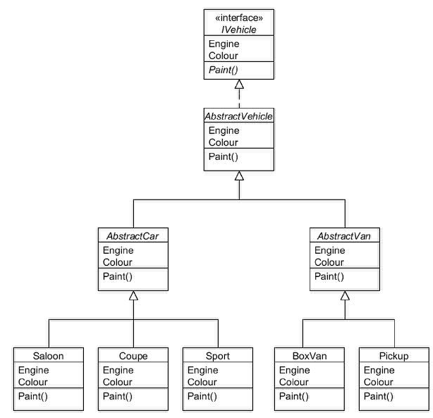

public abstract class AbstractVehicle : IVehicle

{

private IEngine engine;

private VehicleColour colour;

public AbstractVehicle(IEngine engine)

: this(engine, VehicleColour.Unpainted)

{

}

public AbstractVehicle(IEngine engine, VehicleColour colour)

{

this.engine = engine;

this.colour = colour;

}

public virtual IEngine Engine

{

get

{

return engine;

}

}

public virtual VehicleColour Colour

{

get

{

return colour;

}

}

public virtual void Paint(VehicleColour colour)

{

this.colour = colour;

}

**public abstract int Price { get; }**

**public override string ToString()**

**{**

**return this.GetType().Name + " (" + engine + ", " + colour +**

**", price " + Price + ")";**

**}**

}

Each of the concrete subclasses implement the Price getter as appropriate. For example, the Saloon class now looks like this (changes in bold):

public class Saloon : AbstractCar

{

public Saloon(IEngine engine)

: this(engine, VehicleColour.Unpainted)

{

}

public Saloon(IEngine engine, VehicleColour colour)

: base(engine, colour)

{

}

**public override int Price**

**{**

**get**

**{**

**return 6000;**

**}**

**}**

}

The other subclasses are similarly defined, and the Price getter returns:

* 6,000 for Saloon objects;
* 7,000 for Coupe objects;
* 8,000 for Sport objects;
* 9,000 for Pickup objects;
* 10,000 for BoxVan objects.

When a customer buys a vehicle they have the choice of adding any number of optional extras. They can choose from an air-conditioning system, alloy wheels, leather seats, metallic paint, or a satellite-navigation unit. They can choose none at all, or any combination up to all five.

The Decorator pattern is designed to facilitate the addition of state and/or behaviour without having to modify the inheritance hierarchy of the classes being added to. This is accomplished by defining a new hierarchy which itself extends the root of the main tree.

This is shown diagrammatically below:

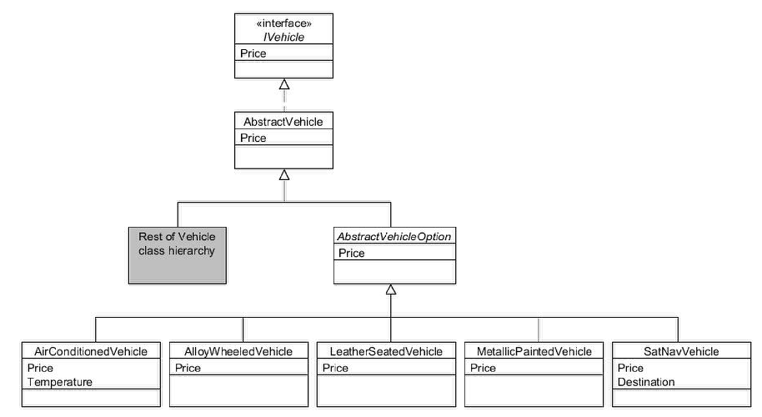

Figure 10.2 : Decorator pattern hierarchy

From the diagram you can see that a new abstract class has been defined called AbstractVehicleOption that inherits from AbstractVehicle. AbstractVehicleOption has five concrete subclasses; one for each option that can be selected.

The AbstractVehicleOption class looks like this:

public abstract class AbstractVehicleOption : AbstractVehicle

{

protected internal IVehicle decoratedVehicle;

public AbstractVehicleOption(IVehicle vehicle)

: base(vehicle.Engine, vehicle.Colour)

{

decoratedVehicle = vehicle;

}

}

AbstractVehicleOption is the abstract "decorator" class and it requires a reference to the IVehicle class which is to be decorated.

Each of the option subclasses is straightforward. They all override the Price getter to add the price of the option to the price of the object that is being decorated. In the case of the AirConditionedVehicle and SatNavVehicle classes, we have also defined an extra method:

public class AirConditionedVehicle : AbstractVehicleOption

{

public AirConditionedVehicle(IVehicle vehicle)

: base(vehicle)

{

}

public override int Price

{

get

{

return decoratedVehicle.Price + 600;

}

}

public virtual int Temperature

{

set

{

// code to set the temperature...

}

}

}

public class AlloyWheeledVehicle : AbstractVehicleOption

{

public AlloyWheeledVehicle(IVehicle vehicle)

: base(vehicle)

{

}

public override int Price

{

get

{

return decoratedVehicle.Price + 250;

}

}

}

public class LeatherSeatedVehicle : AbstractVehicleOption

{

public LeatherSeatedVehicle(IVehicle vehicle)

: base(vehicle)

{

}

public override int Price

{

get

{

return decoratedVehicle.Price + 1200;

}

}

}

public class MetallicPaintedVehicle : AbstractVehicleOption

{

public MetallicPaintedVehicle(IVehicle vehicle)

: base(vehicle)

{

}

public override int Price

{

get

{

return decoratedVehicle.Price + 750;

}

}

}

public class SatNavVehicle : AbstractVehicleOption

{

public SatNavVehicle(IVehicle vehicle)

: base(vehicle)

{

}

public override int Price

{

get

{

return decoratedVehicle.Price + 1500;

}

}

public virtual string Destination

{

set

{

// code to set the destination...

}

}

}

To use the 'decorators' we initially instantiate the car or van we require and then "wrap" them inside the required decorator or decorators. Here is an example:

// Create a blue saloon car

IVehicle myCar = new Saloon(new StandardEngine(1300));

myCar.Paint(VehicleColour.Blue);

Console.WriteLine(myCar);

// Add air-conditioning to the car...

myCar = new AirConditionedVehicle(myCar);

Console.WriteLine(myCar);

// Now add alloy wheels...

myCar = new AlloyWheeledVehicle(myCar);

Console.WriteLine(myCar);

// Now add leather seats...

myCar = new LeatherSeatedVehicle(myCar);

Console.WriteLine(myCar);

// Now add metallic paint...

myCar = new MetallicPaintedVehicle(myCar);

Console.WriteLine(myCar);

// Now add satellite navigation

myCar = new SatNavVehicle(myCar);

Console.WriteLine(myCar);

Console.Read();

The output will be:

Saloon (StandardEngine (1300), Blue, price 6000)

AirConditionedVehicle (StandardEngine (1300), Blue, price 6600)

AlloyWheeledVehicle (StandardEngine (1300), Blue, price 6850)

LeatherSeatedVehicle (StandardEngine (1300), Blue, price 8050)

MetallicPaintedVehicle (StandardEngine (1300), Blue, price 8800)

SatNavVehicle (StandardEngine (1300), Blue, price 10300)

The price shown at each stage is the total of the vehicle plus the selected options as each is "added".

The Decorator pattern is a good example of preferring object composition over inheritance. Had we attempted to use inheritance for the various vehicle options we would have needed to create many different combinations of subclasses to model each combination of selectable options.

Decorator classes are sometimes called "wrapper" classes, since they serve to "wrap" an object inside another object, usually to add or modify its functionality.

#### Facade

Type: Structural

Purpose: Provide a unified interface to a set of interfaces in a subsystem. *Facade* defines a higher-level interface that makes the subsystem easier to use.

Sometimes you need to perform a series of steps to undertake a particular task, often involving multiple objects. The Facade pattern involves the creation of a separate object that simplifies the execution of such steps.

As an example, when the Foobar Motor Company are preparing their vehicles for sale there are a number of steps they have to undertake that utilise various objects. In this chapter we shall assume that the IVehicle interface defines the following additional methods beyond those defined in the introduction.

// Extra methods defined in IVehicle...

void CleanInterior();

void CleanExteriorBody();

void PolishWindows();

void TakeForTestDrive();

The above methods are implemented in AbstractVehicle as follows:

public virtual void CleanInterior()

{

Console.WriteLine("Cleaning interior...");

}

public virtual void CleanExteriorBody()

{

Console.WriteLine("Cleaning exterior body...");

}

public virtual void PolishWindows()

{

Console.WriteLine("Polishing windows...");

}

public virtual void TakeForTestDrive()

{

Console.WriteLine("Taking for test drive...");

}

We shall introduce two further simple classes called Registration and Documentation:

public class Registration

{

private IVehicle vehicle;

public Registration(IVehicle vehicle)

{

this.vehicle = vehicle;

}

public virtual void AllocateLicensePlate()

{

Console.WriteLine("Allocating license plate...");

}

public virtual void AllocateVehicleNumber()

{

Console.WriteLine("Allocating vehicle number...");

}

}

public class Documentation

{

public static void PrintBrochure(IVehicle vehicle)

{

Console.WriteLine("Printing brochure...");

}

}

To implement the pattern we will create a VehicleFacade class that defines a method to prepare the specified vehicle by using the above classes on our behalf:

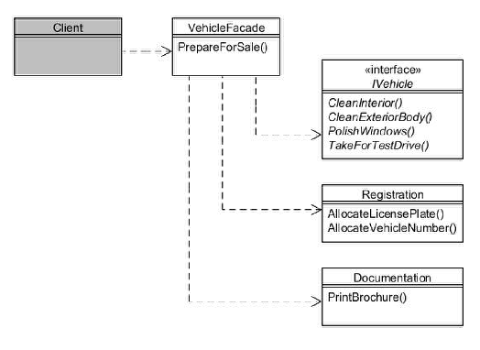

Figure 11.1 : *Facade* pattern

public class VehicleFacade

{

public virtual void PrepareForSale(IVehicle vehicle)

{

Registration reg = new Registration(vehicle);

reg.AllocateVehicleNumber();

reg.AllocateLicensePlate();

Documentation.PrintBrochure(vehicle);

vehicle.CleanInterior();

vehicle.CleanExteriorBody();

vehicle.PolishWindows();

vehicle.TakeForTestDrive();

}

}

Client programs then only need invoke the PrepareForSale() method on a VehicleFacade instance, and therefore need no knowledge of what needs to be done and what other objects are needed. And if something different is needed in a special circumstance, then the individual methods are still available for calling as required.

static void Main(string[] args)

{

VehicleFacade facade = new VehicleFacade();

facade.PrepareForSale(new Saloon(new StandardEngine(1300)));

Console.Read();

}

**Output will be:**

Allocating vehicle number...

Allocating license plate...

Printing brochure...

Cleaning interior...

Cleaning exterior body...

Polishing windows...

Taking for test drive...

#### Flyweight

Type: Structural

Purpose: Use sharing to support large numbers of fine-grained objects efficiently.

Some programs need to create a large number of objects of one particular type, and if those objects happen to have a large amount of state then instantiating lots of them can quickly use up memory. When considering object state, we often note that at least some of it could potentially be shared among a group of objects.

For the Foobar Motor Company, the IEngine hierarchy is a case in point:

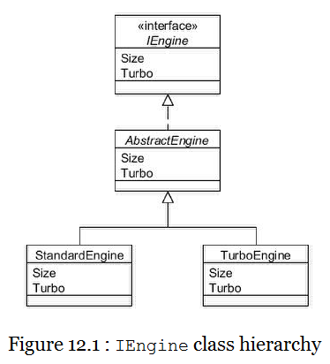

Our simple implementation of IEngine only defines two property getters; Size and Turbo. Let's suppose we instantiate two engines as follows:

Engine engine1 = new StandardEngine(1300);

Engine engine2 = new StandardEngine(1300);

The above would create two separate objects in memory, even though their state is identical. This can be thought of as its intrinsic state; i.e. all 1300cc standard engines will be storing 1300 for the engine size and false for whether it is turbocharged. Creating hundreds or thousands of these would be wasteful of memory, especially since a more realistic Engine class would require many more variables whose values would also be shared.

For the purposes of this chapter another method will be added to the IEngine interface, called Diagnose(). This new method will take a DiagnosticTool object as its argument, and this argument can be thought of as its extrinsic state, since its value is not actually stored in the Engine object; it is used purely so that the engine can use it to run a diagnostic check.

The DiagnosticTool interface looks like this:

public interface IDiagnosticTool

{

void RunDiagnosis(object obj);

}

The EngineDiagnosticTool implements the above for running diagnostics on an engine:

public class EngineDiagnosticTool : IDiagnosticTool

{

public virtual void RunDiagnosis(object obj)

{

Console.WriteLine("Starting engine diagnostic tool for "

+ obj);

Thread.Sleep(5000);

Console.WriteLine("Engine diagnosis complete");

}

}

To simulate a long-running process the method pauses for five seconds. With the above in place we can now add a suitable method to the IEngine interface:

public interface IEngine

{

**// Methods having intrinsic (i.e. shared) state**

int Size { get; }

bool Turbo { get; }

**// Methods having extrinsic (i.e. unshared) state**

**void Diagnose(IDiagnosticTool tool);**

}

The implementation of this new method in AbstractEngine simply issues a call-back to the IDiagnosticTool:

public virtual void Diagnose(IDiagnosticTool tool)

{

tool.RunDiagnosis(this);

}

The Flyweight pattern allows you to reference a multitude of objects of the same type and having the same state, but only by instantiating the minimum number of actual objects needed. This is typically done by allocating a 'pool' of objects which can be shared, and this is determined by a 'flyweight factory' class. Client programs get access to engines only through the factory:

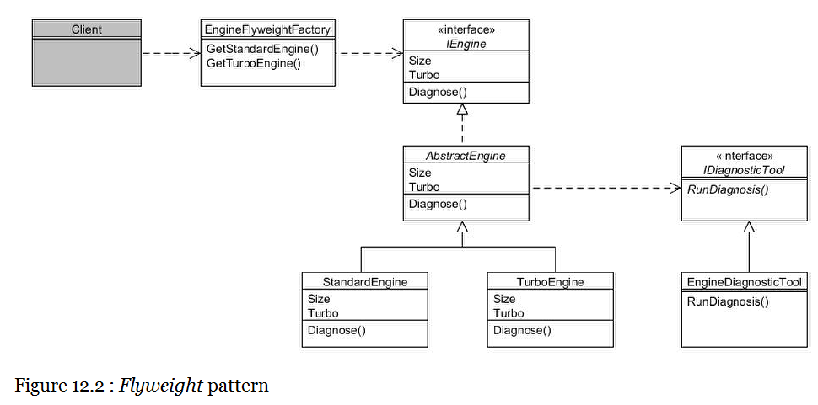

The *EngineFlyweightFactory* class looks like this:

public class EngineFlyweightFactory

{

private IDictionary<int?, IEngine> standardEnginePool;

private IDictionary<int?, IEngine> turboEnginePool;

public EngineFlyweightFactory()

{

standardEnginePool = new Dictionary<int?, IEngine>();

turboEnginePool = new Dictionary<int?, IEngine>();

}

public virtual IEngine GetStandardEngine(int size)

{

IEngine e = null;

bool found = standardEnginePool.TryGetValue(size, out e);

if (!found)

{

e = new StandardEngine(size);

standardEnginePool[size] = e;

}

return e;

}

public virtual IEngine GetTurboEngine(int size)

{

IEngine e = null;

bool found = turboEnginePool.TryGetValue(size, out e);

if (!found)

{

e = new TurboEngine(size);

turboEnginePool[size] = e;

}

return e;

}

}

This class utilises two dictionaries (one for standard engines and the other for turbo engines). Each time an engine of a particular type and size is requested, if a similar one has already been created it is returned rather than instantiating a new one. Client programs use the factory like this:

static void Main(string[] args)

{

// Create the flyweight factory...

EngineFlyweightFactory factory = new EngineFlyweightFactory();

// Create the diagnostic tool

IDiagnosticTool tool = new EngineDiagnosticTool();

// Get the flyweights and run diagnostics on them

IEngine standard1 = factory.GetStandardEngine(1300);

standard1.Diagnose(tool);

IEngine standard2 = factory.GetStandardEngine(1300);

standard2.Diagnose(tool);

IEngine standard3 = factory.GetStandardEngine(1300);

standard3.Diagnose(tool);

IEngine standard4 = factory.GetStandardEngine(1600);

standard4.Diagnose(tool);

IEngine standard5 = factory.GetStandardEngine(1600);

standard5.Diagnose(tool);

// Show that objects are shared

Console.WriteLine(standard1.GetHashCode());

Console.WriteLine(standard2.GetHashCode());

Console.WriteLine(standard3.GetHashCode());

Console.WriteLine(standard4.GetHashCode());

Console.WriteLine(standard5.GetHashCode());

Console.Read();

}

In the above, the variables standard1, standard2 and standard3 all reference the same IEngine object (since they all 1300cc standard engines). Likewise, standard4 references the same object as standard5. Of course, whether it is worth running the diagnostics multiple times on the same objects is arguable depending upon the circumstances! If the arguments passed to the extrinsic method (IDiagnosticTool in our example) need to be stored, this should be done in the client program.

The output is:

*Starting engine diagnostic tool for StandardEngine (1300)*

*Engine diagnosis complete*

*Starting engine diagnostic tool for StandardEngine (1300)*

*Engine diagnosis complete*

*Starting engine diagnostic tool for StandardEngine (1300)*

*Engine diagnosis complete*

*Starting engine diagnostic tool for StandardEngine (1600)*

*Engine diagnosis complete*

*Starting engine diagnostic tool for StandardEngine (1600)*

*Engine diagnosis complete*

*62125865*

*62125865*

*62125865*

*44200505*

*44200505*

#### Proxy

Type: Structural

Purpose: Provide a surrogate or place-holder for another object to control access to it.

Some methods can be time-consuming, such as those that load complex graphical components or need network connections. In these instances, the Proxy pattern provides a 'stand-in' object until such time that the time-consuming resource is complete, allowing the rest of your application to load.

In the chapter discussing the Flyweight pattern, the IEngine hierarchy was enhanced to define the additional method Diagnose(). As you saw, the implementation of RunDiagnosis() in EngineDiagnosticTool is slow (we made it sleep for five seconds to simulate this), so we might consider making this run is a separate thread.

Here is a reminder of the IEngine hierarchy with the additional method:

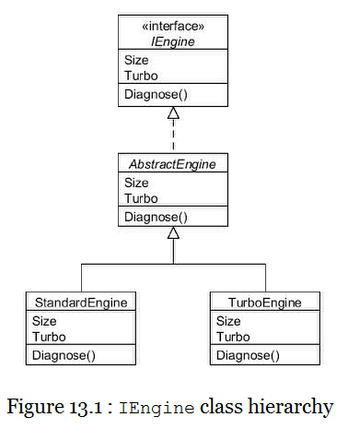

The Proxy pattern involves creating a class that implements the same interface that we are standing-in for, in our case IEngine. The proxy then forwards requests to the "real" object which it stores internally. Clients just access the proxy:

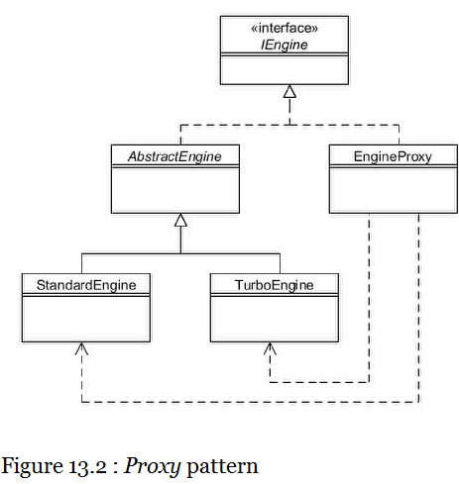

Here is the code for the EngineProxy class:

public class EngineProxy : IEngine

{

private IEngine engine;

public EngineProxy(int size, bool turbo)

{

if (turbo)

{

engine = new TurboEngine(size);

}

else

{

engine = new StandardEngine(size);

}

}

public virtual int Size

{

get

{

return engine.Size;

}

}

public virtual bool Turbo

{

get

{

return engine.Turbo;

}

}

// This method is time-consuming...

public virtual void Diagnose(IDiagnosticTool tool)

{

Console.WriteLine("(Running tool as thread)");

Thread t = new Thread(() => RunDiagnosticTool(tool));

t.Start();

Console.WriteLine("EngineProxy diagnose() method finished");

}

public virtual void RunDiagnosticTool(IDiagnosticTool tool)

{

tool.RunDiagnosis(this);

}

}

The constructor creates either a StandardEngine or TurboEngine object and stores a reference to it as an instance variable. Calls to Size and Turbo getters simply forward to the referenced engine object. Calls to Diagnose() will invoke a separate thread to run the actual diagnosis. This can be useful if you cannot modify the original source for some reason.

### Part IV. Behavioural Patterns

This part describes the eleven behavioural patterns, that is, those that help manage what the classes actually do.

* Chain of Responsibility: Avoid coupling the sender of a request to its receiver by giving more than one object the chance to handle the request;
* Command: Encapsulate a request as an object, thereby letting you parameterise clients with different requests;
* Interpreter: Define the representation of a language’s grammar; Iterator: Provide a way to access the elements of an aggregate object sequentially without exposing its underlying representation;
* Mediator: Define an object that encapsulates how a set of objects interact; Memento: Capture and externalise an object’s state so that it can be restored to that state later;
* Observer: Define a one-to-many dependency between objects so that when one object changes its state, all of its dependents are notified and updated automatically;
* State: Allow an object to alter its behaviour when its internal state changes, as if it were a different class;
* Strategy: Allow clients to change the algorithm that an object uses to perform a function;
* Template Method: Define the skeleton of an algorithm in a method, deferring some steps to subclasses;
* Visitor: Simulate the addition of a method to a class without needing to actually change the class.

#### Chain of Responsibility

Type: Behavioural

Purpose: Avoid coupling the sender of a request to its receiver by giving more than one object a chance to handle the request. Chain the receiving objects and pass the request along the chain until an object handles it.

The Foobar Motor Company receives many emails each day, including servicing requests, sales enquiries, complaints, and of course the inevitable spam. Rather than employ someone specifically to sort through each email to determine which department it should be forwarded to, our task is to try and automate this by analysing the text in each email and making a "best guess".

In our simplified example, we will search the text of the email for a number of keywords and depending upon what we find will process accordingly. Here are the words we will search for and how they should be handled:

* If the email contains "viagra", "pills" or "medicines" then it should be forwarded to a spam handler;
* If the email contains "buy", or "purchase" then it should be forwarded to the sales department;
* If the email contains "service", or "repair" then it should be forwarded to the servicing department;
* If the email contains "complain", or "bad" then it should be forwarded to the manager;
* If the email contains none of the above words then it should be forwarded to the general enquiries department.

Note that only one object needs to handle the request, so if a particular email contains both "purchase" and "repair" it will be forwarded to the sales department only. The sequence in which to check the keywords is whatever seems most sensible for the application; so here we are trying to filter out spam before it reaches any other department.

Now it would be possible, of course, to just have a series of if...else... statements when checking for the keywords, but that would not be very object-oriented. The Chain of Responsibility pattern instead allows us to define separate 'handler' objects that all conform to an EmailHandler interface. This enables us to keep each handler independent and loosely-coupled.

The following diagram shows the pattern:

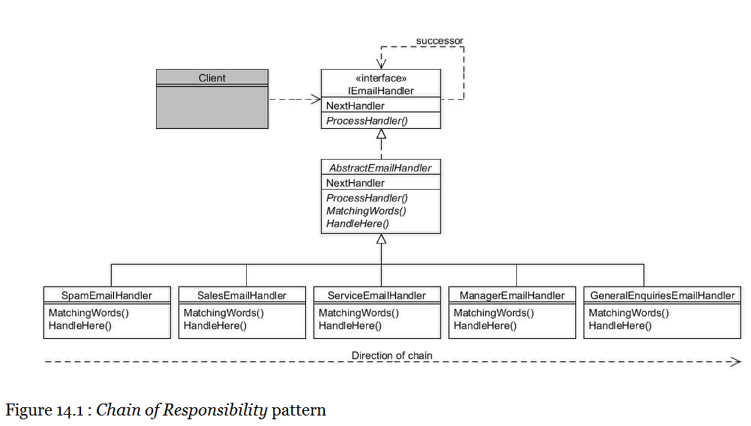

IEmailHandler is the interface at the top of the hierarchy:

public interface IEmailHandler

{

IEmailHandler NextHandler { set; }

void ProcessHandler(string email);

}

The NextHandler setter takes another IEmailHandler object as its argument which represents the handler to call if the current object is unable to handle the email.

The ProcessHandler() method takes the email text as its argument and determines if it is able to handle it (i.e. if it contains one of the keywords we are interested in). If the active object can handle the email it does so, otherwise it just forwards to the next in the chain.

The AbstractEmailHandler class implements the IEmailHandler interface to provide useful default functionality:

public abstract class AbstractEmailHandler : IEmailHandler

{

public static void Handle(string email)

{

// Create the handler objects...

IEmailHandler spam = new SpamEmailHandler();

IEmailHandler sales = new SalesEmailHandler();

IEmailHandler service = new ServiceEmailHandler();

IEmailHandler manager = new ManagerEmailHandler();

IEmailHandler general = new GeneralEnquiriesEmailHandler();

// Chain them together...

spam.NextHandler = sales;

sales.NextHandler = service;

service.NextHandler = manager;

manager.NextHandler = general;

// Start the ball rolling...

spam.ProcessHandler(email);

}

private IEmailHandler nextHandler;

public virtual IEmailHandler NextHandler

{

set

{

nextHandler = value;

}

}

public virtual void ProcessHandler(string email)

{

bool wordFound = false;

// If no words to match against then this object can handle

if (MatchingWords().Length == 0)

{

wordFound = true;

}

else

{

// Look for any of the matching words

foreach (string word in MatchingWords())

{

if (email.IndexOf(word) >= 0)

{

wordFound = true;

break;

}

}

}

// Can we handle emai in this object?

if (wordFound)

{

HandleHere(email);

}

else

{

// Unable to handle here so forward to next in chain

nextHandler.ProcessHandler(email);

}

}

protected internal abstract string[] MatchingWords();

protected internal abstract void HandleHere(string email);

}

The method NextHandler simply stores the argument in an instance variable; the decision making process is made in ProcessHandler(). This has been written to utilise two protected helper methods that must be implemented by concrete subclasses:

* MatchingWords() will return an array of string objects that this handler is interested in;
* HandleHere() is only called if this object can actually handle the email and contains whatever code is required.

The concrete subclasses are straightforward:

public class SpamEmailHandler : AbstractEmailHandler

{

protected internal override string[] MatchingWords()

{

return new string[] { "viagra", "pills", "medicines" };

}

protected internal override void HandleHere(string email)

{

Console.WriteLine("This is a spam email.");

}

}

public class SalesEmailHandler : AbstractEmailHandler

{

protected internal override string[] MatchingWords()

{

return new string[] { "buy", "purchase" };

}

protected internal override void HandleHere(string email)

{

Console.WriteLine("Email handled by sales department.");

}

}

public class ServiceEmailHandler : AbstractEmailHandler

{

protected internal override string[] MatchingWords()

{

return new string[] { "service", "repair" };

}

protected internal override void HandleHere(string email)

{

Console.WriteLine("Email handled by service department.");

}

}

public class ManagerEmailHandler : AbstractEmailHandler

{

protected internal override string[] MatchingWords()

{

return new string[] { "complain", "bad" };

}

protected internal override void HandleHere(string email)

{

Console.WriteLine("Email handled by manager.");

}

}

public class GeneralEnquiriesEmailHandler : AbstractEmailHandler

{

protected internal override string[] MatchingWords()

{

return new string[0]; // match anything

}

protected internal override void HandleHere(string email)

{

Console.WriteLine("Email handled by general enquires.");

}

}

We now need to define the sequence in which the handlers are called. For this example, the following static method has been added to AbstractEmailHandler:

Putting a message through the handlers is now as simple as this:

String email = "I need my car repaired.";

AbstractEmailHandler.handle(email);

This should produce the following output:

Email handled by service department.

#### Command

Type: Behavioural

Purpose: Encapsulate a request as an object, thereby letting you parameterise clients with different requests, queue or log requests, and support undoable operations.

The vehicles made by the Foobar Motor Company each have an installed radio; this is modelled by the following Radio class:

public class Radio

{

public const int MinVolume = 0;

public const int MaxVolume = 10;

public const int DefaultVolume = 5;

private bool switchedOn;

private int volume;

public Radio()

{

switchedOn = false;

volume = DefaultVolume;

}

public virtual bool On

{

get

{

return switchedOn;

}

}

public virtual int Volume

{

get

{

return volume;

}

}

public virtual void SwitchOn()

{

switchedOn = true;

Console.WriteLine("Radio now on, volume level " + Volume);

}

public virtual void SwitchOff()

{

switchedOn = false;

Console.WriteLine("Radio now off");

}

public virtual void VolumeUp()

{

if (On)

{

if (Volume < MaxVolume)

{

volume++;

Console.WriteLine("Volume turned up to level "

+ Volume);

}

}

}

public virtual void VolumeDown()

{

if (On)

{

if (Volume > MinVolume)

{

volume--;

Console.WriteLine("Volume turned down to level "

+ Volume);

}

}

}

}

As you can see, the class enables the radio to be switched on and off, and provided it is switched on will enable the volume to be increased or decreased one level at a time, within the range 1 to 10.

Some of the vehicles also have electrically operated windows with simple up & down buttons, as modelled by the following ElectricWindow class.

Each of the devices (the radio and the electric window) has separate controls, typically buttons, to manage their state. But suppose the Foobar Motor Company now wishes to introduce speech recognition to their top-of-the-range vehicles and have them perform as follows:

* If the speech-recognition system is in "radio" mode, then if it hears the word "up" or "down" it adjusts the radio volume; or
* If the speech-recognition system is in "window" mode, then if it hears the word "up" or "down" it closes or opens the driver's door window.

We therefore need the speech-recognition system to be able to handle either Radio objects or ElectricWindow objects, which are of course in completely separate hierarchies.  We might also want it to handle other devices in the future, such as the vehicle's speed or the gearbox (e.g. upon hearing "up" it would increase the speed by 1mph or it would change to the next higher gear). For good object-oriented design we need to isolate the speech-recognition from the devices it controls, so it can cope with any device without directly knowing what they are.

The Command patterns allows us to uncouple an object making a request from the object that receives the request and performs the action, by means of a "middle-man" object known as a "command object".

In its simplest form, this requires us to create an interface (which we shall call IVoiceCommand) with one method:

public interface IVoiceCommand

{

void Execute();

}

We now need to create implementing classes for each action that we wish to take. For example, to turn up the volume of the radio we can create a VolumeUpCommand class:

public class VolumeUpCommand : IVoiceCommand

{

private Radio radio;

public VolumeUpCommand(Radio radio)

{

this.radio = radio;

}

public virtual void Execute()

{

radio.VolumeUp();

}

}

The class simply takes a reference to a Radio object in its constructor and invokes its VolumeUp() method whenever Execute() is called. We likewise need to create a VolumeDownCommand class for when the volume is to be reduced:

public class VolumeDownCommand : IVoiceCommand

{

private Radio radio;

public VolumeDownCommand(Radio radio)

{

this.radio = radio;

}

public virtual void Execute()

{

radio.VolumeDown();

}

}

Controlling an electric window's up and down movement is just as easy: this time we create classes implementing IVoiceCommand passing in a reference to an ElectricWindow object:

public class WindowUpCommand : IVoiceCommand

{

private ElectricWindow window;

public WindowUpCommand(ElectricWindow window)

{

this.window = window;

}

public virtual void Execute()

{

window.CloseWindow();

}

}

public class WindowDownCommand : IVoiceCommand

{

private ElectricWindow window;

public WindowDownCommand(ElectricWindow window)

{

this.window = window;

}

public virtual void Execute()

{

window.OpenWindow();

}

}

We will now define a SpeechRecogniser class that only knows about IVoiceCommand objects; it knows nothing about radios or electric windows.

public class SpeechRecogniser

{

private IVoiceCommand upCommand, downCommand;

public virtual void SetCommands(IVoiceCommand upCommand,

IVoiceCommand downCommand)

{

this.upCommand = upCommand;

this.downCommand = downCommand;

}

public virtual void HearUpSpoken()

{

upCommand.Execute();

}

public virtual void HearDownSpoken()

{

downCommand.Execute();

}

}

We can view what we have created diagrammatically as follows:

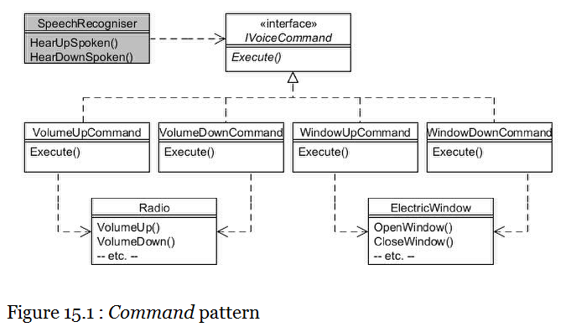

Client programs can now create Radio and ElectricWindow instances, along with their respective IVoiceCommand instances are then passed to the SpeechRecogniser object so it knows what to do.

We will first create a Radio and an ElectricWindow and their respective commands:

// Create a radio and its up/down command objects

Radio radio = new Radio();

radio.SwitchOn();

IVoiceCommand volumeUpCommand = new VolumeUpCommand(radio);

IVoiceCommand volumeDownCommand = new VolumeDownCommand(radio);

// Create an electric window and its up/down command objects

ElectricWindow window = new ElectricWindow();

IVoiceCommand windowUpCommand = new WindowUpCommand(window);

IVoiceCommand windowDownCommand = new WindowDownCommand(window);

Now create a single SpeechRecogniser object and set it to control the radio:

// Create a speech recogniser object

SpeechRecogniser speechRecogniser = new SpeechRecogniser();

speechRecogniser.SetCommands(volumeUpCommand, volumeDownCommand);

Console.WriteLine("Speech recognition controlling the radio");

speechRecogniser.HearUpSpoken();

speechRecogniser.HearUpSpoken();

speechRecogniser.HearUpSpoken();

speechRecogniser.HearDownSpoken();

Now set the same SpeechRecogniser object to control the window instead:

// Control the electric window

speechRecogniser.SetCommands(windowUpCommand, windowDownCommand);

Console.WriteLine("Speech recognition will now control the window");

speechRecogniser.HearDownSpoken();

speechRecogniser.HearUpSpoken();

If you run all the above statements you should see output similar to this:

Radio now on, volume level 5

Window is closed

Speech recognition controlling the radio

Volume turned up to level 6

Volume turned up to level 7

Volume turned up to level 8

Volume turned down to level 7

Speech recognition will now control the window

Window is now open

Window is now closed

**Typical uses of the Command Pattern**

One of the most frequent uses of the Command pattern is in UI toolkits. These provide pre-built components like graphical buttons and menu items that cannot possibly know what needs to be done when clicked, because that is always specific to your application.

Another common aspect of graphical applications is the provision of an "undo" mechanism. The Command pattern is used to accomplish this too; using the example in this chapter, we would add a method to the IVoiceCommand interface like this:

public interface IVoiceCommand

{

void Execute();

**void undo();**

}

Implementing classes then provide the code for the additional method to reverse the last action, as in this example for the VolumeUpCommand class:

public class VolumeUpCommand : IVoiceCommand

{

private Radio radio;

public VolumeUpCommand(Radio radio)

{

this.radio = radio;

}

public virtual void Execute()

{

radio.VolumeUp();

}

**public void undo()**

**{**

**radio.VolumeDown();**

**}**

}

Most applications would be slightly more involved than the above example, in that you would need to store the state of the object prior to performing the code in the Execute() method, enabling you to restore that state when Undo() is called.

#### Interpreter

Type: Behavioural

Purpose: Given a language, define a representation for its grammar along with an interpreter that uses the representation to interpret sentences in the language.

The satellite-navigation systems fitted to some of the Foobar Motor Company's vehicles have a special feature that enables the user to enter a number of cities and let it calculate the most northerly, southerly, westerly or easterly, depending on which command string is entered. A sample command might look like this:

london edinburgh manchester southerly

The above would result in "London" being returned, being the most southerly of the three entered cities. you can even enter the command string like this:

london edinburgh manchester southerly aberdeen westerly

This would first determine that London was the most southerly and then use that result (London) and compare it to Aberdeen to tell you which of those two is the most westerly. Any number of cities can be entered before each of the directional commands of "northerly", "southerly", "westerly" and "easterly".

You can think of the above command string consisting of the city names and directional keywords as forming a simple "language" that needs to be interpreted by the satellite-navigation software. The Interpreter pattern is an approach that helps to decipher these kinds of relatively simple languages.

Before looking at the pattern itself, we shall create a class named City which models the essential points of interest for our example, which is just the name of the city and its latitude and longitude.

public class City

{

private string name;

private double latitude, longitude;

public City(string name, double latitude, double longitude)

{

this.name = name;

this.latitude = latitude;

this.longitude = longitude;

}

public virtual string Name

{

get

{

return name;

}

}

public virtual double Latitude

{

get

{

return latitude;

}

}

public virtual double Longitude

{

get

{

return longitude;

}

}

public override bool Equals(object otherObject)

{

if (this == otherObject)

{

return true;

}

if (!(otherObject is City))

{

return false;

}

City otherCity = (City)otherObject;

return Name.Equals(otherCity.Name);

}

public override int GetHashCode()

{

return Name.GetHashCode();

}

public override string ToString()

{

return Name;

}

}

You will notice that for simplicity the latitude and longitude are stored as doubles. Also not for the latitude position values represent North and negative values represent South. Similarly, a positive longitude represents East and negative values West. The example in this chapter only includes a small number of UK cities which are all Northern latitude and Western longitude, although any city should work should you wish to use your own.

The classes to interpret the language are structured as follows:

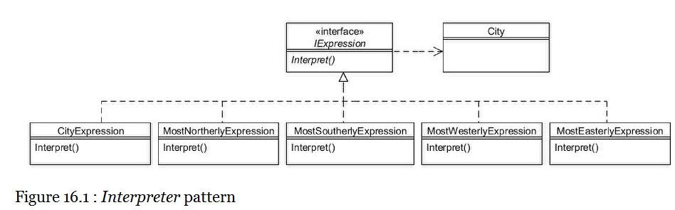

The Interpreter pattern resembles the Composite pattern in that it comprises an interface (or abstract classes) with two types of concrete subclass; one type that represents the individual elements and the other type that represents repeating elements. We create one subclass to handle each type of element in the language.

The IExpression interface is very simple, merely declaring an Interpret() method that returns a City object:

public interface IExpression

{

City Interpret();

}

The first concrete subclass we will look at is CityExpression, an instance of which will be created for each city name it recognises in the command string. All this class needs to do is store a reference to a City object and return it when Interpret() is invoked:

public class CityExpression : IExpression

{

private City city;

public CityExpression(City city)

{

this.city = city;

}

public virtual City Interpret()

{

return city;

}

}

The classes to handle each of the commands (e.g. "northerly") are slightly more involved:

public class MostNortherlyExpression : IExpression

{

private IList<IExpression> expressions;

public MostNortherlyExpression(IList<IExpression> expressions)

{

this.expressions = expressions;

}

public virtual City Interpret()

{

City resultingCity = new City("Nowhere", -999.9, -999.9);

foreach (IExpression currentExpression in expressions)

{

City currentCity = currentExpression.Interpret();

if (currentCity.Latitude > resultingCity.Latitude)

{

resultingCity = currentCity;

}

}

return resultingCity;

}

}

The list of IExpression objects passed to the constructor will be of the CityExpression type. The Interpret() method loops through each of these to determine the most northerly, by comparing their latitude values.

The MostSoutherlyExpression class is very similar, merely changing the comparison:

public class MostSoutherlyExpression : IExpression

{

private IList<IExpression> expressions;

public MostSoutherlyExpression(IList<IExpression> expressions)

{

this.expressions = expressions;

}

public virtual City Interpret()

{

City resultingCity = new City("Nowhere", 999.9, 999.9);

foreach (IExpression currentExpression in expressions)

{

City currentCity = currentExpression.Interpret();

if (currentCity.Latitude < resultingCity.Latitude)

{

resultingCity = currentCity;

}

}

return resultingCity;

}

}

Likewise the MostWesterlyExpression and MostEasterlyExpression classes compute and return the appropriate City:

public class MostWesterlyExpression : IExpression

{

private IList<IExpression> expressions;

public MostWesterlyExpression(IList<IExpression> expressions)

{

this.expressions = expressions;

}

public virtual City Interpret()

{

City resultingCity = new City("Nowhere", 999.9, 999.9);

foreach (IExpression currentExpression in expressions)

{

City currentCity = currentExpression.Interpret();

if (currentCity.Longitude < resultingCity.Longitude)

{

resultingCity = currentCity;

}

}

return resultingCity;

}

}

public class MostEasterlyExpression : IExpression

{

private IList<IExpression> expressions;

public MostEasterlyExpression(IList<IExpression> expressions)

{

this.expressions = expressions;

}

public virtual City Interpret()

{

City resultingCity = new City("Nowhere", -999.9, -999.9);

foreach (IExpression currentExpression in expressions)

{

City currentCity = currentExpression.Interpret();

if (currentCity.Longitude > resultingCity.Longitude)

{

resultingCity = currentCity;

}

}

return resultingCity;

}

}

While the Interpreter pattern does not in itself cover the parsing of an expression, in practice we need to define a class to go through the command string (such as "london edinburgh manchester southerly") and create the appropriate IExpression classes as we go along. These IExpression classes are placed into a "syntax tree" which is normally implemented using a LIFO stack. We shall therefore define a DirectionalEvaluator class to do this parsing, and set-up a small sample of UK cities:

public class DirectionalEvaluator

{

private IDictionary<string, City> cities;

public DirectionalEvaluator()

{

cities = new Dictionary<string, City>();

cities["aberdeen"] = new City("Aberdeen", 57.15, -2.15);

cities["belfast"] = new City("Belfast", 54.62, -5.93);

cities["birmingham"] = new City("Birmingham", 52.42, -1.92);

cities["dublin"] = new City("Dublin", 53.33, -6.25);

cities["edinburgh"] = new City("Edinburgh", 55.92, -3.02);

cities["glasgow"] = new City("Glasgow", 55.83, -4.25);

cities["london"] = new City("London", 51.53, -0.08);

cities["liverpool"] = new City("Liverpool", 53.42, -3.0);

cities["manchester"] = new City("Manchester", 53.5, -2.25);

cities["southampton"] = new City("Southampton", 50.9, -1.38);

}

public virtual City Evaluate(string route)

{

// Define the syntax tree

Stack<IExpression> expressionStack =

new Stack<IExpression>();

// Get each separate token

IList<string> tokens = new List<string>();

int fromIndex = 0;

bool finished = false;

while (!finished)

{

int spaceLocation = route.IndexOf(" ", fromIndex);

if (spaceLocation >= 0)

{

tokens.Add(route.Substring(fromIndex,

spaceLocation - fromIndex));

fromIndex = spaceLocation + 1;

}

else

{

tokens.Add(route.Substring(fromIndex));

finished = true;

}

}

// Parse each token in route string

foreach (string token in SplitTokens(route))

{

// Is token a recognised city?

if (cities.ContainsKey(token))

{

City city = cities[token];

expressionStack.Push(new CityExpression(city));

// Is token to find most northerly?

}

else if (token.Equals("northerly"))

{

expressionStack.Push(new MostNortherlyExpression

(LoadExpressions(expressionStack)));

// Is token to find most southerly?

}

else if (token.Equals("southerly"))

{

expressionStack.Push(new MostSoutherlyExpression

(LoadExpressions(expressionStack)));

// Is token to find most westerly?

}

else if (token.Equals("westerly"))

{

expressionStack.Push(new MostWesterlyExpression

(LoadExpressions(expressionStack)));

// Is token to find most easterly?

}

else if (token.Equals("easterly"))

{

expressionStack.Push(new MostEasterlyExpression

(LoadExpressions(expressionStack)));

}

}

// Resulting value

return expressionStack.Pop().Interpret();

}

// Get each separate token from a string

private IList<string> SplitTokens(string str)

{

IList<string> tokens = new List<string>();

int fromIndex = 0;

bool finished = false;

while (!finished)

{

int spaceLocation = str.IndexOf(" ", fromIndex);

if (spaceLocation >= 0)

{

tokens.Add(str.Substring(fromIndex,

spaceLocation - fromIndex));

fromIndex = spaceLocation + 1;

}

else

{

tokens.Add(str.Substring(fromIndex));

finished = true;

}

}

return tokens;

}

private IList<IExpression> LoadExpressions

(Stack<IExpression> expressionStack)

{

IList<IExpression> expressions = new List<IExpression>();

while (expressionStack.Count > 0)

{

expressions.Add(expressionStack.Pop());

}

return expressions;

}

}

Within the Evaluate() method, when the parser detects a directional command (such as "northerly") it removes the cities on the stack and passes them along with the command back to the stack.

Note that the use above of if...else... statements has been used simply so that the chapter concentrates on the Interpreter pattern.

A better approach would be to use a separate pattern to handle each token such as that defined in Chain of Responsibilities.

Now all that remains is for our client programs to utilise the DirectionalEvaluator passing the command to interpret:

// Create the evaluator

DirectionalEvaluator evaluator = new DirectionalEvaluator();

// This should output "London"...

Console.WriteLine(evaluator.Evaluate

("london edinburgh manchester southerly"));

// This should output "Aberdeen"...

Console.WriteLine(evaluator.Evaluate

("london edinburgh manchester southerly aberdeen westerly"));

Console.Read();

The output will be:

London

Aberdeen

#### Iterator

Type: Behavioural

Purpose: Provide a way to access the elements of an aggregate object sequentially without exposing its underlying representation.

The Foobar Motor Company wanted to produce a brochure listing their range of vehicles for sale and allocated the task to two separate programmers, one to provide the range of cars and the other to provide the range of vans.

The programmer that coded the CarRange class decided to internally store the range using an IList object:

public class CarRange

{

private IList<IVehicle> cars;

public CarRange()

{

cars = new List<IVehicle>();

// Define the range of car models available

cars.Add(new Saloon(new StandardEngine(1300)));

cars.Add(new Saloon(new StandardEngine(1600)));

cars.Add(new Coupe(new StandardEngine(2000)));

cars.Add(new Sport(new TurboEngine(2500)));

}

public virtual IList<IVehicle> Range

{

get

{

return cars;

}

}

}

You can see from the above that the programmer provided a Range getter that returns the IList collection object.

The other programmer decided to store the vans in an array when writing the VanRange class, and therefore his version of the Range getter returns an array of vehicles:

public class VanRange

{

private IVehicle[] vans;

public VanRange()

{

vans = new IVehicle[3];

// Define the range of van models available

vans[0] = new BoxVan(new StandardEngine(1600));

vans[1] = new BoxVan(new StandardEngine(2000));

vans[2] = new Pickup(new TurboEngine(2200));

}

public virtual IVehicle[] Range

{

get

{

return vans;

}

}

}

The problem with this is that the internal representation in both of these classes has been exposed to outside objects. A better approach would be for each of the CarRange and VanRange classes to provide an GetEnumerator() method that returns an IEnumerator object, so that as well as being consistent, the internal representation would not need to be exposed.

For CarRange the additional method will be as follows:

public virtual IEnumerator<IVehicle> GetEnumerator()

{

return cars.GetEnumerator();

}

For VanRange the additional method will need to convert from the array:

public virtual IEnumerator<IVehicle> GetEnumerator()

{

return ((IEnumerable<IVehicle>) vans).GetEnumerator();

}

Now we can process both cars and vans in a consistent manner:

Console.WriteLine("=== Our Cars ===");

CarRange carRange2 = new CarRange();

PrintIterator(carRange2.GetEnumerator());

Console.WriteLine("=== Our Vans ===");

VanRange vanRange2 = new VanRange();

PrintIterator(vanRange2.GetEnumerator());

private static void PrintIterator(IEnumerator iter)

{

while(iter.MoveNext())

{

Console.WriteLine(iter.Current);

}

}

**The 'foreach' loop**

Several of the other chapters in this book have made use of the foreach statement, providing a clean alternative to the above, as follows:

Console.WriteLine("=== Our Cars ===");

CarRange carRange3 = new CarRange();

foreach (IVehicle currentVehicle in carRange3.Range)

{

Console.WriteLine(currentVehicle);

}

Console.WriteLine("=== Our Vans ===");

VanRange vanRange3 = new VanRange();

foreach (IVehicle currentVehicle in vanRange3.Range)

{

Console.WriteLine(currentVehicle);

}

#### Mediator

Type: Behavioural

Purpose: Define an object that encapsulates how a set of objects interact. Mediator promotes loose coupling by keeping objects from referring to each other explicitly, and it lets your vary their interaction independently.

The Foobar Motor Company is looking to the future when vehicles can drive themselves. This, of course, would entail the various components (ignition, gearbox, accelerator and brakes, etc.,) being controlled together and interacting in various ways. For example:

* Until the ignition is switched on, the gearbox, accelerator and brakes do not operate (we will assume the parking brake is in effect);
* When accelerating, the brakes should be disabled;
* When braking the accelerator should be disabled;
* The appropriate gear should be engaged dependent upon the speed of the vehicle.

And all this should happen automatically so the driver can just enjoy the view! (we will assume the vehicle can sense it's position so as to avoid crashes, etc.,).

We will naturally create classes to model the individual components, so there will be an ignition class, a gearbox class, an accelerator class and a break class. But we can also see that there are some complex integrations between them, and yet one of our core object-oriented design principles is to keep classes loosely-coupled.

The mediator pattern helps to solve this through the definition of a separate class (the mediator) that knows about the individual component classes and takes responsibility for managing their interaction. The component classes also each know about the mediator class, but this is the only coupling they have. For our example, we will call the mediator class EngineManagementSystem.

We can see the connections diagrammatically below:

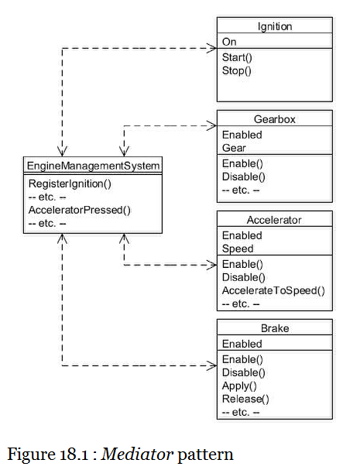

The two way communication is achieved via each of the component classes constructors, in that they accept a reference to the mediator object (so they can send messages to it) and register themselves with the mediator (so they can receive message from it). But each component class has no knowledge of any other component class; they only know about the mediator.

We can see this by looking at the ignition class:

public class Ignition

{

private EngineManagementSystem mediator;

private bool on;

// Constructor accepts mediator as an argument

public Ignition(EngineManagementSystem mediator)

{

this.mediator = mediator;

on = false;

// Register back with the mediator;

mediator.RegisterIgnition(this);

}

public virtual void Start()

{

on = true;

mediator.IgnitionTurnedOn();

Console.WriteLine("Ignition turned on");

}

public virtual void Stop()

{

on = false;

mediator.IgnitionTurnedOff();

Console.WriteLine("Ignition turned off");

}

public virtual bool On

{

get

{

return on;

}

}

}

Note how the constructor establishes the two-way communication, and then how methods that perform events notify the mediator of those events.

The Gearbox class applies the same principles:

public class Gearbox

{

private EngineManagementSystem mediator;

private bool enabled;

private Gear currentGear;

// Constructor accepts mediator as an argument

public Gearbox(EngineManagementSystem mediator)

{

this.mediator = mediator;

enabled = false;

currentGear = Gear.Neutral;

mediator.RegisterGearbox(this);

}

public virtual void Enable()

{

enabled = true;

mediator.GearboxEnabled();

Console.WriteLine("Gearbox enabled");

}

public virtual void Disable()

{

enabled = false;

mediator.GearboxDisabled();

Console.WriteLine("Gearbox disabled");

}

public virtual bool Enabled

{

get

{

return enabled;

}

}

public virtual Gear Gear

{

set

{

if ((Enabled) && (Gear != value))

{

currentGear = value;

mediator.GearChanged();

Console.WriteLine("Now in " + Gear + " gear");

}

}

get

{

return currentGear;

}

}

}

The Gear enum used by Gearbox is as follows:

public enum Gear

{

Neutral,

First,

Second,

Third,

Fourth,

Fifth,

Reverse

}

The Accelerator and Brake classes follow a similar process:

public class Accelerator

{

private EngineManagementSystem mediator;

private bool enabled;

private int speed;

// Constructor accepts mediator as an argument

public Accelerator(EngineManagementSystem mediator)

{

this.mediator = mediator;

enabled = false;

speed = 0;

mediator.RegisterAccelerator(this);

}

public virtual void Enable()

{

enabled = true;

mediator.AcceleratorEnabled();

Console.WriteLine("Accelerator enabled");

}

public virtual void Disable()

{

enabled = false;

mediator.AcceleratorDisabled();

Console.WriteLine("Accelerator disabled");

}

public virtual bool Enabled

{

get

{

return enabled;

}

}

public virtual void AccelerateToSpeed(int speed)

{

if (Enabled)

{

this.speed = speed;

Console.WriteLine("Speed now " + Speed);

}

}

public virtual int Speed

{

get

{

return speed;

}

}

}

public class Brake

{

private EngineManagementSystem mediator;

private bool enabled;

private bool applied;

// Constructor accepts mediator as an argument

public Brake(EngineManagementSystem mediator)

{

this.mediator = mediator;

enabled = false;

applied = false;

mediator.RegisterBrake(this);

}

public virtual void Enable()

{

enabled = true;

mediator.BrakeEnabled();

Console.WriteLine("Brakes enabled");

}

public virtual void Disable()

{

enabled = false;

mediator.BrakeDisabled();

Console.WriteLine("Brakes disabled");

}

public virtual bool Enabled

{

get

{

return enabled;

}

}

public virtual void Apply()

{

if (Enabled)

{

applied = true;

mediator.BrakePressed();

Console.WriteLine("Now braking");

}

}

private void Release()

{

if (Enabled)

{

applied = false;

}

}

}

So we now need the EngineManagementSystem class to serve as the mediator. This will hold a reference to each of the component classes with methods enabling their registration with the mediator. It also has method to handle the interaction between the various components when particular events occur:

public class EngineManagementSystem

{

private Ignition ignition;

private Gearbox gearbox;

private Accelerator accelerator;

private Brake brake;

private int currentSpeed;

public EngineManagementSystem()

{

currentSpeed = 0;

}

// Methods that enable registration with this mediator...

public virtual void RegisterIgnition(Ignition ignition)

{

this.ignition = ignition;

}

public virtual void RegisterGearbox(Gearbox gearbox)

{

this.gearbox = gearbox;

}

public virtual void RegisterAccelerator(Accelerator accelerator)

{

this.accelerator = accelerator;

}

public virtual void RegisterBrake(Brake brake)

{

this.brake = brake;

}

// Methods that handle object interactions...

public virtual void IgnitionTurnedOn()

{

gearbox.Enable();

accelerator.Enable();

brake.Enable();

}

public virtual void IgnitionTurnedOff()

{

gearbox.Disable();

accelerator.Disable();

brake.Disable();

}

public virtual void GearboxEnabled()

{

Console.WriteLine("EMS now controlling the gearbox");

}

public virtual void GearboxDisabled()

{

Console.WriteLine("EMS no longer controlling the gearbox");

}

public virtual void GearChanged()

{

Console.WriteLine("EMS disengaging revs while gear changing");

}

public virtual void AcceleratorEnabled()

{

Console.WriteLine("EMS now controlling the accelerator");

}

public virtual void AcceleratorDisabled()

{

Console.WriteLine("EMS no longer controlling the accelerator");

}

public virtual void AcceleratorPressed()

{

brake.Disable();

while (currentSpeed < accelerator.Speed)

{

currentSpeed++;

Console.WriteLine("Speed currentlt " + currentSpeed);

// Set gear according to speed

if (currentSpeed <= 10)

{

gearbox.Gear = Gear.First;

}

else if (currentSpeed <= 20)

{

gearbox.Gear = Gear.Second;

}

else if (currentSpeed <= 30)

{

gearbox.Gear = Gear.Third;

}

else if (currentSpeed <= 50)

{

gearbox.Gear = Gear.Fourth;

}

else

{

gearbox.Gear = Gear.Fifth;

}

}

brake.Enable();

}

public virtual void BrakeEnabled()

{

Console.WriteLine("EMS now controlling the brake");

}

public virtual void BrakeDisabled()

{

Console.WriteLine("EMS no longer controlling the brake");

}

public virtual void BrakePressed()

{

accelerator.Disable();

currentSpeed = 0;

}

public virtual void BrakeReleased()

{

gearbox.Gear = Gear.First;

accelerator.Enable();

}

}

**Common uses**

A common use of the Mediator pattern is to manage the interaction of graphical components on a dialog. This frequently involves controlling when buttons, text fields, etc., should be enabled or disabled, or for passing data between components.

Note that it may be possible to reduce the coupling further by using the Observer pattern in place of Mediator. This would mean that the component classes (i.e. Ignition, etc.) would not need to hold a reference to a mediator but would instead fire events. The EngineManagementSystem class would then be an observer of the component classes and would still be able to invoke messages on them.

#### Memento

Type: Behavioural

Purpose: Without violating encapsulation, capture and externalise an object's internal state so that it can be restored to this state later.

The Foobar Motor Company's vehicle's naturally have a speedometer mounted on the dashboard, which not only records the current speed but also the previous speed. There is now a requirement for the state to be stored externally at periodic intervals (so that it could, for example, be integrated into a tachograph for goods vehicles).

However, one of the instance variables in the Speedometer class doesn't have a getter method, but to adhere to encapsulation and data-hiding principles it is correctly declared to be private. We also want to adhere to the principle that a class should not have multiple responsibilities, so don't want to also have a build in a state save & restore mechanism into the class. So how can we capture the state of the object?

This chapter will present two different approaches, each having its advantages and disadvantages. In both cases, we make use of a separate class that performs the state saving and restoration, which we shall call SpeedometerMemento. This class takes a reference to the Speedometer object that needs to be externalised:

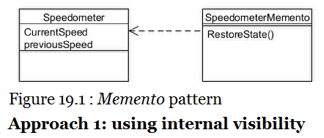

**Approach 1: using internal visibility**

When the access modifier internal is specified this means it is only accessible to other classes in the same assembly. Therefore we can place the speedometer class and its associated memento class into their own assembly, and we will call the latter class SpeedometerMemento.

Here is the very simple Speedometer class:

public class SpeedometerInternalVisibility

{

// Normal private visibility but has accessor method...

private int currentSpeed;

// internal visibility and no accessor method...

internal int previousSpeed;

public SpeedometerInternalVisibility()

{

currentSpeed = 0;

previousSpeed = 0;

}

public virtual int CurrentSpeed

{

set

{

previousSpeed = currentSpeed;

currentSpeed = value;

}

get

{

return currentSpeed;

}

}

}

The SpeedometerMemento class exists in the same assembly. It saves the state of the passed in Speedometer object in the constructor and defined a method to restore that state:

public class SpeedometerMementoInternalVisibility

{

private SpeedometerInternalVisibility speedometer;

private int copyOfCurrentSpeed;

private int copyOfPreviousSpeed;

public SpeedometerMementoInternalVisibility(SpeedometerInternalVisibility speedometer)

{

this.speedometer = speedometer;

copyOfCurrentSpeed = speedometer.CurrentSpeed;

copyOfPreviousSpeed = speedometer.previousSpeed;

}

public virtual void RestoreState()

{

speedometer.CurrentSpeed = copyOfCurrentSpeed;

speedometer.previousSpeed = copyOfPreviousSpeed;

}

}

Note that the CurrentSpeed property getter was used for the currentSpeed instance variable but the previousSpeed variable has to be accessed directly, which is possible because the memento exists in the same assembly.

We can test the memento with this code:

Console.WriteLine("Internal Visibility Approach");

SpeedometerInternalVisibility speedo = new SpeedometerInternalVisibility();

speedo.CurrentSpeed = 50;

speedo.CurrentSpeed = 100;

Console.WriteLine("Current speed: " + speedo.CurrentSpeed);

Console.WriteLine("Previous speed: " + speedo.previousSpeed);

// Save the state of 'speedo'

SpeedometerMementoInternalVisibility memento = new SpeedometerMementoInternalVisibility(speedo);

// Change the state of 'speed'

speedo.CurrentSpeed = 80;

Console.WriteLine("After setting to 80...");

Console.WriteLine("Current speed: " + speedo.CurrentSpeed);

Console.WriteLine("Previous speed: " + speedo.previousSpeed);

// Restore the state of 'speedo'

Console.WriteLine("Now restoring state...");

memento.RestoreState();

Console.WriteLine("Current speed: " + speedo.CurrentSpeed);

Console.WriteLine("Previous speed: " + speedo.previousSpeed);

Running the above results in the following output:

Internal Visibility Approach

Current speed: 100

Previous speed: 50

After setting to 80...

Current speed: 80

Previous speed: 100

Now restoring state...

Current speed: 100

Previous speed: 50

The main disadvantage of this approach is that you either have to put the pair of classes in their own special assembly or accept that other classes in the assembly they are in will have direct access to the instance variables.

**Approach 2: object serialization**

This approach allows you to make all the instance variables private, thus regaining full encapsulation. The Speedometer class has been modified for this and now includes a PreviousSpeed getter, though this is purely to help us test the memento; it's not required by this approach. The class has also been changed to be Serializable (changed marked in bold);

**[Serializable]**

public class SpeedometerObjectSerialization

{

private int currentSpeed;

**private** int previousSpeed;

public SpeedometerObjectSerialization() {

currentSpeed = 0;

previousSpeed = 0;

}

public virtual int CurrentSpeed {

set {

previousSpeed = currentSpeed;

currentSpeed = value;

}

get {

return currentSpeed;

}

}

**// Only defined to help testing...**

**public virtual int PreviousSpeed {**

**get {**

**return previousSpeed;**

**}**

**}**

}

The SpeedometerMemento class now uses object serialization for the state saving and restoration:

public class SpeedometerMementoObjectSerialization

{

public SpeedometerMementoObjectSerialization(SpeedometerObjectSerialization speedometer)

{

// Serialize...

Stream stream = File.Open("speedometer.ser", FileMode.Create);

BinaryFormatter formatter = new BinaryFormatter();

formatter.Serialize(stream, speedometer);

stream.Close();

}

public virtual SpeedometerObjectSerialization RestoreState()

{

// Deserialize...

SpeedometerObjectSerialization speedo;

Stream stream = File.Open("speedometer.ser", FileMode.Open);

BinaryFormatter formatter = new BinaryFormatter();

speedo = (SpeedometerObjectSerialization)formatter.Deserialize(stream);

stream.Close();

return speedo;

}

}

We can check that this achieves the same as the first approach, the only difference being that the RestoreState() method now return the restored object reference:

try

{

Console.WriteLine("Object Serialization Approach");

SpeedometerObjectSerialization speedo = new SpeedometerObjectSerialization();

speedo.CurrentSpeed = 50;

speedo.CurrentSpeed = 100;

Console.WriteLine("Current speed: " + speedo.CurrentSpeed);

Console.WriteLine("Previous speed: " + speedo.PreviousSpeed);

// Save the state of 'speedo'

SpeedometerMementoObjectSerialization memento = new SpeedometerMementoObjectSerialization(speedo);

// Change the state of 'speed'

speedo.CurrentSpeed = 80;

Console.WriteLine("After setting to 80...");

Console.WriteLine("Current speed: " + speedo.CurrentSpeed);

Console.WriteLine("Previous speed: " + speedo.PreviousSpeed);

// Restore the state of 'speedo'

Console.WriteLine("Now restoring state...");

**speedo = memento.RestoreState();**

Console.WriteLine("Current speed: " + speedo.CurrentSpeed);

Console.WriteLine("Previous speed: " + speedo.PreviousSpeed);

}

catch (Exception ex)

{

Console.WriteLine(ex.ToString());

Console.Write(ex.StackTrace);

}

}

Running the above should result in the same output as shown for the first approach. The main disadvantage of this approach is that writing to and reading from a disk file is much slower. Note also that while we have been able to make all fields private again, it might still be possible for someone who gained access to the serialized file to use a hex editor to read or change the data.

#### Observer

Type: Behavioural

Purpose: Define a one-to-many dependency between objects so that when one object changes its state, all it dependants are notified and updated automatically.

The Foobar Motor Company has decided that an alert should sound to the driver whenever a certain speed is exceeded. They also envisage that other things may need to happen depending upon the current speed (such as an automatic gearbox selecting the appropriate gear to match the speed). But they realise the need to keep objects loosely-coupled, so naturally don't wish the Speedometer class to have any direct knowledge of speed monitors or automatic gearboxes (or any other future class that might be interested in the speed a vehicle is travelling).

The Observer pattern enables a loose-coupling to be established between a 'subject' (the object that is of interest; Speedometer in our example) and its 'observers' (any other class that needs to be kept informed when interesting stuff happens).

Because this is a very common need in object-oriented systems, the C# libraries already contains mechanisms that enable the pattern to be implemented. One of these is by utilising the EventHandler event class:

The 'subject' (Speedometer) can have multiple observers, each of which will be notified whenever. an event occurs on the Speedometer object. The Speedometer class looks like this:

public class Speedometer

{

public event EventHandler ValueChanged;

private int currentSpeed;

public Speedometer()

{

currentSpeed = 0;

}

public virtual int CurrentSpeed

{

set

{

currentSpeed = value;

// Tell all observers so they know value has changed...

OnValueChanged();

}

get

{

return currentSpeed;

}

}

protected void OnValueChanged()

{

if (ValueChanged != null)

{

ValueChanged(this, EventArgs.Empty);

}

}

}

The SpeedMonitor class utilises ValueChanged:

public class SpeedMonitor

{

public const int SPEED_TO_ALERT = 70;

public SpeedMonitor(Speedometer speedo)

{

speedo.ValueChanged += ValueHasChanged;

}

private void ValueHasChanged(Object sender, EventArgs e )

{

Speedometer speedo = (Speedometer)sender;

if (speedo.CurrentSpeed > SPEED_TO_ALERT)

{

Console.WriteLine("** ALERT ** Driving too fast! ("

+ speedo.CurrentSpeed + ")");

}

else

{

Console.WriteLine("... nice and steady ... ("

+ speedo.CurrentSpeed + ")");

}

}

}

Client programs simply pass a SpeedMonitor reference to an instance of Speedometer:

// Create a speedometer...

Speedometer speedo = new Speedometer();

// Create a monitor...

SpeedMonitor monitor = new SpeedMonitor(speedo);

// Add automatic gearbox as an observer

AutomaticGearbox auto = new AutomaticGearbox(speedo);

// Drive at different speeds...

speedo.CurrentSpeed = 50;

speedo.CurrentSpeed = 70;

speedo.CurrentSpeed = 40;

speedo.CurrentSpeed = 100;

speedo.CurrentSpeed = 69;

Console.Read();

Running the above will result in the following output:

... nice and steady ... (50)

Now in fourth gear

... nice and steady ... (70)

Now in fourth gear

... nice and steady ... (40)

Now in fourth gear

** ALERT ** Driving too fast! (100)

Now in fourth gear

... nice and steady ... (69)

Now in fourth gear

The real power behind the Observer pattern is that any type of class can now become a monitor provided they implement the Observer interface, and without requiring any changes to be made to Speedometer. Let's create a simulation of an automatic gearbox:

public class AutomaticGearbox

{

public AutomaticGearbox(Speedometer speedo)

{

speedo.ValueChanged += ValueHasChanged;

}

private void ValueHasChanged(Object sender, EventArgs e )

{

Speedometer speedo = (Speedometer)sender;

if (speedo.CurrentSpeed <= 10)

{

Console.WriteLine("Now in first gear");

}

else if (speedo.CurrentSpeed <= 20)

{

Console.WriteLine("Now in second gear");

}

else if (speedo.CurrentSpeed <= 30)

{

Console.WriteLine("Now in third gear");

}

else

{

Console.WriteLine("Now in fourth gear");

}

}

}

Our client program can now just add this as an additional observer and get notification of speed changes as well:

#### State

Type: Behavioural

Purpose: Allow an object to alter its behaviour when its internal state changes. The object will appear need to be reset from time to time (such as after a change of battery) and this is accomplished by means of a particular knob on the dashboard. When the knob is initially pressed, the 'year' value can be set. Turning the knob to the left (i.e. anti-clockwise) causes the previous year to be show, whereas turning it to the right goes forward one year. When the knob is pressed again the year value becomes 'set' and the set-up process then automatically allows the month value to be set, also by making appropriate left or right movements with the knob.

This process continues for the day of the month, the hour and the minute. The following summarises the flow of events:

* When the knob is first pushes the clock goes into "setup" mode for setting the year;
* If the knob is rotated left then 1 is deducted from the year value;
* If the knob is rotated right then 1 is added to the year value;
* When the knob is pushed the year becomes set and the clock goes into "setup" mode for setting the month;
* If the knob is rotated left then 1 is deducted from the month value;
* If the knob is rotated right then 1 is added to the month value;
* When the knob is pushed the month becomes set and the clock goes into "setup" mode for setting the day;
* If the knob is rotated left then 1 is deducted from the day value;
* If the knob is rotated right then 1 is added to the day value;
* When the knob is pushed the day becomes set and the clock goes into "setup" mode for setting the hour;
* If the knob is rotated left then 1 is deducted from the hour value;
* If the knob is rotated right then 1 is added to the hour value;
* When the knob is pushed the hour becomes set and the clock goes into "setup" mode for setting the minute;
* If the knob is rotated left then 1 is deducted from the minute value;
* If the knob is rotated right then 1 is added to the minute value;
* When the knob is pushed the minute becomes set and the clock goes into "finished setup" mode;
* If the knob is pushed again the full selected date and time are displayed.

From the above steps it is clear that different parts of the date & time get set when the knob is turned or pressed, and that there are transition between those parts. A naive approach when coding a class to accomplish this would be to have a 'mode' variable and then a series of if...else... statements in each method, which might look like this:

// *** Don't Do this ***

public void RotateKnobLeft()

{

if(mode == YearMode)

{

year--;

}

if (mode == MonthMode)

{

month--;

}

if (mode == DayMode)

{

day--;

}

if (mode == HourMode)

{

hour--;

}

if (mode == MinuteMode)

{

minute--;

}

}

The problem with code such as the above is that the if... else... conditions would have to be repeated in each action method (i.e. RotateKnobRight(), PushKnob(), etc.,) Apart from making the code look unwieldy it also becomes hard to maintain, as if for example we now need to record seconds we would need to change multiple parts of the class.

The State pattern enables a hierarchy to be established that allows for state transitions such as necessitated by our clock setting example. We will create a ClockSetup class that initiates the states through the interface IClockSetupState, which has an implementing class for each individual state:

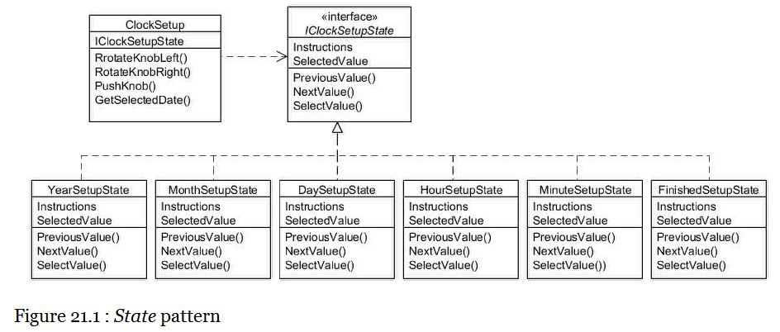

The IClockSetupState interface defines methods for handling changes to the state, plus methods that can provide user instructions and return the actual selected value:

public interface IClockSetupState

{

void PreviousValue();

void NextValue();

void SelectValue();

string Instructions { get; }

int SelectedValue { get; }

}

Looking first at YearSetupState, you will notice that it takes a reference to a ClockSetup object in the constructor (which is known in the language of design patterns as its 'context') and manages the setting of the year. Note in particular in the SelectValue() method how it transitions internally to a different state:

public class YearSetupState : IClockSetupState

{

private ClockSetup clockSetup;

private int year;

public YearSetupState(ClockSetup clockSetup)

{

this.clockSetup = clockSetup;

year = DateTime.Now.Year;

}

public virtual void PreviousValue()

{

year--;

}

public virtual void NextValue()

{

year++;

}

public virtual void SelectValue()

{

Console.WriteLine("Year set to " + year);

clockSetup.State = clockSetup.MonthSetupState;

}

public virtual string Instructions

{

get

{

return "Please set the year...";

}

}

public virtual int SelectedValue

{

get

{

return year;

}

}

}

The other date & time state classes follow a similar process, each transitioning to the next appropriate state when required:

public class MonthSetupState : IClockSetupState

{

private ClockSetup clockSetup;

private int month;

public MonthSetupState(ClockSetup clockSetup)

{

this.clockSetup = clockSetup;

month = DateTime.Now.Month;

}

public virtual void PreviousValue()

{

if (month > 0)

{

month--;

}

}

public virtual void NextValue()

{

if (month < 11)

{

month++;

}

}

public virtual void SelectValue()

{

Console.WriteLine("Month set to " + month);

clockSetup.State = clockSetup.DaySetupState;

}

public virtual string Instructions

{

get

{

return "Please set the month...";

}

}

public virtual int SelectedValue

{

get

{

return month;

}

}

}

public class DaySetupState : IClockSetupState

{

private ClockSetup clockSetup;

private int day;

public DaySetupState(ClockSetup clockSetup)

{

this.clockSetup = clockSetup;

day = DateTime.Now.Day;

}

public virtual void PreviousValue()

{

if (day > 1)

{

day--;

}

}

public virtual void NextValue()

{

if (day < System.DateTime.DaysInMonth(new DateTime().Year,

new DateTime().Month))

{

day++;

}

}

public virtual void SelectValue()

{

Console.WriteLine("Day set to " + day);

clockSetup.State = clockSetup.HourSetupState;

}

public virtual string Instructions

{

get

{

return "Please set the day...";

}

}

public virtual int SelectedValue

{

get

{

return day;

}

}

}

public class HourSetupState : IClockSetupState

{

private ClockSetup clockSetup;

private int hour;

public HourSetupState(ClockSetup clockSetup)

{

this.clockSetup = clockSetup;

hour = DateTime.Now.Hour;

}

public virtual void PreviousValue()

{

if (hour > 0)

{

hour--;

}

}

public virtual void NextValue()

{

if (hour < 23)

{

hour++;

}

}

public virtual void SelectValue()

{

Console.WriteLine("Hour set to " + hour);

clockSetup.State = clockSetup.MinuteSetupState;

}

public virtual string Instructions

{

get

{

return "Please set the hour...";

}

}

public virtual int SelectedValue

{

get

{

return hour;

}

}

}

public class MinuteSetupState : IClockSetupState

{

private ClockSetup clockSetup;

private int minute;

public MinuteSetupState(ClockSetup clockSetup)

{

this.clockSetup = clockSetup;

minute = DateTime.Now.Minute;

}

public virtual void PreviousValue()

{

if (minute > 0)

{

minute--;

}

}

public virtual void NextValue()

{

if (minute < 59)

{

minute++;

}

}

public virtual void SelectValue()

{

Console.WriteLine("Minute set to " + minute);

clockSetup.State = clockSetup.FinishedSetupState;

}

public virtual string Instructions

{

get

{

return "Please set the minute...";

}

}

public virtual int SelectedValue

{

get

{

return minute;

}

}

}

This just leaves the FinishedSetupState class which doesn't need to transition to a different state:

public class FinishedSetupState : IClockSetupState

{

private ClockSetup clockSetup;

public FinishedSetupState(ClockSetup clockSetup)

{

this.clockSetup = clockSetup;

}

public virtual void PreviousValue()

{

Console.WriteLine("Ignored...");

}

public virtual void NextValue()

{

Console.WriteLine("Ignored...");

}

public virtual void SelectValue()

{

DateTime selectedDate = clockSetup.SelectedDate;

Console.WriteLine("Date set to: " + selectedDate);

}

public virtual string Instructions

{

get

{

return "Press knob to view selected date...";

}

}

public virtual int SelectedValue

{

get

{

throw new System.NotSupportedException("Clock setup finished");

}

}

}

As mentioned, the 'context' class is ClockSetup, which holds references to each state and forwards to whichever is the current state:

public class ClockSetup

{

// The various states the setup can be in...

private IClockSetupState yearState;

private IClockSetupState monthState;

private IClockSetupState dayState;

private IClockSetupState hourState;

private IClockSetupState minuteState;

private IClockSetupState finishedState;

// The current state we are in...

private IClockSetupState currentState;

public ClockSetup()

{

yearState = new YearSetupState(this);

monthState = new MonthSetupState(this);

dayState = new DaySetupState(this);

hourState = new HourSetupState(this);

minuteState = new MinuteSetupState(this);

finishedState = new FinishedSetupState(this);

// Initial state is set to the year

State = yearState;

}

public virtual IClockSetupState State

{

set

{

currentState = value;

Console.WriteLine(currentState.Instructions);

}

}

public virtual void RotateKnobLeft()

{

currentState.PreviousValue();

}

public virtual void RotateKnobRight()

{

currentState.NextValue();

}

public virtual void PushKnob()

{

currentState.SelectValue();

}

public virtual IClockSetupState YearSetupState

{

get

{

return yearState;

}

}

public virtual IClockSetupState MonthSetupState

{

get

{

return monthState;

}

}

public virtual IClockSetupState DaySetupState

{

get

{

return dayState;

}

}

public virtual IClockSetupState HourSetupState

{

get

{

return hourState;

}

}

public virtual IClockSetupState MinuteSetupState

{

get

{

return minuteState;

}

}

public virtual IClockSetupState FinishedSetupState

{

get

{

return finishedState;

}

}

public virtual DateTime SelectedDate

{

get

{

return new DateTime(yearState.SelectedValue,

monthState.SelectedValue,

dayState.SelectedValue,

hourState.SelectedValue,

minuteState.SelectedValue,

0);

}

}

}

We can simulate a user's example actions like this:

ClockSetup clockSetup = new ClockSetup();

// Setup starts in 'year' state

clockSetup.RotateKnobRight();

clockSetup.PushKnob(); // year should be 1 on from current

// Setup should now be in 'month' state

clockSetup.RotateKnobRight();

clockSetup.RotateKnobRight();

clockSetup.PushKnob(); // month should be 2 on from current

// Setup should now be in 'day' state

clockSetup.RotateKnobRight();

clockSetup.RotateKnobRight();

clockSetup.RotateKnobRight();

clockSetup.PushKnob(); // day should be 3 on from current

// Setup should now be in 'hour' state

clockSetup.RotateKnobLeft();

clockSetup.RotateKnobLeft();

clockSetup.PushKnob(); // hour should be 2 less than current

// Setup should now be in 'minute' state

clockSetup.RotateKnobRight();

clockSetup.PushKnob(); // minute should be 1 on than current

// Setup should now be in 'finished' state

clockSetup.PushKnob(); // to display selected date

Console.Read();

Running the above should result in the following output relative to your current system date and time, with the above adjustments made.

Please set the year...

Year set to 2016

Please set the month...

Month set to 6

Please set the day...

Day set to 8

Please set the hour...

Hour set to 16

Please set the minute...

Minute set to 14

Press knob to view selected date...

Date set to: 08-06-2016 16:14:00

#### Strategy

Type: Behavioural

Purpose: Define a family of algorithms, encapsulate each one, and make them interchangeable. Strategy lets the algorithm vary independently from clients that use it.

The Foobar Motor Company wishes to implement a new type of automatic gearbox for their cars that will be able to be switched between its standard mode and a special 'sport' mode. The different modes will base the decision of which gear should be selected depending upon the speed of travel, size of the engine and whether it is turbocharged. And it's quite possible they will want other modes in the future, such as for off-road driving.

Just as with the discussion in the chapter for the State pattern, it would be inflexible to use a series of if... else... statements to control the different gearbox modes directly inside our vehicle classes. Instead, we shall encapsulate the concept that varies and define a separate hierarchy so that each different gearbox mode is a separate class, each in effect being a different 'strategy' that gets applied. This approach allows the actual strategy being used to be isolated from the vehicle. In our example, we shall only apply this to the cars:

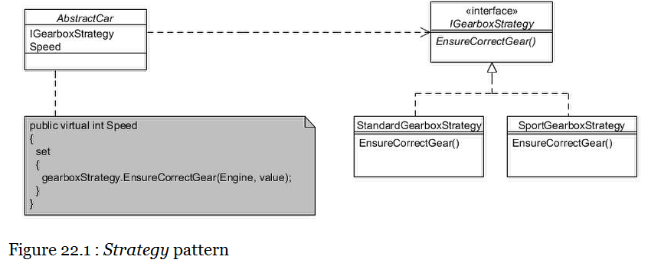

The IGearboxStrategy interface defines the method to control the gear:

public interface IGearboxStrategy

{

void EnsureCorrectGear(IEngine engine, int speed);

}

There are two implementing classes; StandardGearBoxStrategy and SportGearboxStrategy:

public class StandardGearboxStrategy : IGearboxStrategy

{

public virtual void EnsureCorrectGear(IEngine engine, int speed)

{

int engineSize = engine.Size;

bool turbo = engine.Turbo;

// Some complicated code to determine correct gear

// setting based on engineSize, turbo & speed, etc.

// ... omitted ...

Console.WriteLine("Working out correct gear at "

+ speed + "mph for a STANDARD gearbox");

}

}

public class SportGearboxStrategy : IGearboxStrategy

{

public virtual void EnsureCorrectGear(IEngine engine, int speed)

{

int engineSize = engine.Size;

bool turbo = engine.Turbo;

// Some complicated code to determine correct gear

// setting based on engineSize, turbo & speed, etc.

// ... omitted ...

Console.WriteLine("Working out correct gear at "

+ speed + "mph for a SPORT gearbox");

}

}

Our AbstractCar class is defined to hold a reference to the interface type (i.e. IGearboxStrategy) and provide accessor methods so different strategies can be swtiched. There is also a Speed property setter that delegates to whatever strategy is in effect. There pertinent code is marked in bold:

public abstract class AbstractCar : AbstractVehicle

{

**private IGearboxStrategy gearboxStrategy;**

public AbstractCar(IEngine engine)

: this(engine, VehicleColour.Unpainted)

{

}

public AbstractCar(IEngine engine, VehicleColour colour)

: base(engine, colour)

{

**// Starts in standard gearbox mode (more economical)**

**gearboxStrategy = new StandardGearboxStrategy();**

}

**// Allow the gearbox strategy to be changed...**

**public virtual IGearboxStrategy IGearboxStrategy**

**{**

**set**

**{**

**this.gearboxStrategy = value;**

**}**

**get**

**{**

**return gearboxStrategy;**

**}**

**}**

**public virtual int Speed**

**{**

**set**

**{**

**// Delegate to strategy in effect...**

**gearboxStrategy.EnsureCorrectGear(Engine, value);**

**}**

**}**

}

Client programs just set the required strategy:

AbstractCar myCar = new Sport(new StandardEngine(2000));

myCar.Speed = 20;

myCar.Speed = 40;

Console.WriteLine("Switching on sports mode gearbox...");

myCar.IGearboxStrategy = new SportGearboxStrategy();

myCar.Speed = 20;

myCar.Speed = 40;

Console.Read();

This should result in the following output:

Working out correct gear at 20mph for a STANDARD gearbox

Working out correct gear at 40mph for a STANDARD gearbox

Switching on sports mode gearbox...

Working out correct gear at 20mph for a SPORT gearbox

Working out correct gear at 40mph for a SPORT gearbox

#### Template Method

Type: Behavioural

Purpose: Define the skeleton of an algorithm in a method, deferring some steps to subclasses. Template Method lets subclasses redefine certain steps of an algorithm without changing the algorithm's structure.

Each vehicle made by the Foobar Motor Company needs a small number of printed booklets to be produced and provided to the buyer, such as an Owner's Manual and a Service History booklet. The way booklets are produced always follows the same set of steps, but each different type of booklet might need to do each of the individual steps in a slightly different way.

The Template Method pattern enables the definition of one or more abstract methods that are called through a 'template method'. The simple hierarchy is as follows:

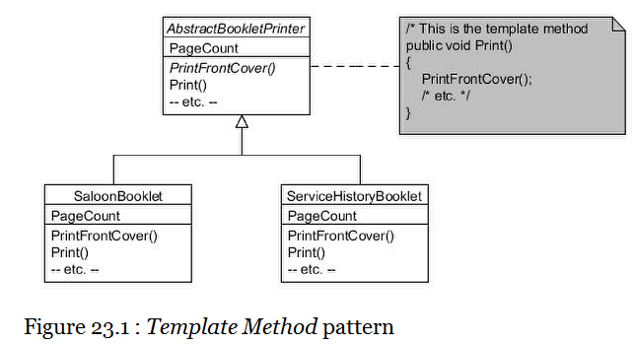

The AbstractBookletPrinter class defines several protected abstract methods and one public 'template method' that makes use of the abstract methods:

public abstract class AbstractBookletPrinter

{

protected internal abstract int PageCount { get; }

protected internal abstract void PrintFrontCover();

protected internal abstract void PrintTableOfContents();

protected internal abstract void PrintPage(int pageNumber);

protected internal abstract void PrintIndex();

protected internal abstract void PrintBackCover();

// This is the 'template method'

public void Print()

{

PrintFrontCover();

PrintTableOfContents();

for (int i = 1; i <= PageCount; i++)

{

PrintPage(i);

}

PrintIndex();

PrintBackCover();

}

}

Each concrete subclass now only needs to provide the implementing code for each abstract method, for example the SaloonBooklet class below:

public class SaloonBooklet : AbstractBookletPrinter

{

protected internal override int PageCount

{

get

{

return 100;

}

}

protected internal override void PrintFrontCover()

{

Console.WriteLine("Printing front cover for Saloon car booklet");

}

protected internal override void PrintTableOfContents()

{

Console.WriteLine("Printing table of contents for Saloon car booklet");

}

protected internal override void PrintPage(int pageNumber)

{

Console.WriteLine("Printing page " + pageNumber + " for Saloon car booklet");

}

protected internal override void PrintIndex()

{

Console.WriteLine("Printing index for Saloon car booklet");

}

protected internal override void PrintBackCover()

{

Console.WriteLine("Printing back cover for Saloon car booklet");

}

}

The ServiceHistoryBooklet is very similar:

public class ServiceHistoryBooklet : AbstractBookletPrinter

{

protected internal override int PageCount

{

get

{

return 12;

}

}

protected internal override void PrintFrontCover()

{

Console.WriteLine("Printing front cover for service history booklet");

}

protected internal override void PrintTableOfContents()

{

Console.WriteLine("Printing table of contents for service history booklet");

}

protected internal override void PrintPage(int pageNumber)

{

Console.WriteLine("Printing page " + pageNumber + " for service history booklet");

}

protected internal override void PrintIndex()

{

Console.WriteLine("Printing index for service history booklet");

}

protected internal override void PrintBackCover()

{

Console.WriteLine("Printing back cover for service history booklet");

}

}

While it is not essential from the point of view of the pattern for the abstract methods to be protected, it is often the case that this is the most appropriate access level to assign since they are only intended for over-riding and not for direct invocation by client objects.

Also note that it's perfectly acceptable for some of the methods called from the 'template method' to not be abstract but have a default implementation provided. But when at least one abstract method is being called, it qualifies as the Template Method pattern.

Client programs merely need to instantiate the required concrete class and invoke the Print() method:

Console.WriteLine("About to print a booklet for saloon cars");

AbstractBookletPrinter saloonBooklet = new SaloonBooklet();

saloonBooklet.Print();

Console.WriteLine("About to print a service history booklet");

AbstractBookletPrinter serviceBooklet = new ServiceHistoryBooklet();

serviceBooklet.Print();

Console.Read();

#### Visitor

Type: Behavioural

Purpose: Represent a method to be performed on the elements of an object structure. Visitor lets you define a new method without changing the classes of the elements on which it operates.

Sometimes a class hierarchy and its code become substantive, and yet it is known that future requirements will be inevitable. An example for the Foobar Motor Company is the IEngine hierarchy which looks like this:

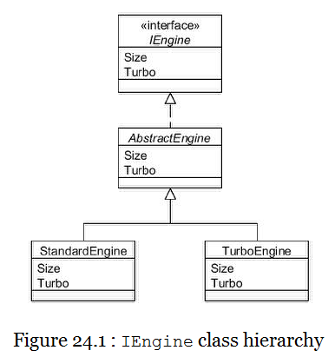

In reality, the code within the AbstractEngine class is likely to be composed of a multitude of individual components, such as a comshaft, piston, some spark plugs, etc. If we need to add some funtionality that traverses these components then the natural way is to just add a method to AbstractEngine. But maybe we know there are potentially many such new requirement and we would rather not have to keep adding methods directly into the hierarchy?

The Visitor pattern enables us to define just one additional method to add into the class heirarchy in such a way that lots of different types of new functionality can be added without any further changes. This is accomplished by means of a technique known as "double-despatch", whereby the invoked method issues a call-back to the invoking object.

The technique requires first the definition of an interface we shall call IEngineVisitor:

public interface IEngineVisitor

{

void Visit(Camshaft camshaft);

void Visit(IEngine engine);

void Visit(Piston piston);

void Visit(SparkPlug sparkPlug);

}

We will also define an interface called IVisitable with an AcceptEngineVisitor() method:

public interface IVisitable

{

void AcceptEngineVisitor(IEngineVisitor visitor);

}

The IEngine interface you have met in prevous chapters (although we will modify it slightly for this chapter). The Camshaft, Piston and SparkPlug classes are each very simple, as follows:

public class Camshaft : IVisitable

{

public void AcceptEngineVisitor(IEngineVisitor visitor)

{

visitor.Visit(this);

}

}

public class Piston : IVisitable

{

public void AcceptEngineVisitor(IEngineVisitor visitor)

{

visitor.Visit(this);

}

}

public class SparkPlug : IVisitable

{

public void AcceptEngineVisitor(IEngineVisitor visitor)

{

visitor.Visit(this);

}

}

As you can see, each of these classes defines a method called AcceptEngineVisitor() that takes a reference to an IEngineVisitor object as its argument. All the method does is invoke the Visit() method of the passed-in IEngineVisitor, passing back the object instance.

Our modified IEngine interface also now extends IVisitable:

public interface IEngine : **IVisitable**

{

int Size { get; }

bool Turbo { get; }

}

The AbstractEngine class therefore needs to implement this new method, which in this case traverses the individual components (camshaft, piston, spark plugs) invoking AcceptEngineVisitor() on each:

public abstract class AbstractEngine : IEngine

{

private int size;

private bool turbo;

**private Camshaft camshaft;**

**private Piston piston;**

**private SparkPlug[] sparkPlugs;**

public AbstractEngine(int size, bool turbo)

{

this.size = size;

this.turbo = turbo;

**// Create a camshaft, piston and 4 spark plugs...**

**camshaft = new Camshaft();**

**piston = new Piston();**

**sparkPlugs = new SparkPlug[]**

**{**

**new SparkPlug(), new SparkPlug(),**

**new SparkPlug(), new SparkPlug()**

**};**

}

public virtual int Size

{

get

{

return size;

}

}

public virtual bool Turbo

{

get

{

return turbo;

}

}

**public virtual void AcceptEngineVisitor(IEngineVisitor visitor)**

**{**

**// Visit each component first...**

**camshaft.AcceptEngineVisitor(visitor);**

**piston.AcceptEngineVisitor(visitor);**

**foreach (SparkPlug eachSparkPlug in sparkPlugs)**

**{**

**eachSparkPlug.AcceptEngineVisitor(visitor);**

**}**

**// Now visit the receiver...**

**visitor.Visit(this);**

**}**

public override string ToString()

{

return this.GetType().Name + " (" + size + ")";

}

}

Now we shall create an actual implementation of IEngineVisitor so you can see how we can easily add additional functionality to engines without any further changes to any engine hierarchy class. The first thing we shall do is to define some clever electronic gizmo that can be attached to an engine that will automatically check each component and diagnose any faults. We therefore define the EngineDiagnostics class:

public class EngineDiagnostics : IEngineVisitor

{

public virtual void Visit(Camshaft camshaft)

{

Console.WriteLine("Diagnosing the camshaft");

}

public virtual void Visit(IEngine engine)

{

Console.WriteLine("Diagnosing the engine");

}

public virtual void Visit(Piston piston)

{

Console.WriteLine("Diagnosing the piston");

}

public virtual void Visit(SparkPlug sparkPlug)

{

Console.WriteLine("Diagnosing a single spark plug");

}

}

We also want to print an inventory of how many of each type of component there is within an engine, so we also have an EngineInventory class:

public class EngineInventory : IEngineVisitor

{

private int camshaftCount;

private int pistonCount;

private int sparkPlugCount;

public EngineInventory()

{

camshaftCount = 0;

pistonCount = 0;

sparkPlugCount = 0;

}

public virtual void Visit(Camshaft camshaft)

{

camshaftCount++;

}

public virtual void Visit(IEngine engine)

{

Console.WriteLine("The engine has: " +

camshaftCount + " camshaft(s), " +

pistonCount + " piston(s), and " +

sparkPlugCount + " spark plug(s)");

}

public virtual void Visit(Piston piston)

{

pistonCount++;

}

public virtual void Visit(SparkPlug sparkPlug)

{

sparkPlugCount++;

}

}

The following diagram summarises how all of these classes interact:

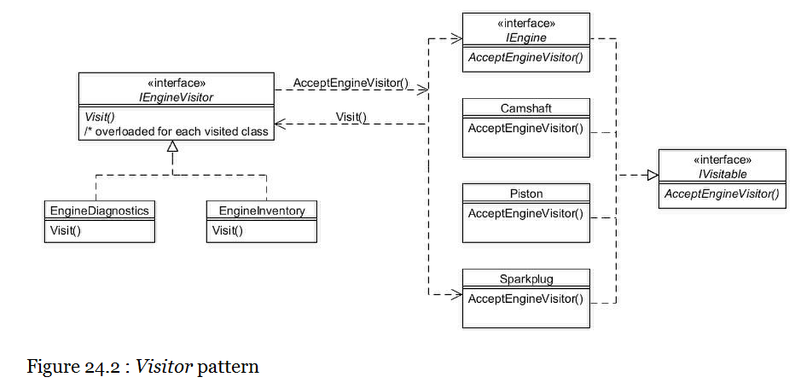

Client programs now only need to invoke the AcceptEngineVistor() method on an instance of IEngine, passing in the appropriate IEngineVisitor object:

// Create an engine...

IEngine engine = new StandardEngine(1300);

// Run diagnostics on the engine...

engine.AcceptEngineVisitor(new EngineDiagnostics());

The above will result in the following output:

Diagnosing the camshaft

Diagnosing the piston

Diagnosing a single spark plug

Diagnosing a single spark plug

Diagnosing a single spark plug

Diagnosing a single spark plug

Diagnosing the engine

And to obtain the inventory (using the same IEngine instance):

// Run inventory on the engine...

engine.AcceptEngineVisitor(new EngineInventory());

The output should show:

The engine has: 1 camshaft(s), 1 piston(s), and 4 spark plug(s)

FYI

1. Coupe car: A coupe is generally thought of as a closed-body style, 2-door car, often sporty in nature. A coupe generally has either 2 seats, or 4 seats placed in a 2+2 configuration, meaning that there are only 2 seats in the rear (as opposed to the standard 3,) and those seats are smaller than average. To comfortably sit in a 2+2-style rear seat, you must be a small child.
2. Sedan/Saloon car: We generally associate sedans with larger, 4-door, closed-roof cars that can comfortably sit 4 or 5.