dekū
User Interface Design Document

Table of Contents

Page

1. Introduction

1.1 Purpose of This Document
1.2 References

2. User Interface Standards

3. User Interface Walkthrough

4. Data Validation

5. Report Formats

Appendix A - Agreement Between Customer and Contractor

Appendix B - Peer Review Sign-off

Appendix C - Document Contributions
1. Introduction

1.1 Purpose of This Document

This document’s purpose is to communicate the user interaction that should take place on this application. It is intended to be read by any user of the system and will contain a detailed breakdown of each page and possible function on this website.

State the purpose of the document and specify the intended readership. Briefly summarize the content. [One paragraph]

1.2 References

Provide a list of all applicable and referenced documents and other media that were used in the creation of this document (e.g., user interface design textbooks or websites, class lecture notes). See the Writing Resources on Blackboard for the appropriate formats for references.

2. User Interface Standards

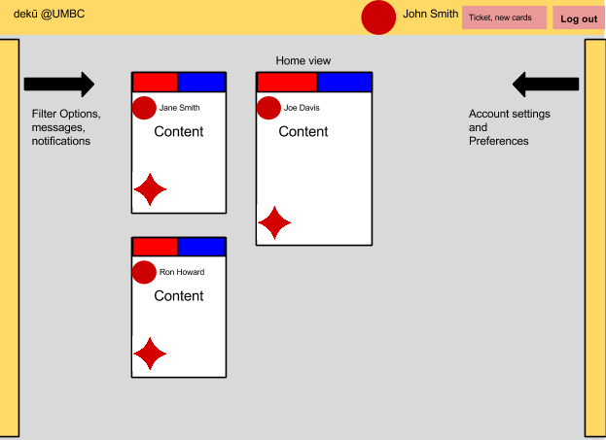

This application strives to adhere to a single page architecture. That means we have minimized the amount of page traversal as much as is considered possible. There are three main pages to be aware of: login/create account page, home feed page, and profile page. While the layout will be very similar between these pages to reduce confusion, the content on each will be unique. To provide the user with more information, there will be menus that the user can bring up by swiping from the side of the screen (think opening the charms menu on Windows 8). On a profile page, the left will contain search options, notifications and messaging, and the right will be about account setting and preferences.

The login/create account page will be very straight forward. The center is devoted to a prompt asking the user to make an account. There will be a header bar that has login textboxes.

There are few buttons on this site. The header has a button for the site which directs to the home page with default filter settings (none), your user name and avatar (to go to your profile page), and a logout button.

Give the reader an overview of the design standards that you will use to maintain consistency in the user interface throughout your system. Use illustrations as necessary. Discuss general screen layouts, common components (e.g., buttons, menus), general error handling, and navigation. You do not need to go into details such as colors and fonts. [Length will vary, but I would expect at least one overall screen layout illustration with explanations of the different screen areas, common components that will be used, and how the user will generally navigate through the system.]

3. User Interface Walkthrough

Provide a diagram that illustrates how the user will navigate from one screen to another (I call this a “navigation diagram”). Label each symbol that represents a screen so that you can reference the screen, if necessary, later in the document. Give a brief description of what the diagram as a whole represents.

Next, guide the reader through a series of screen shots of all system screens. (You do not need to include error and confirmation message/pop-ups). Give the screen shots figure numbers and labels that match those in the navigation diagram. Refer to the figure numbers in the text of the walkthrough. Explain what the reader is seeing in each screen shot: the major screen areas, menus, what each button does, how to navigate to the next screen or return to the previous, etc. Note that if a feature has been standardized (e.g., how to return to the previous screen) and explained in Section 2, you do not need to repeat it here.

Screen shots should not be hand written, but may be drawn using any tool you wish (e.g., Visual Basic, PowerPoint, a drawing program, etc.). At this point in the process, they are a best approximation as to what the user interface will look like in both layout and annotation.

4. Data Validation

Include a full description of all data items that can be entered into the system by the user. The description should include the item’s basic data type (e.g., integer, string), its limits, and its allowable format(s). Be sure to uniquely identify each data item. For example, if you are using a GUI, a data time can be identified by screen name and data item label. A tabular format works well for the data validation information.

5. Report Formats

If your product generates any hard copy reports that cannot be previewed on screen (i.e., are not described in Section 3), show their formats here. Otherwise, omit this section.

Appendix A - Agreement Between Customer and Contractor

The customer for the dekū social content and sharing site has agreed to this site and the User Interface components, which include the graphical appearance and page layout. This document contains agreed upon site layout and navigation content.

If changes to the requirements develop in the future, this document will be amended and all parties will sign off on the document to make sure that the changes are in accordance with the wishes of the customer.

Client

Name _______________________________________________ Date ___________________
Print
Name _______________________________________________ Date ___________________
Signature

Team

Name _______________________________________________ Date ___________________
Print
Name _______________________________________________ Date ___________________
Signature

Name _______________________________________________ Date ___________________
Print
Name _______________________________________________ Date ___________________
Signature

Name _______________________________________________ Date ___________________
Print
Name _______________________________________________ Date ___________________
Signature

Name _______________________________________________ Date ___________________
Print
Name _______________________________________________ Date ___________________
Signature

Name _______________________________________________ Date ___________________
Print
Name _______________________________________________ Date ___________________
Signature

Appendix B - Team Review Sign-off

This document affirms that all of the members of this team have contributed to and reviewed the material within this document. Any minor disagreements between members are listed below.

Team

Name _______________________________________________ Date ___________________
Print
Name _______________________________________________ Date ___________________
Signature
Comments ________________________________________________________________________________________________________________________________________________________

Name _______________________________________________ Date ___________________
Print
Name _______________________________________________ Date ___________________
Signature
Comments ________________________________________________________________________________________________________________________________________________________

Name _______________________________________________ Date ___________________
Print
Name _______________________________________________ Date ___________________
Signature
Comments ________________________________________________________________________________________________________________________________________________________

Name _______________________________________________ Date ___________________
Print
Name _______________________________________________ Date ___________________
Signature
Comments ________________________________________________________________________________________________________________________________________________________

Name _______________________________________________ Date ___________________
Print
Name _______________________________________________ Date ___________________
Signature
Comments ________________________________________________________________________________________________________________________________________________________
Appendix C - Document Contributions

Identify how each member contributed to the creation of this document. Include what sections each member worked on and an estimate of the percentage of work they contributed. Remember that each team member must contribute to the writing (includes diagrams) of each document produced.

