Integrating COVID Models at Different Scales for Infection Risk Estimation and Control Optimization

SARS-COV-2 infections result from interactions at fine spatial and temporal scales; however, case clusters occur within a larger scale epidemiological context. Appropriately integrating the interactions between processes that occur across spatial and temporal scales is essential for simulating systems of disease transmission and understanding infection risk. Here we present a simulation engine that places a fine scale network based infection model within the broader epidemiological context of the study population. Using this system, we are able to simulate seeding events and fully explore the control strategy space.

Our simulation engine can integrate a spatially explicit COVID-19 case estimation technique at the county scale with institution level disease transmission at a “building” scale. The case estimation technique takes into account location specific factors around infection control and population level movement to estimate disease burden in a given location. The institution level model uses a multigraph to integrate social and spatial contact networks under various hazard reduction strategies at two different time scales. This allows us to model individual level interactions in the local context of the COVID-19 pandemic, opening a closed system to external forces.

Our model provides realistic estimates of SARS-COV-2 outbreaks and the ability to discover novel control strategies. By integrating models at multiple scales, our simulation engine empowers decision makers to develop location specific preparedness policies based on realistic estimates of how SARS-COV-2 will spread through their institutions.

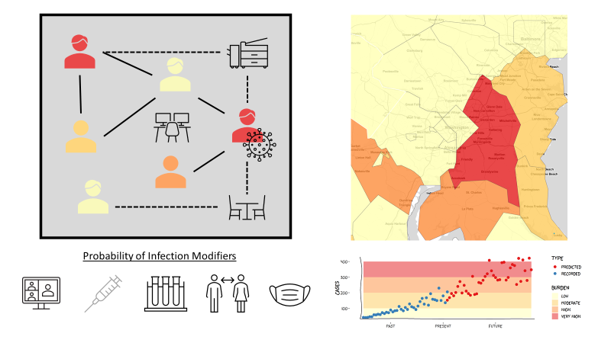

Figure : Infections spread over spatial and social contact networks. Non-pharmaceutical interventions and leave policies modify the probability of infection. Clusters are seeded based on the current and projected disease burden in individuals’ home counties.