Multi-Threading approach to save/process data for Prostate Biopsy Guidance project

Summary:

Introduction:
In order to have the first clinical pre-procedure prostate biopsy guidance system we need to save long term RF/BMode data. Currently, the developed software throws memory allocation overflow even in TESLA machine (24G RAM) for 12 second acquisition time. Moreover, in next step, system requires to use a processing module to extract elastography color-maps which needs to boost up memory management.

Hussam comments (what about this introduction){To preform the required tasks during biopsy guidance. Huge amount of RF/Bmode data has to be saved. This data is estimated to be in the range of Gigabytes. Some ways to grab the data and keep it in memory is preformed, but non of the methods tried until now solved the problem completely. Also, Using a computer with higher memory did not give the desired result. Therefore, A new implementation of the software is suggested that uses multi-threading as will be discussed below.}

Overview of Solution:

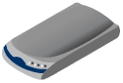
Hardware requirements:
Using SSD hard-drive to save data we ensure the writing speed is at maximum. Ultrasonix-Touch needs an external SSD hard-drive (preferably with capacity more than 200G). We need to make sure there is a SATA connection/space available.


Software requirements:
Using another thread in order to save data is a good solution. We divide the whole application into a main and corresponding sub-threads. Main thread runs right after calling main function of the project which creates a GUI with QT. Based on QT signal/slot definition, this main thread starts collecting data using VTK. Therefore, data acquisition is a part of the main thread. Right after receiving the first frame, a new thread is being created and starts monitoring allocated buffer for data acquisition. At the proper time, the new created thread starts flushing buffer into hard-disk. After that and then the buffer pointer recycles to the beginning of the allocated address. Following diagram shows processes, threads and their communication with the main thread.

[activity diagram here]

There are some processing modules (like elastography map) which requires to communicate ion with the this main thread in a timely fashion. These modulesThey are all in the same thread pool as the main thread and communicate asynchronously with the main thread. In terms of having conversation with main thread there are some obstacles.
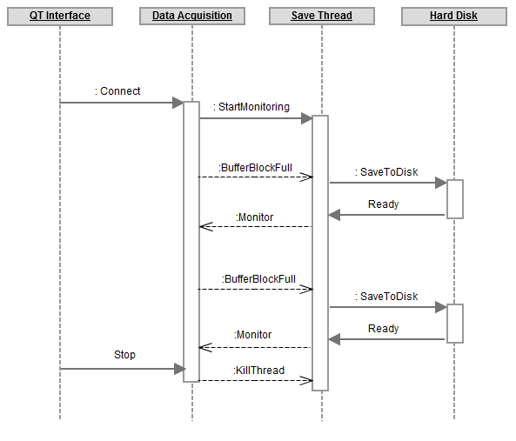

Thread Synchronization:
We need to synchronize sub-threads with the main thread. This synchronization makes the saving the buffer match the status of data acquisition. So, when the buffer block is full, that triggers the saving sub-thread to write to disk and after finishing with the procedure wait to until it receive next trigger signal which will be a one way sync method. On the other hand, we have processing thread(s) which in some cases need to be synchronized in two ways. They should trigger after receiving a frame from data acquisition stream and then should lock until the process is finished. Then they can send a response back to main thread to indicate their readiness to receive next frame.

There are two different approaches for thread synchronization with main thread.
- monitoring buffer pointer:In this approach saving thread will look into the buffer position. If it is less than a threshold value nothing happens. But if the pointer passes the threshold value, the thread reads that full part of the buffer and starts saving it into disk. Right after finishing this process, the threads goes to monitoring state and look for the position of pointer. If again it passes through another threshold value then another save attempt occurs. The main thread instead, returns the pointer to the first allocate address after using all allocated buffer space.
The processing thread also monitors the pointer when it is in resting state. Resting state means the previous processing time is finished. This process may need to duplicate the RF frame data into another memory address as the saving thread may clear that buffer block instantly.
- using a command pointer:
We allocate a small memory address for each thread communicating with the main thread. Via this common memory address between pair threads, we deliver messages and commands between threads. There might be some data stored in this memory address, such as memory address to read frame or number of missing frames (for processing thread) or the file size, time-stamp or last read pointer position (for saving thread).
This approach provides a two-way communication between threads and is an extendable solution.

Thread dependency:
We need to ensure that none of these processes in different threads is using/locking the same shared memory address. In that case we have to duplicate the memory data they work with. In this way threads will run in completely independent manner.

Thread life-cycle:
We need to make sure all threads are on the same pool so their life-cycles relies on the main thread. So, no overhead during operation and debugging will happen.

Source-code requirements:
In case of both approaches above, we need to implement a threading wrapper. This wrapper makes us able to run different processes simultaneously. For the first approach we may not need to use a wrapper and we can share the buffer pointer between threads.
For the second approach we need a command class/interface in order to assign a memory command pointer for each thread and to use that memory address within thread.

Parameter estimation:
We need to calculate buffer size, estimated execution time of the sub-threads (such as processing and saving threads) and it’s correlation with the main thread (data acquisition). These numbers will help us estimate how many buffer blocks and memory spaces are required for Prostate Biopsy Guidance system. We also need to calculate frame loss rate according to processing time of the sub-threads. Calculating these parameters enables us to better manage memory between threads.

Cons and Pros:
We expect to face a few problems corresponding “frame loss”. Delay in data acquisition also needs to be considered after multi-thread implementation.

Questions:
Since we are able to acquire RF data, we can generate BMode data. So, we should make sure if it is really needed to save RF data and BMode with cost of lower frame-rate or not.

Hussam (Why not in this format){What is the advantage of saving RF and bmode data compared to saving RF data alone}.

