

**Lego Phantom**

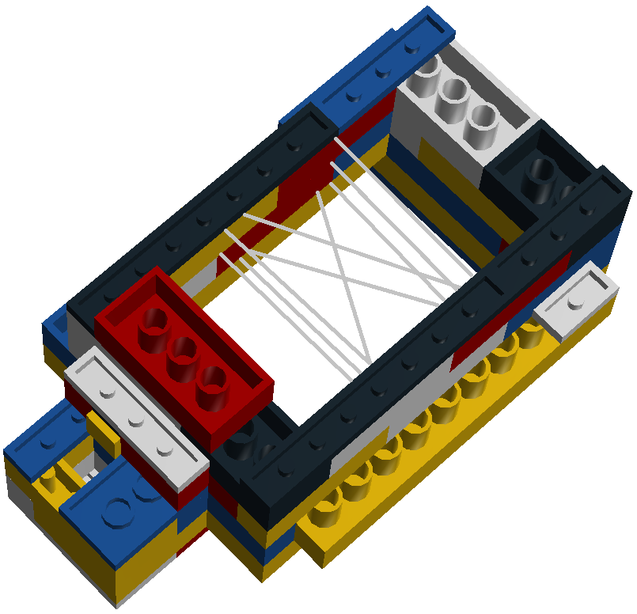



Queen’s University Laboratory for Percutaneous Surgery

Contents

Introduction 1

Developer 1

Purpose 1

Provided Components 1

Excluded Components 1

Preparation 1

Proper Lego Phantom Orientation 2

Wire Used in the Perk Lab 2

N-Wire Threading 3

Inserting the Electromagnetic Tracker Reference 3

Registration Landmarks 4

Important Information 4

Frequently Asked Questions 5

Parts List 6

Building Instructions 7

## Introduction

This instructional booklet is a detailed explanation of how to build the Lego Phantom. The approximate building time is 30 minutes.

## Developer

This Lego Phantom design and instructional booklet were developed in the [Queen's University Laboratory for Percutaneous Surgery](http://perk.cs.queensu.ca/) (Perk Lab) in Kingston, Ontario by [Ryan Walsh](mailto:r.walsh@cs.queensu.ca) in June 2013.

## Purpose

The purpose of this instruction booklet is to clearly describe the process of building an identical phantom from a cheap and accessible material (*ie.* Lego). The Lego Phantom is to be used during the calibration of an ultrasound imager using fCal from the [Plus Library](https://www.assembla.com/spaces/plus/wiki). The goal of this project was to create the phantom from a material that is readily available to any person and relatively cheap (less than $20 CAD). The Lego Phantom was also required to maintain the precision and accuracy of other phantom models (less than 1 millimetre of error). This will allow any experiments performed in the [Perk Lab](http://perk.cs.queensu.ca/) be easily recreated in any other lab.

## Provided Components

1. This instructional booklet (InstructionManual.pdf)
2. A 3D CAD file of the Lego Phantom to be used in fCal (LegoPhantom.stl)
3. A configuration file of the Lego Phantom to be used in fCal (PlusConfiguration_Sonix_Ascension_LegoPhantom.xml)

## Excluded Components

1. Lego blocks (Lego blocks can be purchased in 24 different countries [here](http://shop.lego.com/en-CA/Pick-A-Brick-ByTheme))
2. Wire
3. fCal, the Plus Library and other software (fCal and the Plus Library can be found [here](https://www.assembla.com/spaces/plus/wiki))
4. Ultrasound Imager and other related hardware
5. Sonix GPS and Ascension Technology Corporation 3D tracking related hardware

## Preparation

It is recommended that all Lego blocks be washed before they are used in the Lego Phantom to remove any large particles that could create noise during Spatial Calibration in fCal. Washing instructions can be found [here](http://service.lego.com/en-us/helptopics/) under Products->General Product Queries->How do I sanitize or wash my LEGO Elements.

## Proper Lego Phantom Orientation

To understand the proper orientation of the Lego Phantom, refer to Figure 1.

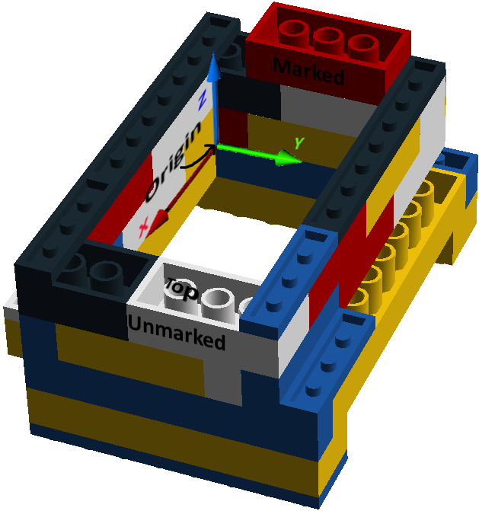

Figure 1: Lego Phantom Orientation and Coordinate System

Note that the phantom is designed to be used in a way that may seem “upside down” to other Lego users. Additionally, while the colour of the blocks is arbitrary and can be completely ignored, it is strongly recommended that a bright red 2x4 brick be placed on the marked side of the phantom as shown in Figure 1. This block is used to make Spatial Calibration in fCal easier for the user since an ultrasound probe has a marked and unmarked side. The marked side of the ultrasound probe should be held closest to the marked side of the Lego Phantom during Spatial Calibration. The ultrasound probe should be held above the top of the Lego Phantom while imaging the wire pattern during Spatial Calibration.

## Wire Used in the [Perk Lab](http://perk.cs.queensu.ca/)

A total of 3 25 centimetre lengths of cotton yarn string were used in the Lego Phantom. Each string was used as one layer of N-Wire. The strings had a diameter of 0.3 millimetres or 0.16 millimetres when compressed. It is important that a wire has the same compressed diameter as those used in the [Perk Lab](http://perk.cs.queensu.ca/) because the diameter of each wire affects their description in the Plus configuration file (PlusConfiguration_Sonix_Ascension_LegoPhantom.xml).

## N-Wire Threading

Threading instructions can be found on pages 30, 31 and 33 of this booklet. Each step corresponds to one layer of wire in an ‘N’ shaped pattern.

It is very important that the location of the wires is exactly identical on all phantoms. As a result, each wire should be pulled taught and tightly against the inside of the “nub” (the circular extrusion of the piece that will be placed above it) as shown in the diagrams. To do this, only loosely attach the Lego brick above each layer of wire. Then, when the wire is completely taught in the correct position, tightly secure the brick above the layer of wire.

## Inserting the Electromagnetic Tracker Reference

It is very important that the electromagnetic tracker reference does not move relative to the Lego Phantom during the ultrasound calibration. See Figure 2 for instructions on how to properly insert and secure the probe.

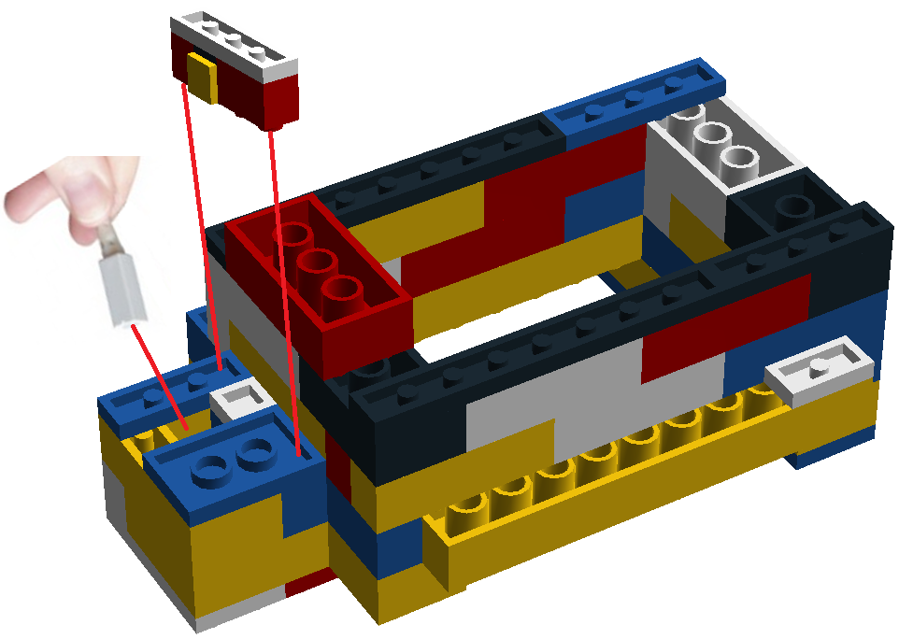

Figure 2: Inserting and Securing the Electromagnetic Tracker Probe

The orientation of the electromagnetic tracker reference does not matter, but it is important that it is inserted all the way into its slot and tightly secured by the clamp piece.

## Registration Landmarks

Registration landmarks are used during the Phantom Registration in fCal. There are 8 unique registration landmarks on the Lego Phantom that must be identified in order. Refer to Figure 3 for the location of each registration landmark.

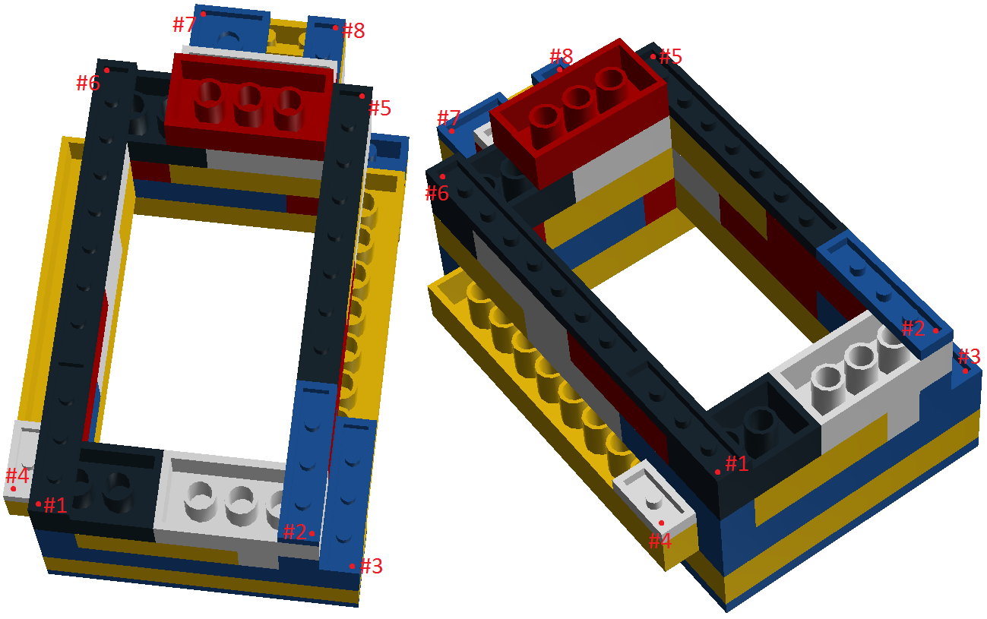

Figure 3: Location of the Lego Phantom registration landmarks

Note that – in order to define a unique point – when identifying these reference points, the stylus tip should be inserted into the tile piece and pressed against the bottom corner where the two edges meet.

## Important Information

The purpose of this instructional booklet is not to teach a user how to use fCal and the [Plus Library](https://www.assembla.com/spaces/plus/wiki). Therefore, it is assumed that the user has a working knowledge of ultrasound calibration using fCal in the [Plus Library](https://www.assembla.com/spaces/plus/wiki).

In order to be able to visualize the Lego Phantom during Phantom Registration in fCal, the Plus configuration file (PlusConfiguration_Sonix_Ascension_LegoPhantom.xml) must contain the path of the 3D CAD file (LegoPhantom.stl). Since each user may have a different path, none has been included in the provided Plus configuration file (PlusConfiguration_Sonix_Ascension_LegoPhantom.xml). Therefore, if a user wishes to change the directory of either the Plus configuration file or the 3D CAD file, they must add the absolute path (from the root directory) of the 3D CAD file to line 105 of the Plus configuration file.

Not all Lego blocks need to be identical to those used in this instruction set. The purpose of the Lego Phantom is to be accessible to anyone anywhere in the world. Therefore, things like colours of the blocks (it is strongly recommended that the bright red 2x4 brick on the marked side of the Lego Phantom be included for orientation purposes), symbols on them and even the number of blocks used (*eg.* a 2x4 brick can be replaced with 2 2x2 bricks as long as the dimensions of the Lego Phantom as a whole do not change) are unimportant. However, it is crucial that the location of each NWire’s start and end point and each reference point be *exactly* where they are shown in this instructional booklet for a proper ultrasound calibration.

The Lego Phantom model described in this instructional booklet is 1.3.

## Frequently Asked Questions

**Question:** I am getting a large error (greater than 1 millimetre) after I perform a Spatial Calibration in fCal. What is wrong?

**Answer:** There must be an inconsistency between your Lego Phantom N-Wire pattern and the one described in the provided Plus configuration file (PlusConfiguration_Sonix_Ascension_LegoPhantom.xml). You should try carefully threading your Lego Phantom another time. If you wish to view the Plus configuration file to find any discrepancies and fix them (either in the configuration file or on your Lego Phantom), open the plus configuration file with a text editor. On lines 146 through 158, you will find the ordered threetuples describing the x, y, and z coordinate of the start point and end point of each wire spanning the Lego Phantom (the x, y and z values are in millimetres from the origin). Refer to Figure 1 in the Proper Lego Phantom Orientation section to understand the phantom coordinate system.

## Parts List

## Building Instructions