Guide to install and implement Arduino IDE and ESP32

Step 1: Install the Arduino IDE
- Open your web browser and go to the official Arduino download page:
Official download link: https://www.arduino.cc/en/software
- Choose the installer for your operating system:
  - Windows: download the .exe installer (or Microsoft Store version)
  - macOS: download the .dmg file
  - Linux: download the AppImage or .zip file
- Run the installer and follow the on-screen prompts, accepting the default options.
- When installation finishes, open the Arduino IDE. You should see a blank sketch (code file) with two empty functions: setup() and loop().
Tip: This guide uses Arduino IDE 2.x, the current version. If you already have the older 1.8.x IDE, the steps are almost identical — just note that menu items may be worded slightly differently.

Step 2: Install the ESP32 Board Package
By default, the Arduino IDE only knows how to program official Arduino boards. To program an ESP32, you need to add Espressif's ESP32 board package.

Add the Boards Manager URL
- Open Preferences:
  - Windows/Linux: File > Preferences
  - macOS: Arduino IDE > Settings
- Find the field labeled "Additional boards manager URLs".
- Click the small icon at the end of the field to open the URL list window, and paste in the link below (or add it directly into the field):
https://espressif.github.io/arduino-esp32/package_esp32_index.json

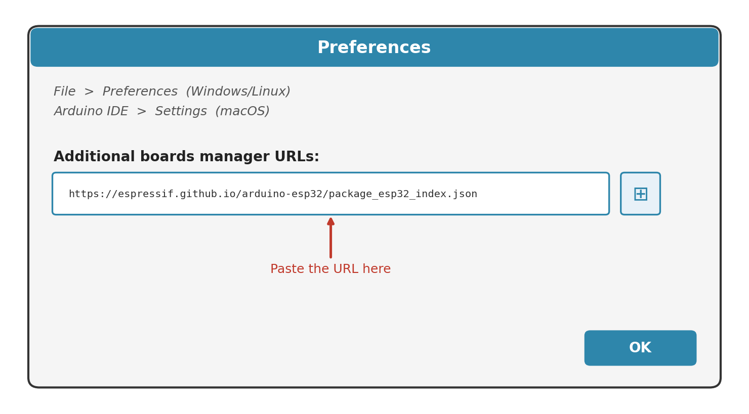
- Click OK to save.

Install the ESP32 Package
- Open the Boards Manager: Tools > Board > Boards Manager…
- In the search box, type "esp32".
- Find the package called "esp32 by Espressif Systems" and click Install.
- Wait for the download and installation to finish — this can take a few minutes depending on your internet speed.
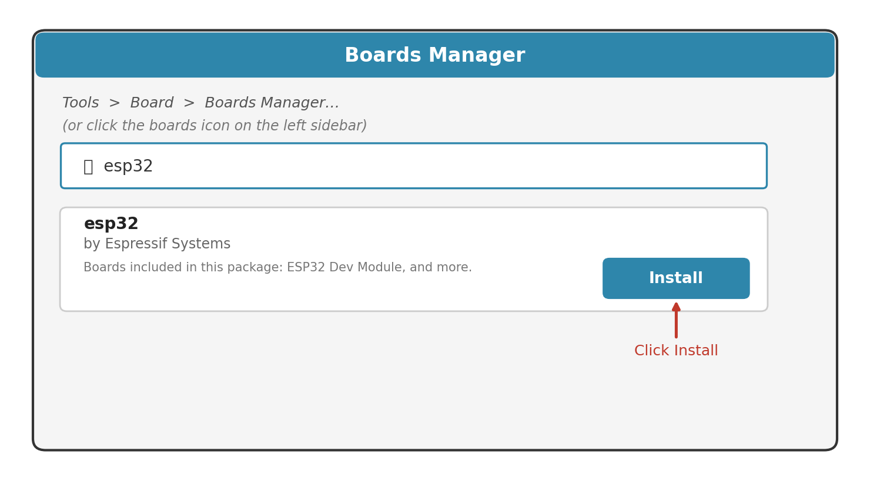

Tip: If the boards manager URL field already has another entry (e.g., for a different board), add the ESP32 URL on a new line rather than replacing it — you can list multiple URLs.

Step 3: Configure the Development Environment
- Connect your ESP32 board to your computer using a USB data cable.
- In the Arduino IDE, go to Tools > Board > esp32, and select your exact board model (for a generic board, choose "ESP32 Dev Module").
- Go to Tools > Port, and select the port your board appears on:
  - Windows: something like COM3, COM5, etc.
  - macOS/Linux: something like /dev/cu.usbserial-XXXX or /dev/ttyUSB0
- Leave other settings (Upload Speed, Flash Frequency) at their defaults unless you have a specific reason to change them.
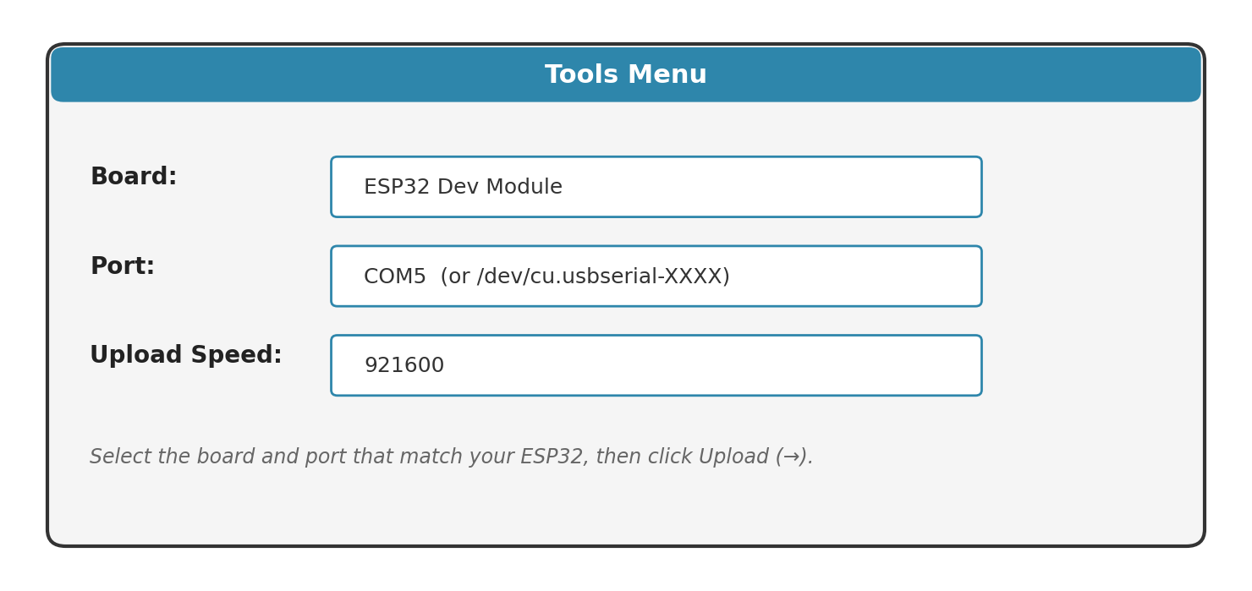

Tip: Don't see your board's port? Install the CP2102 or CH340 USB-to-serial driver (search for your board model + "driver") and reconnect the cable.

Step 4: Upload Your First Program
Let's verify everything works using the classic "Blink" example, which flashes the ESP32's onboard LED.
- Open the example sketch: File > Examples > 01.Basics > Blink.
- Most ESP32 dev boards use GPIO 2 for the onboard LED. If needed, replace LED_BUILTIN in the code with the number 2, as shown below:
void setup() {
pinMode(2, OUTPUT); // GPIO 2 controls the onboard LED
}

void loop() {
digitalWrite(2, HIGH); // turn the LED on
delay(1000); // wait 1 second
digitalWrite(2, LOW); // turn the LED off
delay(1000); // wait 1 second
}
- Click the Upload button (the right-pointing arrow icon in the toolbar).
- Watch the console at the bottom of the window. You'll see "Compiling…" then "Uploading…"
- Some ESP32 boards require you to hold the BOOT button while uploading starts, and release it once you see "Connecting…." If the upload fails at "Connecting", try this.
- Once you see "Done uploading," the onboard LED should start blinking once per second.
Tip: If upload fails with a timeout error, double-check the correct Port is selected, try a different USB cable, or hold BOOT during the connecting phase as described above.

