HadSLP2r_lowvar: a version of HadSLP2r consistent with HadSLP2.

David Parker, Met Office Hadley Centre, Exeter, UK, January 2013.

The existing global monthly HadSLP2r mean-sea-level pressure update dataset, covering January 2005 to date, is the NCEP-NCAR Reanalysis (Kistler et al., 2001), adjusted so that its 1961-1990 averages match those of HadSLP2. But no attempt was made to ensure consistent variance between HadSLP2 and HadSLP2r.

This has been rectified as follows:

1. HadSLP2 and NCEP-NCAR Reanalysis averages (μ₁ and μ₂) and standard deviations (σ₁ and σ₂) of monthly mean-sea-level pressure in each 5° latitude x 5° longitude box were created for 1975-2004. This period was chosen because the NCEP-NCAR Reanalysis is more reliable then than in 1961-1990, and its variance then is more likely to be compatible with its variance since 2005. Figure 1 shows the HadSLP2 averages and standard deviations for January, and Figure2 shows the corresponding NCEP-NCAR Reanalysis fields. Comparison of Figures 1 and 2 demonstrates that the NCEP-NCAR Reanalysis has more variance than HadSLP2. This is confirmed by the ratios for January and July plotted in Figure 3. In some locations such as the Himalayas and southwestern Africa, the NCEP-NCAR Reanalysis appears to be the more irregular. However the construction of HadSLP2 included reduced-space optimal interpolation (Allan and Ansell, 2006) and HadSLP2 is therefore expected to have too little variance in general.

2. The monthly NCEP-NCAR Reanalysis fields of mean-sea-level pressure for 2005-date were adjusted as follows: i) μ₂ was subtracted to yield anomalies; ii) these anomalies were multiplied by σ₁ / σ₂, making the variance consistent with that of HadSLP2; iii) μ₁ was added, making the averages consistent also. The new version of HadSLP2r is denoted HadSLP2r_lowvar. An alternative procedure, namely scaling up the variance of HadSLP2 for 1871-2004 so that its variance matches that of the NCEP-NCAR Reanalysis in 1975-2004, is not recommended because the variance of HadSLP2 has historically-varying biases owing to changes in availability of data.

Higher statistical moments such as skewness have not been adjusted. That would require a quantile-matching procedure. But given that the data are monthly averages, the Central Limit theorem implies that they are likely to be approximately Gaussian so that adjustment of the mean and standard deviation should be sufficient. Because HadSLP2 is expected to have too little variance as noted above, it follows that HadSLP2r_lowvar will also have too little variance. This is demonstrated by the comparisons with the NCEP-NCAR Reanalysis in Figure 4. The merit of HadSLP2r_lowvar is only that it is statistically approximately consistent with HadSLP2, not that it is “correct”. However Reanalyses also lack long-term consistency, owing to changes in input data types and coverage. Future Reanalyses along the lines of the surface-pressure-based 20th Century Reanalysis (Compo et al., 2011) are expected to yield improved consistency and accuracy in historical global mean-sea-level pressure analyses.

HadSLP2r_lowvar is suitable only for applications requiring long-term consistency in variance. It is not suitable for applications such as verification of seasonal predictions or of models, as its anomalies will be misleadingly small.

References

Allan, R.J., and T.J. Ansell, 2006: A New Globally Complete Monthly Historical Gridded Mean Sea Level Pressure Dataset (HadSLP2): 1850–2004. J. Climate, 19, 5816–5842, doi: 10.1175/JCLI3937.1

Compo, G. P., J.S. Whitaker, P.D. Sardeshmukh, N. Matsui, R.J. Allan, X. Yin, B.E. Gleason, R.S. Vose, G. Rutledge, P. Bessemoulin, S. Brönnimann, M. Brunet, R.I. Crouthamel, A.N. Grant, P.Y. Groisman, P.D. Jones, M.C. Kruk, A.C. Kruger, G.J. Marshall, M. Maugeri, H.Y. Mok, Ø. Nordli, T.F. Ross, R.M. Trigo, X.L. Wang, S.D. Woodruff and S.J. Worley (2011), The Twentieth Century Reanalysis Project, Quarterly J. Royal Meteorological Society, 137, 1-28, DOI: 10.1002/qj.776.

Kistler, R., W. Collins, S. Saha, G. White, J. Woollen, E. Kalnay, M. Chelliah, W. Ebisuzaki, M. Kanamitsu, V. Kousky, H. van den Dool, R. Jenne, and M. Fiorino, 2001. The NCEP-NCAR 50-year reanalysis: Monthly means, CD-ROM and documentation. Bulletin of the American Meteorological Society, 82: 247-267, doi: http://dx.doi.org/10.1175/1520-0477(2001)082<0247:TNNYRM>2.3.CO;2.

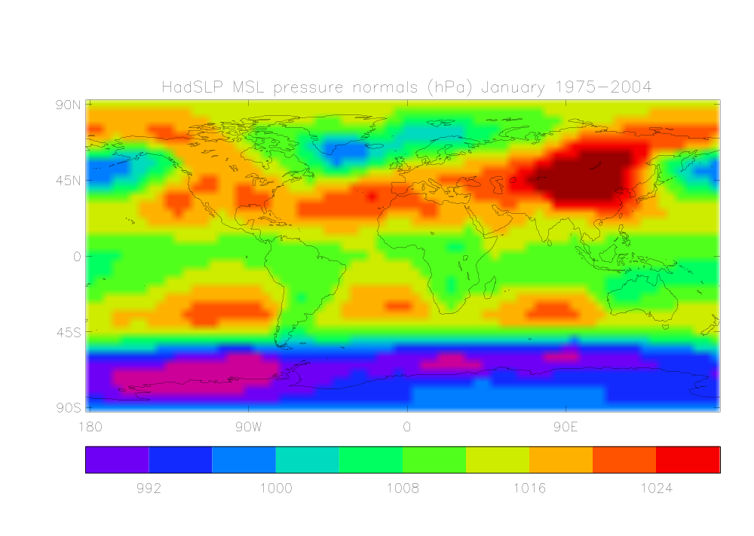

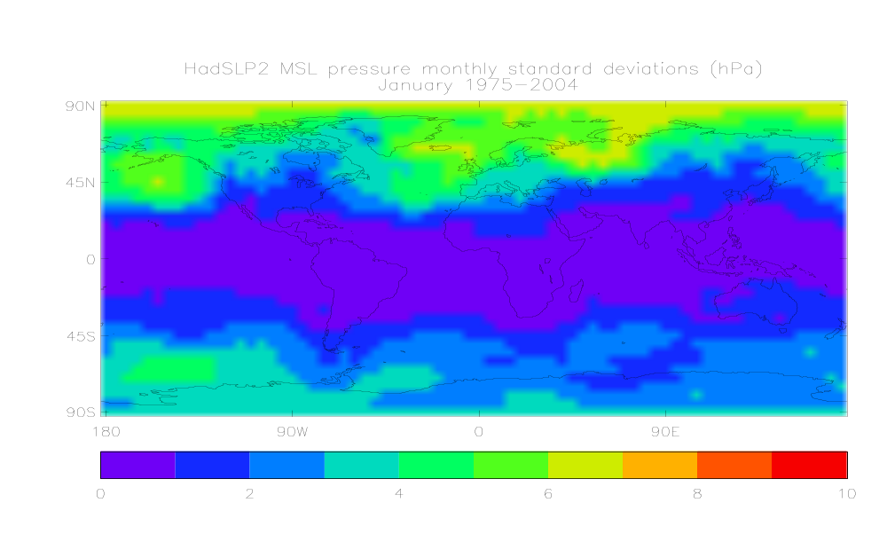

Figure 1. HadSLP2 mean-sea-level pressure normals (upper panel) and standard deviations (lower panel), January, 1975-2004 (hPa).
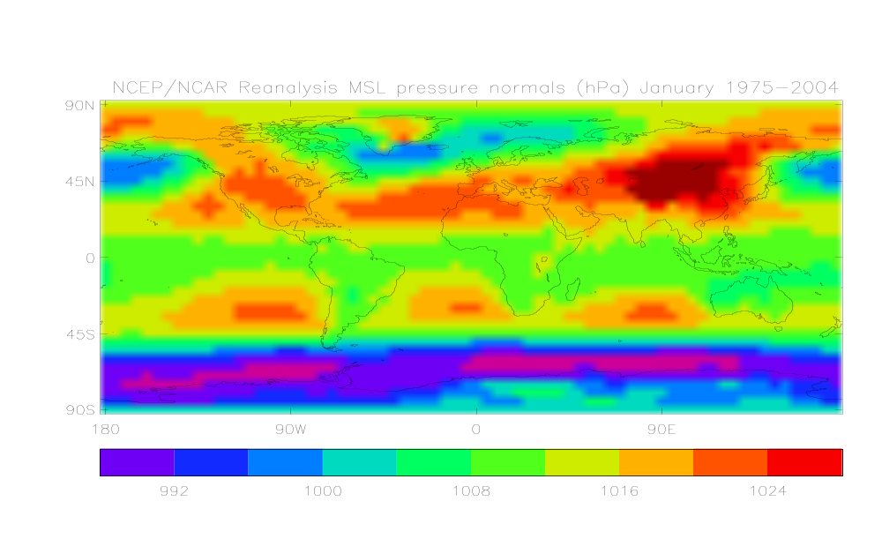

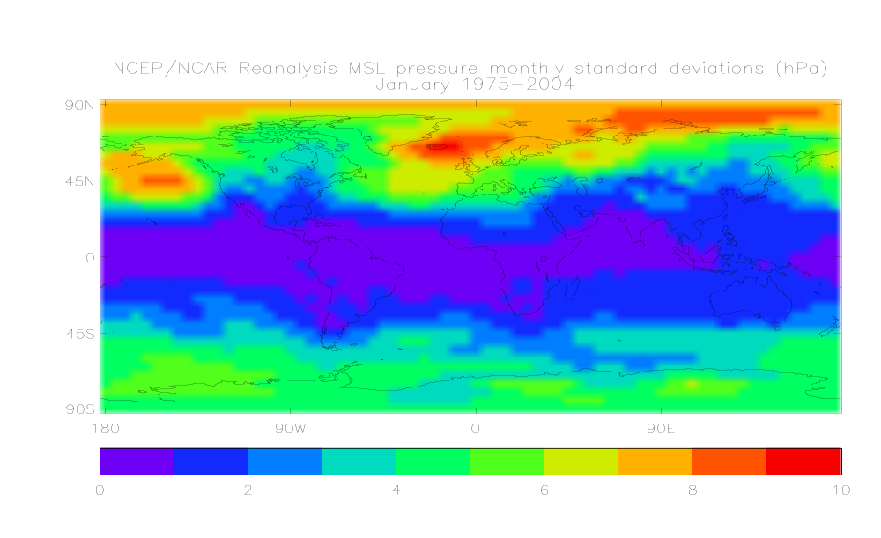

Figure 2. NCEP-NCAR Reanalysis mean-sea-level pressure normals (upper panel) and standard deviations (lower panel), January, 1975-2004 (hPa)

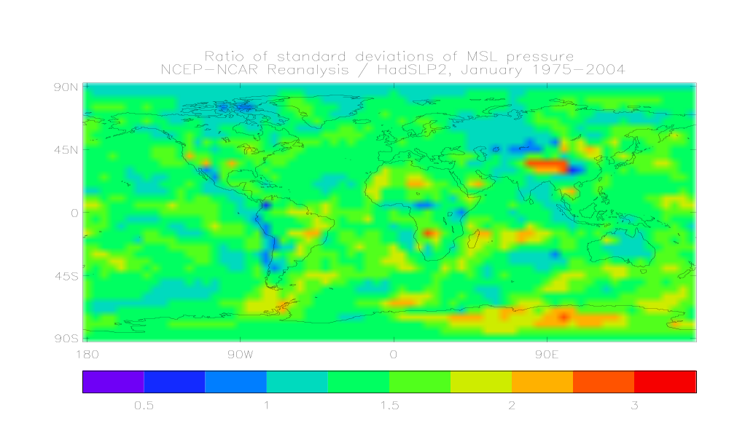

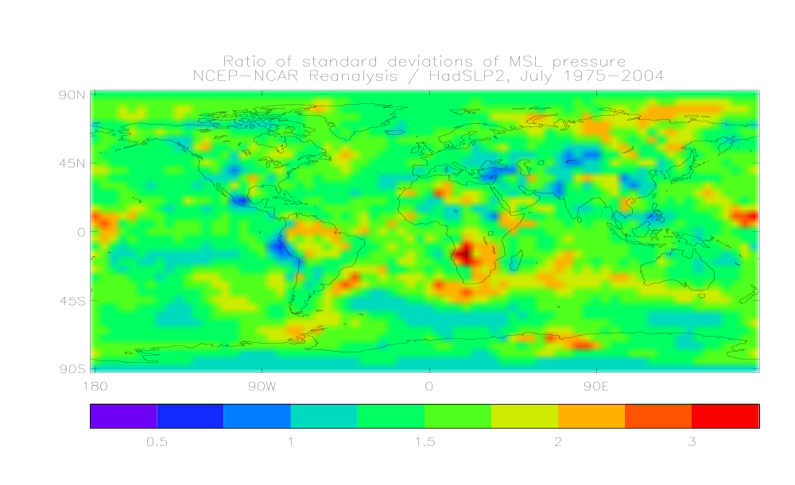

Figure 3. Ratio of standard deviations of MSL pressure, NCEP-NCAR Reanalysis / HadSLP2, January 1975-2004 (upper panel) and July 1975-2004 (lower panel).

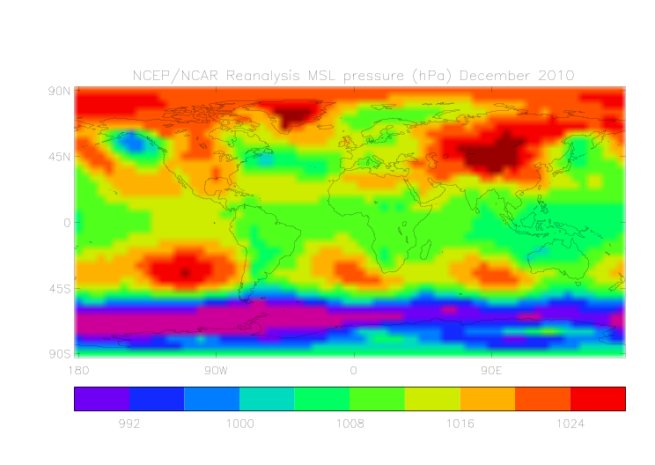
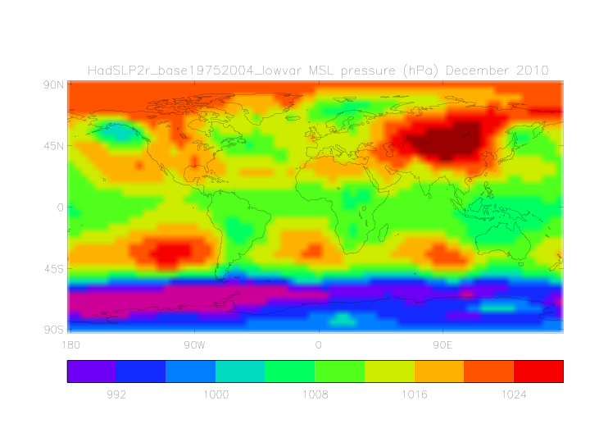
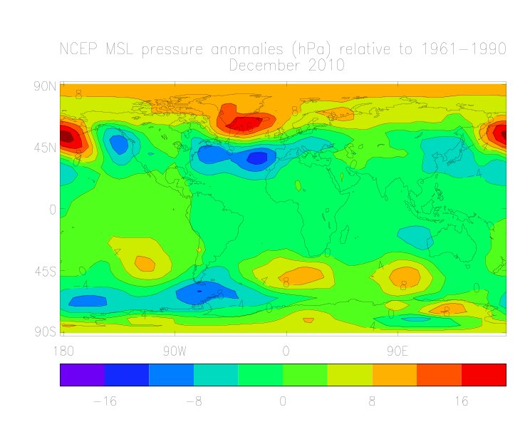
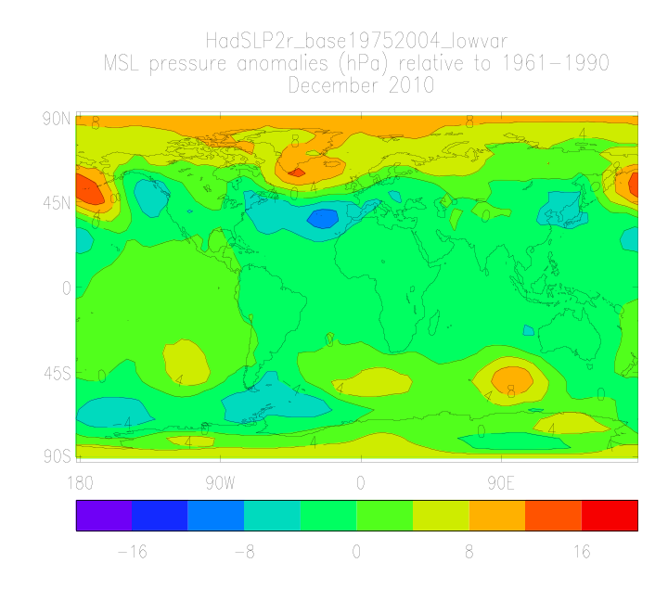

Figure 4. Monthly mean-sea-level pressure (hPa), December 2010. Upper left: NCEP-NCAR Reanalysis. Upper right: HadSLP2r_lowvar. Lower left: NCEP-NCAR Reanalysis relative to its 1974-2004 average. Lower right: HadSLP2r_lowvar relative to HadSLP2 1974-2004 average.

