Dario Gomez

CSD 310

Assignment 5.2

4/8/2025

The below functions are what I chose to work with on assignment 5.2

The first function is LENGTH used with an Alias of Name Length. This can be used when trying to determine the length of any given string including any spaces within. This could be used to locate extremely long or short values. Maybe someone entered initials only instead of a full name.

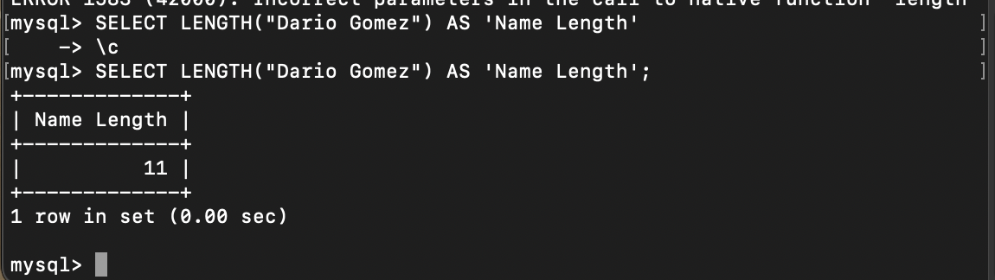

My second Function is WEEK. This will return the week of the year the date given is assigned to. In this case 4/8/25 is inside of the 14th week of the year. This could be useful when locating sales in each week for a company. 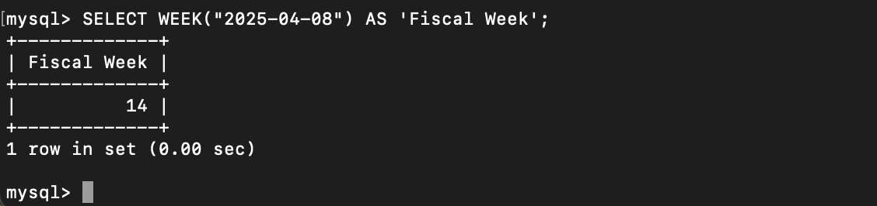

The third function I chose was Current_USER. This will return the username and hostname for the MySQL account. This can be used to understand who is logged in at any time and if you are under the correct user as different users may have different permissions.

