Dario Gomez

CSD310

Assignment 6.2

4/15/2025

After using SOURCE

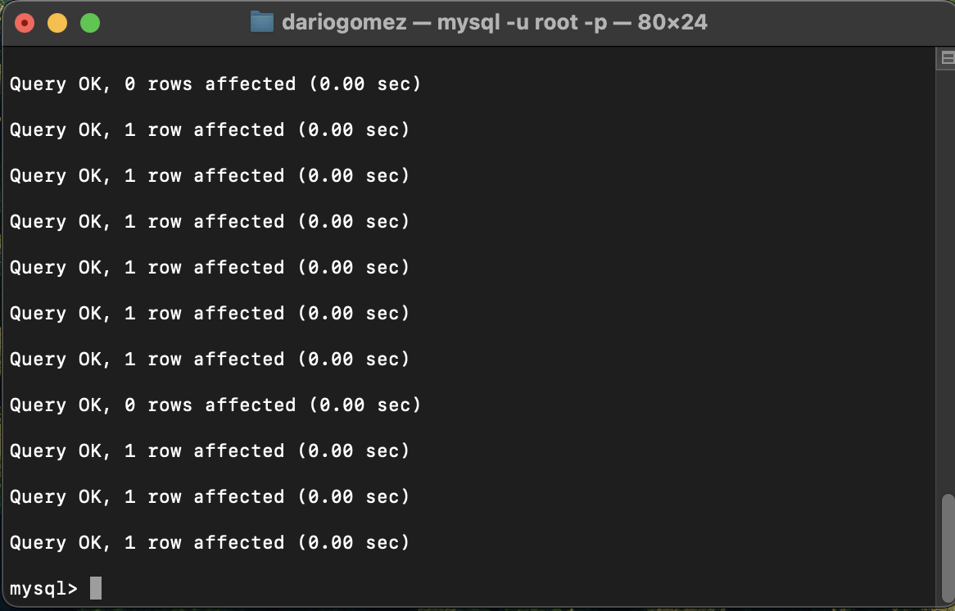

SHOW TABLES  
