Dario Gomez

CSD 325

Assignment 8.2

Ran code through terminal. I have a Macbook so im not sure if the pop up window is specific to windows

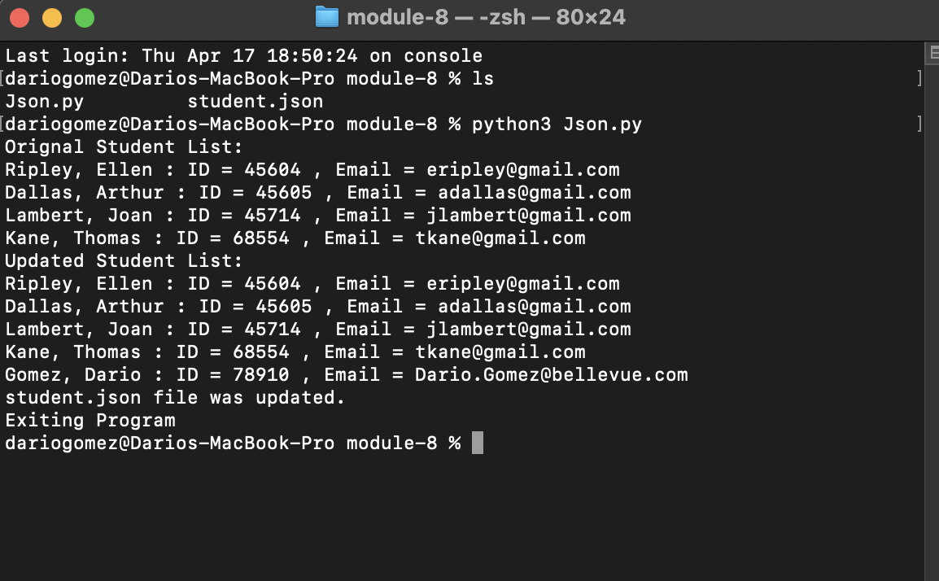

JSON contents

[  
 {  
 "F_Name": "Ellen",  
 "L_Name": "Ripley",  
 "Student_ID": 45604,  
 "Email": "[eripley@gmail.com](mailto:eripley@gmail.com)"  
 },  
 {  
 "F_Name": "Arthur",  
 "L_Name": "Dallas",  
 "Student_ID": 45605,  
 "Email": "[adallas@gmail.com](mailto:adallas@gmail.com)"  
 },  
 {  
 "F_Name": "Joan",  
 "L_Name": "Lambert",  
 "Student_ID": 45714,  
 "Email": "[jlambert@gmail.com](mailto:jlambert@gmail.com)"  
 },  
 {  
 "F_Name": "Thomas",  
 "L_Name": "Kane",  
 "Student_ID": 68554,  
 "Email": "[tkane@gmail.com](mailto:tkane@gmail.com)"  
 },  
 {  
 "F_Name": "Dario",  
 "L_Name": "Gomez",  
 "Student_ID": 78910,  
 "Email": "[Dario.Gomez@bellevue.com](mailto:Dario.Gomez@bellevue.com)"  
 }  
]