Dario Gomez

CSD 325

Assignment 9.2

4/24/2025

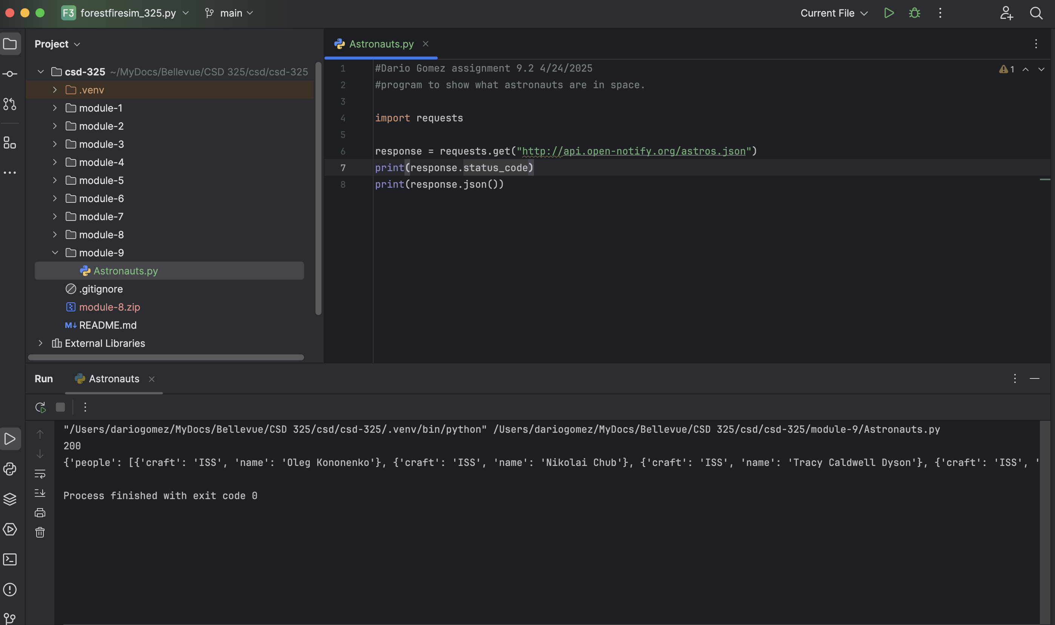

Formatted results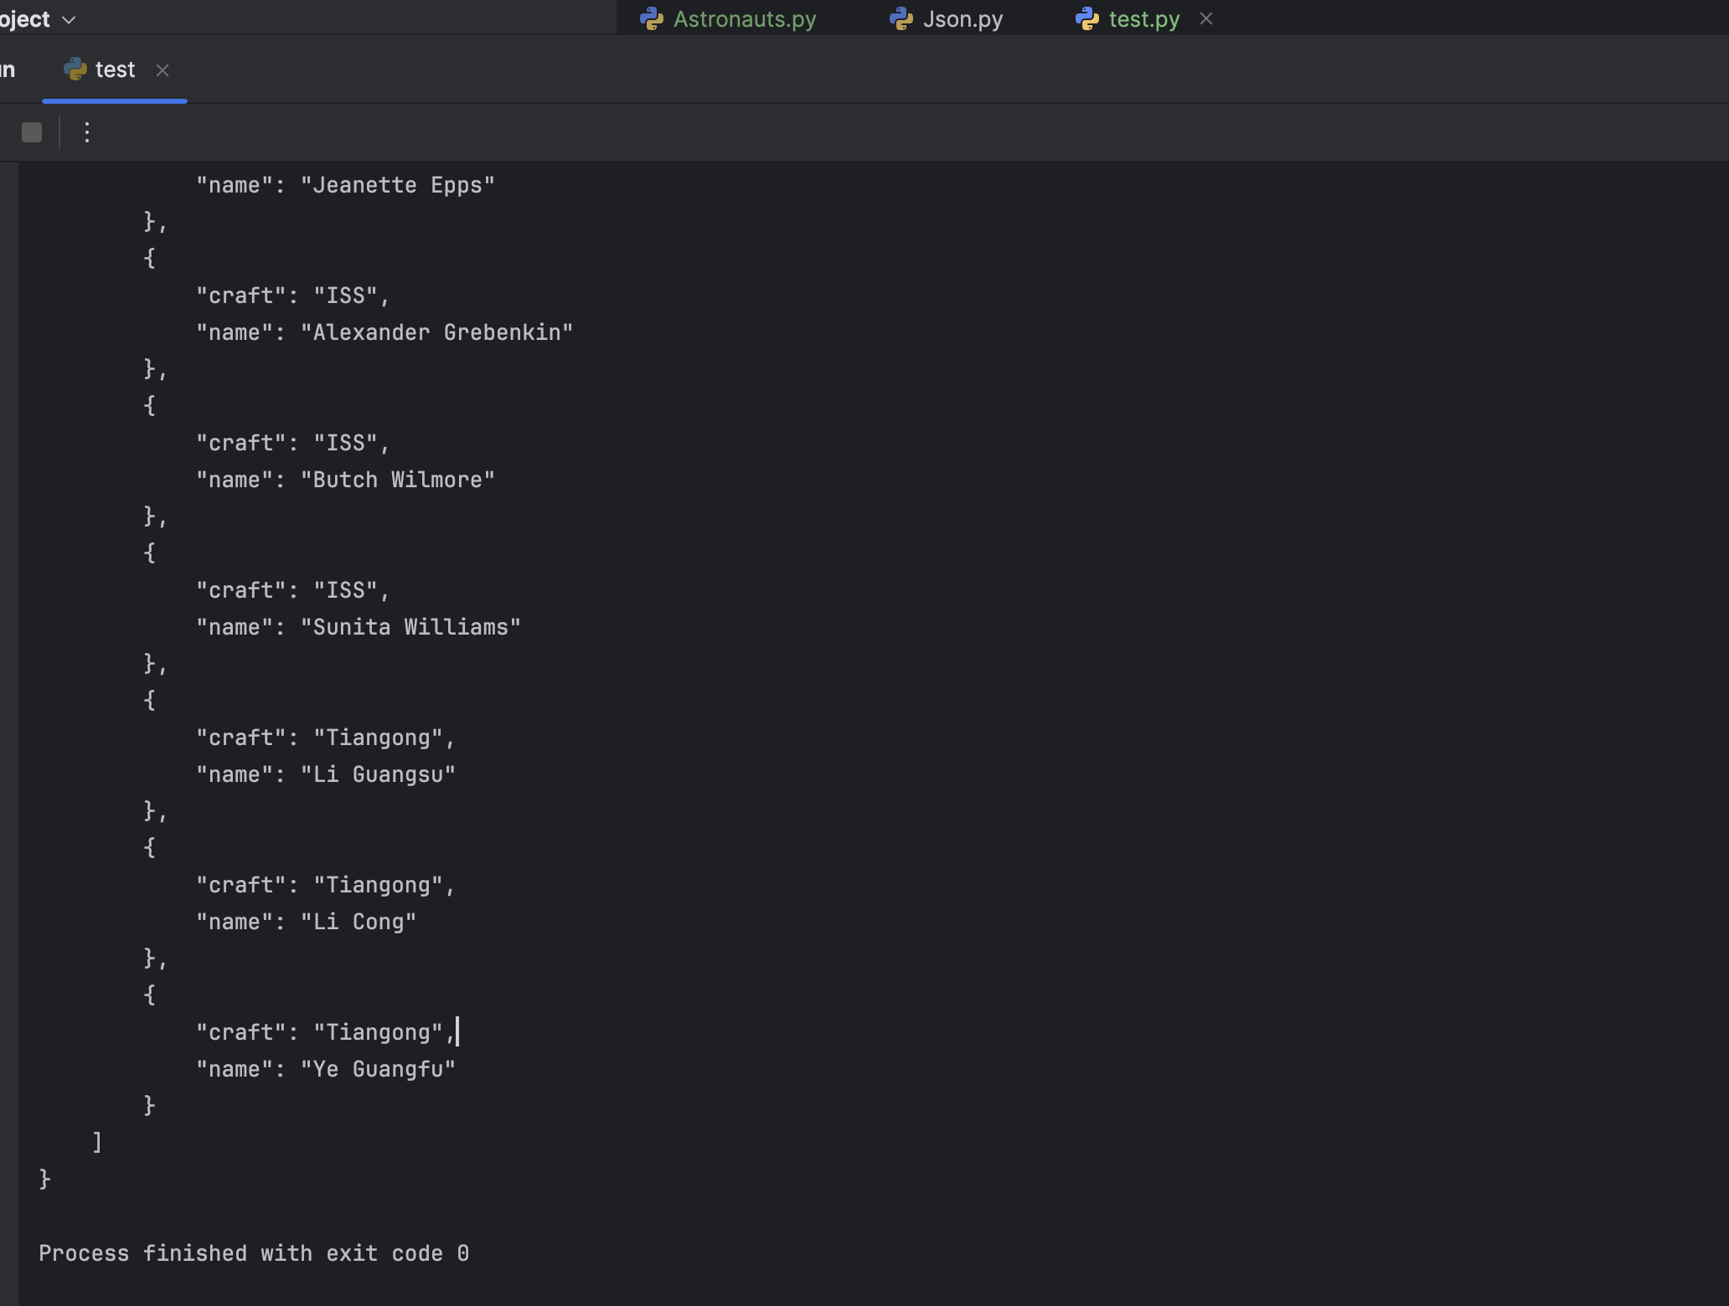

Gold API https://api.gold-api.com/price/XAU