Restaurant Management Application – Design Report
Coursework: Design Exercises (CW1)
Name: Okyanus
Student ID: 10927274
Module: COMP2000
Date: 25/09/2025
GitHub Repo Link:
Exercise 1 Context of Use & Intended Users
Analyse the scenario to identify the context of use and the intended users of the system.
Intendent Users
Primary users
1-) Staff (restaurant employees): Managers waitstaff supervisors.
Goals: Keep the menu accurate; monitor, confirm, change, or cancel reservations; react quickly to new bookings/changes; maintain smooth FOH operations.
2-)Customers: New and returning diners.
Goals: Find dishes in Menu, check prices and visuals, book edit and cancel table reservations stay informed about reservation changes.
Secondary users
IT/ADMIN/OWNERS: Oversee data integrity, roles, and usage; audit and troubleshoot.
Kitchen leads: Rely on accurate menu availability set by staff.
Contexts of Use
Physical/Environmental
Staff: in the restaurant busy, noisy dining rooms, single-hand use while standing; quick-glance interactions between tasks.
Guests: At home or outside the establishment, casual, exploratory browsing or quick booking.
Social/Organizational
Staff: Time pressured, collaborative setting; multiple staff members may edit menus and manage the same reservation timeline, need auditability and conflict handling.
Guests: Individual or group decision-making (selecting times for multiple people); expectations for confirmation and transparent status updates.
Technical
Platform: Mobile app with responsive UI for various screen sizes/orientations.
Data & APIs: Authenticated access via RESTful API for users/auth/roles; menu and reservations persisted/managed locally with SQLite and synced with server when online.
Notifications: Push/local notifications with per-user preference controls (opt-in/out by category).
Security: Role based access control, secure login, least privilege for endpoints, offline first with secure local storage.
Key Tasks by User Type
Staff
1-) Add/edit/delete menu items (name, price, image) quickly; batch edits; mark “unavailable” without deletion.
2-) View reservation list, filter by time/status, inspect details, and cancel when needed with reason logging.
3-) Receive real time notifications for new or changed reservations, action from notification (deep links).
Guests
1-) Browse menu with images/prices; search/filter (dietary tags, categories).
2-) Create reservation (date/time, party size, special requests), receive confirmation.
3-) Edit/cancel reservations, see clear policies (cutoff times, fees if any).
4-) Receive notifications for status changes (confirmed, modified, cancelled).

Constraints & Usability Considerations
Authentication & RBAC: Separate staff vs guest capabilities; prevent cross role access in UI and API.
Offline first: Local SQLite as source for menu/reservations when offline, queued sync and conflict resolution.
Performance: Snappy list rendering, image caching; graceful degradation on slow networks.
Notifications UX: Fine grained preferences (e.g., “new reservation,” “reservation changes,”) easy mute/unmute.
Accessibility: Large tap targets, high contrast, support for screen readers, clear error states.
Internationalization (future proof): Currency/locale formatting for prices and date-times.
Auditability: Track who changed menu items or reservation statuses, timestamps for staff actions.
Privacy & Compliance: Store minimal PII, secure transport/storage; clear consent for notifications.

Exercise 2: 20 marks
• Design the user interfaces for the mobile application using a low-fidelity prototype (e.g., paper
sketches or basic digital wireframes).
• Include a storyboard to illustrate user interactions and task flows.
• Ensure the design follows the HCI principles covered during the semester

1-) Main Login & Register Pages
- Screen: Simple login with email + password also Register with password confirmation by writing it twice
- Option: Role is determined by after login (Staff vs Guest) role based privileges.
- HCI Principle: Visibility of system status → show error messages, “loading…” indicators.
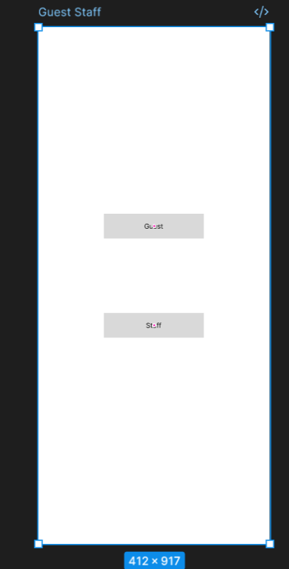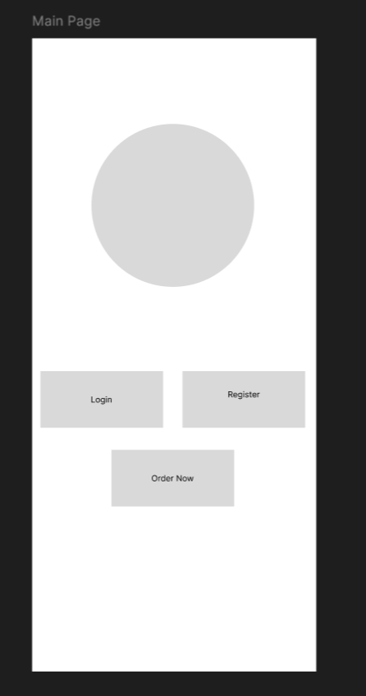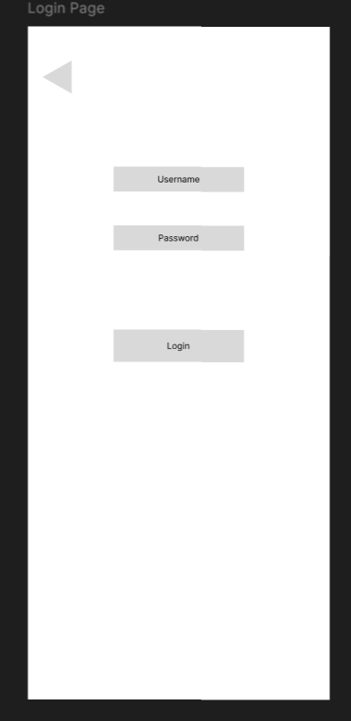
Guest Side
- Home/Menu Screen
  - Top: Restaurant logo, navigation bar.
  - Middle: Scrollable list of menu items → each item has image (thumbnail), name, price.
  - Bottom: “Make a Reservation” button.
  - HCI Principle: Recognition over recall (visual images of food, no hidden menus).
- Reservation Form Screen
  - Input fields: Date picker, Time picker, Number of guests, Notes.
  - Confirm button.
  - Feedback: “Reservation Confirmed” pop-up.
  - HCI Principle: Error prevention (restrict invalid dates/times).
- My Reservations Screen
  - List of upcoming reservations with edit/cancel options.
  - HCI Principle: User control and freedom (easy cancellation/undo).
- Notification Preferences Screen
  - Toggles for: Reservation confirmation, Reservation changes, Promotions.
  - HCI Principle: Flexibility and efficiency.
Staff Side
- Dashboard Screen
  - Two buttons: “Menu Management” | “Reservations.”
  - Notification bell icon shows new reservations.
  - HCI Principle: Consistency and standards (clear icons).
- Menu Management Screen
  - List of current menu items.
  - Buttons: Add | Edit | Delete (with confirmation prompt).
  - HCI Principle: Error prevention (confirmation before delete).
- Reservations Screen
  - List of upcoming reservations with customer name, time, party size.
  - Options: Cancel reservation, View details.
  - HCI Principle: Visibility (clear status of each reservation).

1. Purpose of Evaluation
The purpose of this formative evaluation was to test the low-fidelity wireframes/sketches of the Restaurant Management Application with real users. The goal was to uncover early usability issues before investing time in developing a high-fidelity version.

2. Evaluation Method
Chosen method: Think-Aloud with Paper Prototype Testing
- Users interacted with printed wireframe screens (or simple digital sketches).
- The facilitator acted as the “computer,” swapping screens when users tapped/clicked on elements.
- Participants were encouraged to verbalise their thought process.
- This method is suitable because it works well with non-functional prototypes and still reveals user expectations and confusions.

3. Participants
Two representative users were involved:
- User A (Guest): A customer who often books restaurants online.
- User B (Staff): A restaurant employee familiar with menu updates and handling reservations.
Both reflect the two primary user groups of the app.

4. Test Environment
- Conducted in a classroom setting with paper sketches of the main screens (Login, Menu, Reservation Form, My Reservations, Staff Dashboard, Menu Management, Reservation List).
- Facilitator managed screen transitions by showing the “next” sketch.
- Notes were taken on where users hesitated, made errors, or asked questions.

5. Test Tasks (on Low-Fidelity Prototype)
Guest Tasks
- Log in as a guest (using the login sketch).
- Browse menu items and find the price of one dish.
- Make a reservation for two people tomorrow at 7:00 pm.
- Cancel the reservation using the “My Reservations” screen.
- Change notification settings to turn off promotional alerts.
Staff Tasks
- Log in as staff (staff account sketch).
- Add a new menu item with name, price, and image.
- Edit a menu item to change its price.
- Check today’s reservations and cancel one.
- View a new reservation notification and open the details screen.

6. Procedure
- Introduction: Explained that the prototype is not a real app but a series of sketches. Emphasised that the test is about the design, not the users.
- Task Execution (Think-Aloud): Users performed tasks while describing what they thought each button or screen meant.
- Facilitator Role: Swapped sketches when users “clicked” something. Probed gently if the user seemed confused.
- Debrief: Asked for impressions, likes, dislikes, and suggestions.

7. Findings (from Paper Prototype Test)
- User A (Guest):
  - Successfully browsed the menu and made a reservation.
  - Was unsure about where to find their reservation later — the “My Reservations” label wasn’t obvious. Suggested using “My Bookings” instead.
  - Liked the toggle switches for notifications but asked if “Promotions” meant discount offers or booking updates (wording unclear).
- User B (Staff):
  - Easily added a menu item using the provided form sketch.
  - Initially confused between “Delete” and “Mark Unavailable” — suggested clearer icons/labels.
  - Wanted the reservation list to have a filter option (by date/time) since large restaurants handle many bookings.
General Observations:
- Both users tapped menu icons first before reading labels → icons should be clear and conventional.
- The paper flow worked smoothly — users could follow tasks without major confusion.
- Confirmation dialogues (e.g., for cancelling reservations or deleting menu items) were expected but not shown in the prototype — should be added in the next iteration.

8. Conclusions & Next Steps
- Prototype is usable, but terminology (“Reservations” vs “Bookings”) and notification settings need refinement.
- Staff features should separate delete vs unavailable options more clearly.
- Add search/filter tools for reservation management.
- Add confirmation prompts for destructive actions.
- Iterate the wireframes based on feedback before moving to a mid/high-fidelity design.

