16:25 to 17:10
Next meeting – 28th of November 15:00
PO thoughts based on 3 Personas and research:
Make email for tablet
For children, let them know what is going to happen, encouraging.
Dentist questions: book appointment, wait in the lobby, walking in, cleaning mouse.
Robot can explain during the time of waiting. Key feature – report from the robot.
Talking with the dentist. Make friends, explain. Same friend in the office (robot). After kids done appointment, app makes sure they follow routine.
If kids have points – they receive a gift (bigger or smaller)
App will include:
- A short intro tutorial to learn navigation, prompts to torn on/off options, colour scheme choice) – gradual exposure.

- Landscape and Portrait orientation – start with small mobile device(find statistics on most used device)
- No timers!!!
- Teeth brushing routine tracker

- Visual, icon-base progress and reward system and reminders (badges, streaks, gentle animations with “disable” button). No judgment or punishment when missed.
- QT Robot talks in encouraging, but gentle way.
App impact
- Asking questions about how people feel, what emotions (helping with emotional side), about type of brush, type of toothpaste, tracking frequency and DURATION of brushing. (maybe make them brush their teeth till the finish of the animation?). Sharing with dentist.
- Tabs with the information (told by QT Robot) on how first visit with dentist is going to be like and how to prepare for that. Asking how stressful you feel before and after the tutorial
- App features and explanations should be visual but also have text description and clear labels.
- Predictable navigation and naming what page/actions follow next for user.
- Dark theme button for brightness sensitive people: json file config
- Sound is disabled by default and prompt to turn on when meeting with the robot.
- App will not contain any complex instructions, only literal, details steps to follow. It should be tested later for reduced cognitive load. Any word with specific meaning should have text explanation on the side, or visual explanation.
- Colours:
- Some instructions and steps are colour-coded (but find the way to not rely on it too much)

- Low-stimulation palette (would you like entire app like this, or have it more bright-coloured for general audience and button to switch on another, low-stimulation palette?)

- Would you like Dashboard for parents to track their children’s progress on teeth hygiene?
- Will children have their own accounts, or would they be under parental account? Like a family account on one tablet?
- Would you register user via mobile phone, email, or just name and unique username?
- If have 2 children under same account, do you want them to have separate profiles?
- What kind of data practitioner nee to record?
- From user app and their routine
- On the appointment from a Robot?
- Would you like zoom-in options or just bigger elements?
Structure application so features can be changed in one config file.
- For some users, remembering passwords is complicated, it should be password less recognition (via face or phone number), or email? (start with one – maybe email)

- What features would you need on a home screen? (it is the most important screen and defines if user will use an app)
Notes after meeting:

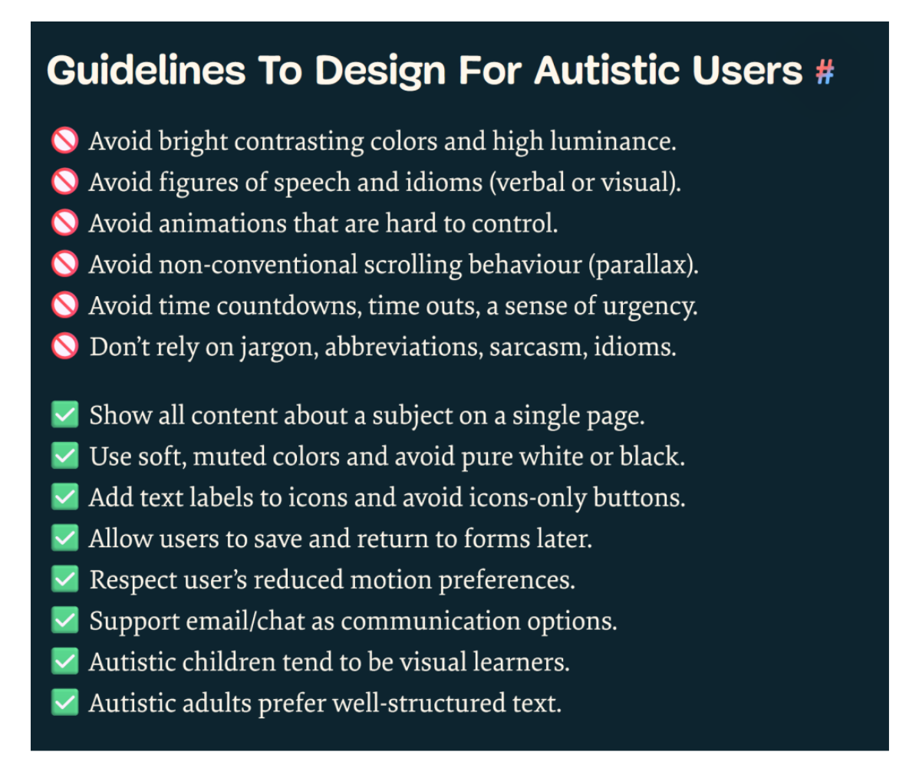

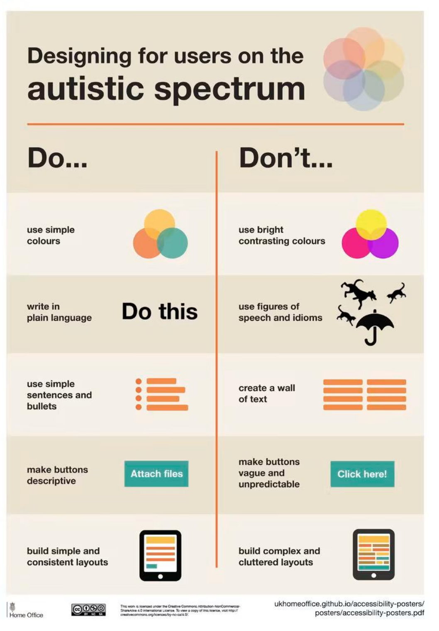

Start with the robot questions:
Would you like me to let you know how…
(Images and descriptions on the screen.)
Make sure all functionality is combined and coherent.
Are you willing to come?

If parents have more than 2 kids – switch between the profile. Just the parents face. ? Waiting for clarification.
QTRobot – may make mistakes
Speaker recognition is limited (yes/no, or ask to spell)

Email + password authentication or face recognition further – they can forget password.
Ethical approval application for the next meeting – clarify with JJ.

Focus just only authentication for Robot, children – later. It is a discussion point and project should be scalable for that solution.
Information and stress relief. Tracking the routine and giving gifts. Robot is a friend and meet the same robot.

What are other ways robot can recognise a child?
Prototype before xmas – a few first screens with features running.
Share email with the link

